Manuscript Maize Mills

Exploratory Data Analysis

Table of contents

# Data Exploration

## Plot: Overview

## Plot: Daily 24-hour average by date

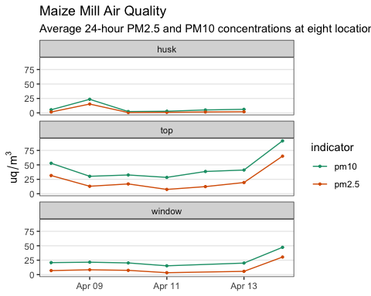

## Plot: Day time vs night time averages (6-18, 18-6)

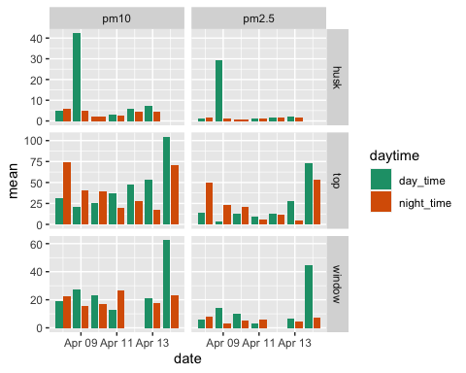

## Plot: Exposure in hours in categories of hazard

### Percent (US EPA)

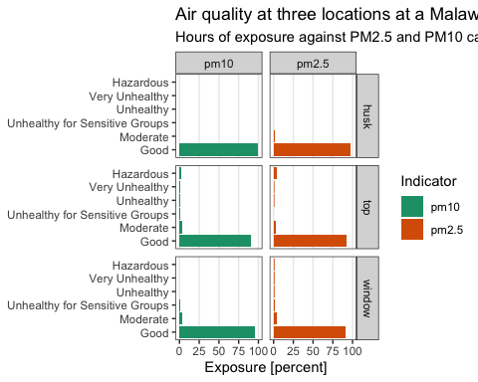

### Percent - WHO 2021

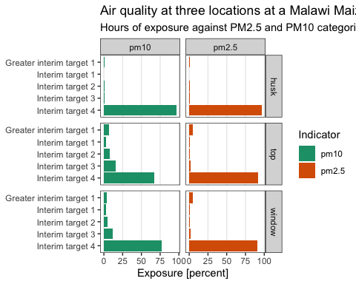

### Waffle plot - WHO 2021 (used)

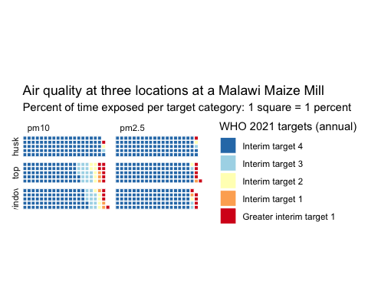

# Analysis of peaks

Questions:

* What does air quality say about who this effects? Vulnerability
* Does the built environment matter? Windows, Operators

## Table: Peaks over the limit for hazardous ([worldhealthorganization2021who])

* Peak for PM2.5: > 35 Greater interim target 1, Annual
* Peak for PM10: > 70 Greater interim target 1, Annual
* Table 1 counts the number of data points (5 minute intervals between them) above these two limits over all days (column n shows the total number of data points)

Table 1: Number of peaks as defined by WHO 2021 target 1 for pm2.5 and pm10

| location | n | pm10 | pm2.5 |
| --- | --- | --- | --- |
| husk | 1132 | 8 | 10 |
| top | 1608 | 109 | 87 |
| window | 1240 | 49 | 61 |

## Plot: Overview (as reference)

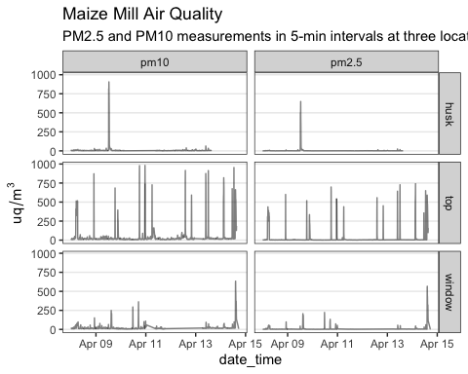

## Detail into peak (event)

**Issues**

* measurements for husk, top, and window not taken at the exact same time
* events might be at different times
* separate analysis for each indicator and location

**Method for pm10 and pm2.5 and location top**

* Each time the pm values are above 100, we assume an “event” happens
* An “event” means that the mill is switched on
* We number events in increasing order
* Then, we take the mean of the values that are above 100 for each event
* The number of minutes of exposure are calculated by multiplying each data point with 6 minutes
* this is because measurements are taken every 6 minutes

### pm10 location top

See Table 2.

Table 2: Table caption me!

| date | event_no | location | indicator | minutes | mean_exposure |
| --- | --- | --- | --- | --- | --- |
| 2021-04-08 | 1 | top | pm10 | 120 | 393 |
| 2021-04-08 | 2 | top | pm10 | 18 | 469 |
| 2021-04-09 | 3 | top | pm10 | 18 | 437 |
| 2021-04-09 | 4 | top | pm10 | 36 | 284 |
| 2021-04-10 | 5 | top | pm10 | 24 | 560 |
| 2021-04-10 | 6 | top | pm10 | 24 | 675 |
| 2021-04-11 | 7 | top | pm10 | 24 | 360 |
| 2021-04-11 | 8 | top | pm10 | 60 | 138 |
| 2021-04-12 | 9 | top | pm10 | 6 | 101 |
| 2021-04-12 | 10 | top | pm10 | 24 | 496 |
| 2021-04-12 | 11 | top | pm10 | 18 | 439 |
| 2021-04-13 | 12 | top | pm10 | 24 | 479 |
| 2021-04-13 | 13 | top | pm10 | 24 | 557 |
| 2021-04-14 | 14 | top | pm10 | 36 | 554 |
| 2021-04-14 | 15 | top | pm10 | 18 | 432 |
| 2021-04-14 | 16 | top | pm10 | 18 | 593 |
| 2021-04-14 | 17 | top | pm10 | 84 | 404 |

Table 3: The median event time (milling process) for location top and indicator pm10 is 24 minutes with a median exposure of 439. Following US EPA standards, operators are exposed to pm10 at hazardous concentration for half and hour during every milling process.

Table 3: Table caption me!

| location | indicator | median_minutes | median_exposure |
| --- | --- | --- | --- |
| top | pm10 | 24 | 439 |

### pm25 location top

See Table 4.

Table 4: Table caption me!

| date | event_no | location | indicator | minutes | mean_exposure |
| --- | --- | --- | --- | --- | --- |
| 2021-04-08 | 1 | top | pm2.5 | 114 | 325 |
| 2021-04-08 | 2 | top | pm2.5 | 18 | 299 |
| 2021-04-09 | 3 | top | pm2.5 | 18 | 304 |
| 2021-04-09 | 4 | top | pm2.5 | 36 | 239 |
| 2021-04-10 | 5 | top | pm2.5 | 18 | 498 |
| 2021-04-10 | 6 | top | pm2.5 | 30 | 411 |
| 2021-04-11 | 7 | top | pm2.5 | 12 | 358 |
| 2021-04-12 | 8 | top | pm2.5 | 12 | 487 |
| 2021-04-12 | 9 | top | pm2.5 | 18 | 295 |
| 2021-04-13 | 10 | top | pm2.5 | 18 | 375 |
| 2021-04-13 | 11 | top | pm2.5 | 18 | 507 |
| 2021-04-14 | 12 | top | pm2.5 | 36 | 505 |
| 2021-04-14 | 13 | top | pm2.5 | 12 | 270 |
| 2021-04-14 | 14 | top | pm2.5 | 18 | 413 |
| 2021-04-14 | 15 | top | pm2.5 | 72 | 394 |
| 2021-04-14 | 16 | top | pm2.5 | 6 | 160 |

Table 5: The median event time (milling process) for location top and indicator pm2.5 is 18 minutes with a median exposure of 367. Following US EPA standards, operators are exposed to pm2.5 at hazardous concentration for half and hour during every milling process.

Table 5: Table caption me!

| location | indicator | median_minutes | median_exposure |
| --- | --- | --- | --- |
| top | pm10 | 24 | 439 |

# Appendix

## Interactive Plots

**only viewable in HTML version**

**Top**

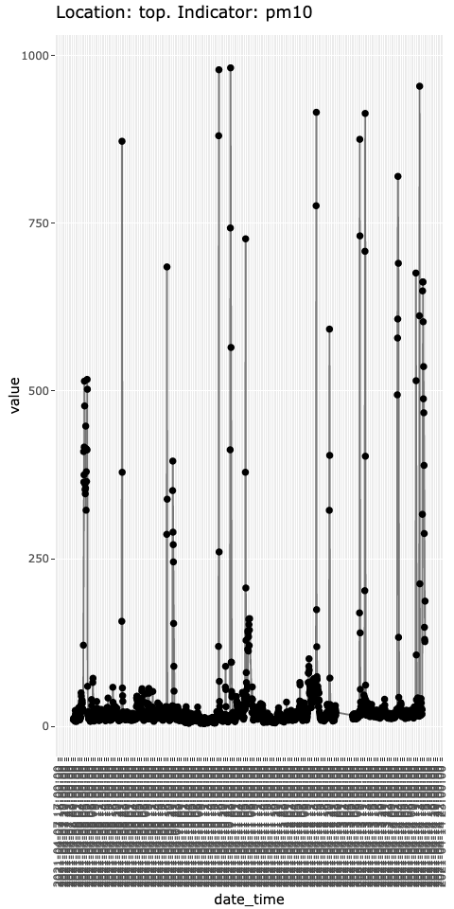

**Husk**

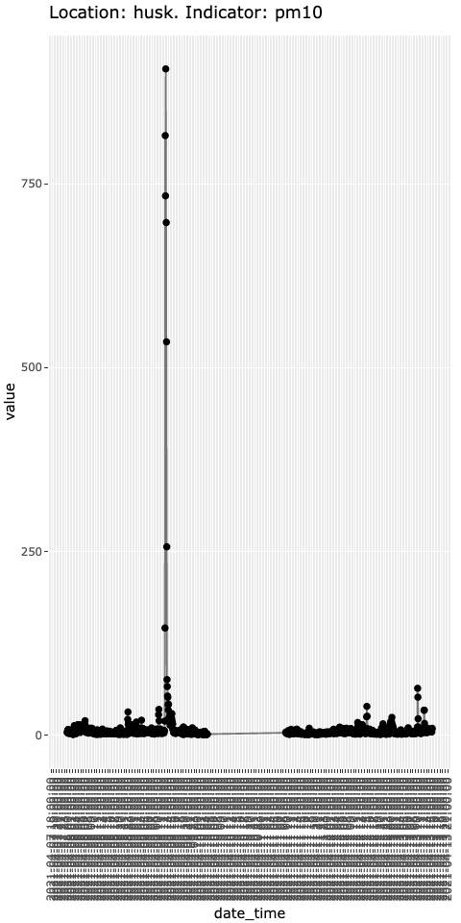

**Window**

