Thesis title

Your name

# Background

Describe the background of the problem you will tackle in your project. **This section should take around one page; refer to mostly peer-reviewed source.** Start from the most general overview and converge to the area of your interest. For instance, if you work with a startup which tries to provide sanitation facilities to rural areas, your first section could be *Global sanitation*, the second section would be *Sanitation in Kenya*, and the third one may be: *The startup’s approach.* This way, you describe the problem on the global scale and converge to the area of your work and interests for the next months. You can include a representative figure, if you do, refer to it in text.

Figure 1. Tree on Mount Victoria Devonport, New Zealand. Image taken by [Daniel Schwen](https://commons.wikimedia.org/wiki/User:Dschwen) ([CC BY-SA 2.5](https://creativecommons.org/licenses/by-sa/2.5/deed.en)).

# Problem statement and goals

This section should be concise and clear. It should **not** be **longer than 5-7 sentences**. The clearer the goal is, the easier it will be for you to ask correct research questions in the next section. Additionally, the easier it will be to set a proper timeline for your work.

# Research Questions

Write bullet-point questions which you identified as the most important. **Don’t write more than 2-3 sentences here. Focus more on bullet point questions.** Make sure that you use some sort of metric in the questions to later define whether you reached the goal set by the question or not.

Instead of writing:

How to improve the prototype?

Write:

How can a prototype be improved to increase the separation rate from 90% to 95%?

Of course, not all the questions can be quantitative in nature but make sure that you set a tangible goal in the question, whenever possible. You can add a figure here to give background for one of the most important questions or to show the reason why you ask this kind of question.

# Methods

Describe how are you going to answer your research questions in practice. **Write one paragraph per research question.** This is one of the most important parts of this proposal, please put effort into developing your methodology.

# Planning

## Gantt chart

Put some effort into estimating how much time you will need to perform every task. **Don’t write more than 4-5 sentences**. **Focus on the figure** presenting the time requirements for tasks. This figure is a Gantt chart. It can be as simple as the one in Figure 2. You can also make a more detailed one using one of the MS Excel [templates](https://create.microsoft.com/en-us/templates/gantt-charts).

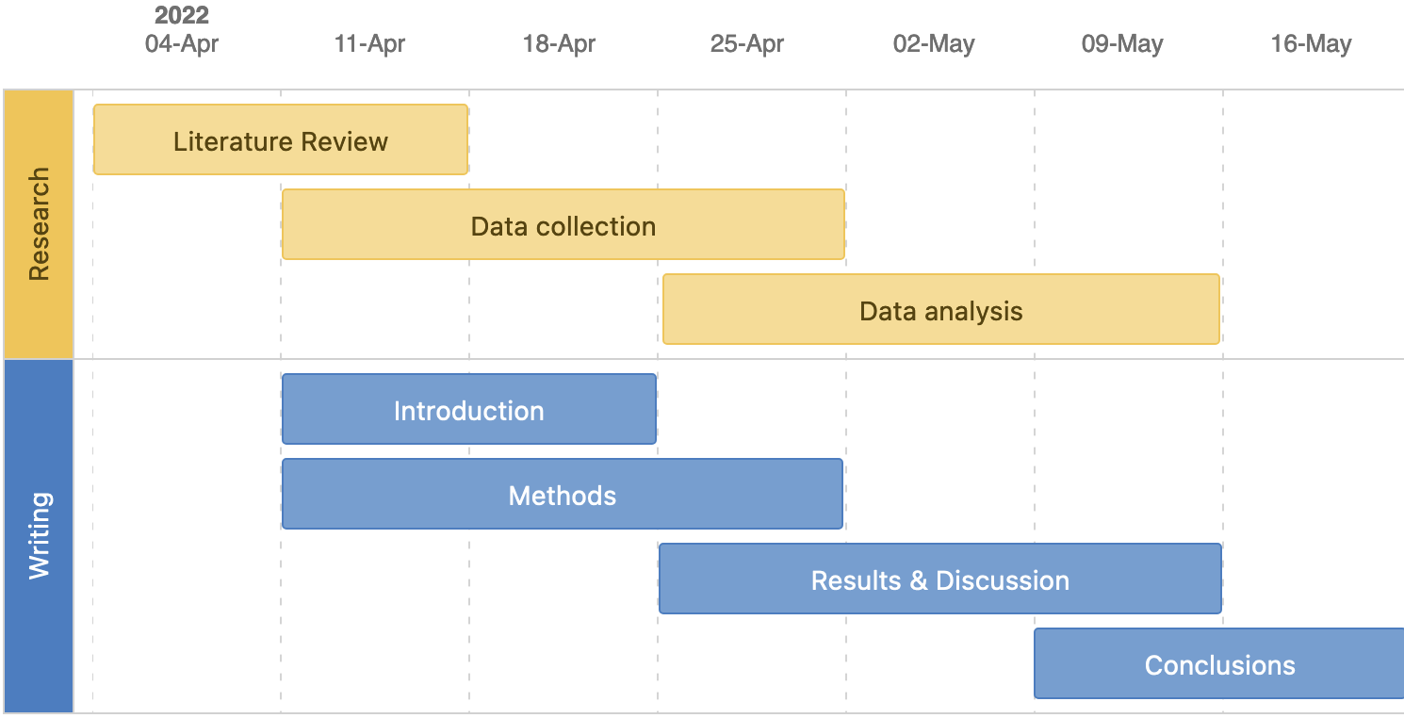

*Figure 2. Gantt chart for research work and thesis writing.*

Feel free to describe the most important phases of your project and mention the potential bottlenecks or showstoppers you identified at the beginning.

## Mind Map

A mind map is a diagram showing your center idea in the middle and the associated ideas around it with arrows indicating relationships and hierarchies between ideas.

Figure . Exemplary mind map (source: [Wikimedia Commons](https://commons.wikimedia.org/wiki/File:022_PM_Project_Life_Cycle_Model.png)).

You are invited to draw a mind map of your project. It is expected to help you visualize and plan for the upcoming steps and tasks. Potentially, you may also identify some bottlenecks, which risks can be mitigated in advance.

# Data Management Plan (DMP)

This is a draft DMP. It can and will change during the project. The purpose of this DMP is to outline some initial ideas about the data that will be collected, generated or re-used. **The table is the important part, don’t write plain text but the questions for data collection. Focus on filling in the table.** This DMP should follow the Methods section: in Methods you describe how you measure variables, here you describe what you measure.

# Data collection

What type, format of primary data will you generate? Which existing data (yours or third-party secondary data) will you reuse? Briefly describe the primary data you will generate. Also mention any existing data that will be (re)used. The descriptions should include the type, format and brief documentation of each dataset. You can use the template table provided below. For examples on data types, see [Data management section in GHE Student Wiki](https://unlimited.ethz.ch/display/ghestudents/Data+source+types)

|  |  |  |  |
| --- | --- | --- | --- |
| **dataset** | **data type** | **data format** | **data documentation** |
| *Waste characterisation of public bins in Kreis 4* | *Observational data* | *paper-based → Google Sheet → CSV export of raw data* | *The preliminary variables (columns in table) of this dataset are: id, location, waste category, weight in kg with .00 kg accuracy)*  *The dataset will have 50 observations of bins (rows in table).*  ***Alternatively:*** *provide a link to a draft Google Sheet that has the variables as columns.* |
| etc. |  |  |  |

## 

# Data storage

Details for data storage are covered in the [Data management section of the GHE student Wiki](https://unlimited.ethz.ch/display/ghestudents/Data+management)*.* Briefly describe how you will store raw data you want to collect yourself and how you expect to analyze it (what tools you will use).

# Budget

Include the expected budget for the project.

|  |  |  |  |  |
| --- | --- | --- | --- | --- |
| **No** | **expense** | **amount** | **unit price [CHF]** | **total price [CHF]** |
| 1 | Thermocouple | 2 | 15 | 30 |
| 2 | Arduino | 1 | 20 | 20 |
|  | **Total** |  |  | **50** |

# References

Bachelor’s thesis and semester project should include around **10 references** in the proposal; master’s thesis should be more detailed and include **at least 20 references**. Make sure you use the APA 7 style and that you include DOIs as hyperlinks. Please use the Zotero capabilities to add the references - **don’t do it manually**. Follow [this tutorial](https://unlimited.ethz.ch/display/ghestudents/Reference+management) on how to use Zotero with MS Word. An example is provided below. Remember to cite every reference you included in this section!

Anand, C. K., & Apul, D. S. (2014). Composting toilets as a sustainable alternative to urban sanitation – A review. *Waste Management*, *34*(2), 329–343. DOI: [10.1016/j.wasman.2013.10.006](https://doi.org/10.1016/j.wasman.2013.10.006)

Balasubramanya, S., Evans, B., Ahmed, R., Habib, A., Asad, N. S. M., Rahman, M., Hasan, M., Dey, D., Camargo-Valero, M., Rao, K. C., & Fernando, S. (2017). Take it away: The need for designing fecal sludge disposal services for single-pit latrines. *Journal of Water, Sanitation and Hygiene for Development*, *7*(1), 121–128. DOI: [10.2166/washdev.2017.073](https://doi.org/10.2166/washdev.2017.073)