Thesis title

Your name

# Background

Describe the background of the problem you will tackle in your project. Start from the most general overview and converge to the area of your interest. This section must be supplemented with at least 5 peer reviewed references that illustrate both the state-of-the-art and the research gaps. Figures and Tables can be included to support your findings. Please refer to every Figure and Table you include in the text. For example, trees are beautiful, as shown in Figure 1.

Figure 1. Tree on Mount Victoria Devonport, New Zealand. Image taken by [Daniel Schwen](https://commons.wikimedia.org/wiki/User:Dschwen) (CC BY-SA 2.5).

# Problem statement

This section should clearly explain the problem that you are seeking to address. It is a natural continuation of the background section, which will have explained the current state of knowledge related to your problem.

# Goal and Research Questions

The first thing in this section needs to be the goal of your thesis: what it is you hope to achieve. This is followed by the research questions which you will answer. By answering the research questions, you will achieve your goal.

Research questions should be SMART: Specific, Measurable, Achievable, Realistic, Time-bound. For example: “What is the best design for a motor?” is not a SMART research question. “What is the maximum RPM that a 3D printed chain from plastic can withstand before it breaks?” is a SMART question. Note also that yes/no questions are not SMART, nor are they acceptable.

# Methods

This is where you describe what it is you plan to do, how you plan to do it, where and why you plan to do it. For example: you should clearly describe the experiments you plan to conduct, the number of site visits you plan to make, the list of materials you are hoping to use, and other such detailed information that communicates how far in a detail you have thought about your work. This section should also include a summary of your estimated costs. It would be appropriate but not mandatory to include two to three references related to your specific methodologies and/or protocols.

# Gantt chart

Put some effort into estimating how much time you will need to perform every task. Present your time plan on a Gantt chart. It can be as simple as the one in Figure 2. You can also make a more detailed one using one of the MS Excel [templates](https://create.microsoft.com/en-us/templates/gantt-charts).

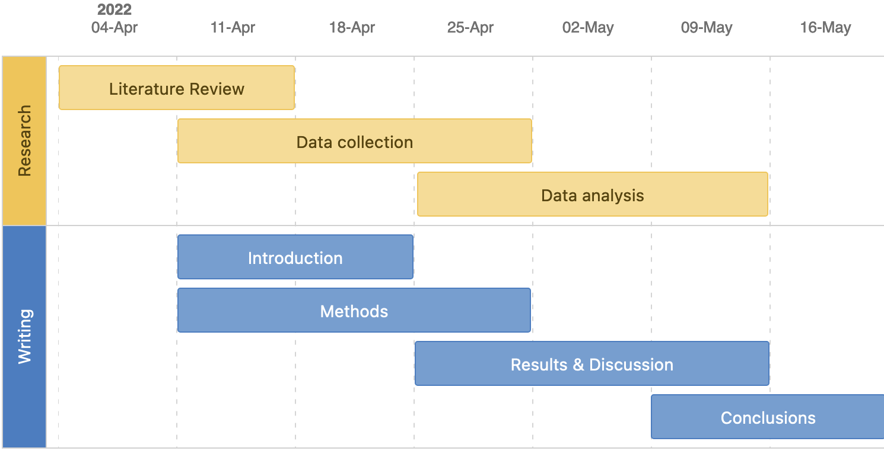

*Figure 2. Gantt chart for research work and thesis writing.*

# Data Management Plan (DMP)

This is a draft DMP. It can and will change during the project. The purpose of this DMP is to outline some initial ideas about the data that will be collected, generated or re-used.

Briefly describe the primary data you will generate. Mention any existing data that will be (re)used. The descriptions should include the type, format and brief documentation of each dataset. You can use the template table provided below. For examples on data types, see [Data management section in GHE Student Wiki](https://unlimited.ethz.ch/display/ghestudents/Data+management).

|  |  |  |  |
| --- | --- | --- | --- |
| **dataset** | **data type** | **data format** | **data documentation** |
| *Waste characterization of public bins in Kreis 4* | *Observational data* | *paper-based → Google Sheet → CSV export of raw data* | *The preliminary variables (columns in table) of this dataset are: id, location, waste category, weight in kg with .00 kg accuracy)*  *The dataset will have 50 observations of bins (rows in table).*  ***Alternatively:*** *provide a link to a draft Google Sheet that has the variables as columns.* |

## Data storage

Details for data storage are covered in the [Data management section of the GHE student Wiki](https://unlimited.ethz.ch/display/ghestudents/Data+management)*.* Briefly describe how you will store raw data you want to collect yourself and how you expect to analyze it (what tools you will use).

# References

Make sure you use the APA 7 style and that you include DOIs as hyperlinks. Please use the Zotero capabilities to add the references - **don’t do it manually**. Follow [this tutorial](https://unlimited.ethz.ch/display/ghestudents/Reference+management) on how to use Zotero with MS Word. An example is provided below. Remember to cite every reference you included in this section!

Anand, C. K., & Apul, D. S. (2014). Composting toilets as a sustainable alternative to urban sanitation – A review. *Waste Management*, *34*(2), 329–343. DOI: [10.1016/j.wasman.2013.10.006](https://doi.org/10.1016/j.wasman.2013.10.006)

Balasubramanya, S., Evans, B., Ahmed, R., Habib, A., Asad, N. S. M., Rahman, M., Hasan, M., Dey, D., Camargo-Valero, M., Rao, K. C., & Fernando, S. (2017). Take it away: The need for designing fecal sludge disposal services for single-pit latrines. *Journal of Water, Sanitation and Hygiene for Development*, *7*(1), 121–128. DOI: [10.2166/washdev.2017.073](https://doi.org/10.2166/washdev.2017.073)