open by default

a data management strategy

Lars Schöbitz

June 12, 2023

# Project

## My role - **Open Science Specialist**

* research data management
* reproducible workflows
* mindset for Open Science
* research communication
* teaching data science tools
* proposal writing

Open Science Specialist - Job Description: https://github.com/Global-Health-Engineering/job-descriptions/tree/main/open-science-specialist

## Data Management Strategy

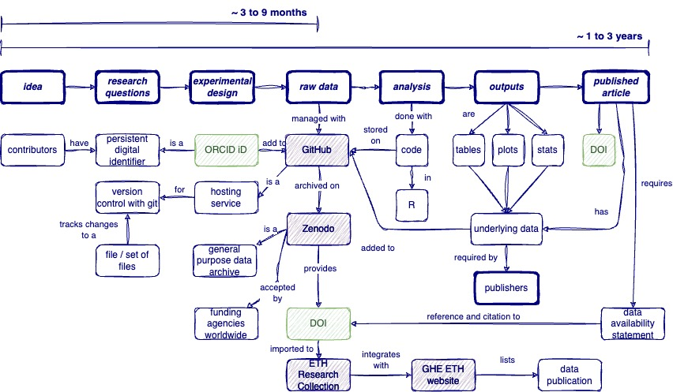

# Characteristics

## Data at Global Health Engineering

* small (few MBs)
* tabular
* non-sensitive
* topics (waste management, sanitation, air quality, etc.)

# Pain Points

## Lost and overwhelmed

* terminology (underlying data, raw data, processed data, metadata, open sources, open access, …)
* licensing (CC-BY, MIT, public domain, code, data)
* security & privacy (phone numbers, GPS locations of houses)
* repositories (documentation, upload, maintenance)

## Computational tools

* intimidating
* hard
* not everyone’s business

## Scientist as a lone ranger

* acts alone (until becoming a manager/professor)
* exposure to tools (100s throughout research career at different institutions)
* own stack of tools (builds their own individual worksflows -> not team oriented)
* the way to do it (doesn’t have time to learn what would be most effective for a team)

# DMP?

<https://github.com/Global-Health-Engineering/dmp-sor4d>