Save Files
- Extract GAB_GAS.zip to the Gobal\Plugins\GAB\GAS directory.

Create Custom Hook
System Support>Administration>GAB Script Hook Maintenance
- Click the [New Hook] button to get the next available custom Hook Id.
- For Hook Description, enter “HR&P Timeclock Export”.
- Click the [New Seq] button to add a new sequence to this hook.
- For GAS Program, browse to and select “Global\Plugins\GAB\GAS\HRP_Timeclock_Export.gas”.
- Be sure both “Active” checkboxes are checked, and click the [Save Seq] then [Save Hook] buttons.

Create Custom Menu Item
- Right click on the desired Menu Heading, and select “Add Custom Menu Item”.
- For Type, select “GAB”.
- Enter a Title for this new menu item.
- Browse to and select the custom Hook Id, created previously.
- Click the [Save] button, and enter User/Group permissions, as necessary.
***please note: it may be necessary to re-start the Global Shop Session to activate the new menu item.
Running the Application
After running On Line>Transactions>Daily Balancing, select the new menu item, and the following screen will open. Enter your client Id and a pay date range.

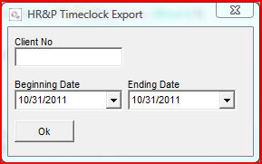

If no records are found in the date range entered, the following message will appear. Click the [Ok] button to return to the entry screen to modify the date selection.

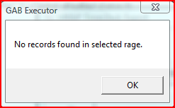

The resulting file, named HRPexport_yyymmdd.csv (where yyyymmdd = current date) will be written to the Global\Files directory.

