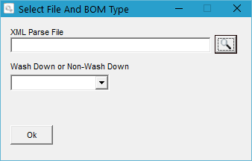

Select an XML file using the Browser button.

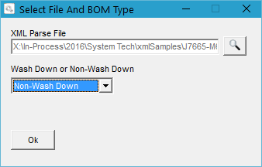

Select either WashDown or Non-WashDown.

Click Ok.

First the GAB script will read the entire XML file.

Then it will begin creating the routers. Using the router templates and part description to determine the raw material part to use on the Router. This found part will replace the Raw material placeholder that is contained on the router.

The GAB script will use the description node from the XML and attempt to find the matching raw Material part within inventory.

-Refer to Raw Material Numbering Schema.xlsx to see the Raw Material Part number and the Material mapping.

If the Gab script cannot successfully find a raw material part number based on the description the GAB script will ask the user for the raw material part number.

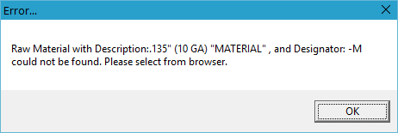

The inventory browser will be opened and the user must select a part.

Note: If the user skips, or cancels the selection 2 times in a row, the GAB script will end and not continue.

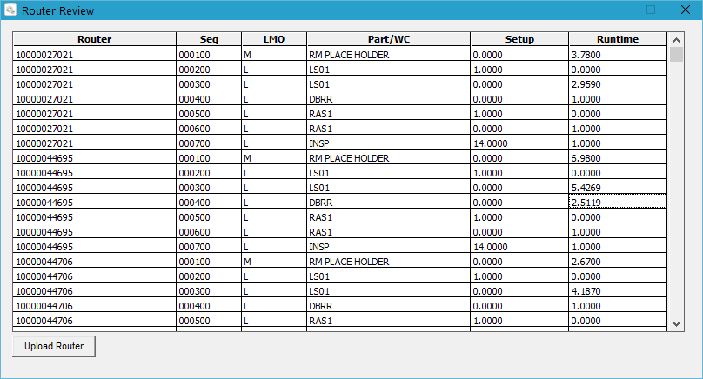

The Router review screen will appear.

The Template router number will be replaced with the Serial Part Number.

The Sequences will match that of the template router.

The Material sequence will be replaced and show the part number from inventory that was found based on the part description, or from the user selection if the part could not be determined from the description.

The Setup and Runtime columns can be modified by the user.



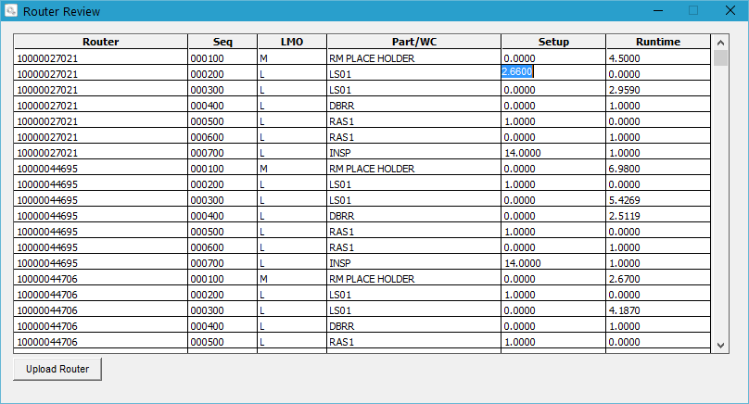

Once the changes have been made to the screen for the runtime and setup the user can hit the Upload Router button. This will upload the router into the system and take the user to the BOM review screen.

If the user does not wish to upload the Router on the screen into Global Shop, they are able to click the X on the screen. This will not upload the router, but allow the user to continue to the BOM review screen.

Uploaded Router within Global Shop. Showing the changes that were made in the last 2 screenshots.

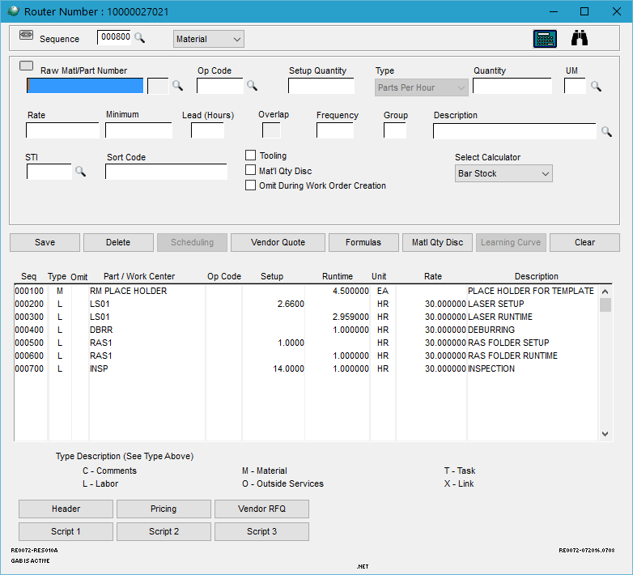

BOM Review and Upload:

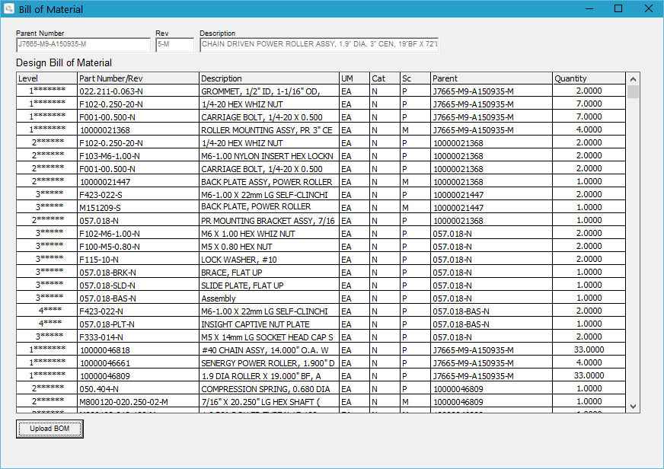

The BOM review screen allows the user to see all information being uploaded into a BOM. This allows the user to verify that information isn’t missing within the XML.

This screen is view only. No information can be edited on this screen.

Once the BOM has been reviewed, the user can hit the Upload BOM button and the BOM will be uploaded into Global.

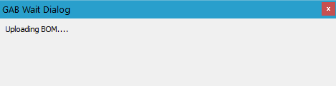

Once this message has cleared, the information has been uploaded into Global Shop.

BOM Uploaded:

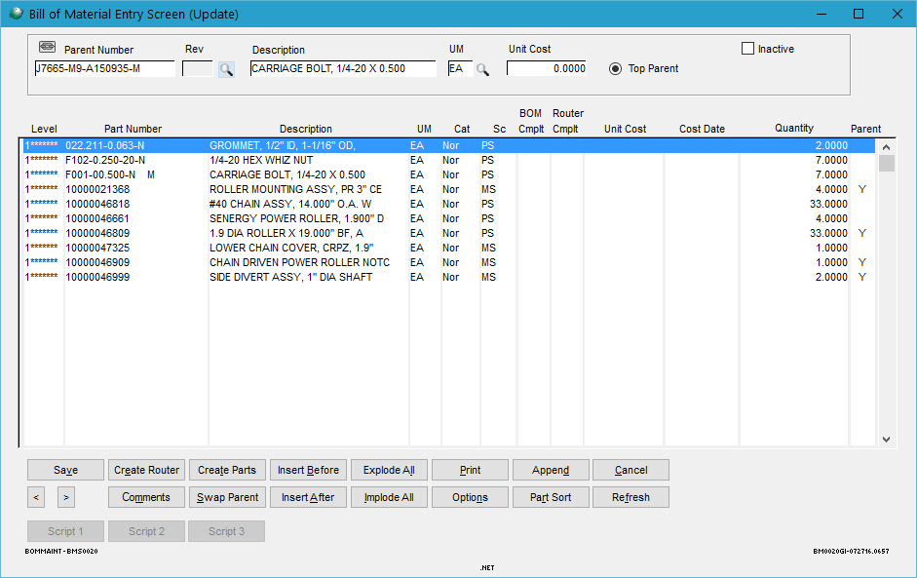

Exploded BOM: 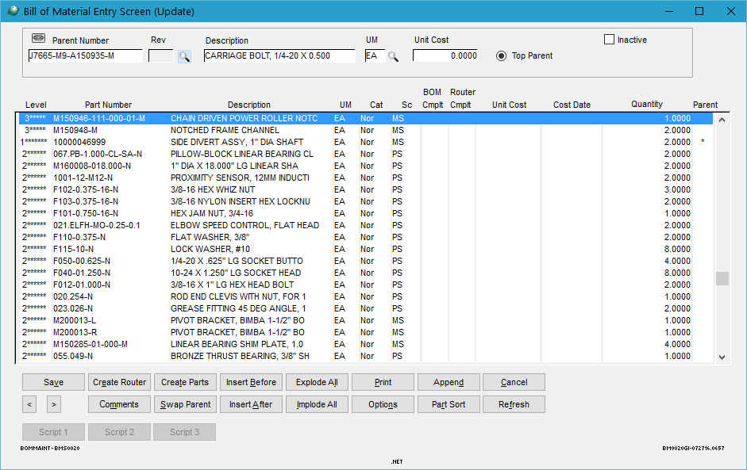

DCC Upload:

After the BOM has be uploaded the GAB script will then attempt to add any document to the BOM.

The GAB script will search in this directory: [\\STI-099\Shop Folder\Mechanical\PDF Drawings\](file:///\\STI-099\Shop%20Folder\Mechanical\PDF%20Drawings\)

Any documents found within that directory that shares the name of the Parent BOM will be attached to the corresponding BOM parent’s document control.