Employee Points System Usage Instructions

The program assumes that you are using and doing Daily Balancing as normal in Global Shop. The rules for using Daily Balancing apply for the points system, so Shifts, Departments, Employees, Employee Shifts need to be setup inside Global Shop.

First, go to Online System > File > Shift Maintenance. The program uses the Mins Before and Mins After in Start and Stop to determine if the employee is Early, Late, Out Early, Out Late. Enter the number of minutes before or after you allow until the user is considered for one of the previously listed occurrences. The program also looks at the Hours assigned to each day to determine if the employee worked the required amount of hours for that day. If they worked less than the minimum shift hours for that day the employee will be considered for a Under Hours occurrence.
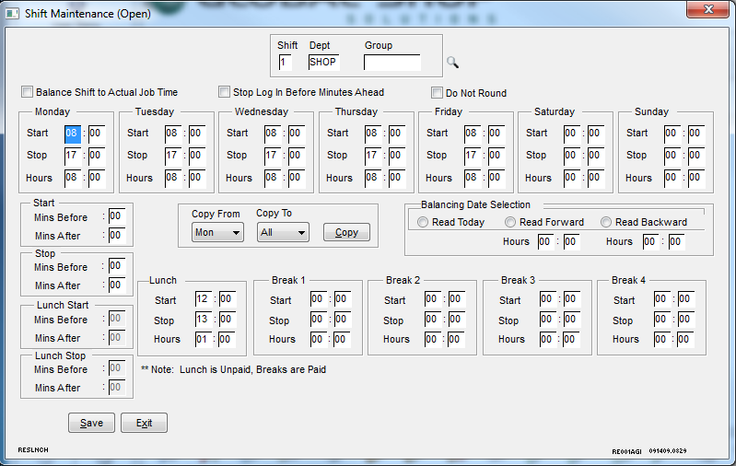
Next enter the Occurrence Point Maintenance screen. Select from the following predefined list of Occurrences that can be assigned a point value:
Absent
Early
Late
Early Out
Late Out
Under Hours
Select the occurrence and assign the appropriate point value. A zero point value is acceptable as well. Click Save to save change.
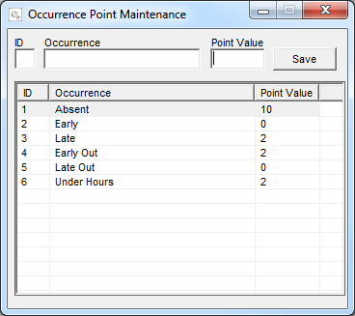
Once finished then run the Employee Occurrence Review. A date range can be selected, and can be ran by Employee or Department. All employees or departments can be selected as well as multiple range selections of employees and departments.

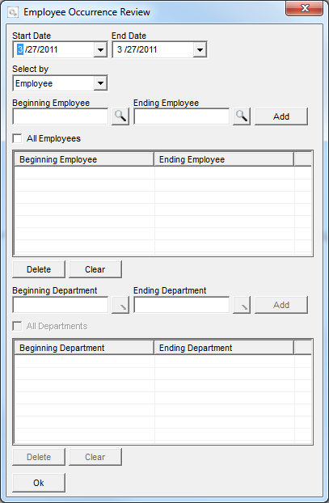
Once selections are made, press the Ok button. Then the program will begin searching for occurrences based on the selections made. It first evaluates Absences. It checks to see if a absence record was placed in Time and Attendance, this requires that absences are put into Global Shop. If the absence record is flagged as Unexcused, then it is considered a occurrence. Then it checks to see if the employee was early or late for the shift, out early or late for the shift, and if the employee worked less than the hours of the shift. Records are checked using shift/department/balancing group. Each of these offenses is considered a occurrence. An employee under this scenario could potentially receive 3 occurrences for one day.

The program will the display a list ordered by employee number, and date/time occurred. It will automatically display the default point value for the occurrence type. The Points field can be modified if it is decided another point value wants to be assigned for that occurrence. The Notes button beside each occurrence can be selected to enter unlimited information about the occurrence that is found relevant. If the occurrence was saved previously the points and notes will show from last time saved. Once all changes are made, click Save this will save this information to the database.
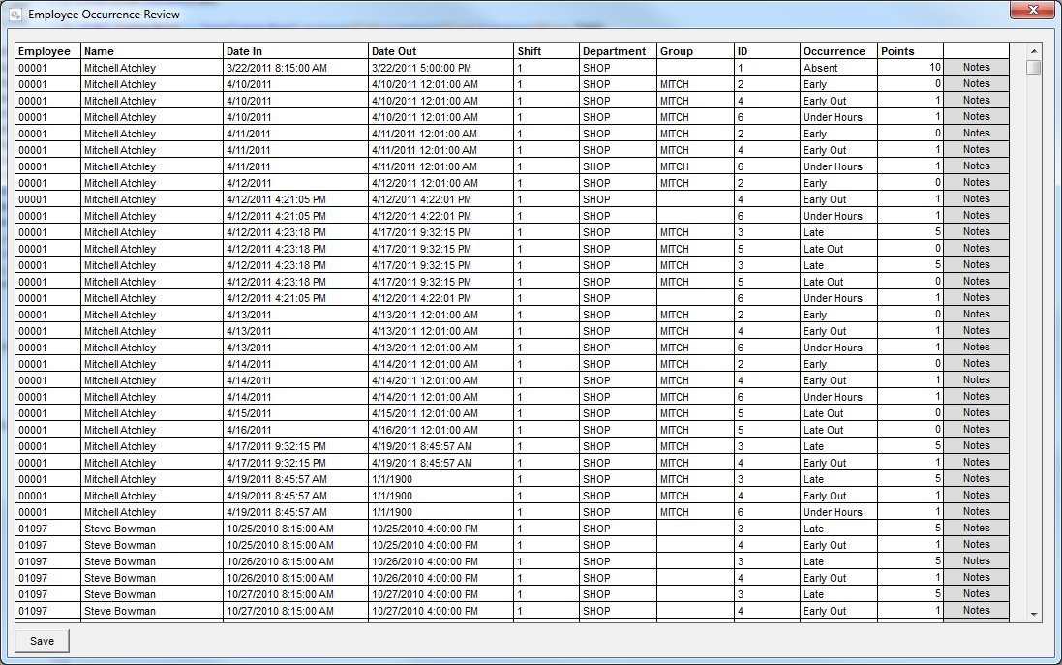

Lastly, the Employee Occurrence Report can be ran to display point totals for a date range. The same selection screen is available as used in the review system. The user can run the report by employees or departments. If ran be employees the report gives totals by employee, and if ran by departments, the report gives totals by employee as well as by department.

