BN, May 3, 2018

**A. This project has 2 features:**

1/Maintenance: Project Management > Administration > Project ETC Maintenance

Receive input of ETC values for Project Management.

Inputs are Hours/Labor/Material/Outside for Groups of Phases of a Project and for a range of months.

User has to select the range of months starting from current month.

2/Export the Project Management data for one/multiple projects into a csv file

User will select 1/multiple/All projects to export to csv file.

**\*\*\* Added in Version 2:**

* **Unattended program that captures the Actual values at the end of each month and save to GCG_3855_EtcAct, as well as the estimate of the next month**
* **Added columns:**

Last_Month_ETC_Hours (J) = The estimate of the current month that is estimated at the end of the previous month.

Last_Month_ETC_Dollars (K) = The estimate of the current month that is estimated at the end of the previous month.

*(J) and (K) is captured at the end of each month, but user can override it by click the Finalize checkbox when running the report.*

Act_Current_Month_Hours (L) = The actual of report month – The actual of previous month

Act_Current_Month_Dollars (M) = The actual of report month – The actual of previous month

* **Added Total on the right side of each Phase, Project**
* 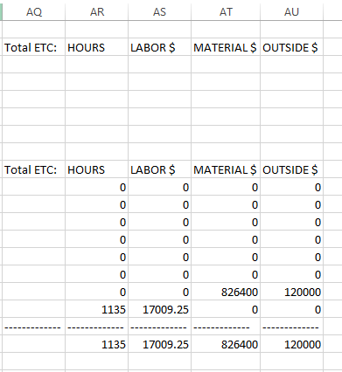
* **Added project summary for each project, that aggregate by Group:**
* 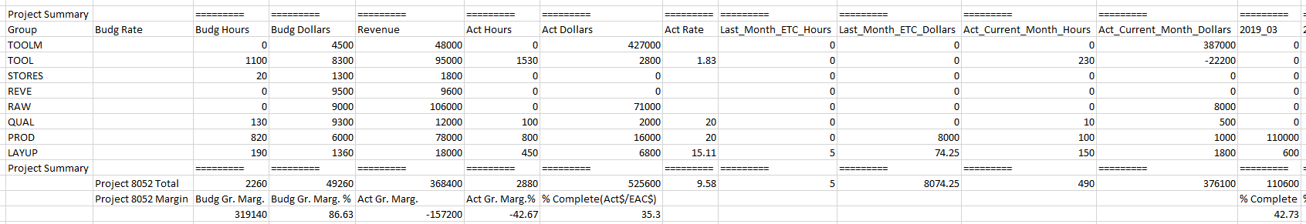**\* Added these fields:**
* 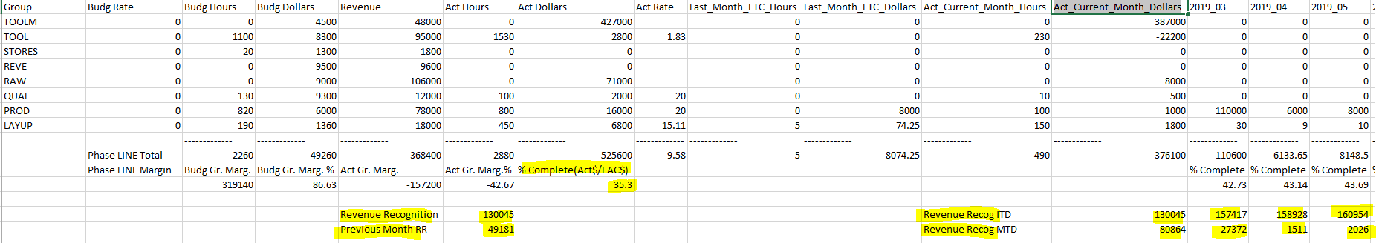

**B. Screenshots:**

1/Maintenance: Project Management > Administration > Project ETC Maintenance

Maintenance program is first launched:

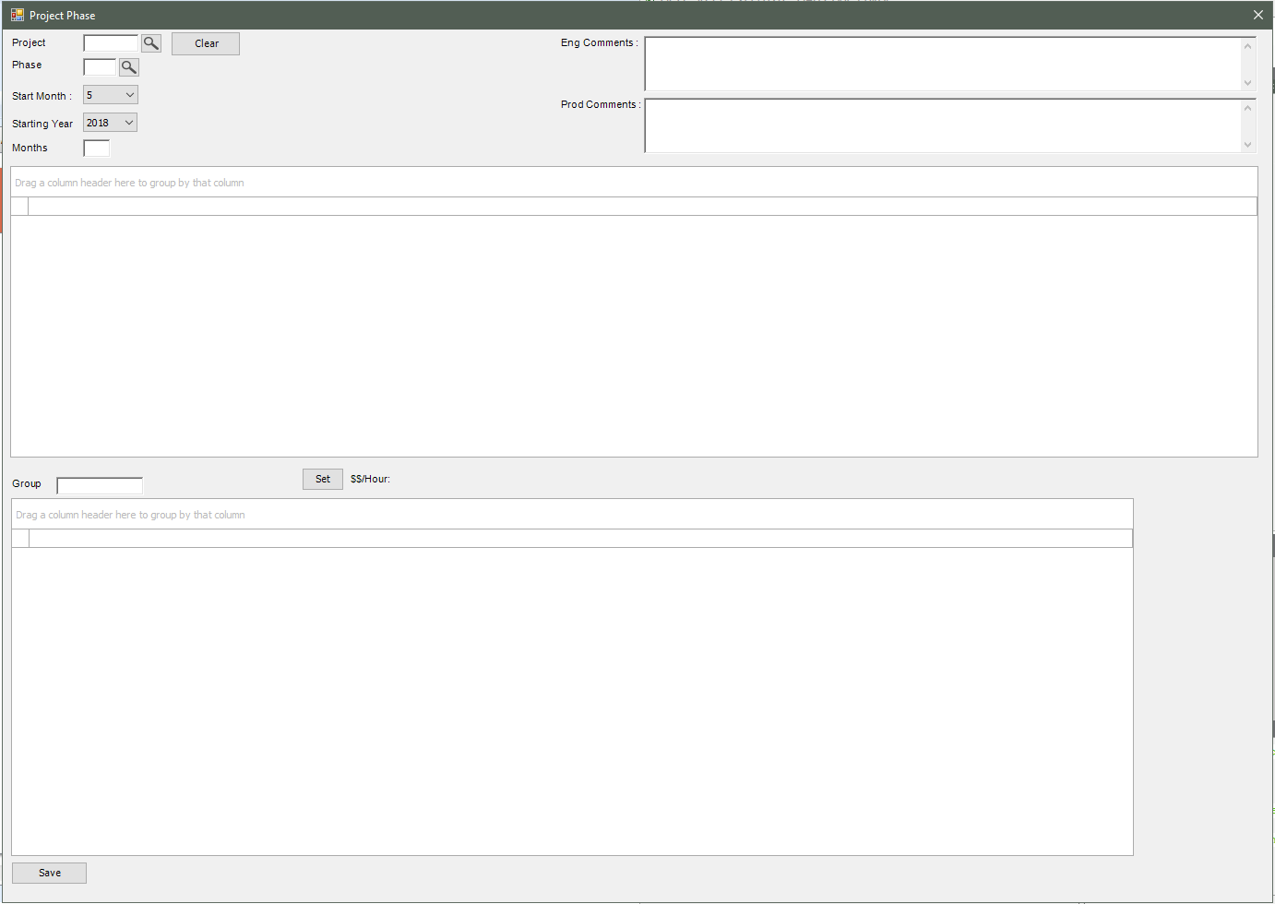

Click the Project browser to select a project.

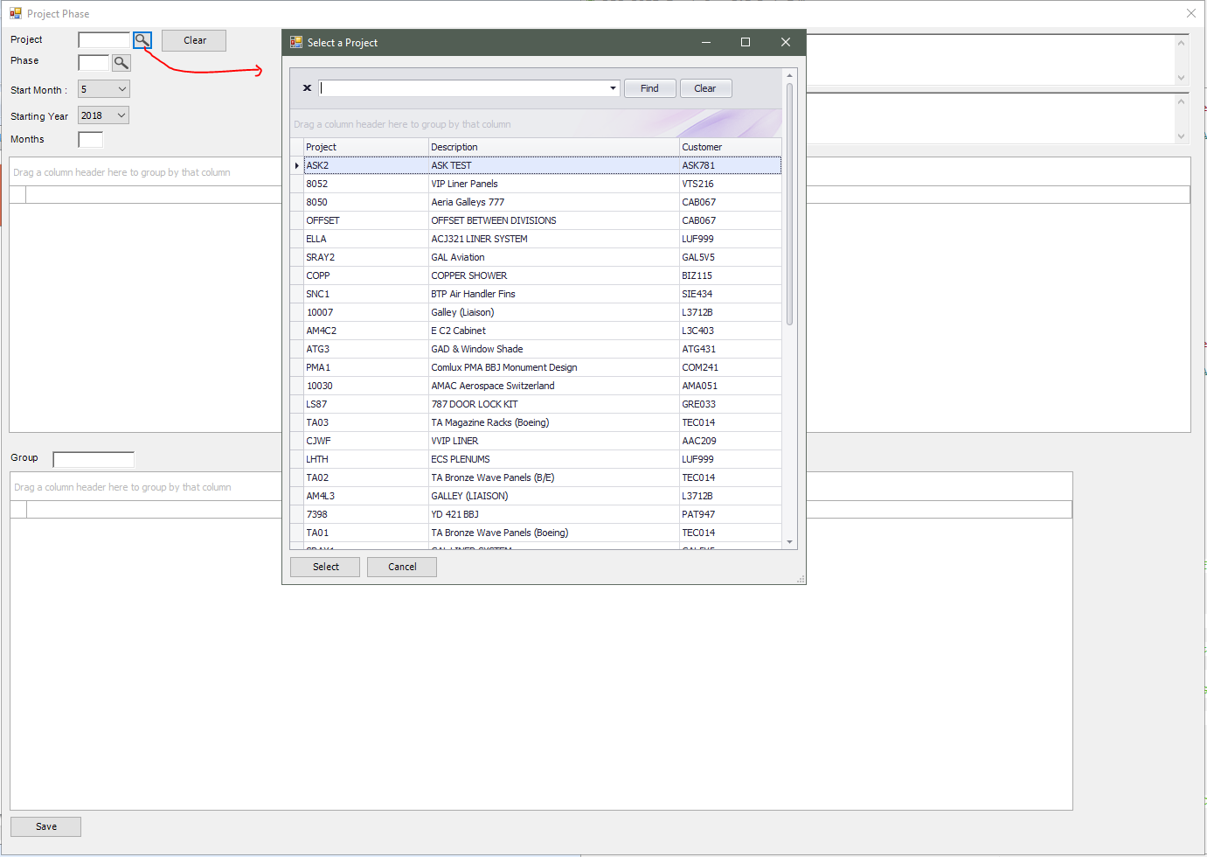

Select a Phase of the project:

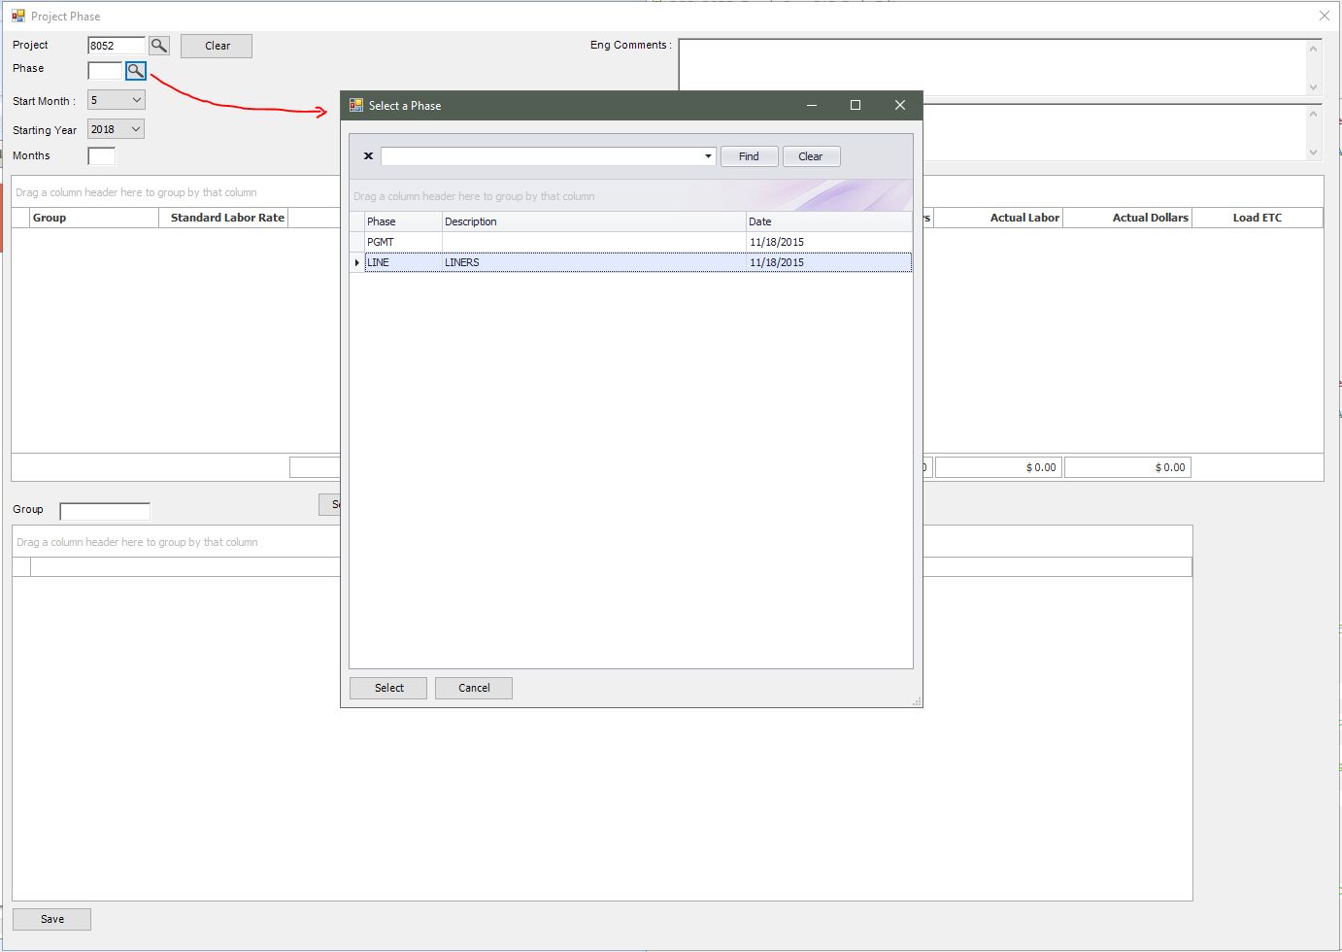

After the Phase is selected, select a number of months. In this example, we select 24 months. Move the mouse out of the Phase text box, the Groups of the selected Phase will be populated in the Upper grid.

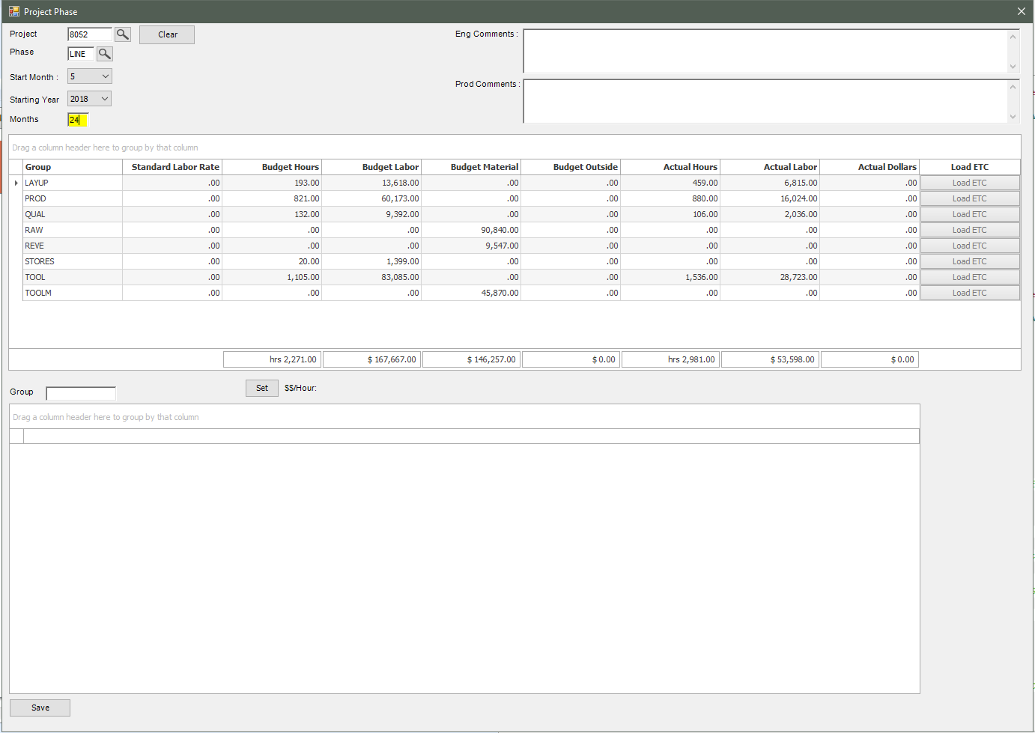

Each Group will have a button “Load ETC”.

Click the button Load ETC, the program will calculate the Hour Rate = Actual Labor / Actual Hours of that Group and display beside the label $$/Hour. (if Actual Labor and Actual Hours are blank, it will get the Standard Labor Rate).

The Lower grid will be populated with a number of months that we want do the estimates. In this case, we select 24 months, so 24 records will be created accordingly to 24 months starting from the current month.

If there are data previously saved for a particular month in database, those data will be populated, if not , it will be blank record.

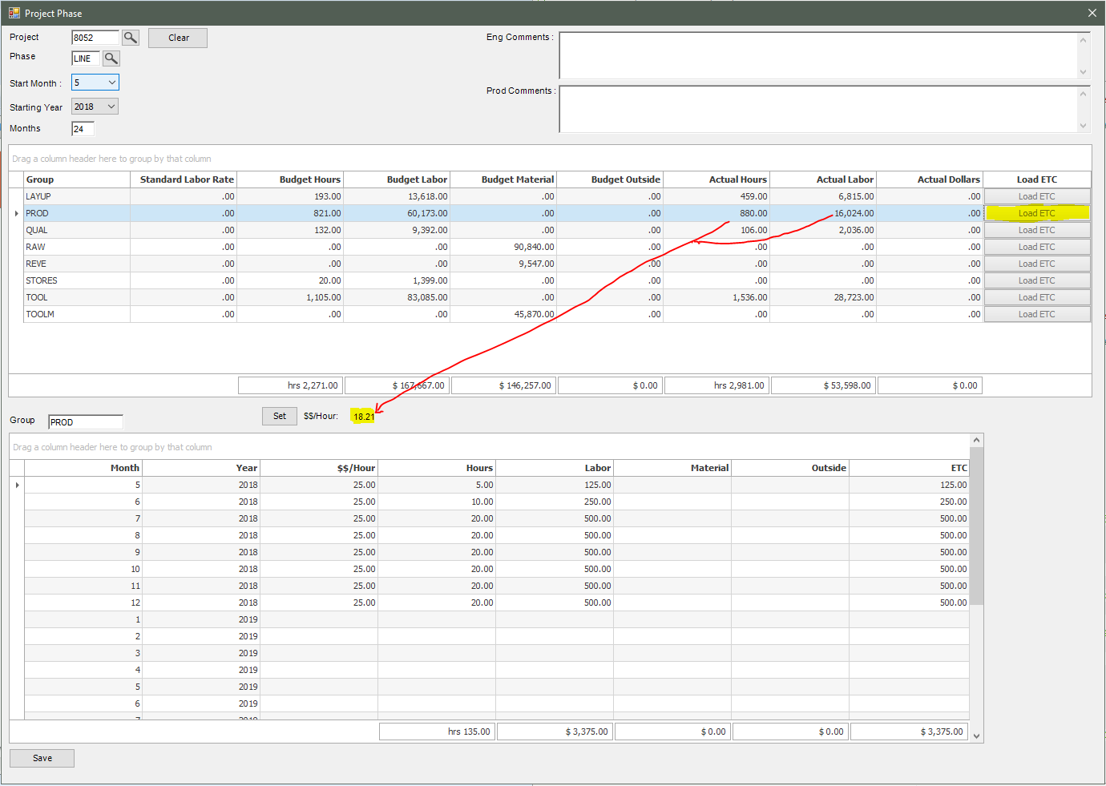

User can actively modify values in the lower grid. If user click Set button, all the records will be set to that Hour Rate and recalculate the lower grid.

Click Save button to save data to database which will be used in the export to Excel section of the program.

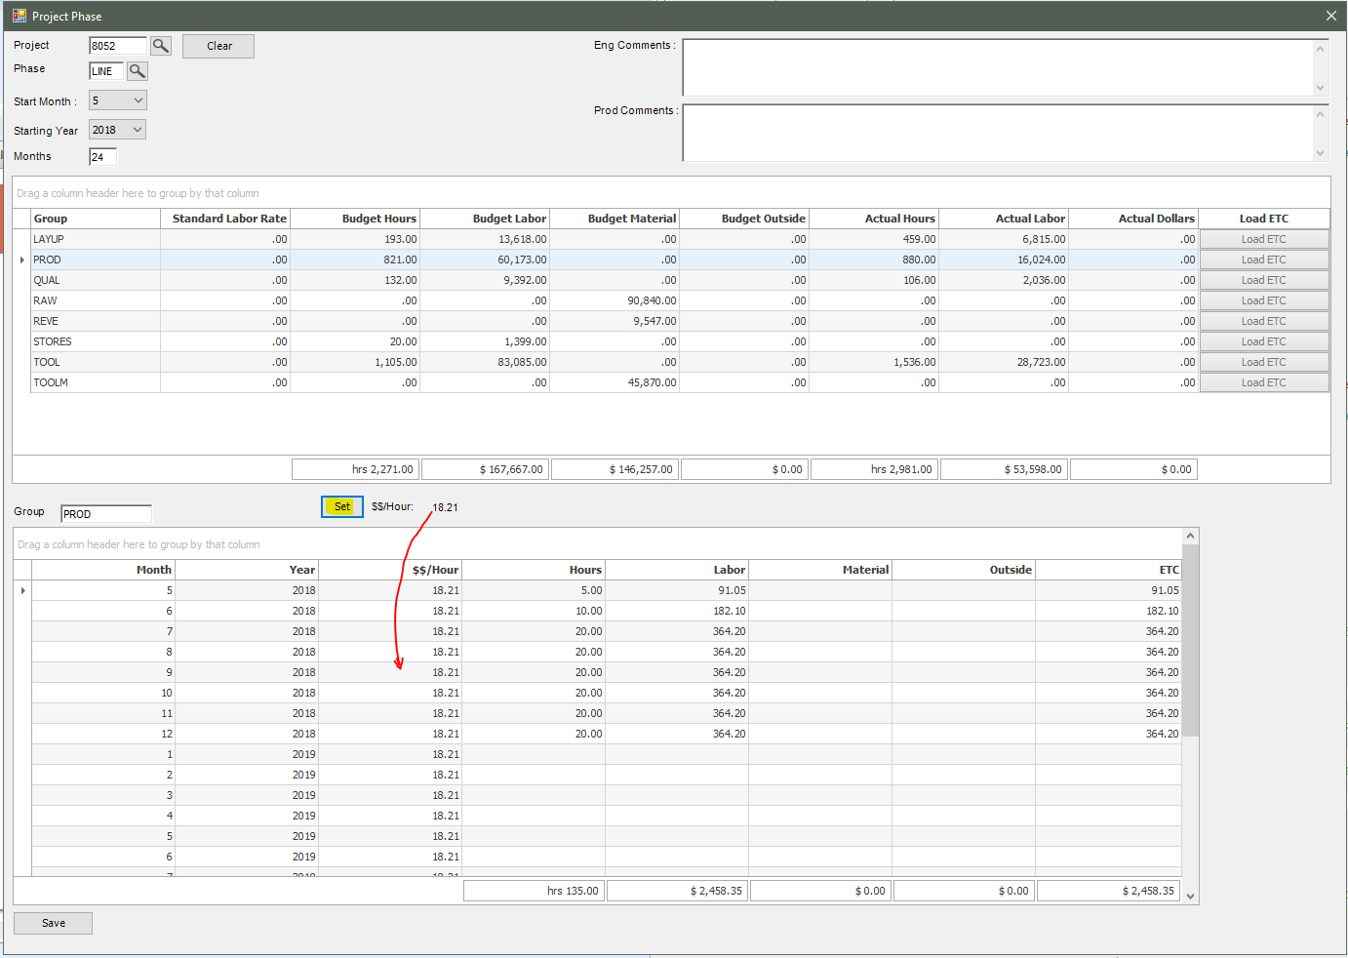

2/Export the Project Management data for one/multiple projects into a csv file

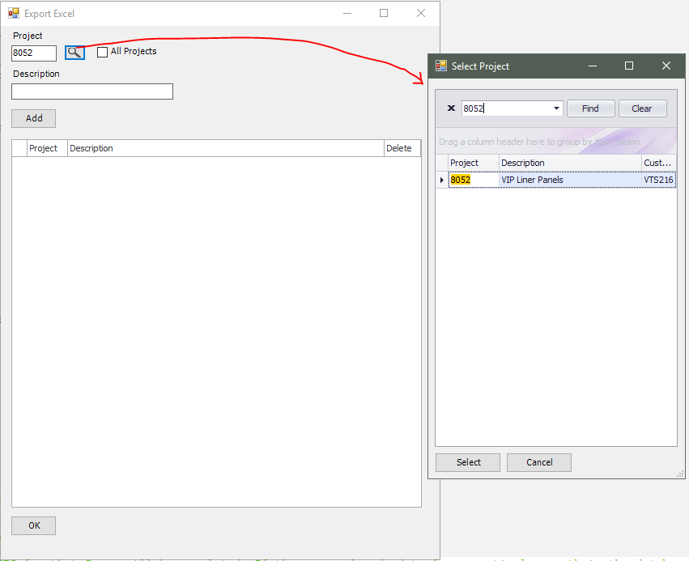

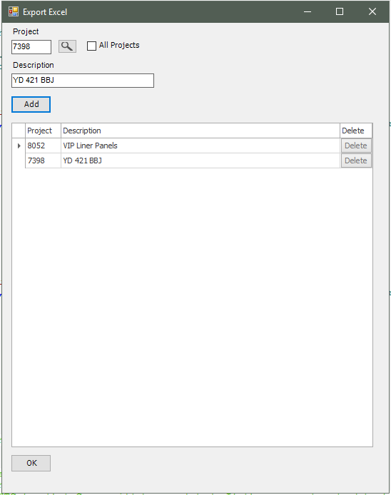

In this example, we select 2 projects and click OK

User will select the folder to save the csv to.

Saving in progress:



Csv file exported:

The calculation is as following:

Budg Dollars = Sum of Budget (Material + Labor + Outside)

Actual Dollars = Sum of Actuals (Material + Labor + Outside)

For detail: ETC of every month = ETC values of (HOURS + Material + Outside) (they never have Labor with Material, or Labor with Outside being positive at the same time)

For Total: ETC of every month = ETC values of (Labor + Material + Outside)

When moving from left to right, we have the % complete = (Act Dollars + Culmulated ETC)/EAC Dollars.

EAC Dollars = Act Dollars + Sum of all months'ETC.

Budg Hrs Var = Budg Hours - EAC Hours

Budg $ Var = Budget Dollars - EAC Dollars

