Quote: 8183

Purpose: Custom E-Invoicing scripts that will merge the single page pdf’s into a multipage pdf per customer. Also support subject/body customization per company code.

General:

The customer option is a 2 step setup process.

**First** the invoice delivery flag in the Customer>Options screen must be saved to Email or Both.

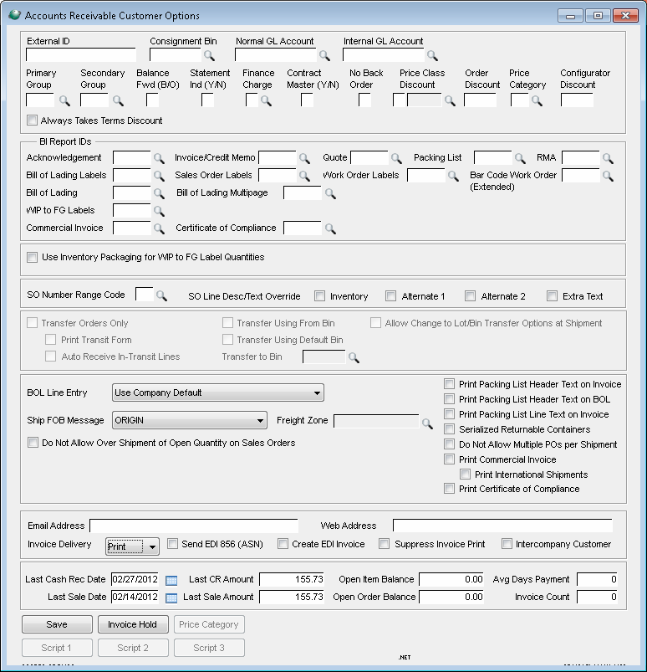

**Secondly**, the emails to be sent to must be setup within he Customer>E-Invoice Cont (script 2) button the customer master

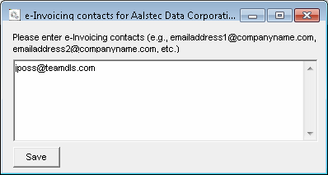

Once both setup steps are completed for customers, they will be active for e-invoicing.

**Operations:**

The E-invoicing script will run as usual at time of Invoice batch processing. The e-invoice process runs after the Update Invoices and Files item has completed. This option is done within the Invoicing process.

The single pdf’s will be created and a single email will be created as a log. It will have a deferred delivery date of the next day at 11:59 PM.

A task scheduler item that runs at the end of the day is setup. This task is what actually merges the multiple pdf’s into 1 multipage pdf doc per customer, reformats the emails, removes unneeded emails, and removes the deferred delivery date.

Once the task has ran, the emails should now be allowed to process through Courier2. Courier2 is what will send the emails.

Usually this item runs as a task, but for testing purposes it has been added to the menu under, System Support > Administration > Manual E-Invoice Merge (Task).

The Supervsr user is the only user that has access to this menu item in the test company.

After the task item has run, the merged pdf’s should be contained within the Global\Plugins\Invoices\Merged directory. This is where the pdf’s are stored to be used by the email when it sends out.

This directory does not clean out. All files added to that location will remain. Even after the email has been sent.

**Subject/Body Text Customization:**

A text file can be created within the Global\Plugins\GAB\GAS directory per company code.

Name: EInvoicing_Body_Text_CCC.txt, where CCC is the company code.

Supported Wildcards:

%DATE% = Current date

%CUSTOMER% = Customer Name

%COMPANY% = Company Name

The format of the file should be as follows: SUBJECT TEXT*!*BODY TEXT where *!* separates the subject from the body text. If the program cannot find this *!*, it will assume the entire textfile contains Body text only.

If the company specific file is not found it looks for the generic file, EInvoicing_Body_Text.txt.

If that file is not found it will use a default subject and body.