Maintenance Screen running off custom menu item:

Maintenance screen running from custom menu item will display following error when adding a new work center to the screen. The program will exits then, but the work center still saves to the custom table.

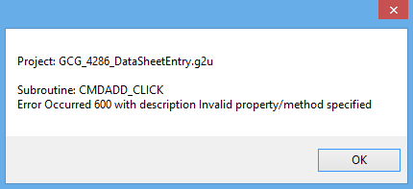

When trying to delete, the following error occur, and it will not delete work center from table.

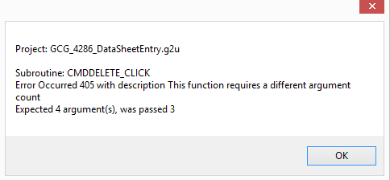

Running off GUI, hook 31813:

When clicking on a cell and the entry gets populated on the textboxes, the RAD # dropdown will not get populated. Then after an entry is populated on the textboxes, clicking on the grid again will produce the following error. Both of these issues might be related:  
  
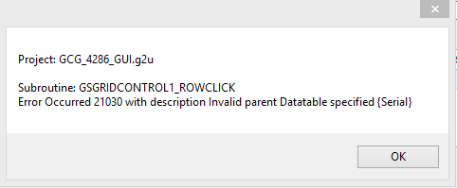

If a non-numeric value is entered in a textbox that is expected to receive a numeric value, a message box will appear with an error, but upon closing out of that textbox, the code will check the textbox again without clearing it, generating the same message box immediately, surrendering the project to an infinite loop of message box madness.

Clicking on save will not clear out the drop down lists.

Trying to save with some blank textboxes will spit out storing format errors.

If you try to save entry for the same serial number, it will ask you if you want to override the data. If you click yes, it will successfully do so, but if you click no, the following OCTSRS error gets thrown:

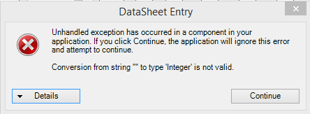

Then exiting out of that error, it will generate the GAB error:

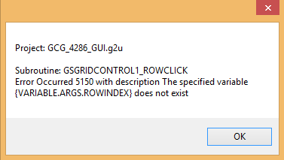

Trying to delete an entry from the grid right after deleting an entry will produce the following error:

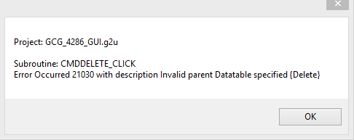

When the code runs for a work center that is not part of the maintenance screen, the following error will occur:  
  
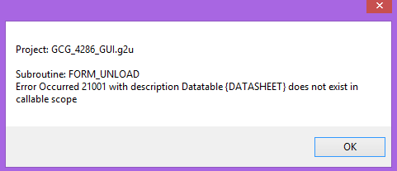

Information Edit:

Since all you can do in this screen is modify information, the save button should not create the screen that says that the data for that wo/suffix/seq/rad# already exists?

Same issue with the delete after the delete:

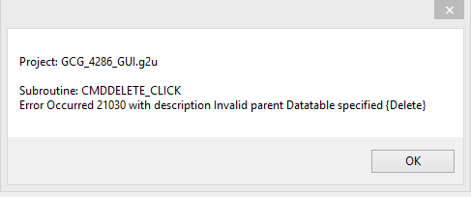

When changing from one work center to another, the following error occurs:

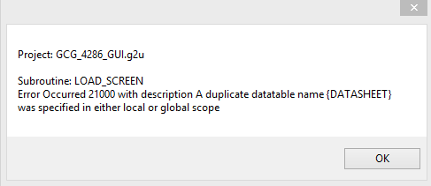

Deleting up to the last record of the grid will produce the following error:

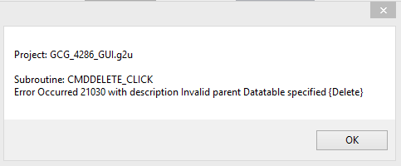

Maintenance program

Adding a second workcenter will result in following error:  
  
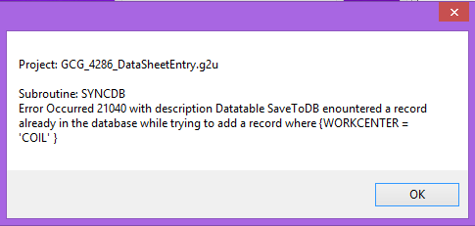

The workcenter included in the error was the first workcenter, so it may be trying to save all new entries every time.

Deleting after a deletion will generate next error:

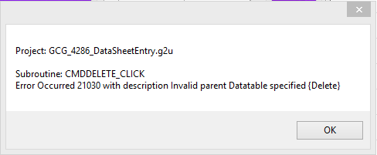

Data Sheet Entry

When a row has been selected and is populated on the text boxes, if you click on the grid again, the following error will be generated:

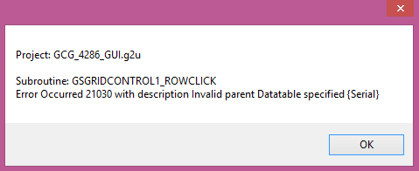

The RAD # that are populated are populated from the numbers selected when clicking on process, but the table is generated from the custom data table. So if there are RAD numbers for that work order that were previously processed but are not part of the RAD numbers in the pull down menu. If these numbers are selected and the data is populated into the text boxes, the following error will be generated when trying to re-add the entry into the table

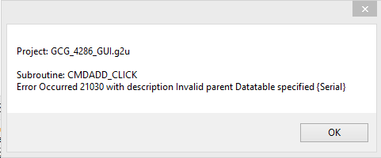

Deleting after a deletion will generate the following error:

