Preventing a group of users from clocking into Job/Suffix/Seq.

This project will have three different modules.

First:

This project will be using a custom table with the only purpose to flag special op-codes. This table should only have one column, OP_CODE. These are the op-codes that will be used to prevent users from clocking into and closing specific Job/Suffix/Seq.   
Information to this table will be modified through a maintenance program that will run from a custom menu item under Shop Floor Control > File > [insert clever title]. This should generate a screen similar to this:

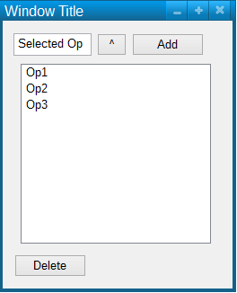

The quote mentions that only users in a specific user group would have the ability to maintain these op codes. We should ask the customer what the user group is to fulfill this request.  
The grid will be initially populated with all opcodes stored in the custom pervasive table. The textbox should be locked and only populated when the user selects an Op code through the browser. The browser should pull all Op codes from pervasive. The add button will add the Opcode in the textbox into the grid if it is not already there. The delete button will delete the selected Opcode in the grid. The database updated with every addition and deletion.  
We may choose to include the Op code description on the grid, but I think it is not necessary.

Second:

In the GUI We need a check when a user is trying to close an open Job/Suffix/Seq.  
If the Job/Suffix/Seq has an op code associated with it, we need to query the custom table to see if the op code matches any entries saved on the table.  
If there is a match, the code should check to see if the user is part of a specific user group. I am uncertain if this is the same user group that has the ability to modify which opcodes get saved. If the user is not part of said user group, the code will prevent the user from closing the Job/Suffix/Seq, throwing a warning specified in the quote.

Third:

In the GUI, we need a check when a user is trying to clock into a Job/Suffix/Seq. This check will verify that if any previous sequences for the Job/Suffix are still open, the Op-code associated with these open sequences is not part of the special Op codes listed in the custom table. That is, go through the previous sequences for the Job/Suffix, if any sequence is open, and the opcode attached to that open sequence is found in the custom table, stop the clock-in process and notify the user that a previous job/suffix/sequence is not closed and the user will be unable to clock into the new sequence.

*Note: There is a part of the quote that says that in order to proceed with the process, the Employee ID should have a GS User ID assigned. That is, if the employee ID has not been assigned a GS User Id, the process will stop. It needs to be known if this is the case for all sequences, or just sequences with the Op-codes that match the custom table.