**voestalpine Roll Form Corporation Requirements – Tracking multiple heats through WIP to FG**

**Knowns**

* Customer is using auto transfer of WIP to FG by op code from GUI
* Customer will issue multiple heats of material to a job
* Customer must identify, by FG, the heat that was used for a specific lot/run

**Requirements**

* WIP to FG from GUI (already available)
* Inherit heat number from raw material into parent product, but allow user to select the heat number to apply if there are multiple heats issued to job detail for that job (need for custom)

**Assumptions**

* Only allow 1 heat per sequence
* If there is only 1 heat, use that heat number
* If there are multiple heats issued to WIP, bring up the screen described below and allow the operator to select the heat and quantity (from the “good” pieces screen)

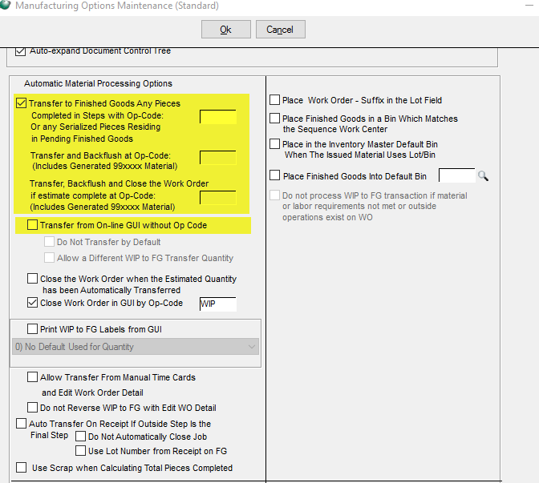

Similar to the lot/bin/heat/serial screen that pops up when issuing material to WIP, vRFC would like a screen to pop up after the employee claims pieces on the shop floor through the GUI and the sequence is a WIP to FG step (either through WIP to FG by op code or without op code)

This screen will have heat number, which the user must select (only 1) and the quantity claimed tagged with the auto generated lot number and heat number selected when the parts are processed from WIP FG transactions

*** print WIP to FG Labels from GUI on the auto transfer at the GUI will also need to pass the heat selected to the WIP to FG label (report id 1835)