ARC 4558 – Update Inventory Info Across Locations

The Tool House was looking for a simple way to update Parts with multiple locations. That way they are updating the information once and not 3-5 times for each part number.

Updated Fields:

INVENTORY_MSTR.

PRODUCT_LINE

DESCRIPTION

UM_INVENTORY

FLAG_INACTIVE

AMT_PRICE

AMT_ALT_COST

UM_PURCHASING

TIME_MATERIAL_LEAD

FLAG_LOT

FLAG_SERIALIZE

FACTOR_CONVERSION

OBSOLETE_FLAG

CODE_SORT

INVENTORY_MST2

CODE_SOURCE

DESCRIPTION_2

DESCRIPTION_3

NAME_VENDOR

INVENTORY_MST3

CONSUMP_CONV

INV_CROSS_REF

All Fields

PART_XREF_USER

All Fields

0025 Before

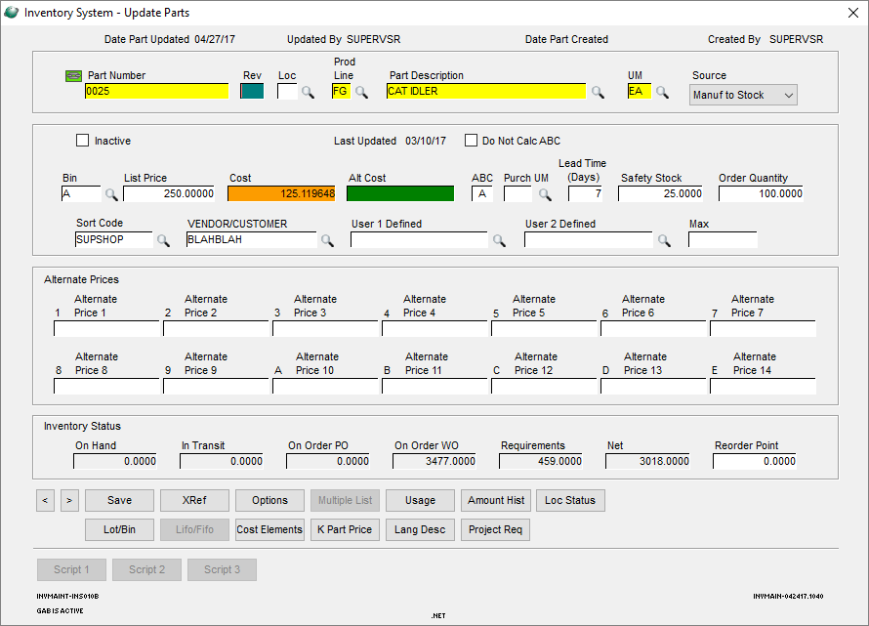

0025 Loc TX Before – Individual Information

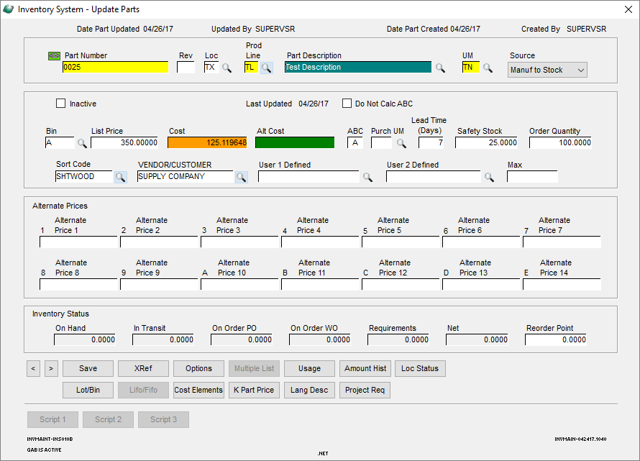

0025 After Updating

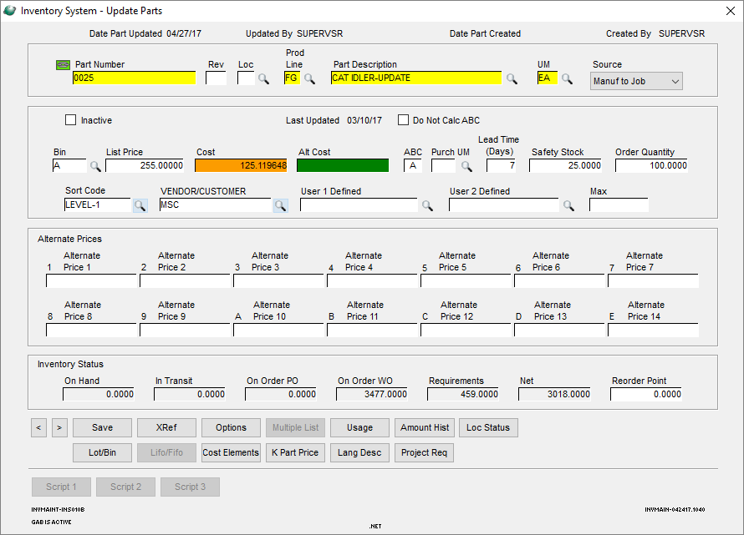

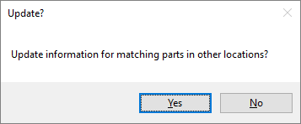

0025 Loc TX After – Information now matches the location above and this was done in one process

