Program will automatically fill in Customer Name

Validate field:

* PayerID (Customer number) has to be valid customer
* CheckOrEffectiveDate: can not be blank, format: YYMMDD
* CheckNumber: Will be the sum of the grouped records, can not be blank

(muliple customer, each customer can have multiple checks)

* All Amount numbers should be all numeric
* Invoice number should exist in AR_Open_Items for that customer
* Invoice date has to be correct for that Invoice, format: MM/DD/YYYY
* For each line, amount has to be equal: Gross = Discount + Net

Batch number prefix is ‘H’

Excel Input:

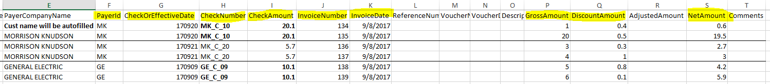

Output: Result from batch H0015

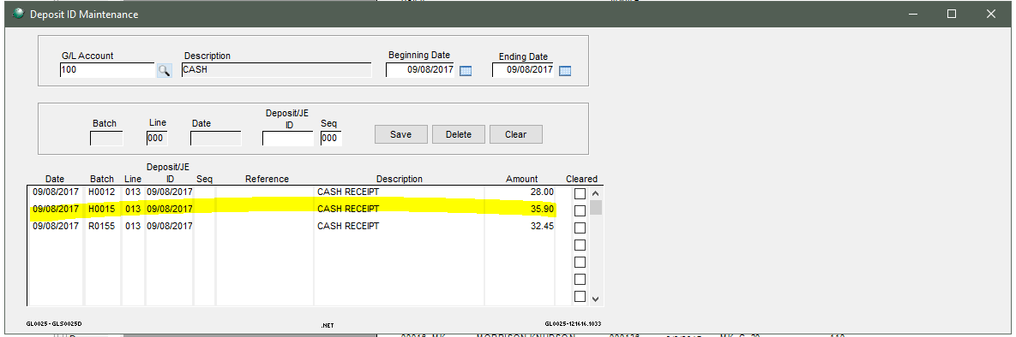

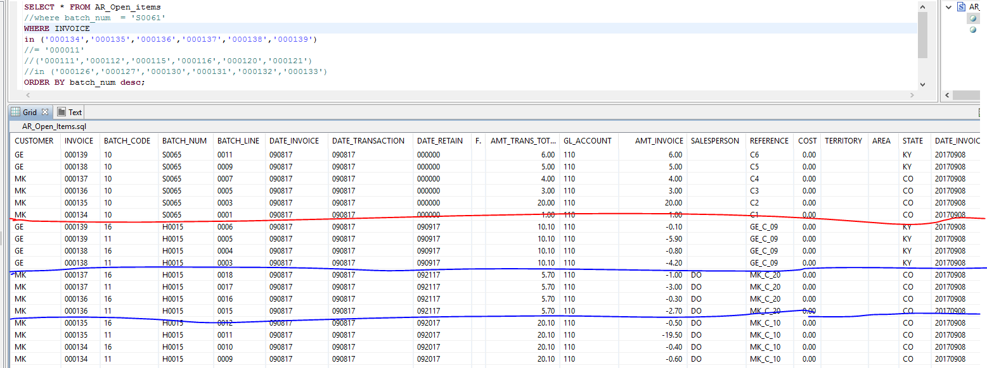

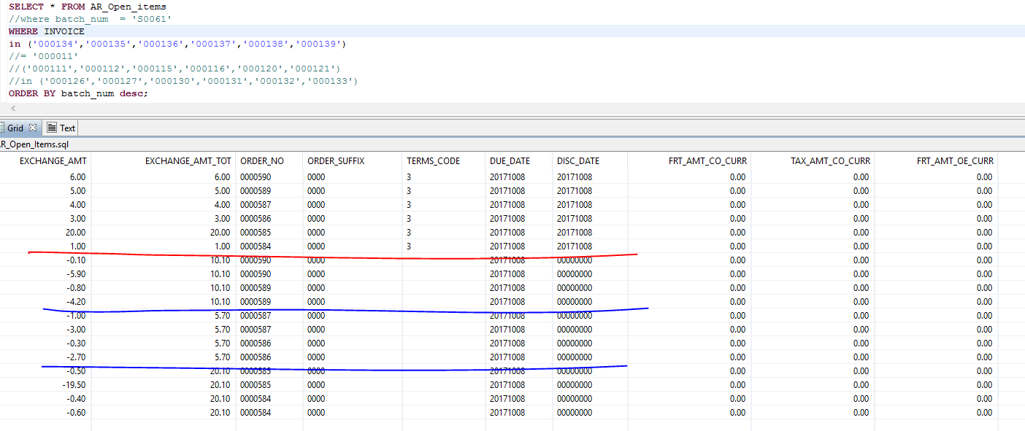

AR Cash Receipt:

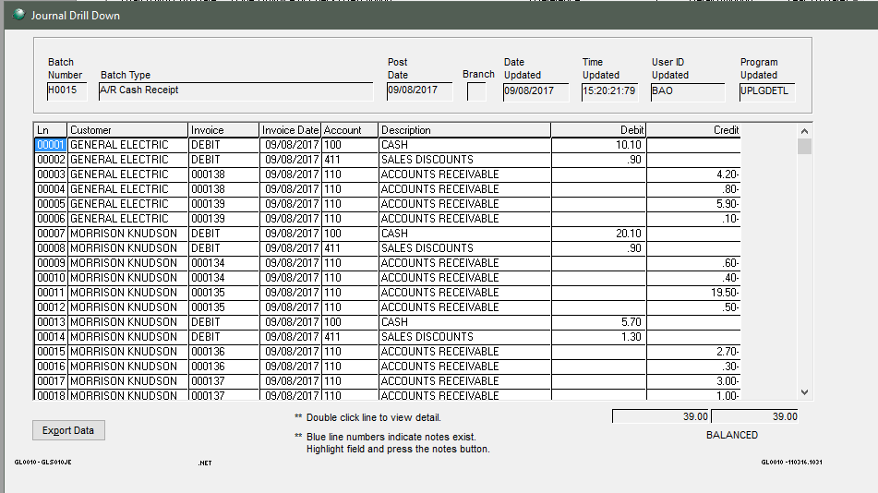

Cash Account:

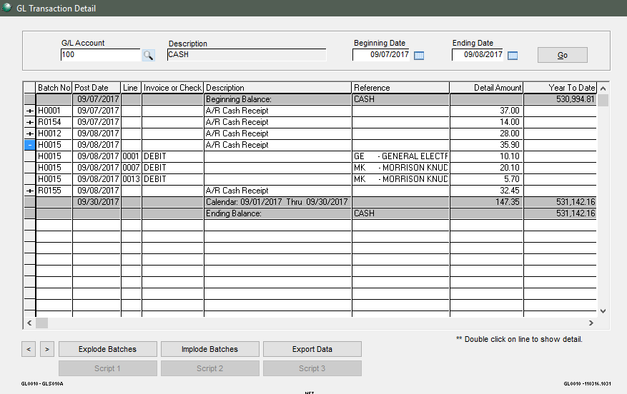 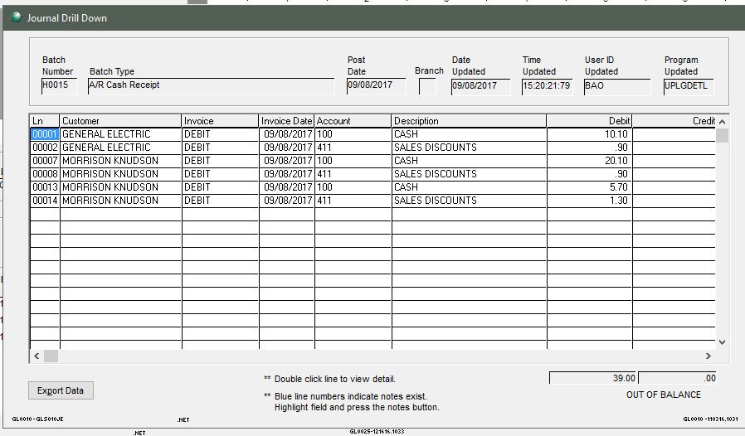

Account Receivable Account:

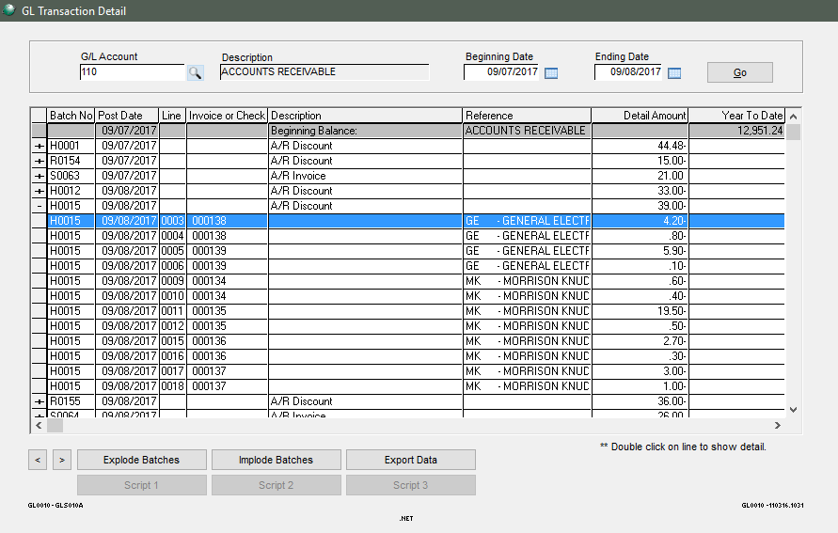 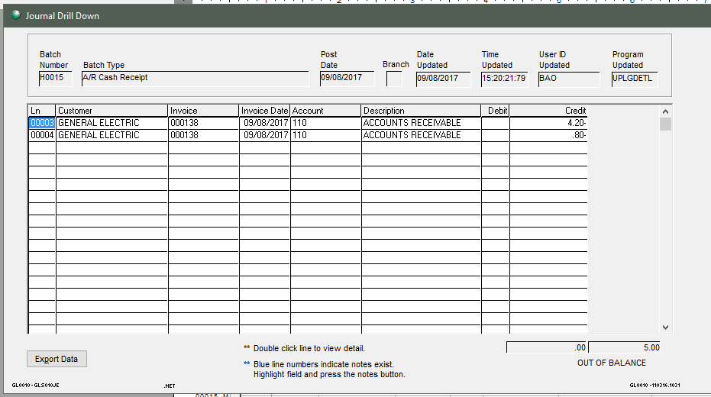

Sales Discount:

