# **ARC 4769 – E-Faktur**

1. Create an invoice from Order Entry > Transactions > Invoicing.
2. There are 2 buttons, New E-Faktur and Add E-Faktur. New E-Faktur button is used for creating a new E-Faktur and Add E-Faktur to add the invoice into an existing E-Faktur.

**NEW E-Faktur**

1. Click on New E-Faktur button to create a new E-Faktur for the invoice.
2. Enter the E-Faktur number, E-Faktur Date, Transaction Type, and Additional Info and PPNBM Rate (if applicable)

1. Click Add Invoice if you need to add another invoice into the same E-Faktur number.
2. Click Save to save the E-Faktur.
3. CSV button will show up once the E-Faktur is saved. Click on CSV button to export the E-Faktur data to .csv file. The user can use this file to import it to E-Faktur app.

**Add To E-Faktur**

1. Click Add To E-Faktur button to add the invoice into an existing E-Faktur.
2. Select the customer number.

1. Select the E-Faktur number.

1. Click Save or Update to save the E-Faktur.

**Order Entry > Files > E-Faktur with Edit**

This program is used for modifying an existing E-Faktur

1. Click Open button and select an E-Faktur,

1. Change any information if necessary and click the Save button. Any change that is made will increase the Rev number.

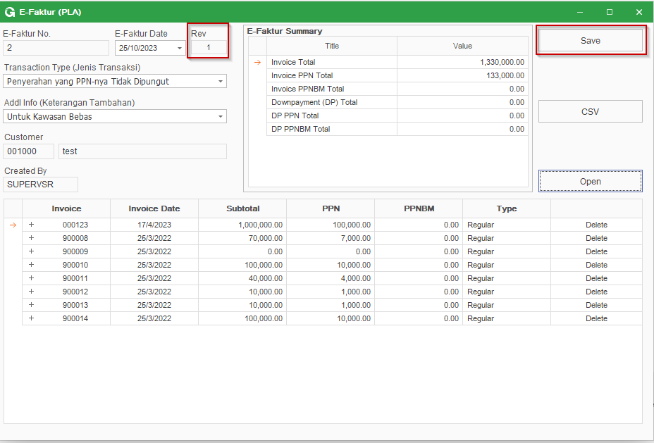

**Order Entry > View > E-Faktur Dashboard**

This dashboard is used for exporting selected multiple E-faktur to .csv at once.

1. Select the date range filter and hit Refresh button to load E-Faktur grid.

1. Check Select All if the user would like to select all E-Faktur that are displayed on the grid, or select manually one by one. Once it is done, right click on the grid and click Export CSV to export the CSV file.

1. Click Export Excel if the user would like to export the E-Faktur list from the grid to .xls file.