'BN, Apr 18, 2018

This report will show all open/closed Work Orders within the Date Range Selected.

If there is a link from WO to SO, SO number will be populated.

In case SO is not populated, the Unit Price will be pulled from the most recent SO of that particular part.

The Following Formulas will be used:

Formula for Normal Min/PC (Hrs Req'd*60)/Qty Ordered

Avg $/DLH (Extended Amount/Hrs Req'd)

Actual Min/PC (Actual Hours*60/QTY Complete from closed orders)

Note field will be saved to GAB_4169_WO_Notes

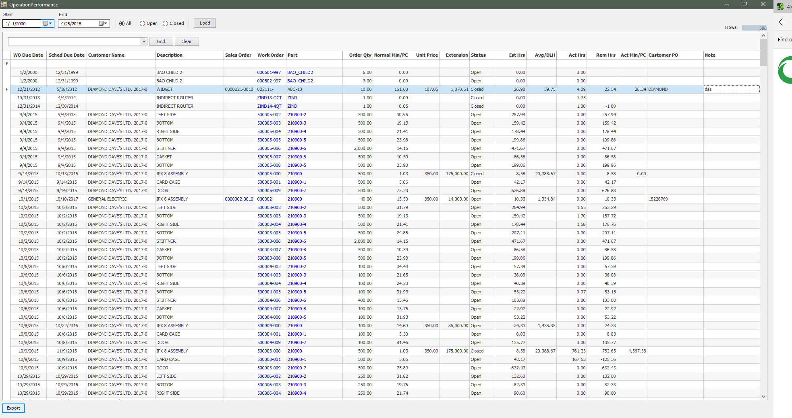

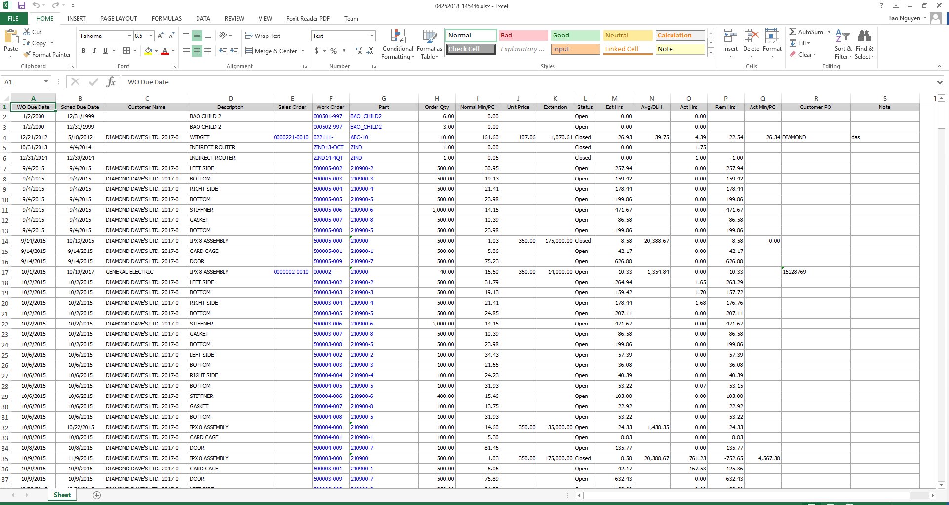

Note column can be viewed and edited by clicking in the Note cell

