BN, Apr 30, 2018

This program will add a checkbox to the order header for "Do Not Ship Early".

Upon clicking Save button of the order header/or clicking the Line button, the program will save the order number in a custom table GCG_4987_NoShipEarly.

Before populating the Shipment New screen (screen OES0FSN) a check will be done to see if the order has at least 1 line that has the promised date later than today and is in the list GCG_4987_NoShipEarly.

If there is, a message box will pop up letting user to decide whether to proceed.

Screen shots:

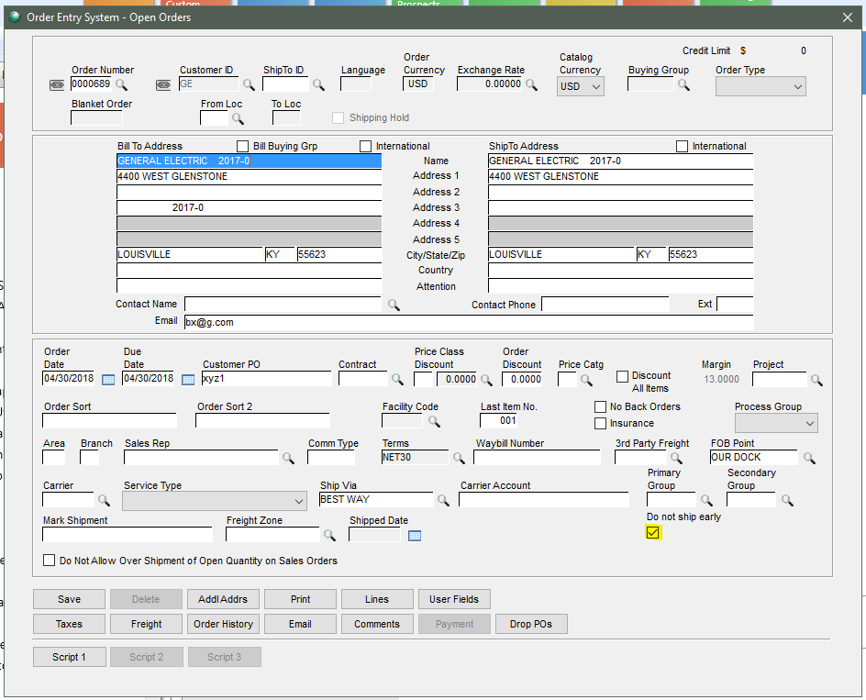

Let's do an example. We create an Order line having the Promised Date 05/02/2018 and today is 04/30/2018:

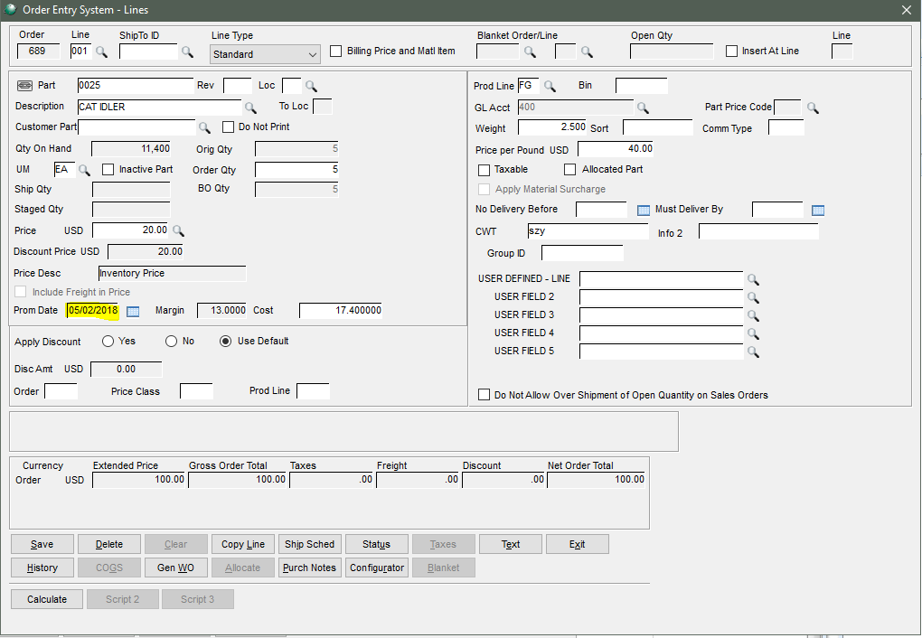

Now create a new shipment: Order Entry > Transactions > Shipments > New:

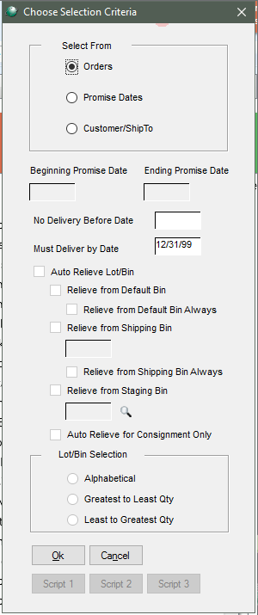 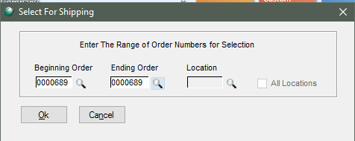 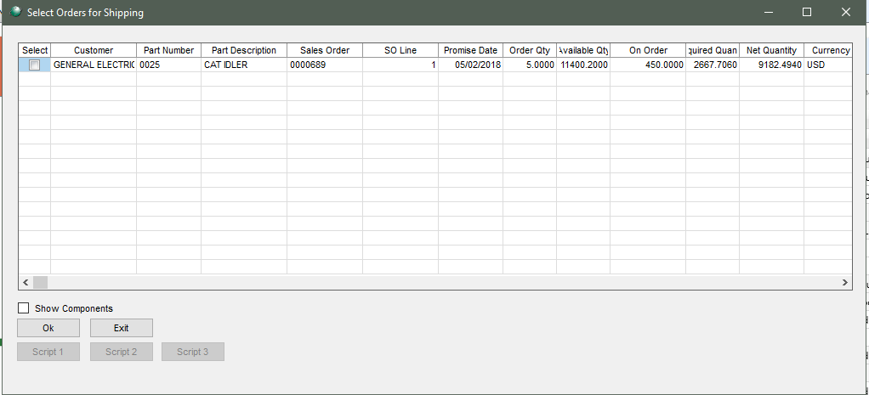

Before populating the Shipment New screen (screen OES0FSN) a check will be done to see if the order has at least 1 line that has the promised date later than today and is in the list GCG_4987_NoShipEarly.

If there is, a message box will pop up letting user to decide whether to proceed.

In this example, we have that item promised date of 05/02/2018 and today is 04/30/2018.

So the message box pops up for this order 0000689:

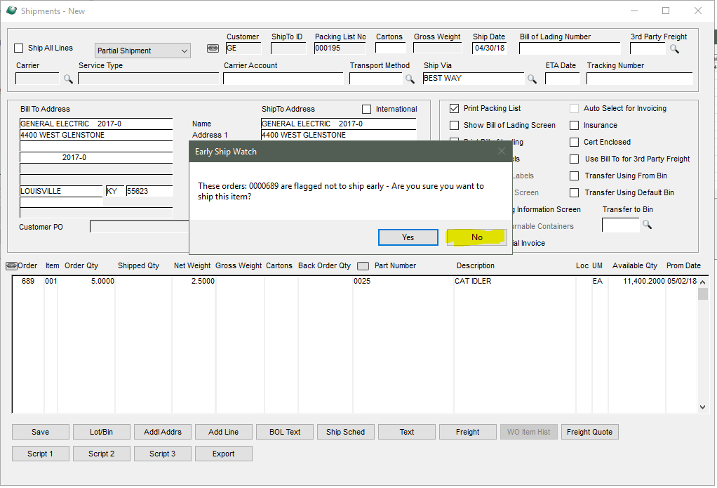

So in the No selection, a message box will tell user to close the screen because they can not ship if in this casse:

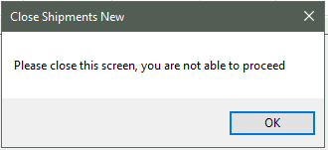

Save button is disabled:

