**Project 5030 Custom Tool Kit and Trace Files/Tables/Fields**

**1.Get the Table name from a File, or the File from a Table name:**

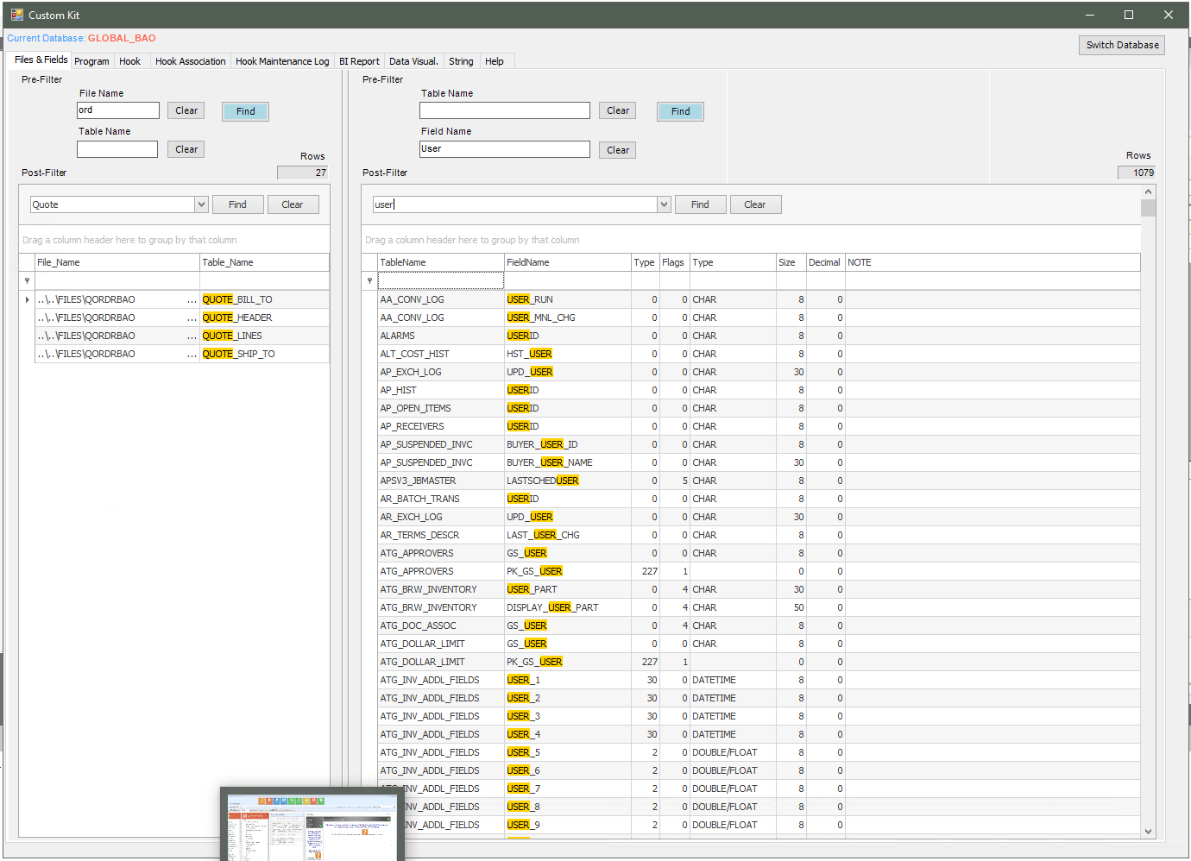

*1.1 This will help us collecting the files from customer in order to simulate in our company code during the development.*

*1.2 The search is instant, saving us a lot of time than looking for the table strutures via the PCC.*

*1.3 We can instantly know what Table or what Field in the WHOLE database that has a specific keyword. This can not be done via the PCC.*

*1.4 We also know the type/flag/size of a field. This is critical, as we want to create some custom table that has fields which will exchange data with the core tables fields. So the type/size of the custom fields have to be same as the core’s. Looking for each fields via the PCC will take from 10 to 30 seconds to display a table structures. This program again shows the result instantly.*

*1.5 We can switch database from one to another, including the Global_Common.*

*1.6 This program enhances to searching by combinning the GAB processing structure implemented in codes and the built-in search features of the gsGrid.*

*Each grid will have a Pre-Filter and Post-Filter. The Pre-Filter is the searching criteria to populate the grid. The Post-Filter is the built-in feature of the gsGrid where we can Find/Sort/Filter the grid.*

*Ex: We Pre-Filter for File Name like ORD by enter ORD in the File Name textbox and click Find, this gives us 64 records. Then we can Post-Filter (Find/Sort/Filter) the grid based on the 64 records found in the Pre-Filter.*

**2.Tab Program**

*The tab Program shows the Program App name used in each Menu Item. This helps us to open the screen via a GAB custom program by using the LaunchTask, CallWrapper, or when we want to report issues to Cobol team.*

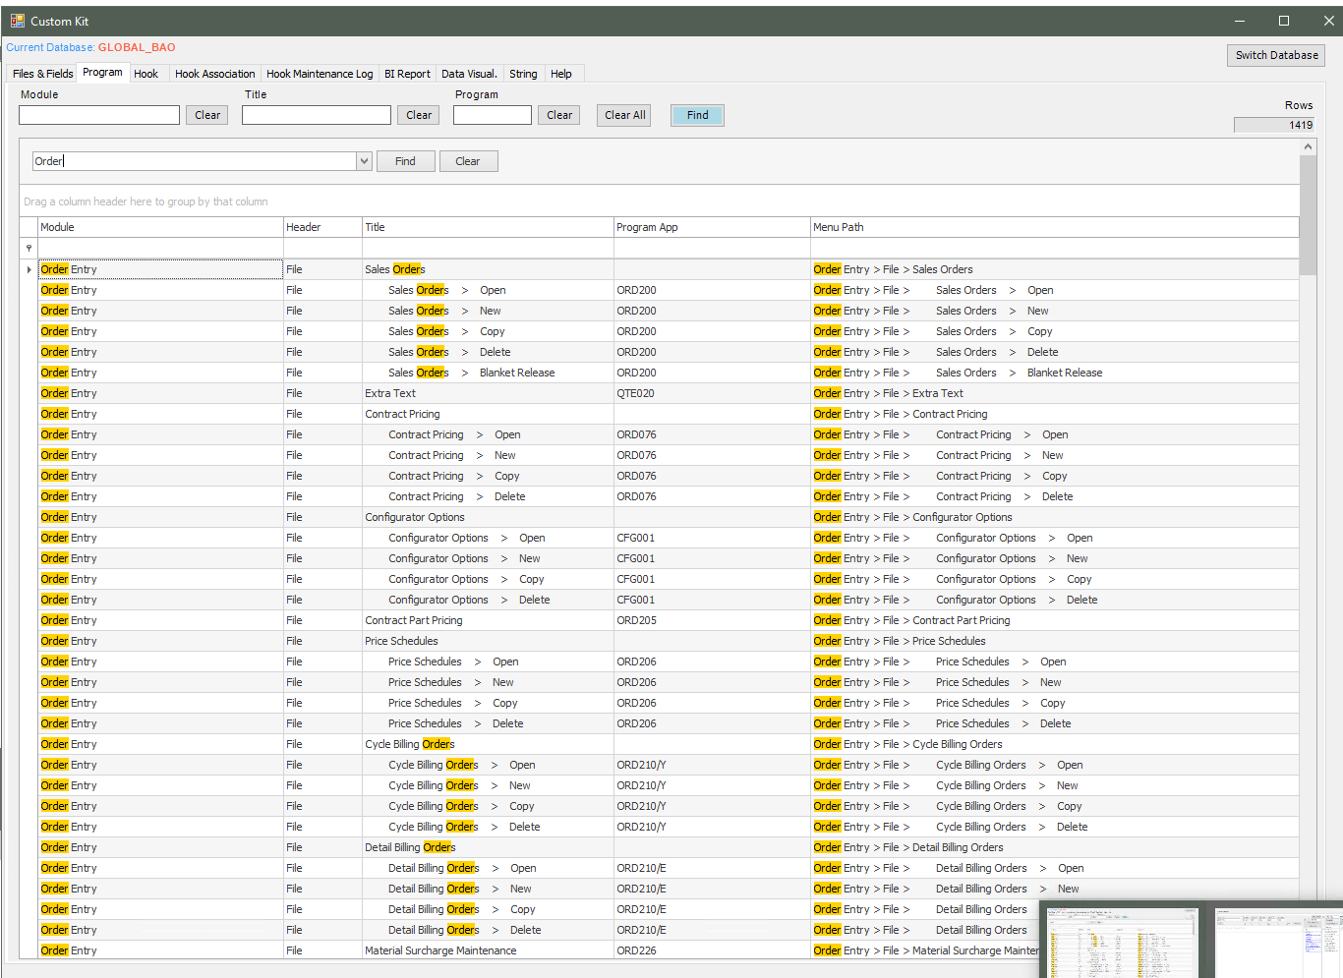

**3. Tab Hook/Hook Association/Hook Maintenance Log**

Help the task quicker than the GAB Hook Maintenance Screen

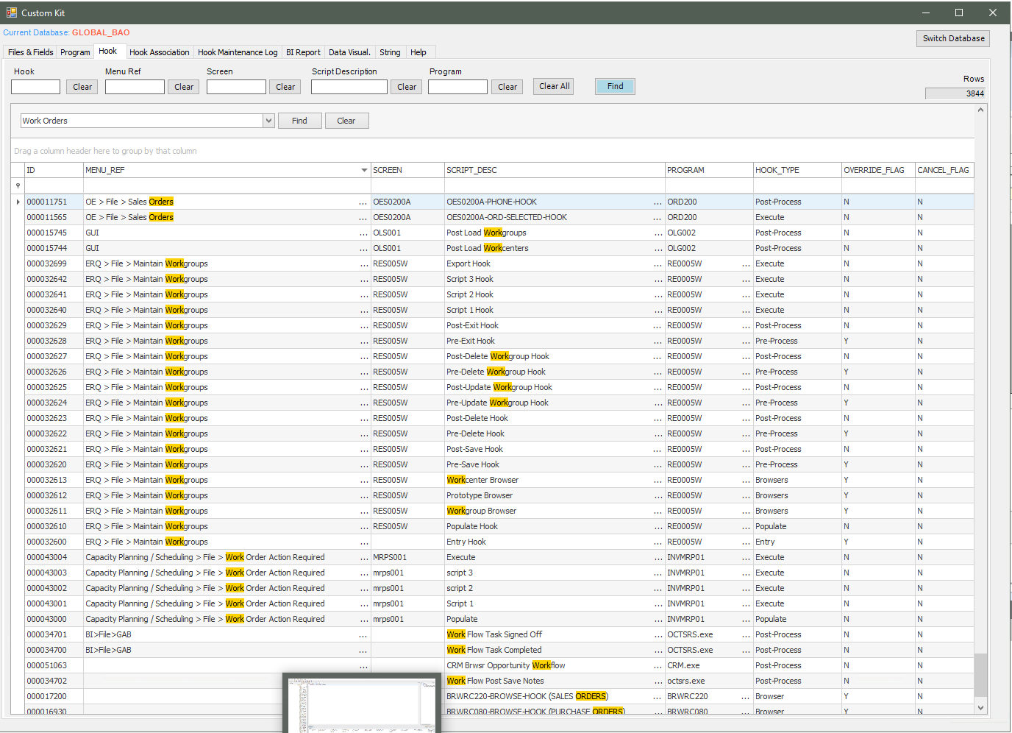

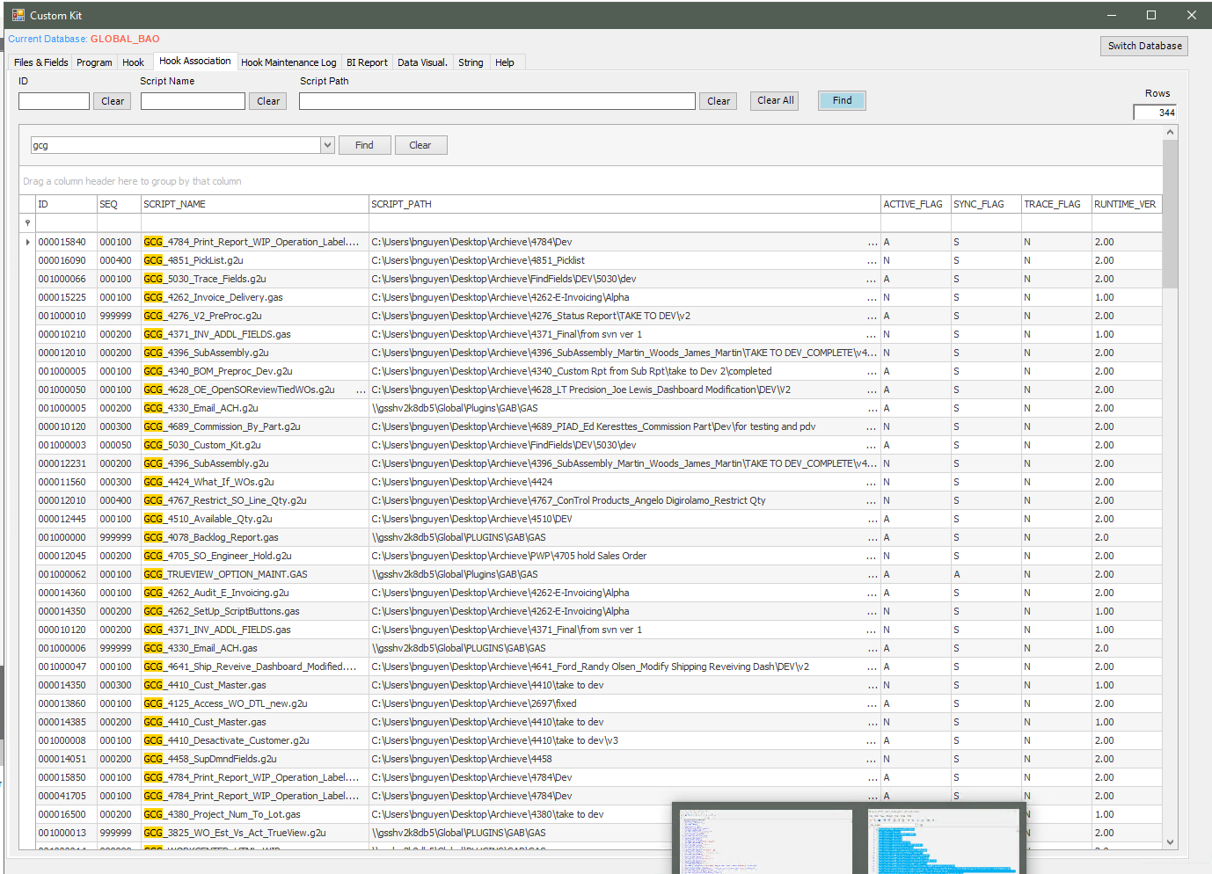

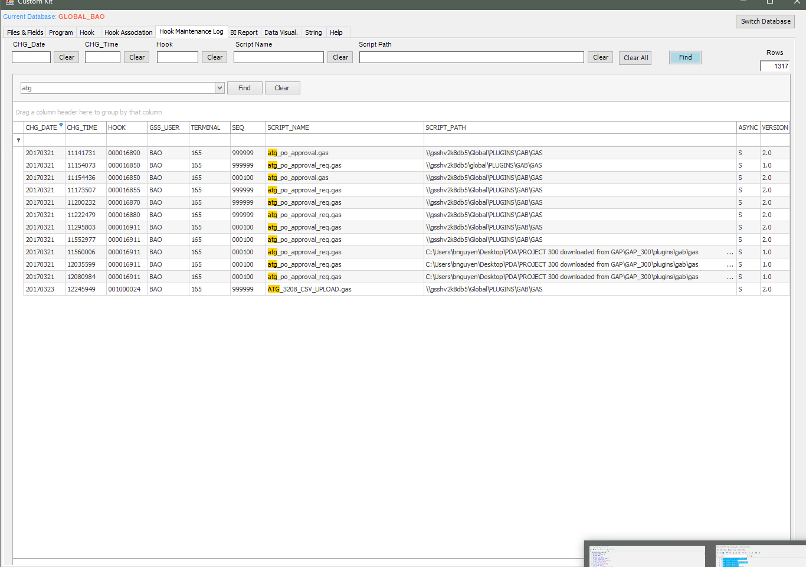

**4.Tab BI Report**

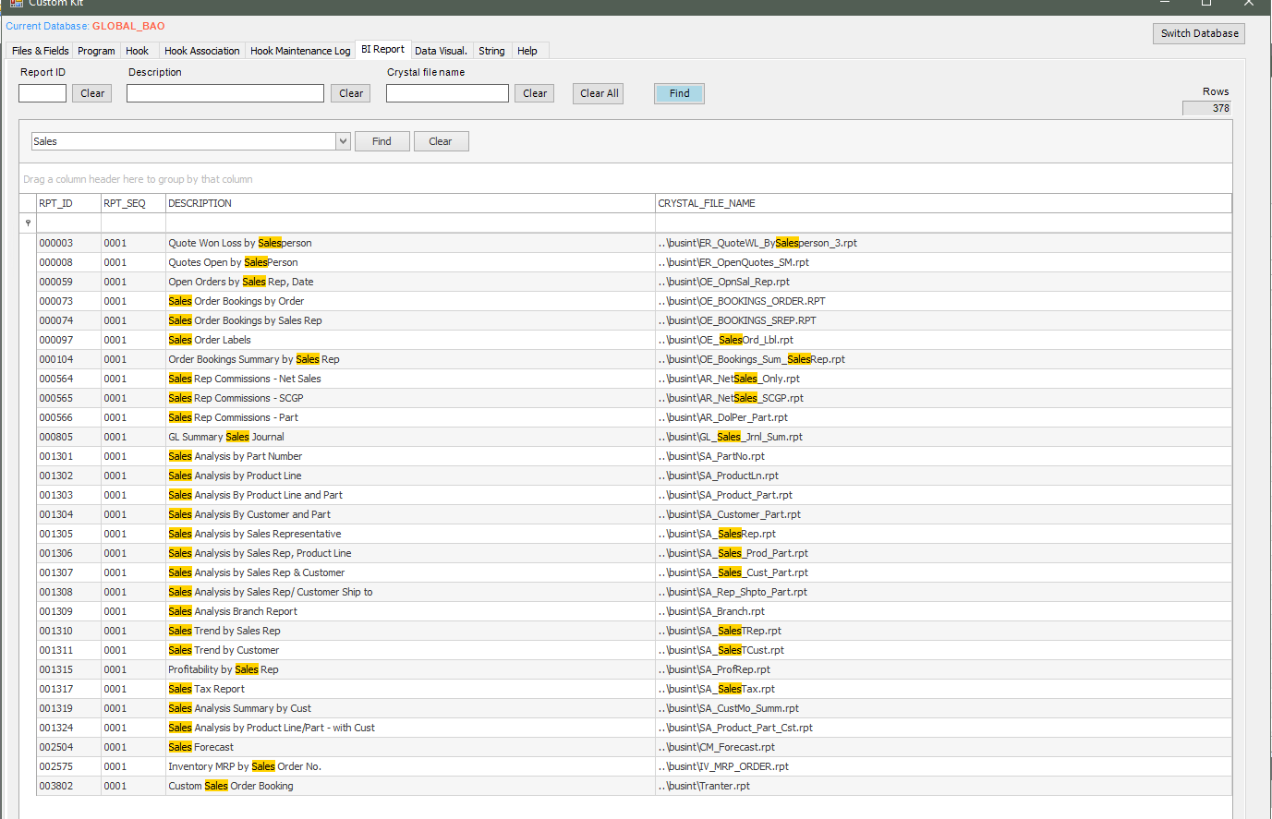

**5. Data Visual**

*5.1 Tab Data Visual is a mimic of PCC. The good thing is we can make use of the fiter/sort built-in feature of the gssGrid to quickly look for a keyword.*

*5.2 We can type in the pattern of Select/From/Where/Group By/Order By then the program will generate the SQL for us. Or we can put in the SQL directly to the second SQL box (below the Min Width texbox)*

*5.3 If we want to select a great amount of columns from a table. Follow these steps:*

*-Select * from that table*

*-Check the checkbox Get Column name for Select*

*-Click on any cell of the column we want to select, it will be concatenated with comma to input in the Select textbox.*

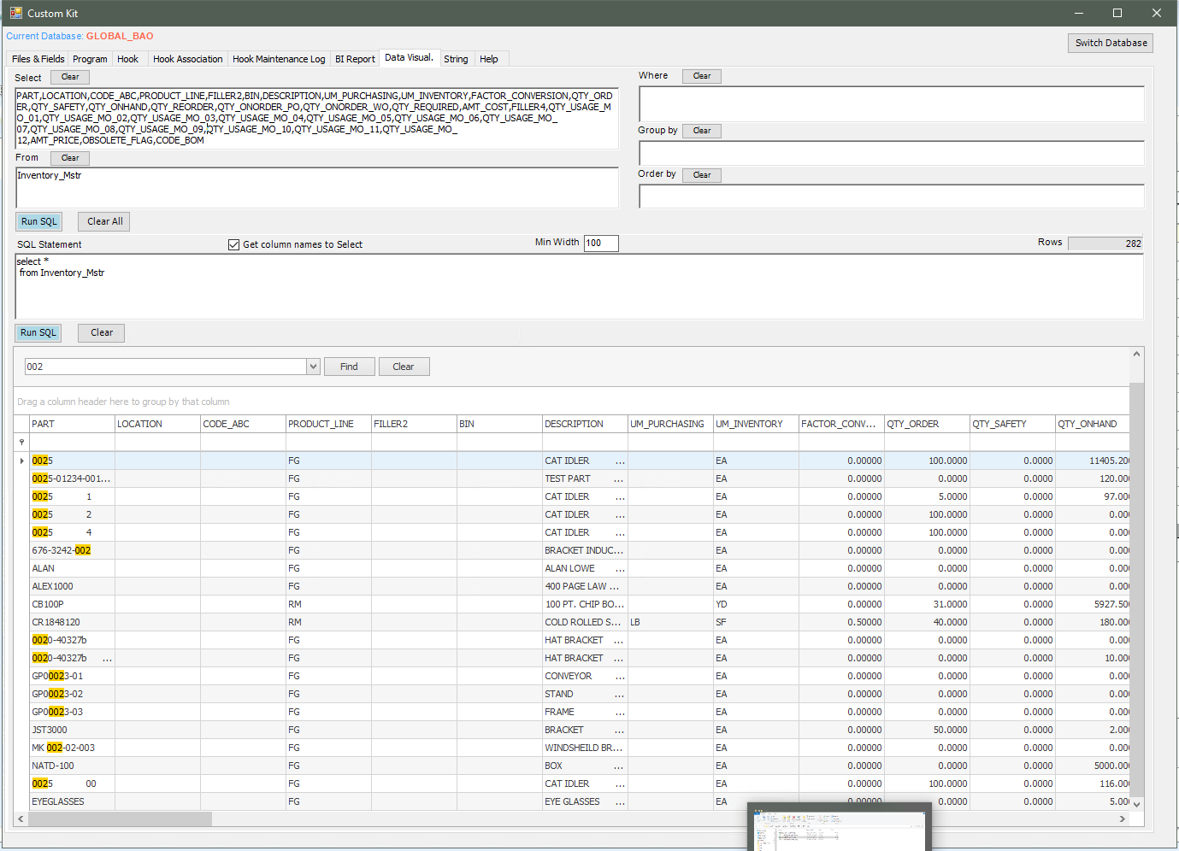

**6.String**

If we want to generate a Map of columns to use the SaveToDB function in GAB, we just copy the column names and put in this textbox, then click Add.

We can add one by one pair if the column names of GAB and Database are different.

The Map string will be generated and the grid in the middle will be populated.

We can modify the grid and Generate back another Map string using the Inner and Outer delimited.

Count string length is on the right side.

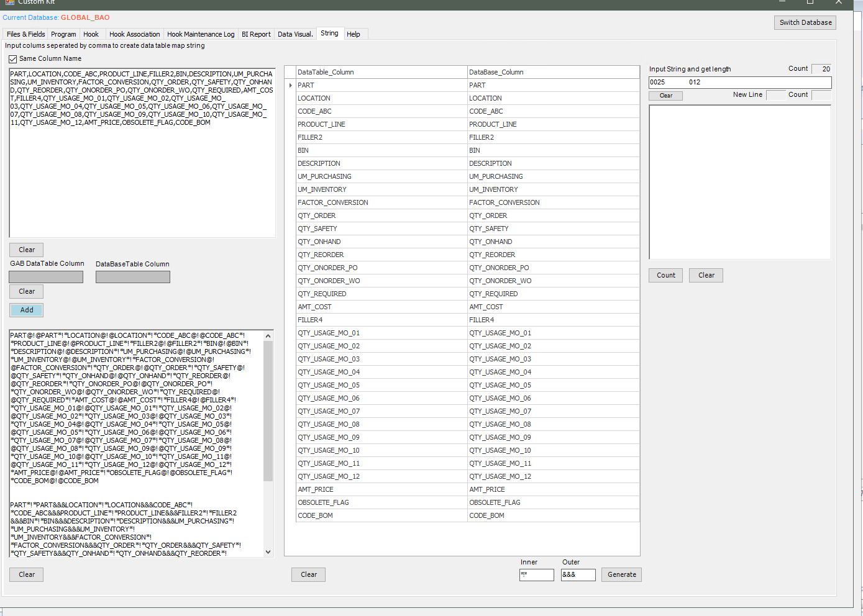

**7. Trace Fields**

*7.1 Medod 1: Via the Core Trace File: Turn on Debug, Do the core processing, Close completely the core processing, Turn off Debug, then Trace the field.*

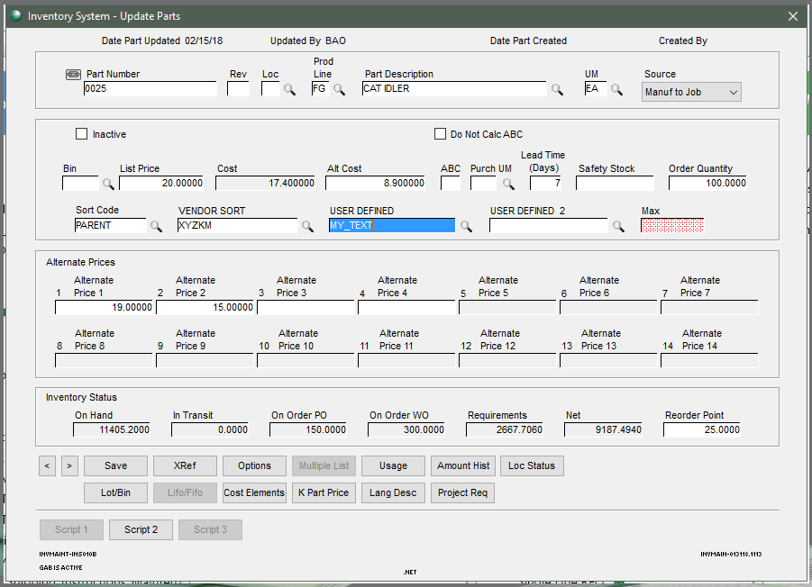

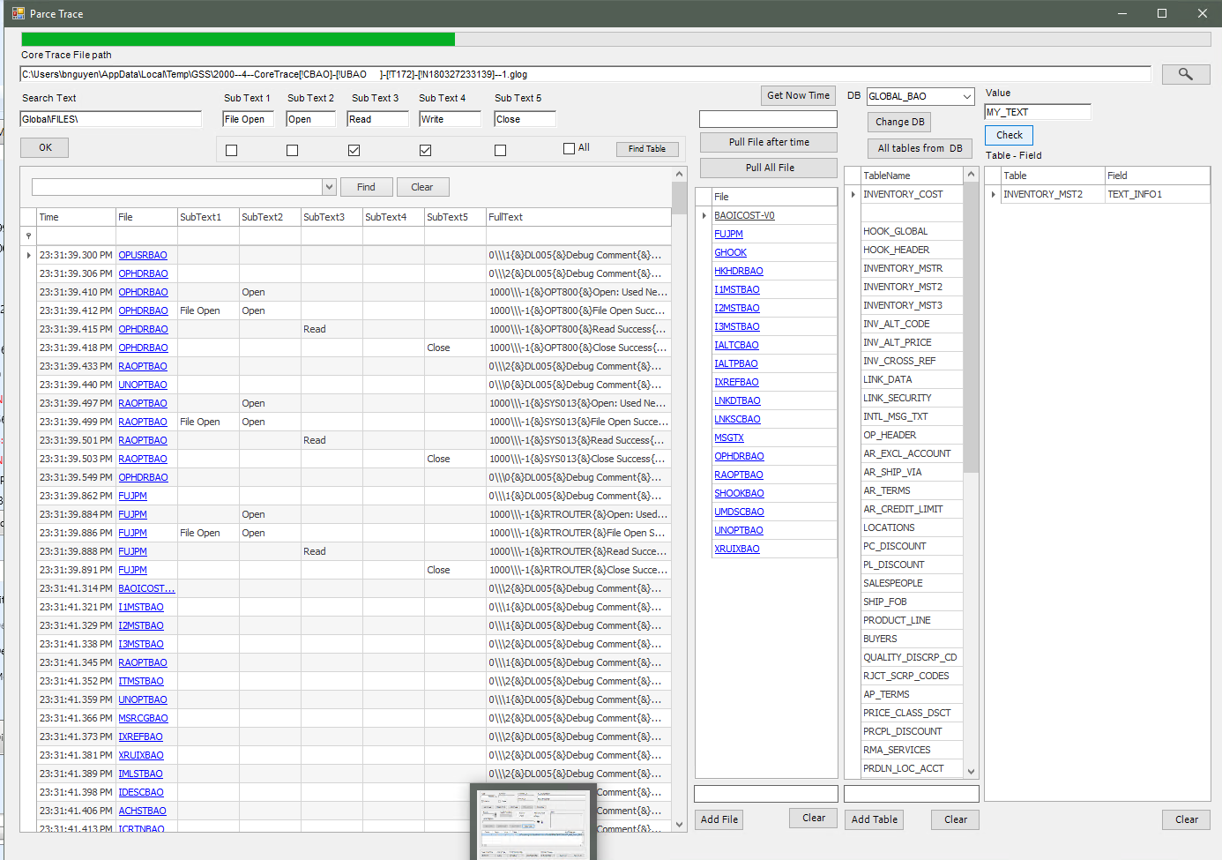

*7.2 Method 2: Manually add the File/Table if we know for sure what File/Table we are looking for*

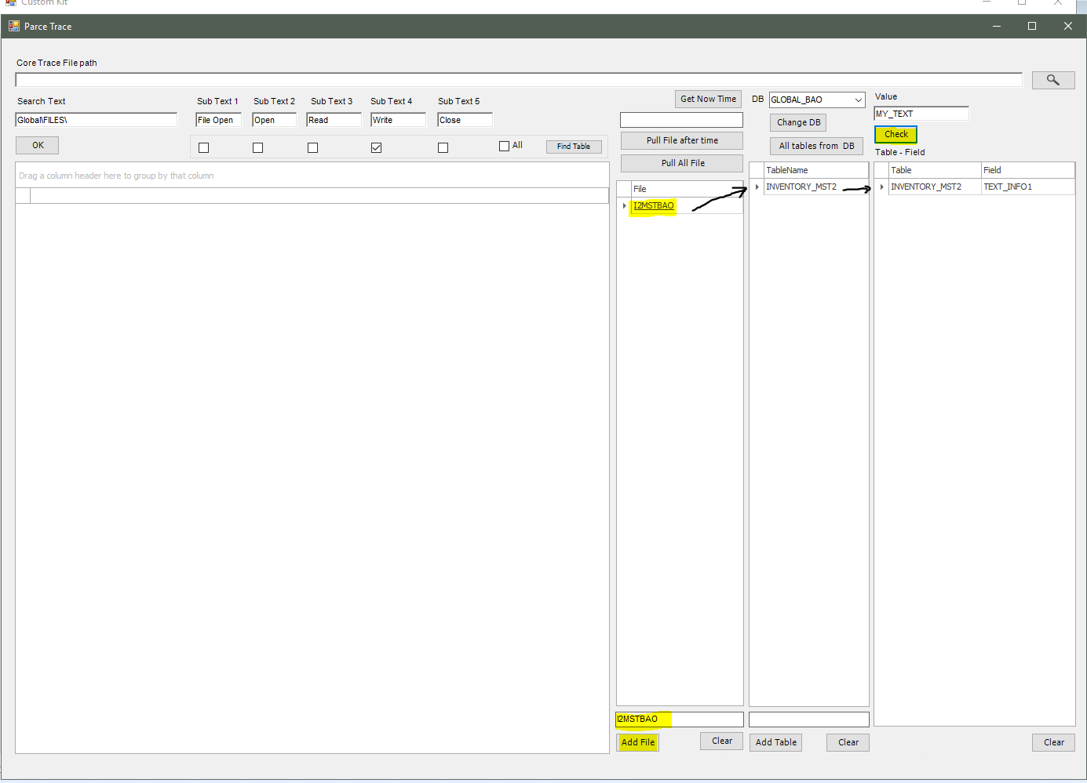

*7.3 Method 3: Start a point of time before doing the process, Do the core processing, Close the core processing completely, Pull the File, then Check*

