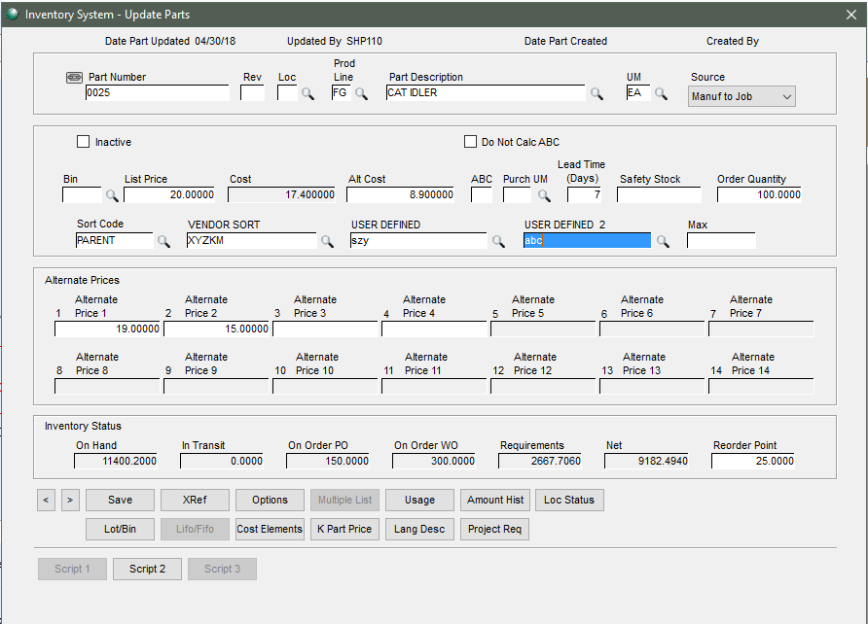

Inventory > View > Supply and Demand

The drawing number (User Defined 2 from V_Inventory_Mst2.Text_Info2) will added to the supply and demand screen and sit in place of the Consigned field

** Only following Supply and Demand screens will be changed with this specification:

Inv / View /Supply and Demand ; Supply and Demand (No Dollars WO) ; Supply and Demand (No Dollars)

