**1/Project 5128 specs:**

**A. Add column to AR Aging Tab:**

Days Since Invoice between the Due Date and the Type columns.

Definition of Days Since Invoice is count of days since the invoice date

* + For example, current day is 3/27/18. If invoice date was 3/26/18, Days Since Invoice = 1.

*AR Aging Tab – Current View*

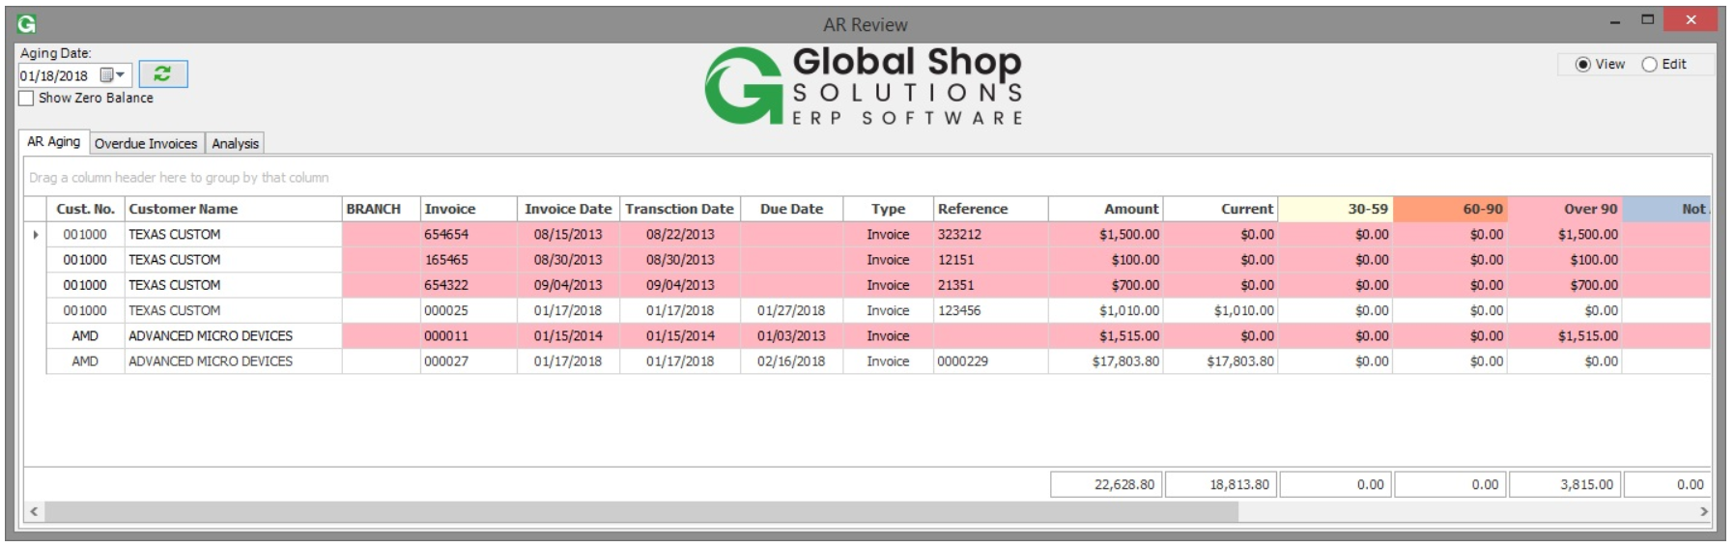

**B. Add columns for Overdue Invoices Tab:**

B1. Invoice Date in between Invoice and Due Date columns.

B2. Days Since Invoice between the Due Date and the Invoice Balances

*Overdue Invoices Tab – Current View*

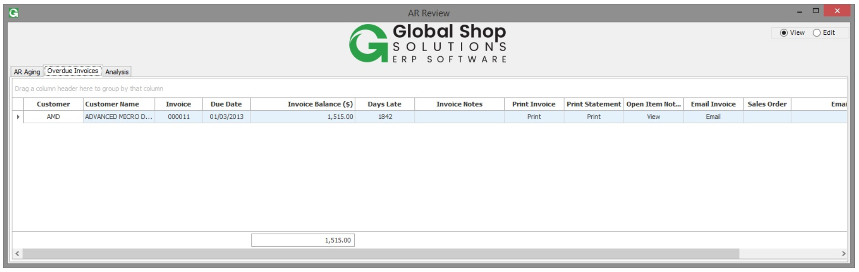

**C. Dashboard will utilize Custom Memo Notes Program (**GAB_MEMO_NOTES.G2U. **written by Trent) for entering in notes for the Invoice rather than the Core System Notes**

**2/Screenshots of project 5128**

**A.**

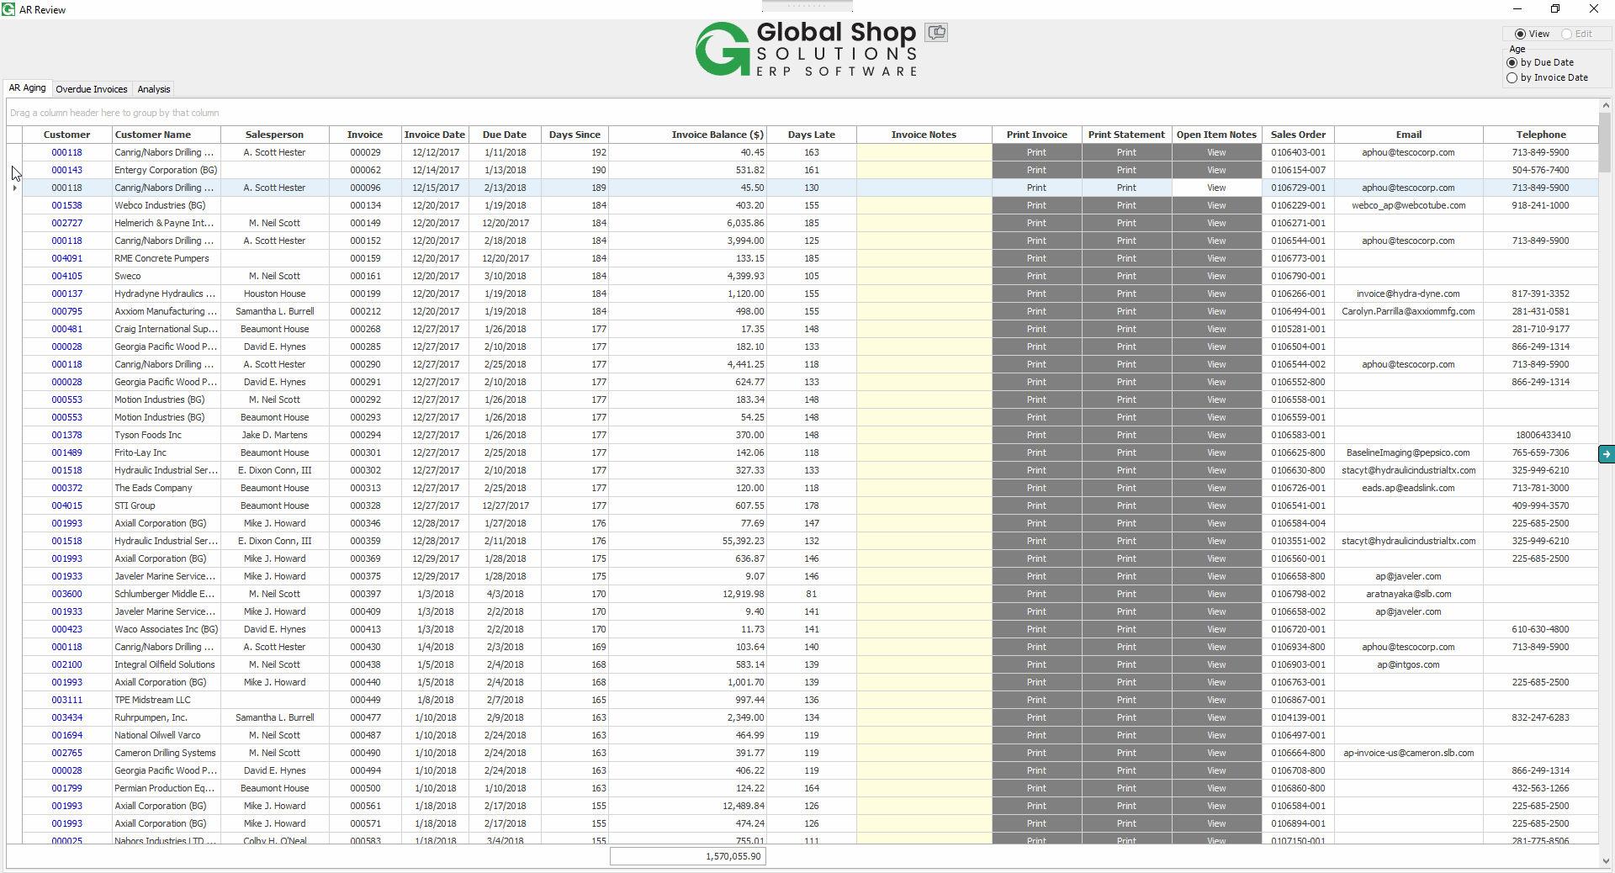

**B.**

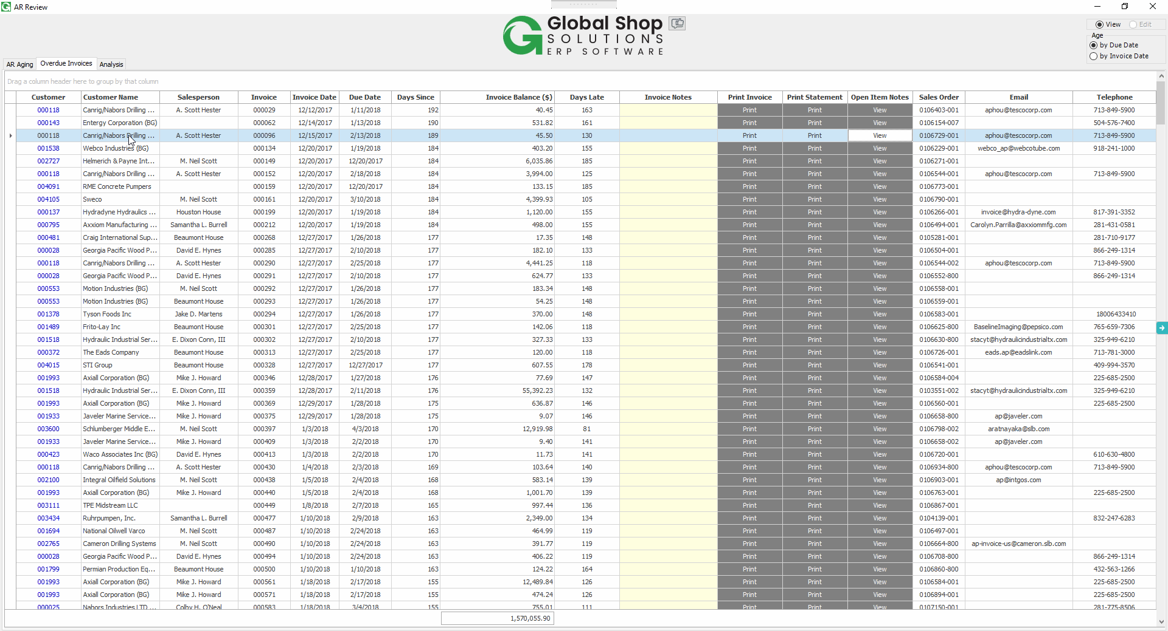

**C. Custom program from Trent for Open Item Notes when clicked**

