BN, Dec 2018

Project 5304

Customer: Zephyr Products, Inc.

This project is a modification of project 5234. From project 5234 - Shipping Dashboard, we will build 2 versions:

1/Version 1: Shipping Dashboard 5304 (see Pic 1):

In this version, we enhanced the following features:

* Add MRP calculation: color in light green for MRP lines
* Add Document Control Link (button Link in each line if clicked will open the Document Control of the underlined part)
* Add Sales Person column
* Dynamically label the 5 User Fields of Order Line to the company settings (OE_USER_FLDS_LN)
* Improve the speed by discharging the load of Database engine and let the local memory does the work.

***Pic 1:***

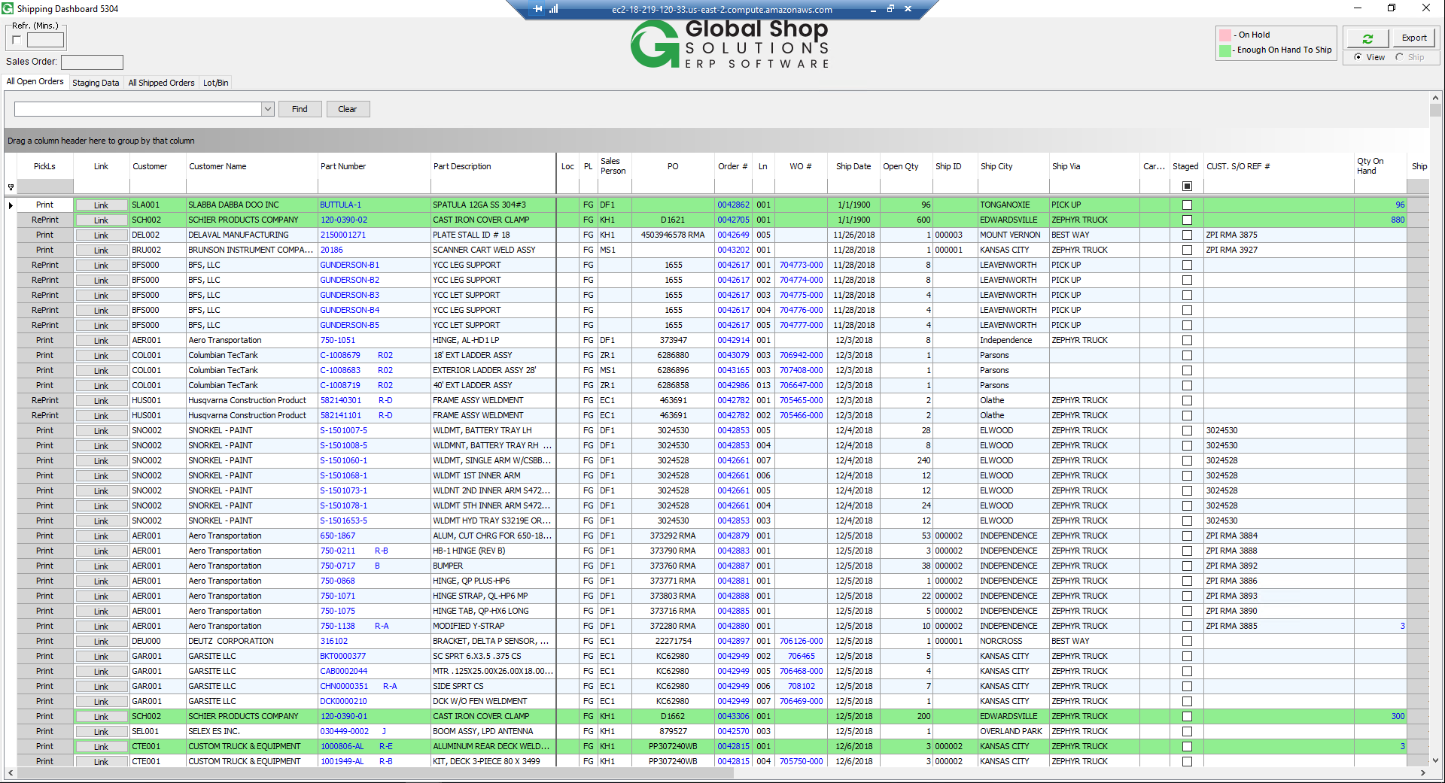

2/KA Shipping Dashboard 5304 (see Pic 2):

This version is built on top of version 1:

* A Cutoff date will be added at the right top of the form. Default Cutoff date is 4 weeks from current date. This date is applied for the filter of the Order Line Date Item Promise.
* Add a child grid displaying the WO details of all WOs (Parent WO and Children WOs). Parent WO line (having suffix 000) are colored light blue.
* Columns of child grid are:

+ Document Control Link, Part, Job, Suffix, Loc, Description, Open Qty, Due Date

+ First Material of Job Operations

+ Job Steps (those with # sign are closed sequences) other than miscellaneous

+ Last Touch Date

+ Idle Days since last touch

+ PO Number of first Outside Seq if there are any Ouside Sequence other than miscellaneous

+ PO created Date

+ Bin number of the WOs (from Wip_Bin)

***Pic 2:***

