BN, Feb 2019

Project 5327: PTO Approval (Absence Request)

Customer: **Life Line Emergency Vehicles**

Customer does not use Payroll feature of GSS.

*** Create Administrator group name ABSADMIN and add user as Administrator. In this case, we add Supervsr:

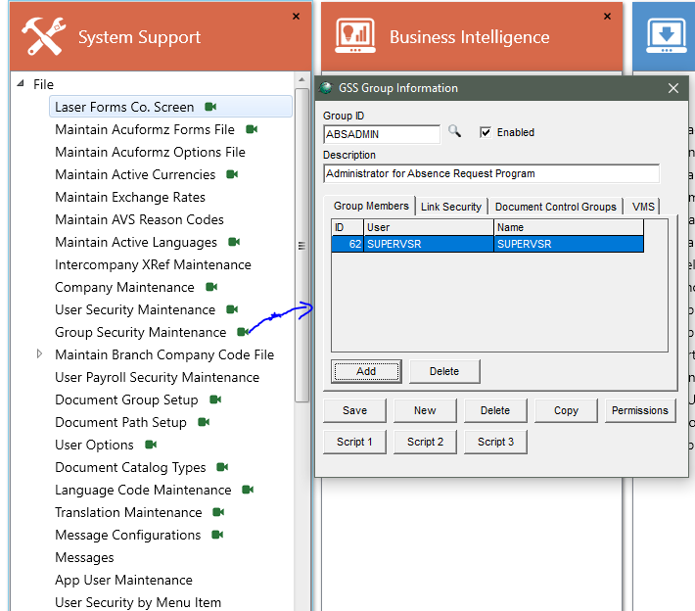

**1/Import Vacation Left from a csv file to Employee_MSTR.Vacation_Left**

If you are working with a third party Payroll provider, we can import Vacation left from a csv file.

User has to be in Administrator group ABSADMIN to use this import program. Otherwise, he will get a message:

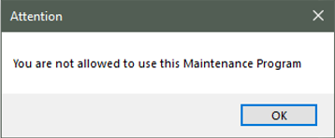

Open the program at: *Payroll > Administration > Import Employee Vacation – 5327*

Select the file to upload

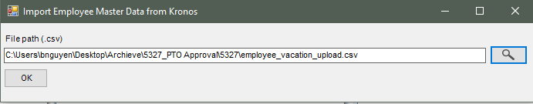

Upload the file. Then a result message will pop up.

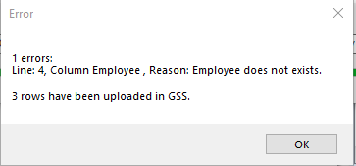

A result file will be also saved to the same location of the import file.

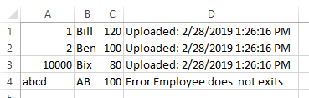

**2/Maintenance**

User has to be in Administrator group ABSADMIN to use this Maintenance program. Otherwise, he will have a message as above.

Current Payroll Earning Codes in Company Option (standard) > Payroll may look like this:

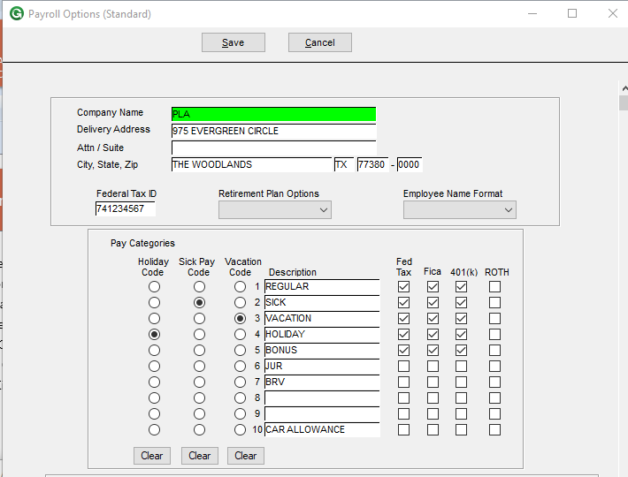

Open Maintenance program at: *On Line System > Administration > Absence Request Maintenance - 5327*

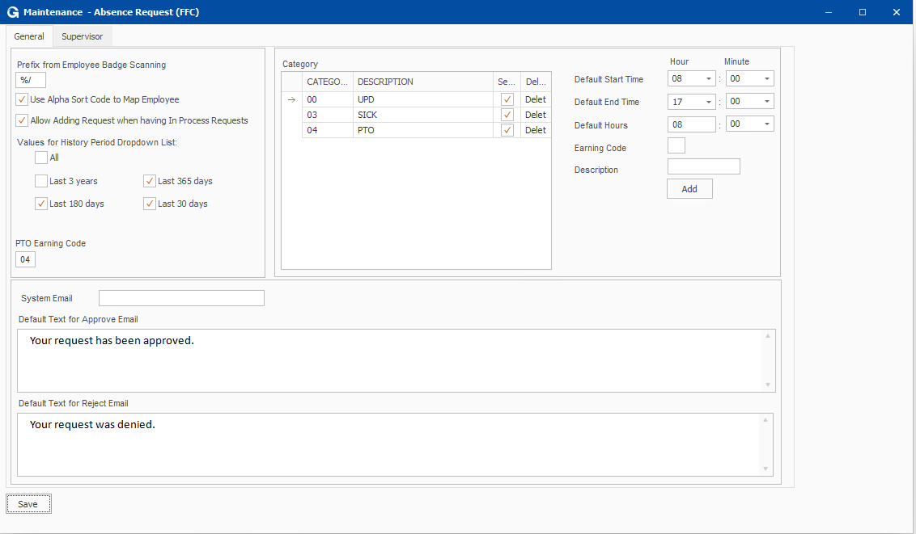

*2.1 Prefix from Employee Badge Scanning:* This is the prefix generated by the scan machine and machinde provider specific.

*2.2 Use Alpha Sort Code to Map Employee:* check this if you use alpha sort code to map employee. The expected scanning string will look like this ZZAAAAA where ZZ is the prefix and AAAA is the alpha sort.

If it is unchecked, the AAAAA is the employee number.

*2.3 PTO Earning Code: Put this earning code will tell the program to deduct the PTO once the manager approves the request.*

*2.4 Categories need to be added to the grid that match exactly the Earning Codes in Company Option (standard) > Payroll:* Then you will have to select what category to be displayed in the dropdown list of the Request screen. You may add the EC that is greater than 10, for example: 11 – PTO, 12 – UDP (Unpaid)

*2.5. Default Hour/Minute:* are values that will be displayed as default at the Request screen.

*2.6. Supervisor tab:*

Select managers and their supervised departments and add to the grid. This will tell the program in Approval screen to allow manager to see only employee requests of his department.

Administrator account can see all the requests of all employees.

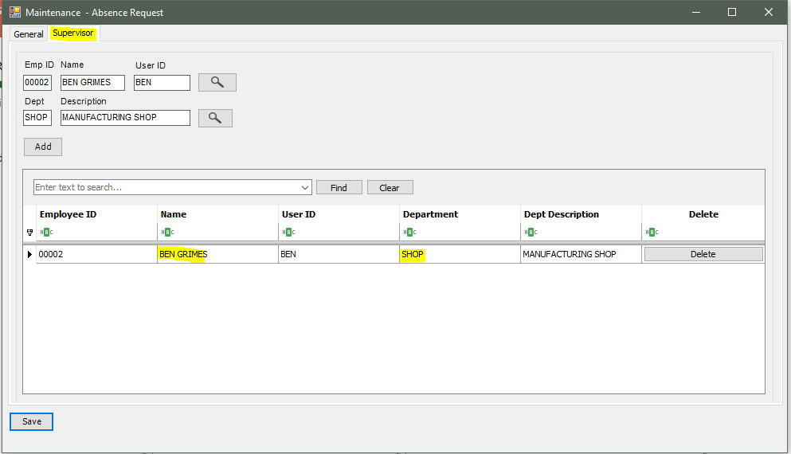

In our next example, we have these following employees, where M is the manager of the SHOP department.

E is for employee.

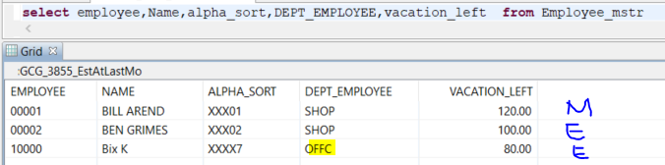

**3/Operation:**

*3.1/ Request:*

The Request screen can be opened from the GUI > Script 1 button (named Time Off).

(It can also be open from *On Line System > Transactions > Absence Request 5327,* and with this one, it will map the user id with the employee id and he will not have to scan)

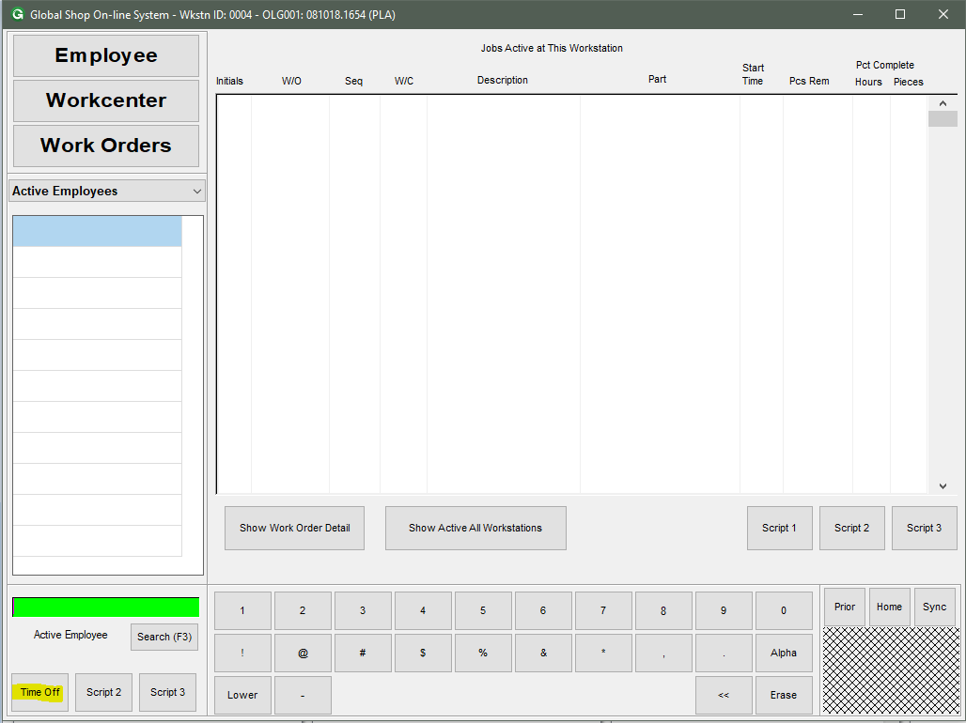

User will have to scan their employee bage to run. Focus at the Employee textbox and scan, the click load:

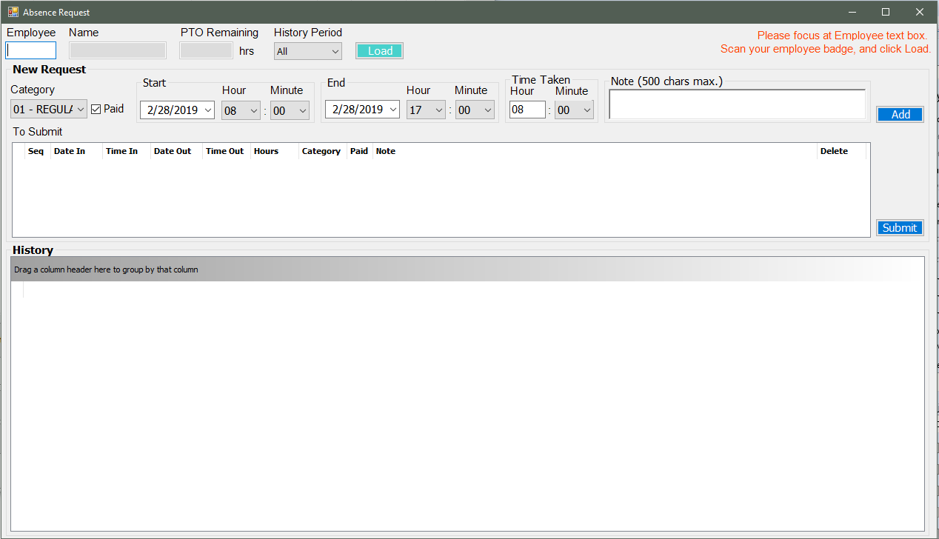

After clicking Load, we have this for Bill Arend:

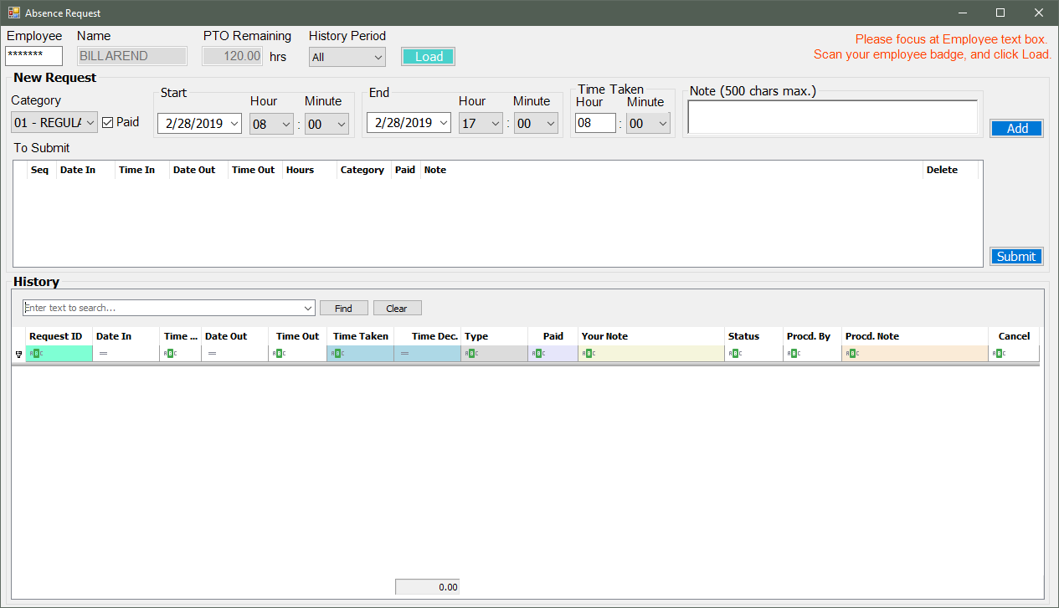

Enter 3 records and click Add. The grid will display our selection. We verify them then click Submit.

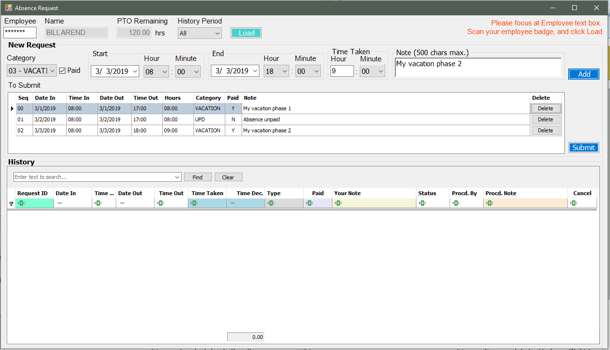

The 3 records are added to the History, flagged In Process:

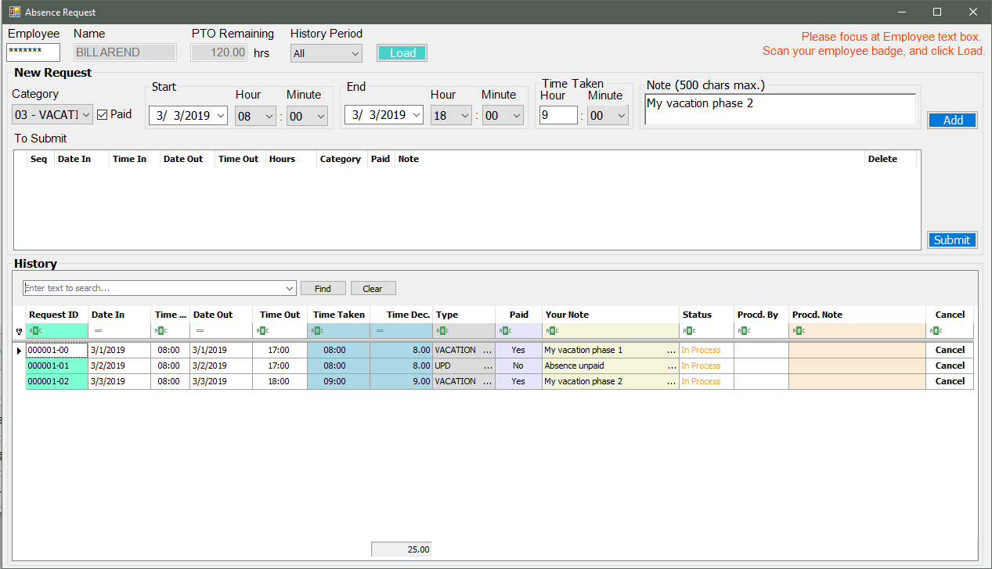

User can click Cancel to cancel a request but it has to be before the request is processed by the manager:

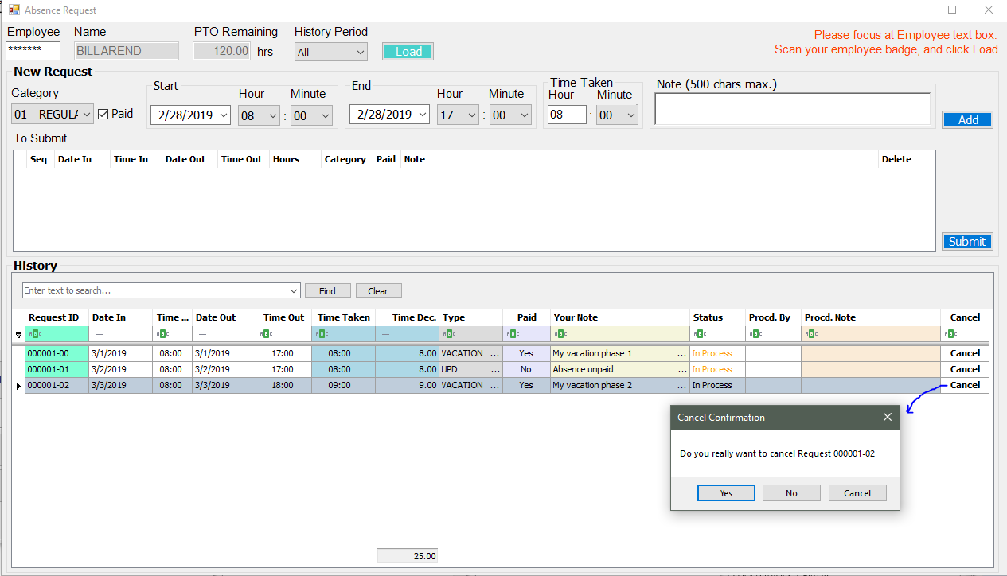

After cancelling, the grid will look like this:

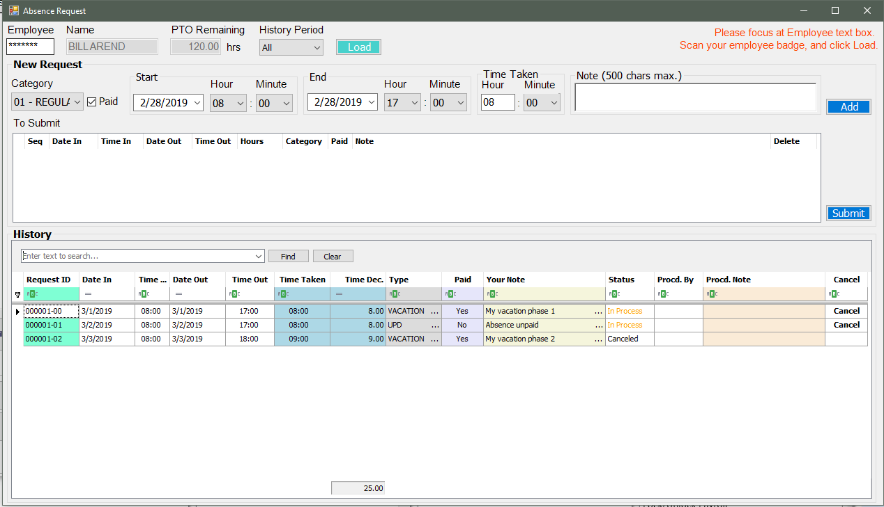

Scan and Load other employee – Bix K, and then add some records. Bix K is in different Department (OFFC) to Bill Arend:

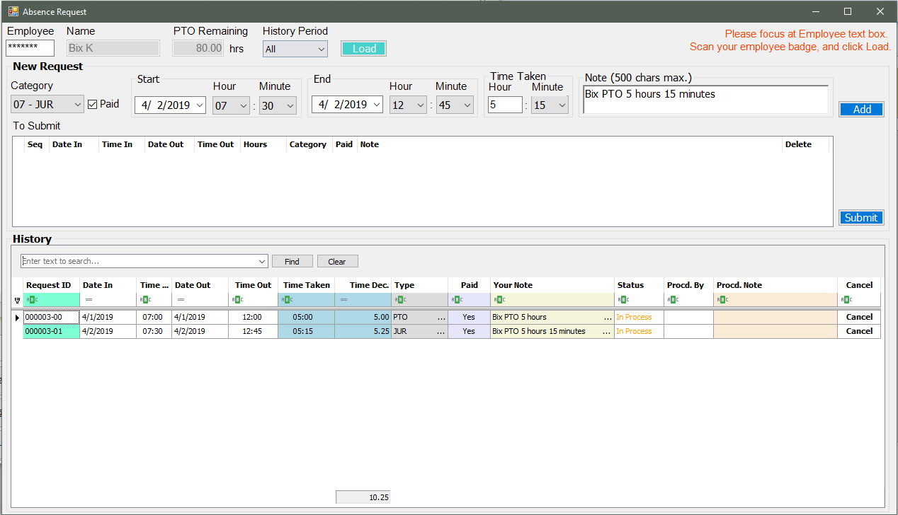

*3.2/Approval:*

Open Approval at *On Line System > Transactions > Absence Approval 5327*

Only Managers that are mapped at the Maintenance program can open this menu item.

In this example, we open under Ben Grimes, we will see the request from Department SHOP because he is mapped to manage this department:

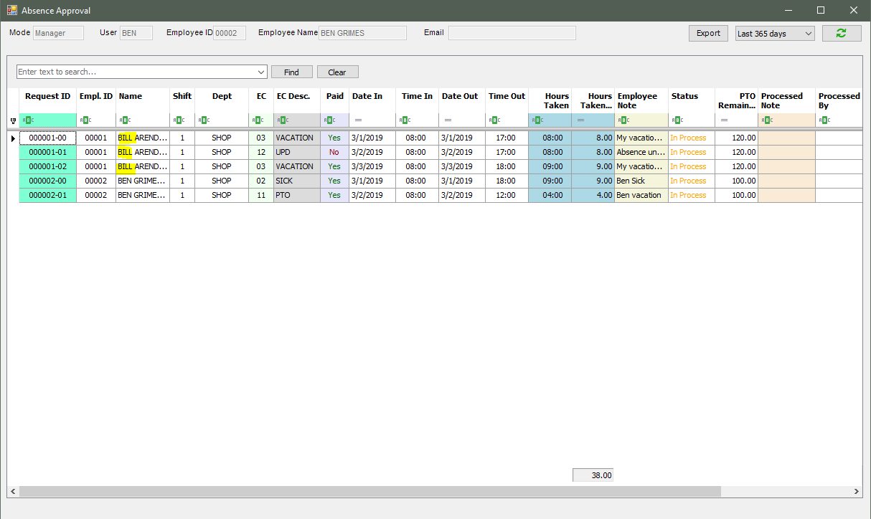

After Bill Arend cancel a record, the line will be updated with the label Canceled:

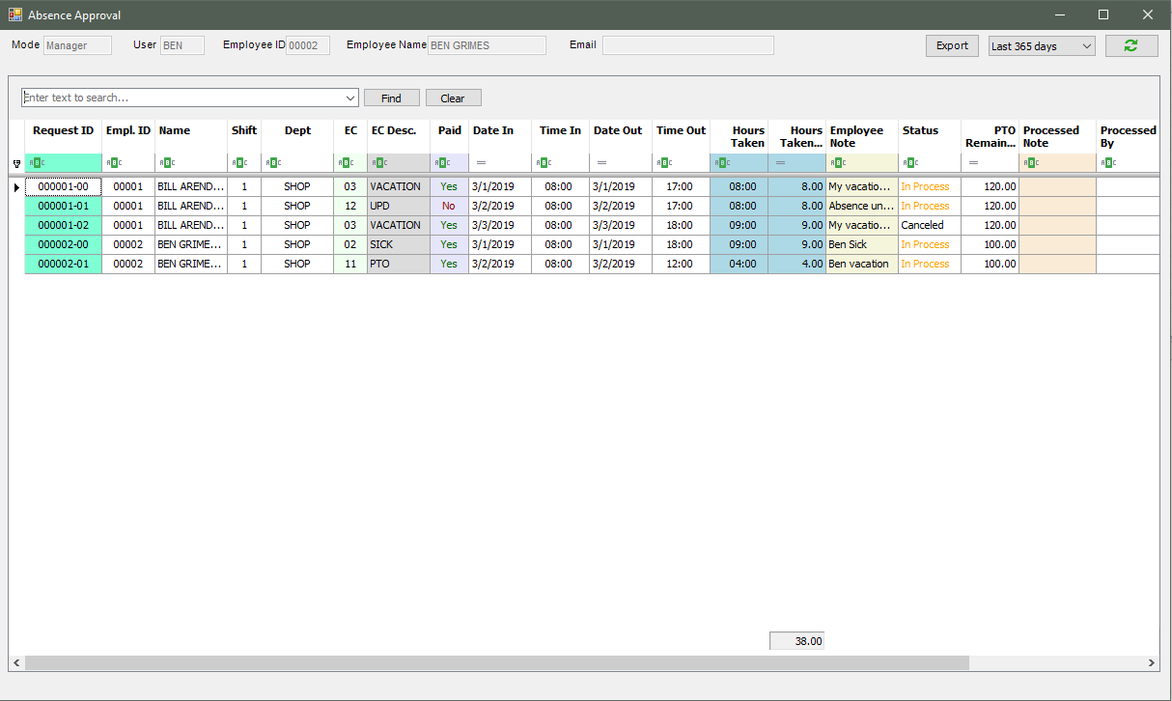

Click the rows with status In Process to process:

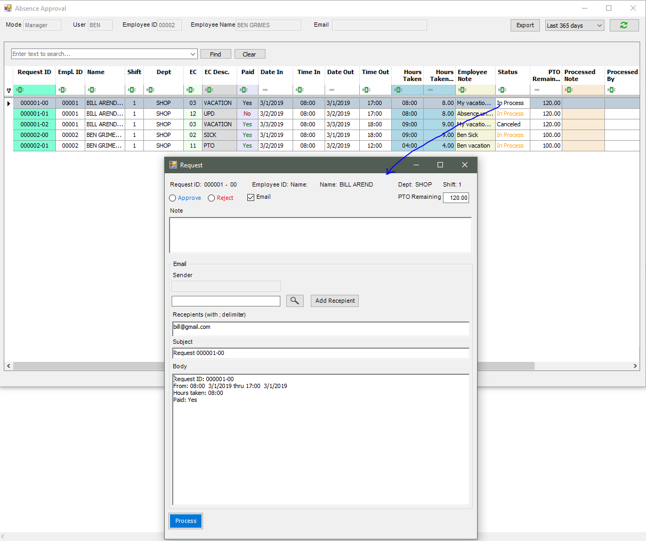

Select Approve or Reject as well as Email or not:

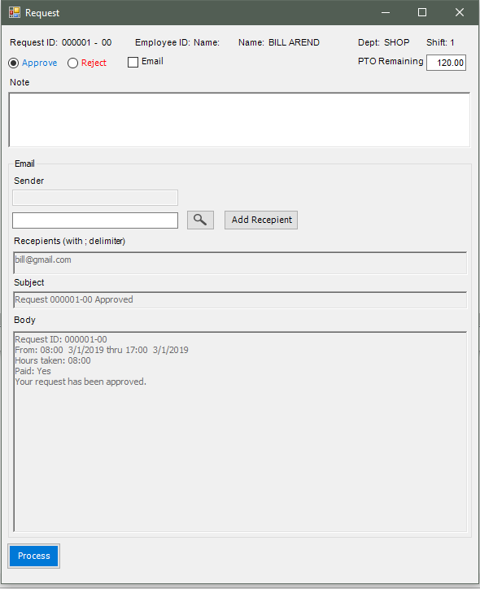

After approving, the row will be updated the Status as Approved, and the PTO Remaining will be deducted if that request is a Vacation/PTO request.

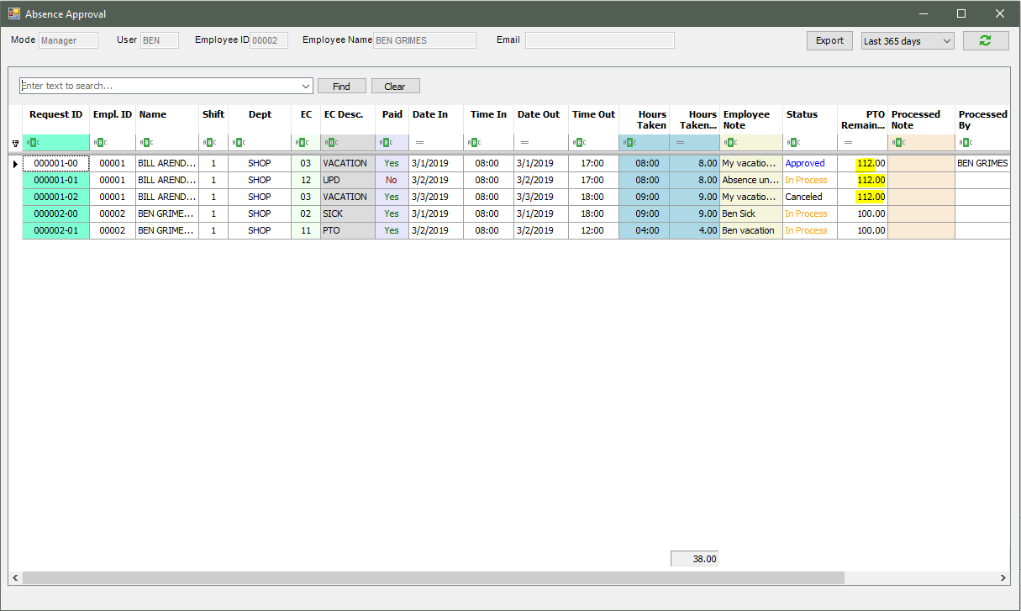

Employee Bill Arend logged into the Request screen will see the result displayed as Approved:

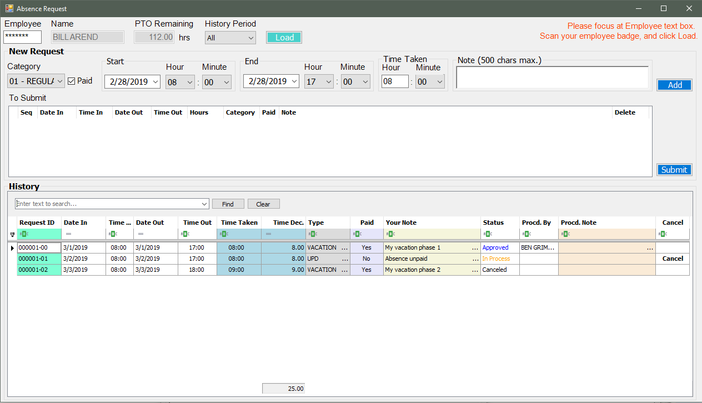

This is the case for Reject processing, with Processed Note:

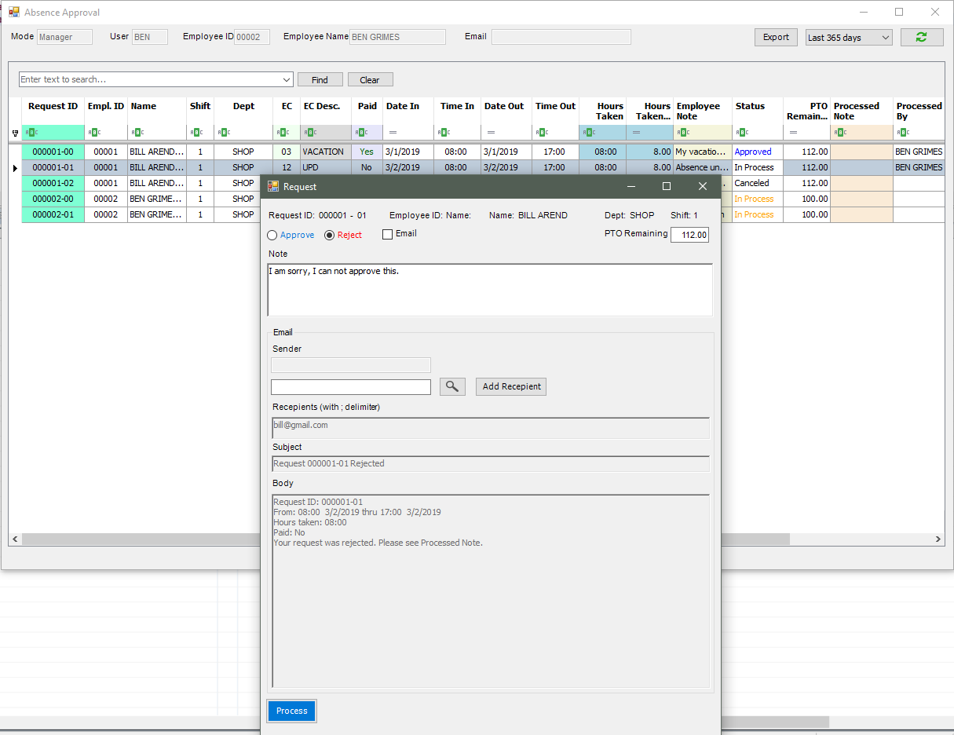

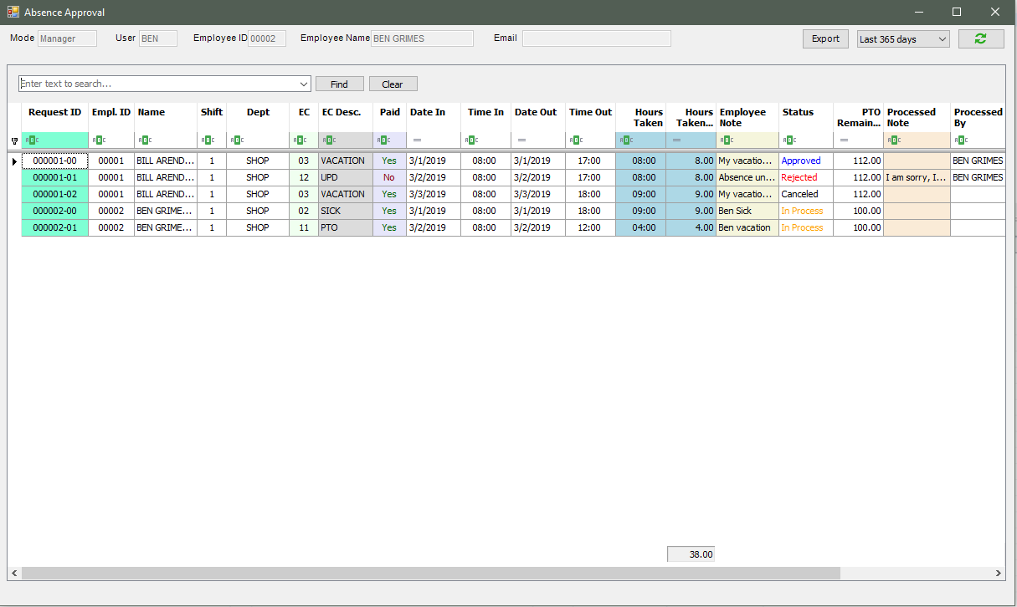

Bill see the Rejected request 000001-01 just updated if he click Load again.

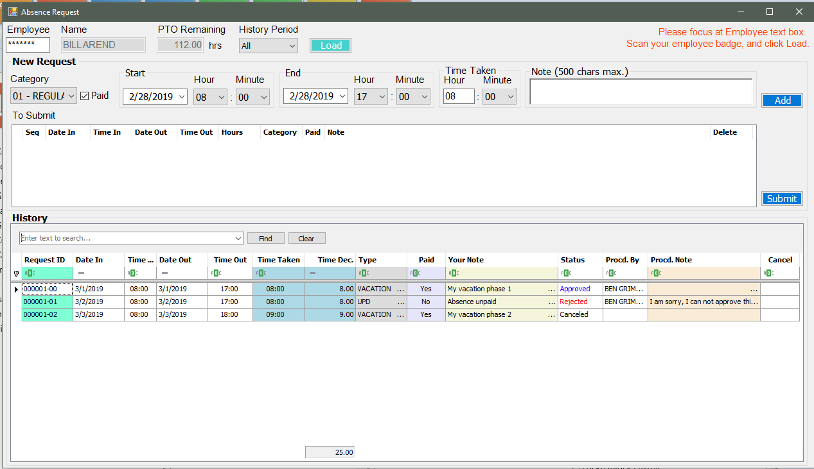

Manager can click Export to export to Excel spreadsheet. Before Export, he can filter/sort the grid then click Export will export what is displayed from the grid:

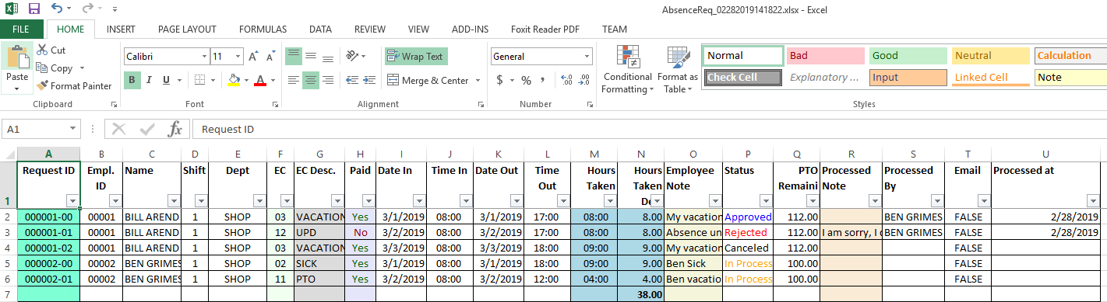

*3.3/Approval Screen under Supervsr (Administrator account):*

Under this account, we can see all requests of all employees, for example, Bix requests are not seen by manager Ben, because Bix is from other Department – OFFC, while Ben manages only SHOP Department.

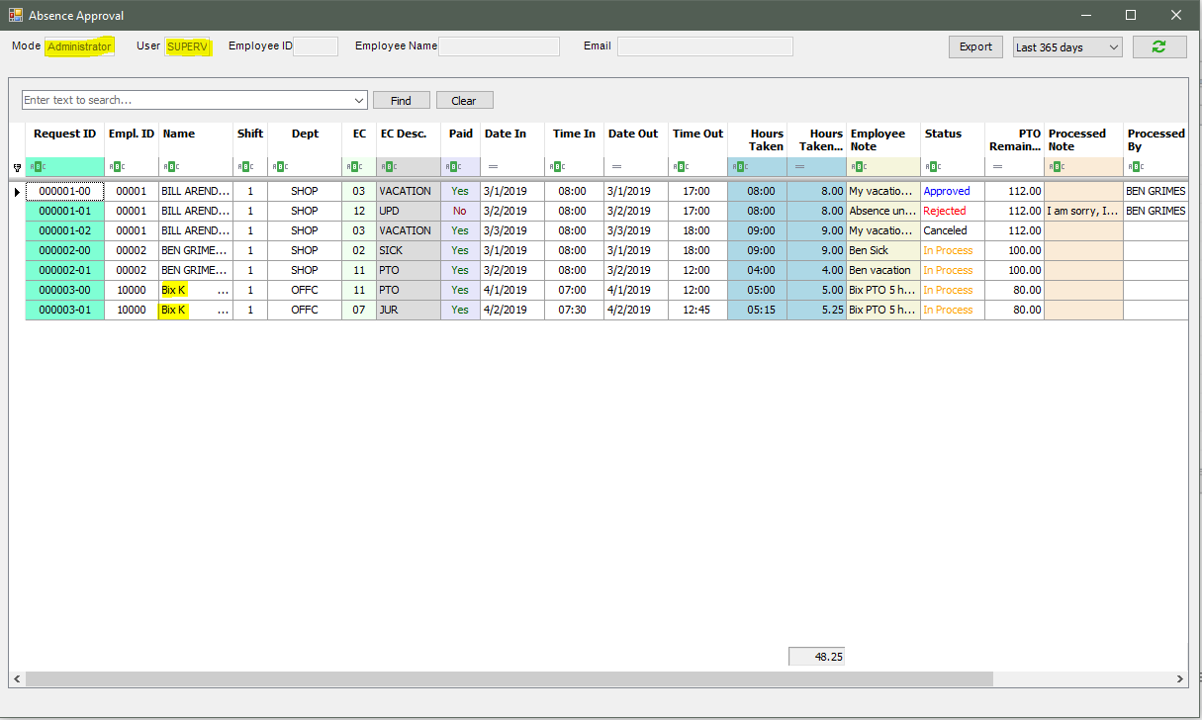

We approve a record for Bix, this time, we approve the JUR earning code (request 000003-01), after approving, the PTO remaining is not deducted, becaulse PTO remaining is only deducted when the EC is Vacation/PTO:

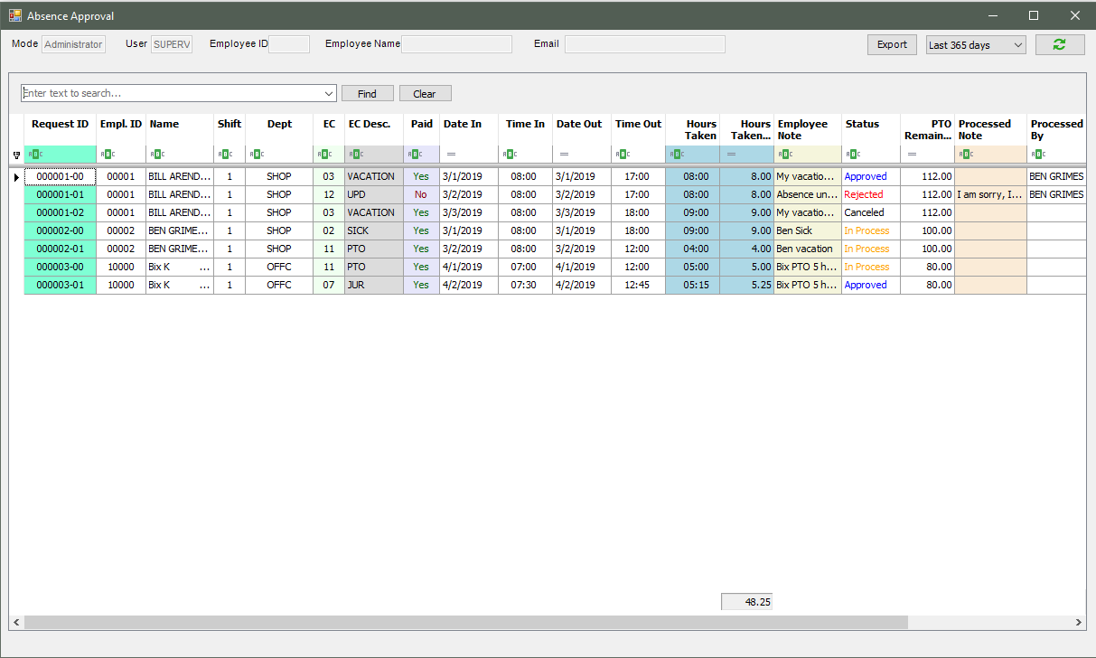

If we approve a PTO/Vacation request for an employee having not enough PTO remaining hours, we will have a message: (Ben only has 84 PTO left and we try to approve his request of 99 hours).

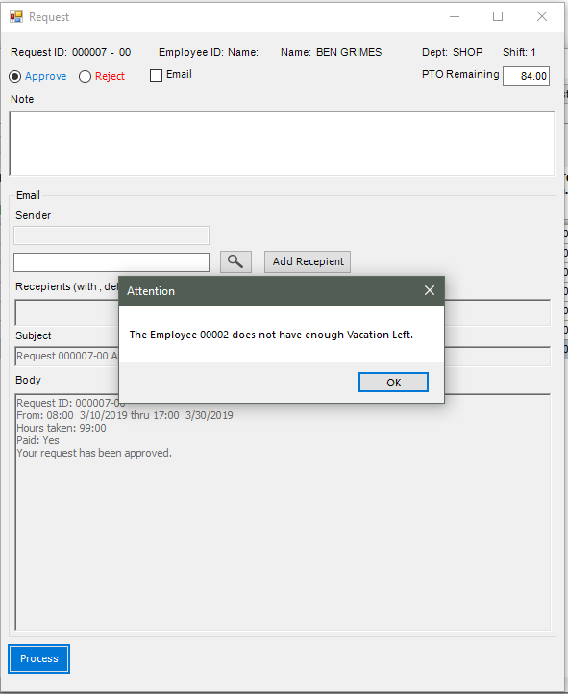

*3.4/ Email employee if the Email is checked:*

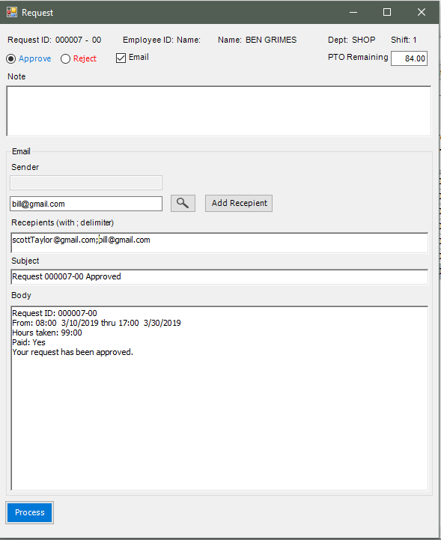

*3.5/ Micellaneous:*

Expand the form to see Proccessed At column:

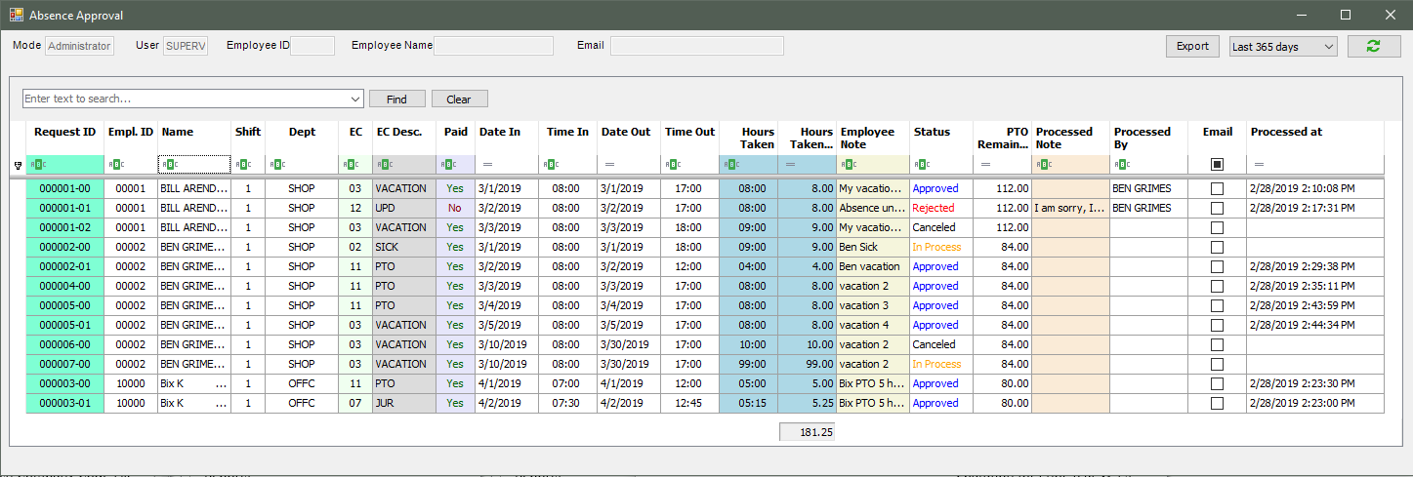

You may filter the Status as Approve to get the summary number:

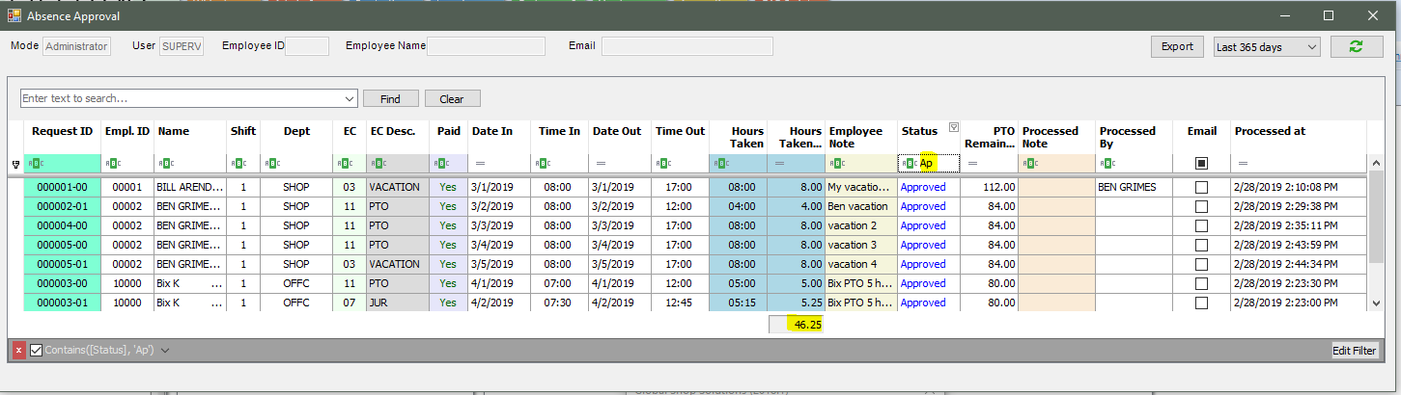

Or filter by Name and Status:

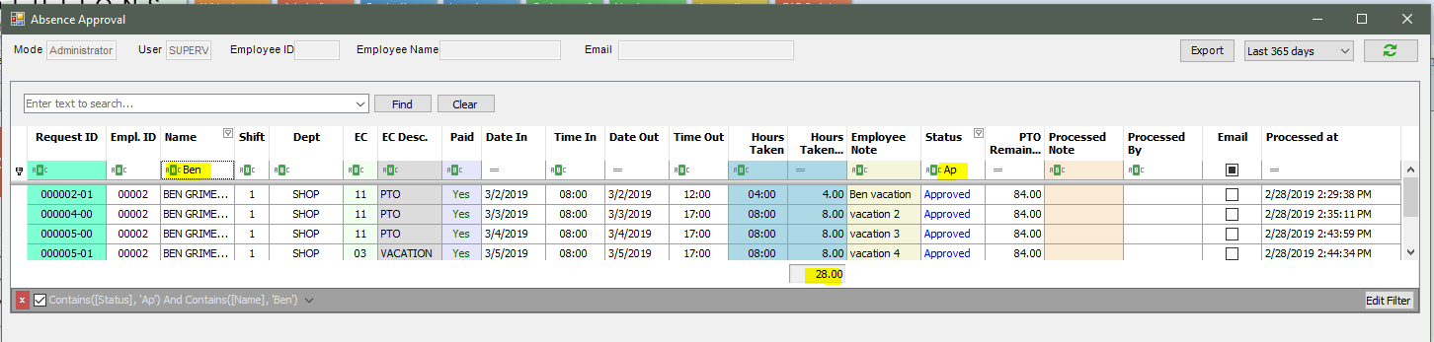

The note fields when clicked will open a note for if user wants to see the whole message:

