BN, Jan 2018

**Project 5342 - Current Work In Progress as a True View**

Customer: Pequea Machine, Inc.

Contact: Jay Lake

Email:jaylake@pequea.com Phone Number: 717-354-4343

***This project will create trueview web pages that is similar with the screen: On Line System > View > Current Work in Progress (No Dollars)

***User will maintain the selection of a combination of Department + Employee Group + Shift + Scroll (table body scroll feature)

***The Maintenance program will be run from On Line System > Administration > Maintenance - Current WO in Progress Trueview – 5342

***The TrueView one time running will be open from On Line System > View > TrueView - Current WO in Progress (No Dollars) – 5342

*** In order for the data to be refreshed at an interval of time(minimum 120 secs), we need to set up in Task Scheduler. The program should be run Daily from 6:00 am and it is coded to stop running automatically at 11pm.

Core program from which we imitate: On Line System > View > Current Work in Progress (No Dollars)

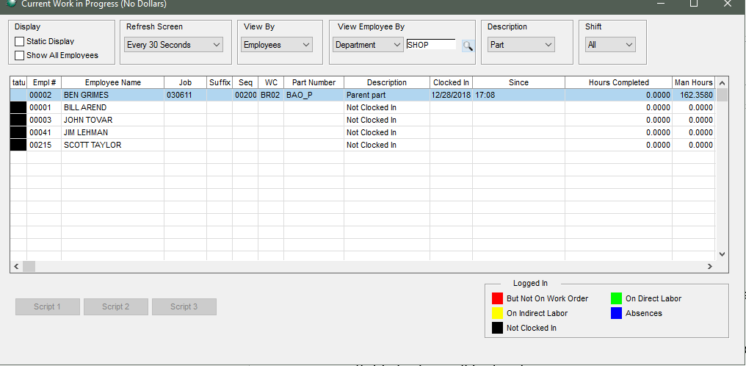

**1/ On Line System > Administration > Maintenance - Current WO in Progress Trueview – 5342**

Open Maintenance program and add selection. Then click Save.

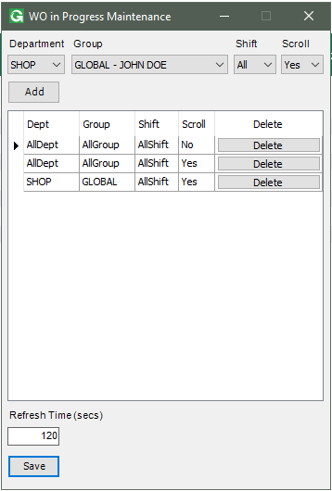

**2/ On Line System > View > TrueView - Current WO in Progress (No Dollars) – 5342**

The Web pages are generated under Global\BUSINT\Custom\TrueView\5342\XXX

where XXX is the company code.

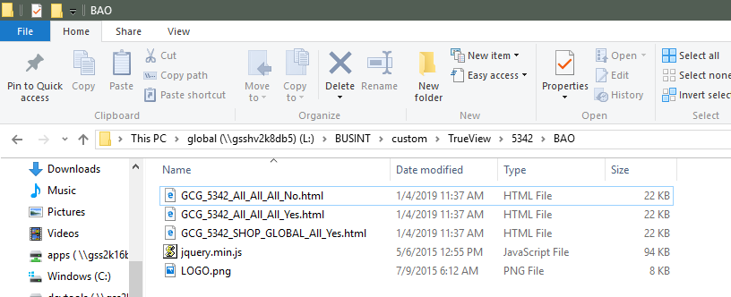

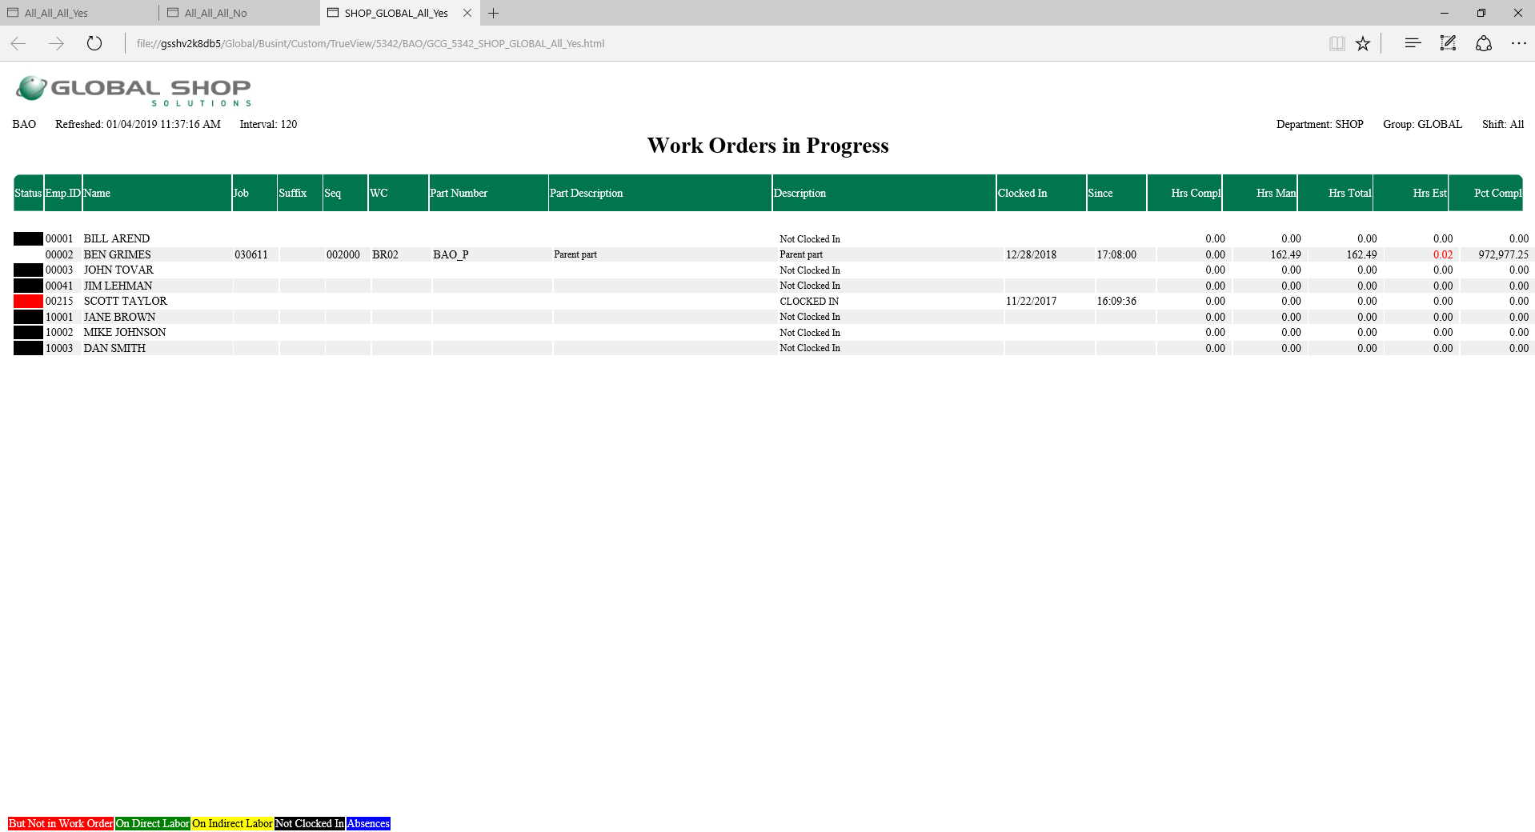

**3/Task Scheduler**

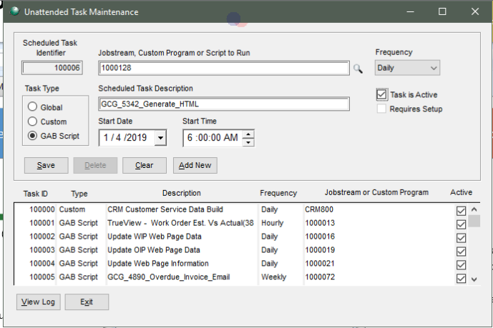

In order for the data to be refreshed at an interval of time(minimum 120 secs), we need to set up in Task Scheduler. The program should be run Daily from 6:00 am and it has coded to stop running automatically at 11pm.