BN, Mar, 2018

Customer: **Caragh Precision** – Contact: Karl Leonard [karlleonard@caragh.ie](mailto:karlleonard@caragh.ie?subject=GSRX-CAR180-3520191222-4-GSRX) +35391755773  Ext.  264

This project will explode a bom, display Inventory Master data of components, and can Create New Parts/Update Parts

Run from a custom menu item

**Screenshots:**

**1/Run the program from Bill Of Material > Administration > Create Parts from BOM:**

User has to be in security group ‘BOMGEN’ in order for the **Editable** checkbox, **Create New Part**, **Update Existing Part** to be enabled.

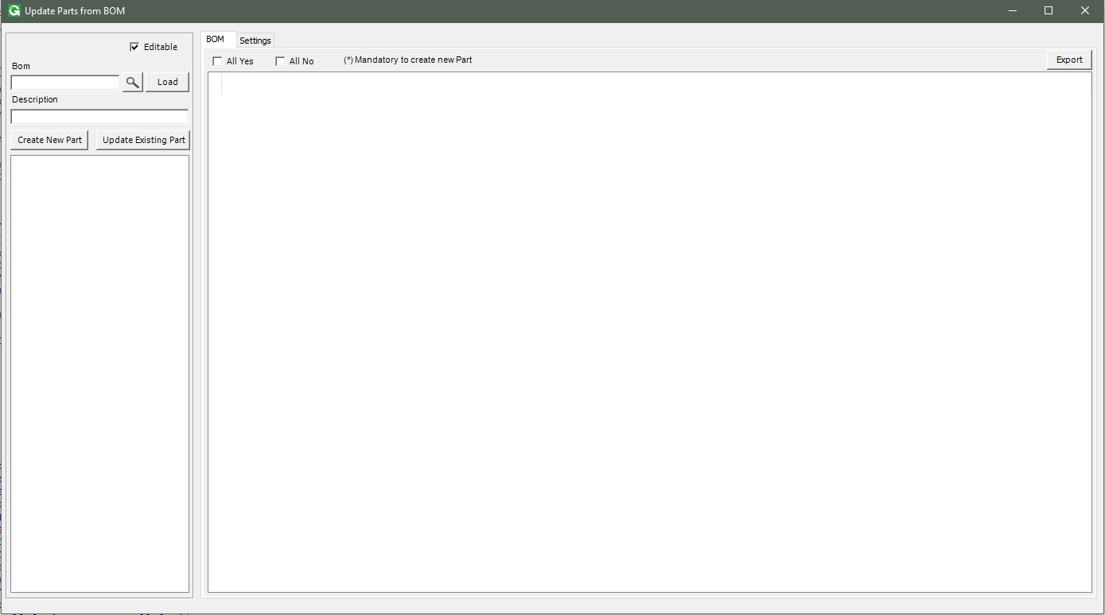

**2/Select a BOM and click Load:**

The program will explode the Bom and build a treeview and a grid view.

**Non Existing Part** will be flagged in the treeview as **Part#_Non Exist** and flagged in the grid as No.

When we focus a node in the treeview, the grid will focus on the according row:

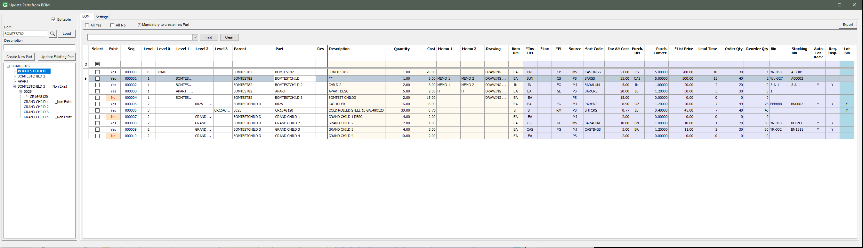

When we click a cell on the grid from column Select to column Rev, the according treeview node will be marked bold:

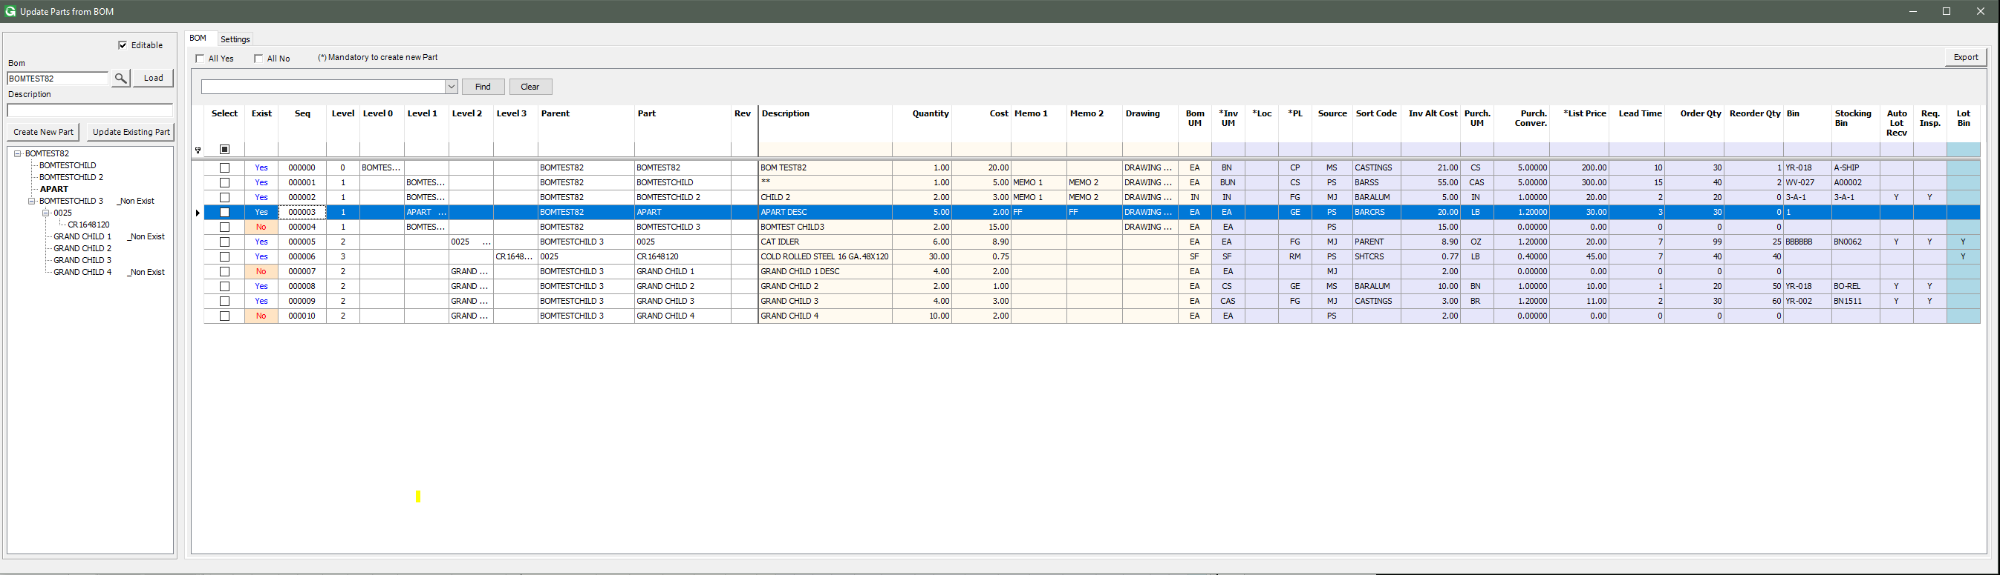

The grid is built to generate the Level columns (Level 0, Level 1, Level 2, etc.). This will help:

* Make the BOM look as a tree in the grid, help user easily know the levels, which child belongs to which parent.
* Export to Excel feature will give this treeview style of the grid for report purpose.

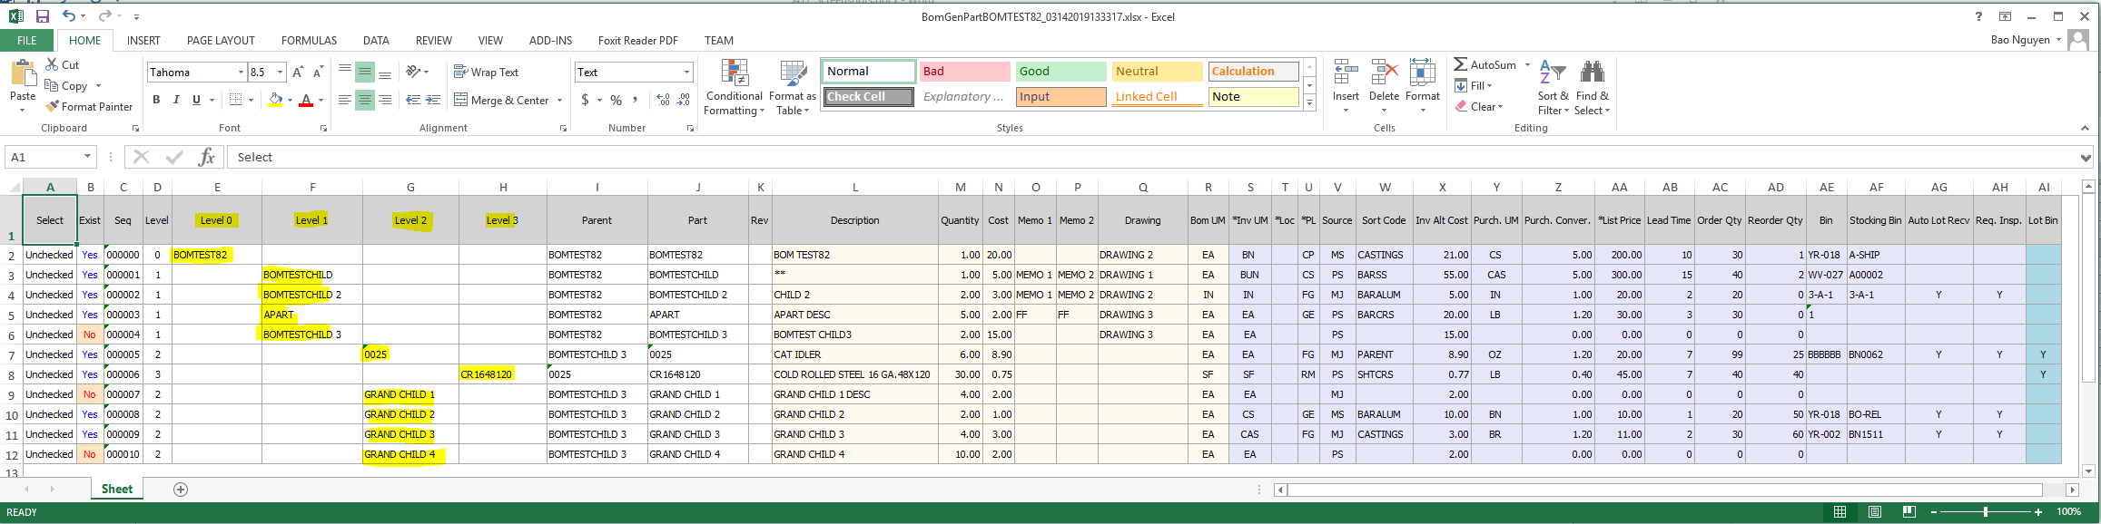

User can select what column to be displayed, as well as decimal display in Setting tab. If they want to save this for the next run, click Save Option. This will save the setting per user.

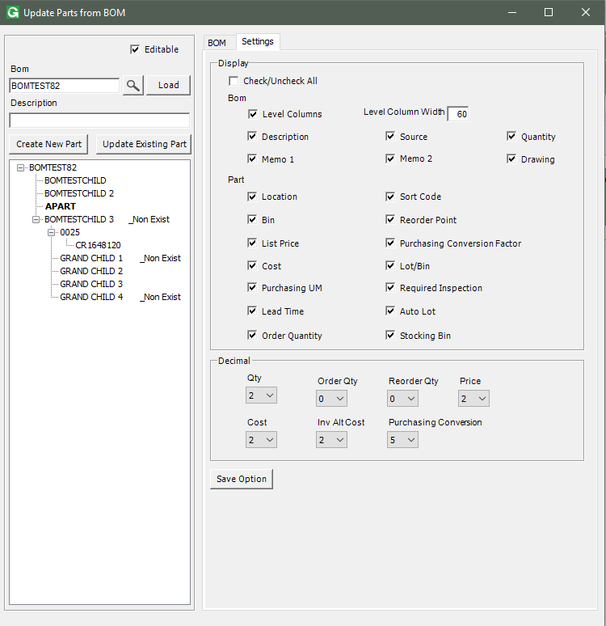

**3/Create New Part/Update Existing Part:**

*Yellow section is for BOM data that is not modifiable. Violet section is for Inventory Master data that is modifiable.*

Select No rows then click Create New Part:

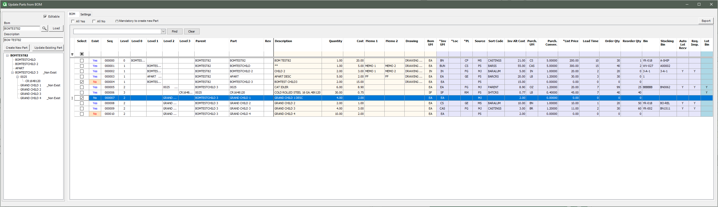

Select Yes rows to Update Existing Part:

