BN, modified to be project 5437

Customer: Caragh Precision – Contact: Karl Leonard

Added features:  
    1/Add summary for numeric fields

2/ Make User1H, User2H, User 1, User 2, Quality Risk (User 3), User 4 editable.  
   3/When opening the dashboard, the program will add Dispose Records for those NCMR not having any Disposed Records.   
   4/Serialize/Deserialize saves the user setting for the grid  
    5/Process clicked: Set the Filler to '' will make the disposed records to be checked 'Disposed'

in the core screen Quality System > File > Quality Reject/Disposition, and deemed Disposed in the Dashboard

Screenshots:

When the dashboard is loaded, the program will process all records. If the Reject Qty Remaining & Reject Value Remaining > 0, and it does not has any Disposed Quantity/Disposed Value sequence, the program will add sequence 001 for Disposed Quantity/Disposed Value and set the qty/value to those of the remaining. Then the program will set the remaining qty/value to 0. The Disposed code will be harcoded as Z + Scrap Code

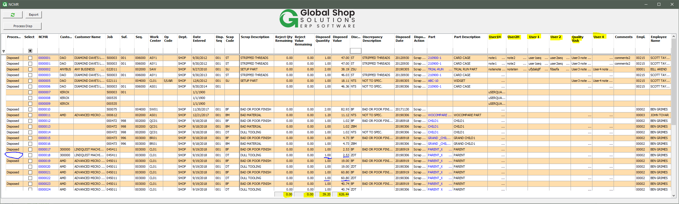

At this moment, the sequence 001 is created but it is not flagged Disposed yet:

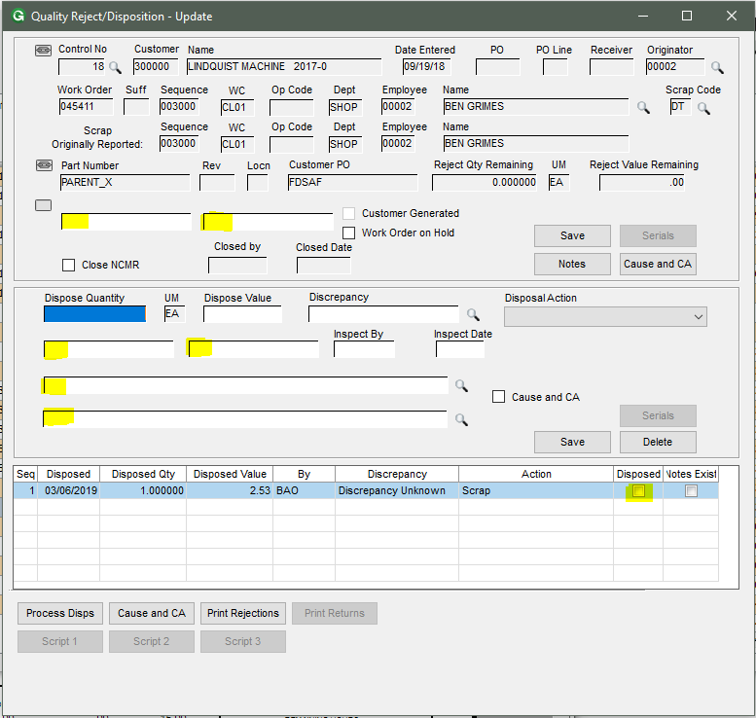

The record will be flagged disposed when the user selects the record on the dashboard and click **Process Disp.**

The other yellow textboxes are the user fields displayed and editable in the dashboard.