**BN, Apr 2019**

**Project 5447 - Router/Bom Cost Buildup**

**Customer: Hy-flex Corporation**

**Benefit:**

Change Estimate and Quoting quickly when changing the Material price and report the changes.

**Business Case:**

Tariffs and Trade issues have made raw material costs volatile due to which there is a need to reprice their routers and perform BOM Cost build up for all parts associated with a particular customer and generate a quote rather than manually doing it for each part and then creating a separate quote for the same.

**Solution:** This entire process will be made easy by creating a custom menu item that will do it at the click of a button. This custom menu item will allow for a user to select a customer and select the price mark up category as selected in global shop. Once the quote is created for all parts, the old price is stored in one of the alt price field and the new price for each part on the quote is stored in the respective list price field in the inventory header.

A report will be generated at the time of creation of the quote to compare the new price to the old price along with the percentage difference. This report can be generated from a custom menu item as well.

**Scenario and processing:**

We have inventory parts that all have routers. Some inventory parts also have a bom.

By selecting a Customer and a Price markup, we can rebuild the cost for the Router/Bom for this customer.

If that Part has a Bom, the Bom cost buildup will be run, otherwise, the Router cost buildup.

After running the cost buildup, a quote will be generated for that customer, then 2 compare price reports will be generated.

There is also a custom menu item where user can select and run a the 2 compare price reports again which is done by retrieving data from a history custom table.

**Estimating / Routing & Quote Management > File > Bom/Router Cost Buildup 5447**

Select a customer and markup price to run the program

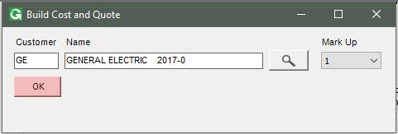

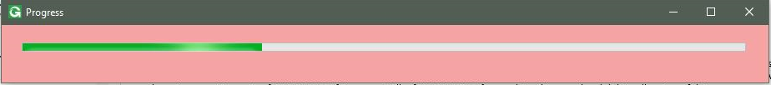

Program will get the next available quote number to generate a quote

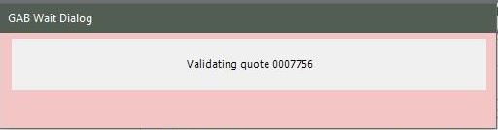

**Result**

First report is generated:

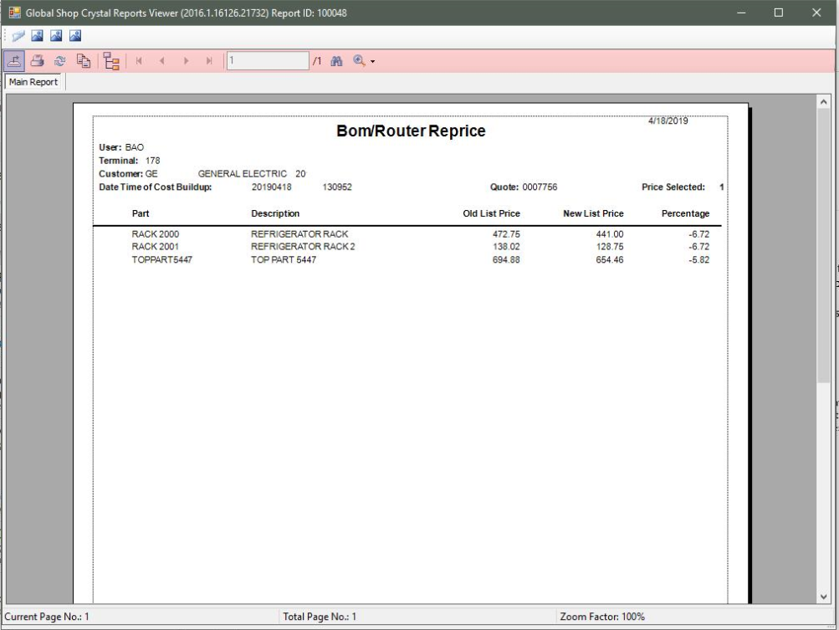

Second Report:

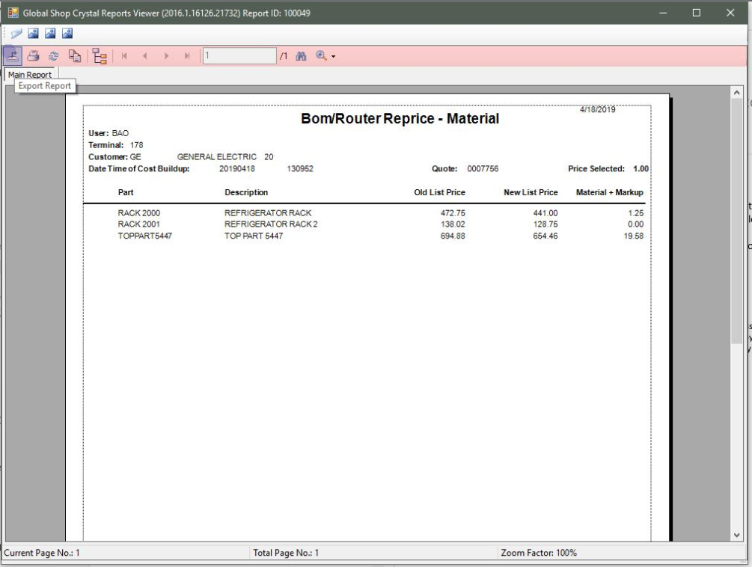

Quote screen will be opened automatically after we close the reports

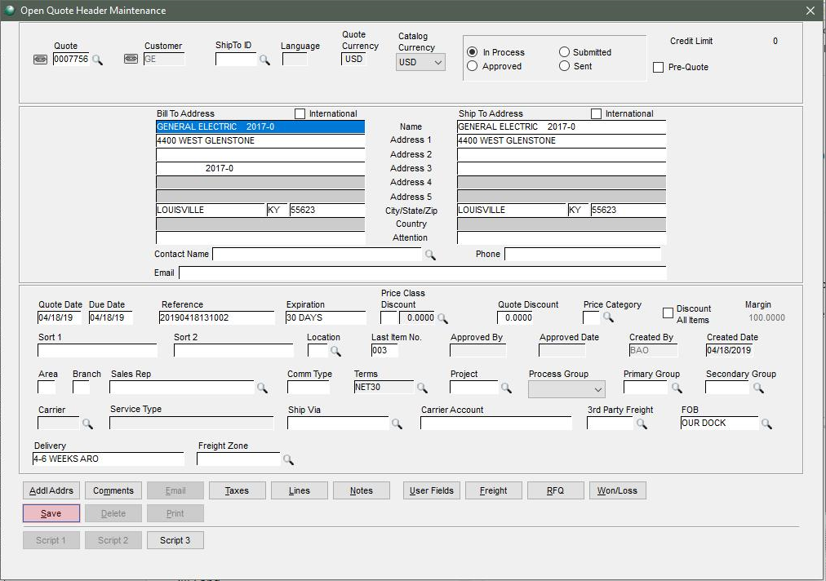

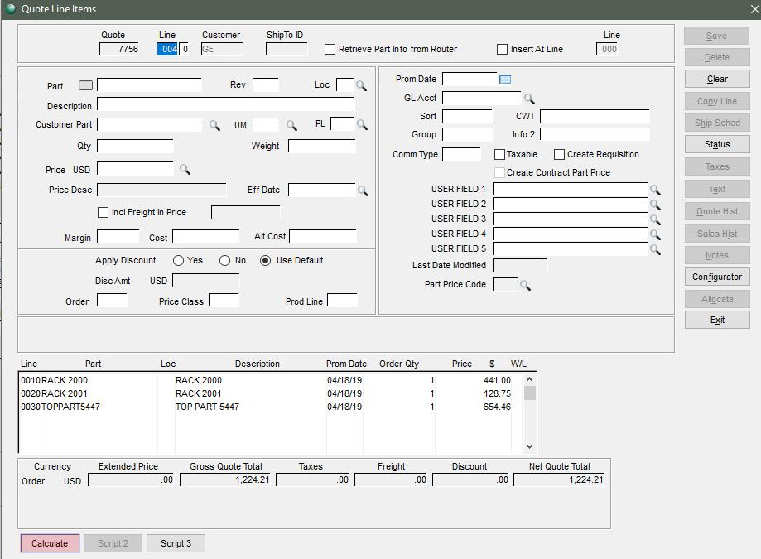

**Estimating / Routing & Quote Management > Reports > Compare Price Cost Buildup 5447**

The reports once run will be saved to history table, so we can re-run it from a custom menu item.

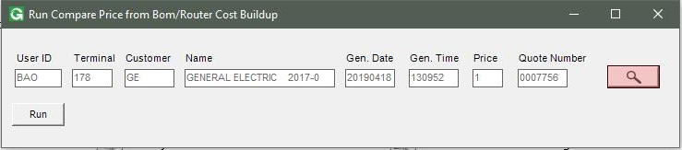

Click Browser to select the report to run:

