BN, Feb 2019

Project 5457 Exchange Variance Gains/Losses Reclassification

**1/Installation:**

* Create 3 tables by running these script:

GCG_5457_Batch.sql

GCG_5457_Maint.sql

GCG_5457_Waiting.sql

* Copy these files to the Global\GAB\GAS folder:

GCG_5457_Maintenance.g2u

GCG_5457_Maintenance.g2u.sig

GCG_5457_Reclass.g2u

GCG_5457_Reclass.g2u.sig

* Create 2 hooks attached sequences with:

GCG_5457_Maintenance.g2u

GCG_5457_Reclass.g2u

* Create 2 Custom menu item attached to those 2 hooks

**2/ Specs:**

Ensure that there are three exchange accounts set up in Global Shop

A – Main Exchange account where all the exchange entries are posted

B – One Account for Exchange Gains

C – One Account for Exchange Losses

Custom menu item: General Ledger > Transactions > Gains/Loss Reclassification Batch - 5457

Re-allocates all the dollars that posted in GL Account A (Exchange Variance) during a specific period and then re-post the Debit (positive values) to Account C and the Credit (negative values) to Account B.

To setup account A:

a. System Support > Administration > Standard > Inventory Accounting Options > Purchasing Tab > Exchange variance account

b. System Support > Administration > Standard > General Ledger

c. System Support > Administration > Standard > Accounts Receivable Table Maintenance > Exchange Variance

This custom program will pull records for Account A in GL_Detail then:

* User can genearte a batch number for a date range (within a month). The records’ references will be marked #WRA_BatchNum (Waiting for ReAllocating) if a bach is generated for those records.
* User can delete a batch number which rolls back the to its original Reference value (not really because only 4 chars of Original Reference is back)
* User can post the batch number at a later time.

What the batch will do is to Credit to Gains account, Debit to Losses account, and based on the balance, it Credit/Debit the Exchange Variance Account.

If the batch is posted, it will be removed from the pending grid on the right, and records for that batch in the A account will be marked #RAD_BatchNum (already ReAllocated)

The accounts are maintained in the maintenance program at custom menu item: General Ledger > Administration > Gains/Losses Reclassification Maintenance – 5457

2.1/ General Ledger > Administration > Gains/Losses Reclassification Maintenance – 5457

Select accounts and prefix letter for batch number auto generation.

This menu item can only be accessed by user in security group XCHGACCT. So you need to set up group security under System Support > File > Group Security Maintenance

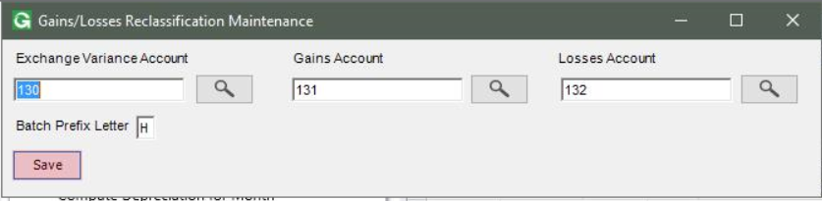

2.2/ General Ledger > Transactions > Gains/Loss Reclassification Batch - 5457

This menu item can only be accessed by users in security group XCHGEVAR. So you need to set up group security under System Support > File > Group Security Maintenance

Select a date range and click Retrieve. In this case we get the first half of April 2017.

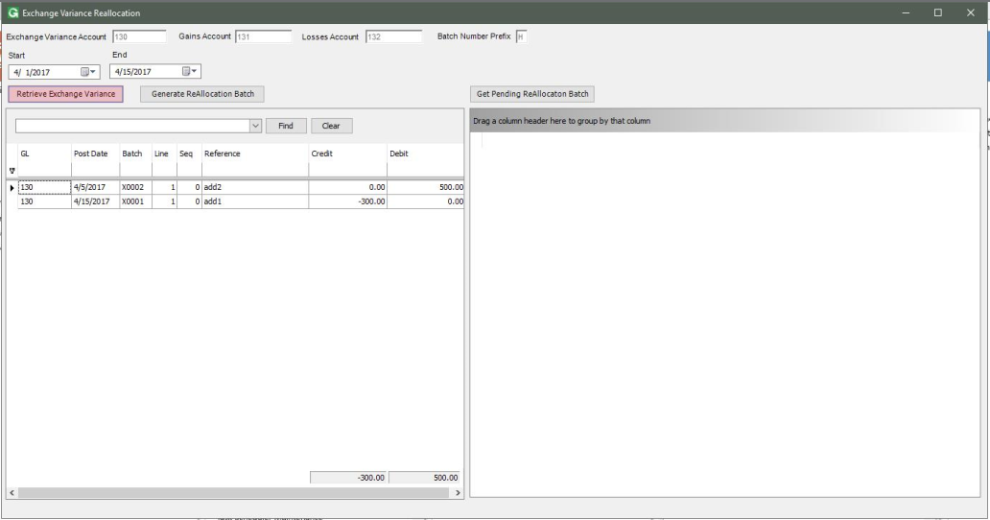

Click Generate to generate a batch from this date range. A batch will be generated and populated in the grid on the right. User can delete this batch or post.

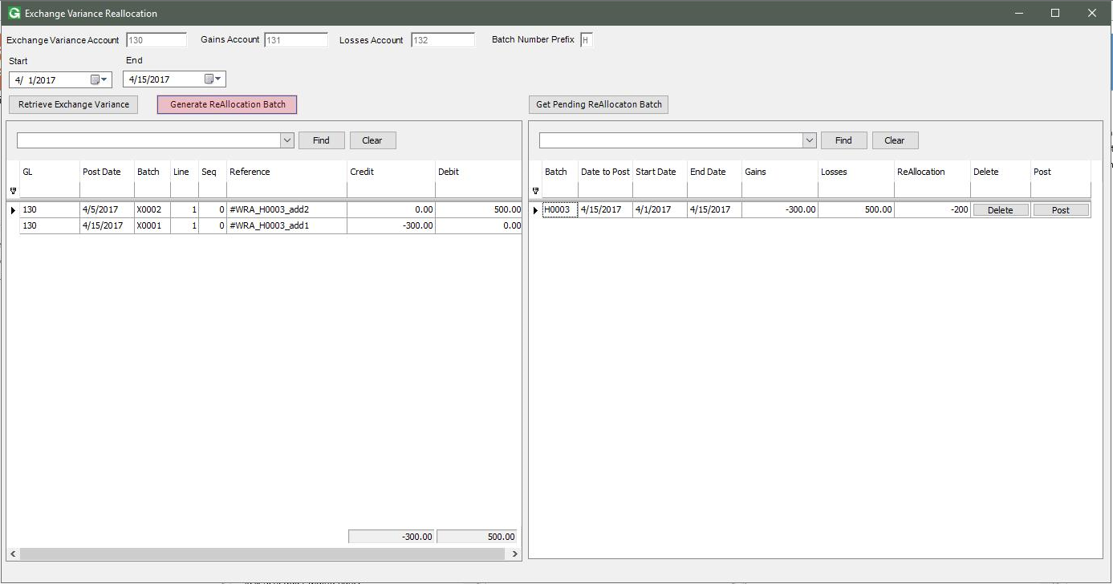

Select the the whole month April 2017. Click Retrieve and then Generate to get another batch for that date range.

This time the program will only care about the reference that is not marked #WRA or #RAD, so it will create a batch for those records (in this case the last 2 records).

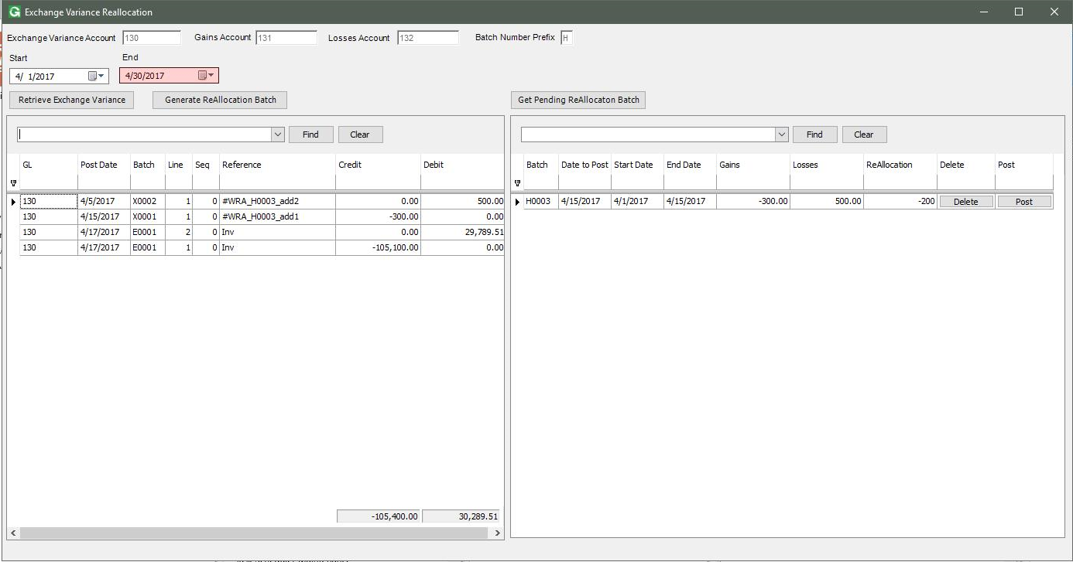

Now we have 2 batches:

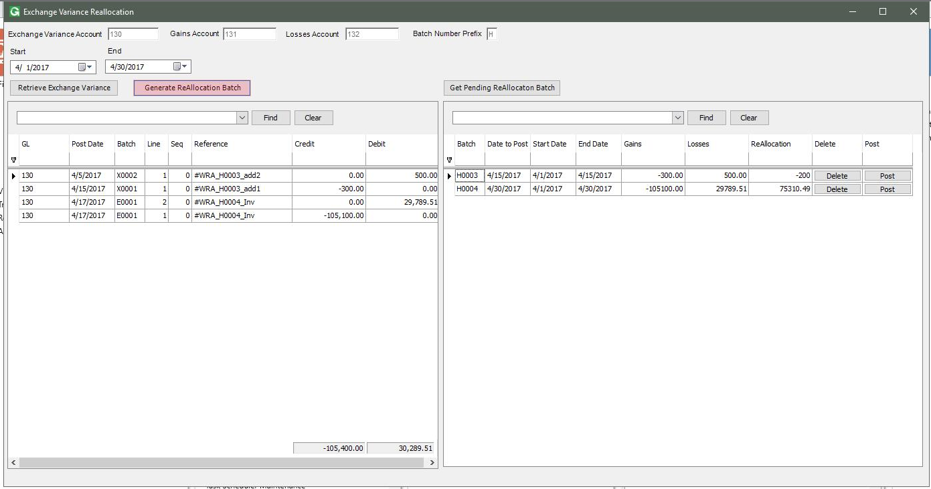

Click Delete the first Batch.

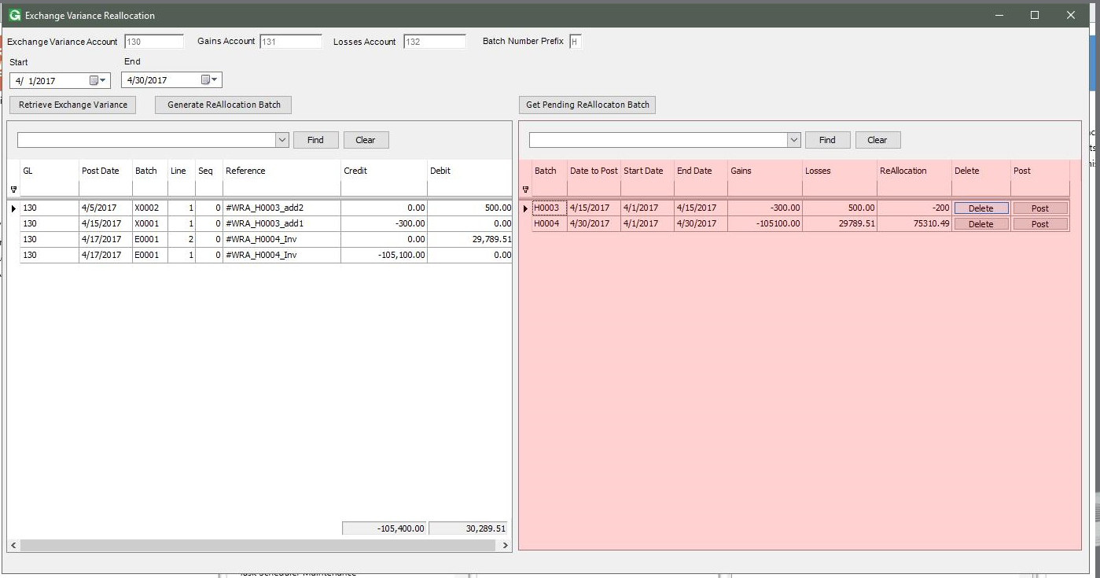

The reference of the first 2 rows on the left grid is rolled back.

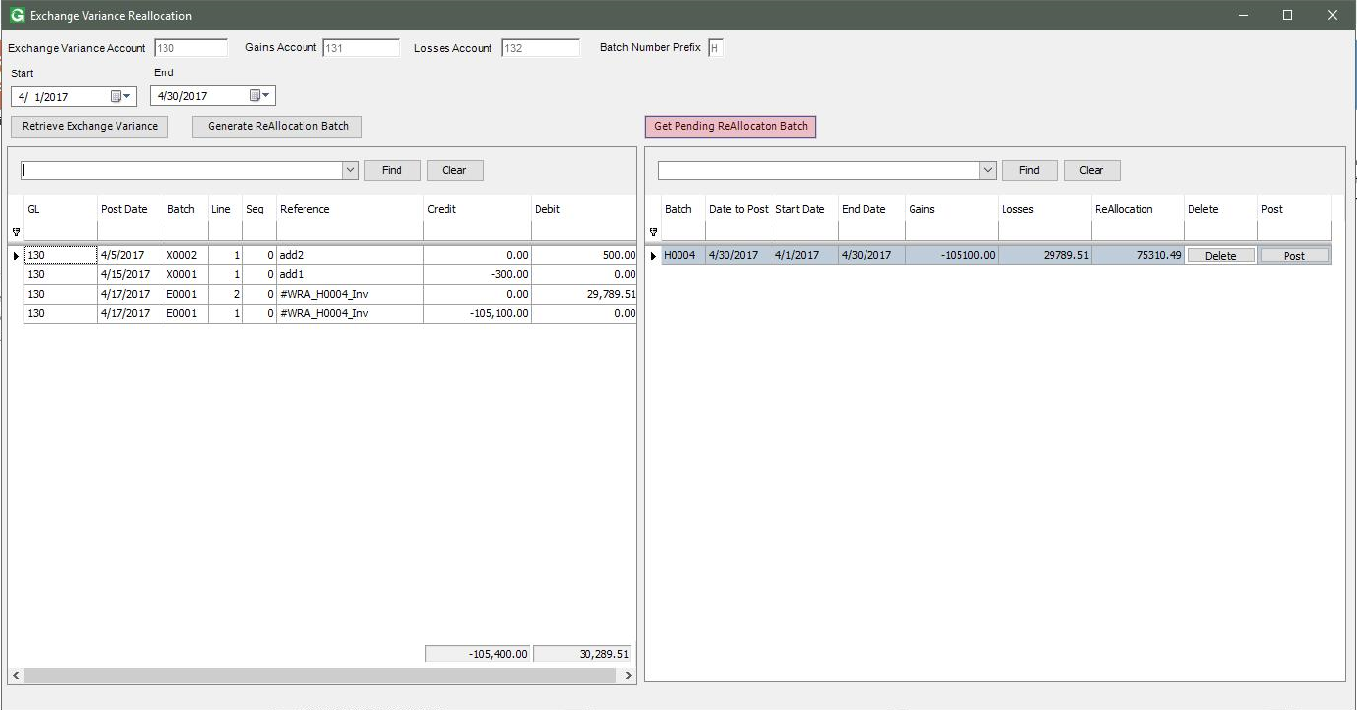

Click Generate again, this time the program will only care about the reference that is not marked #WRA or #RAD, so it will create a batch for those records.

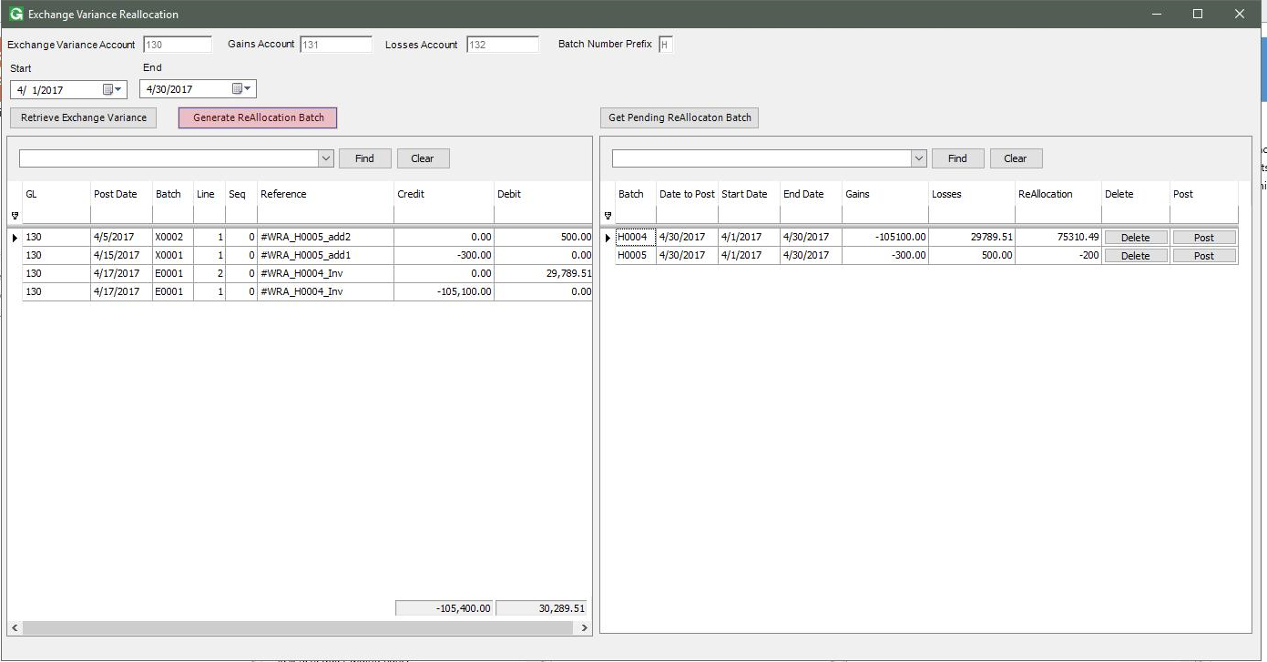

Click Post the batch H0004, then get the result.

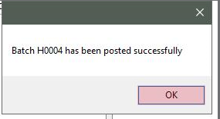

The result after posting 1 batch. The posted batch will be removed from the second grid.

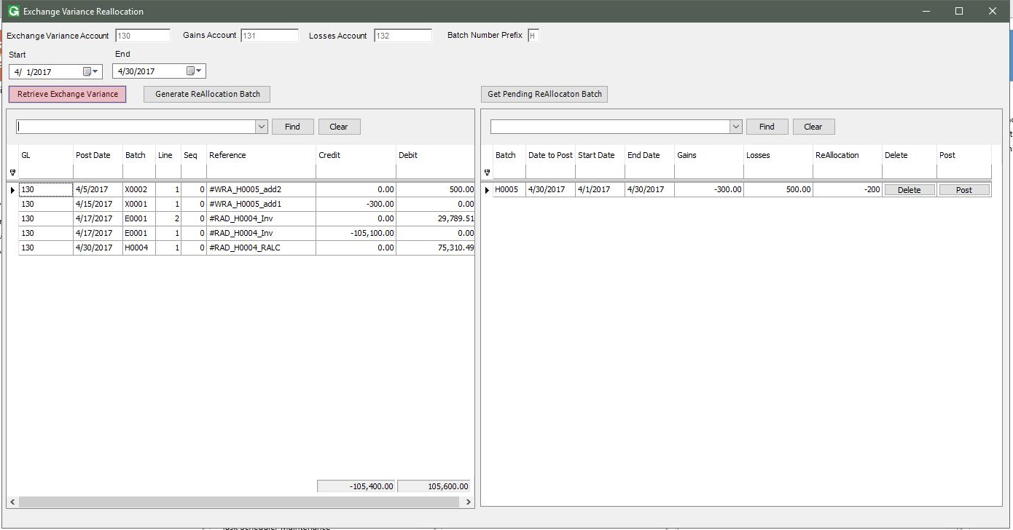

Data after the batch H0004 is posted:

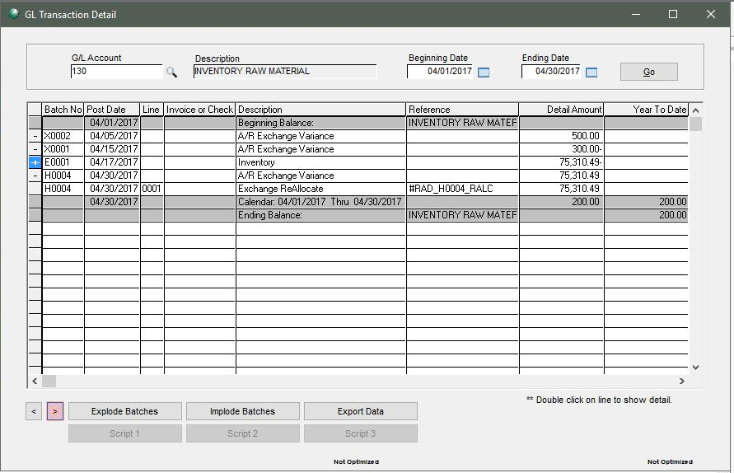

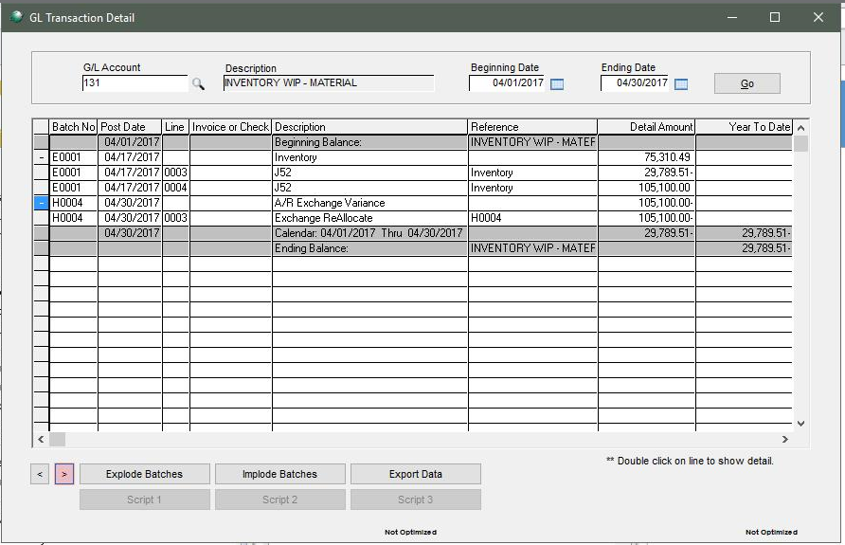

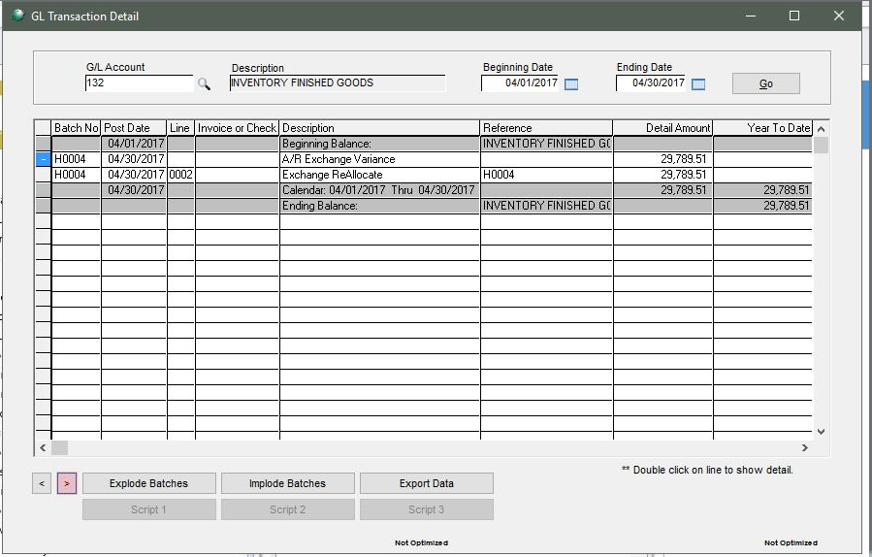

Click Post the batch H0005, and get the result.

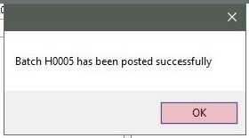

Result after the batch H0005 is posted:

