**BN, Mar 21, 2019**

**Customer: Control Fluids**

**5462 - Auto Calculate Freight at PO Receipt**

**Specs:**

1/Maintenance program will setup the percentage for each vendor (GCG_5462_Maintenance.g2u).

2/At PO Receipt the program, clicking OK button, the program will check the percentage, if there isn't any percentage setup for that vendor, it will prompt user if he wants to proceed.

2.1 If there is a percentage setup, the calculation of Freight Amount will be done as following: Freight Amount = Percentage * QtyReceived * Purchase Unit Cost.

2.2 The Amount of the Freight on the PO Receipt screen will be overwritten with the Freight Amount calculated just before the system proceed the OK button.

2.3 After the OK button is hit, the screen will be cleared out, so user will not see the Freight calculated.

View Freight attached to Script 1 button. If clicked (before click OK button), user can see the Freight Amount calculated.

2.4 If there is no percentage setup, user will have 3 options: Cancel, Proceed, Enter percentage

**Screenshots:**

User has to be in security group VENDPCT to use the Maintenance program. Otherwise will get this message:

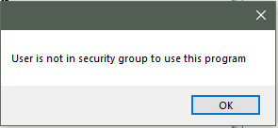

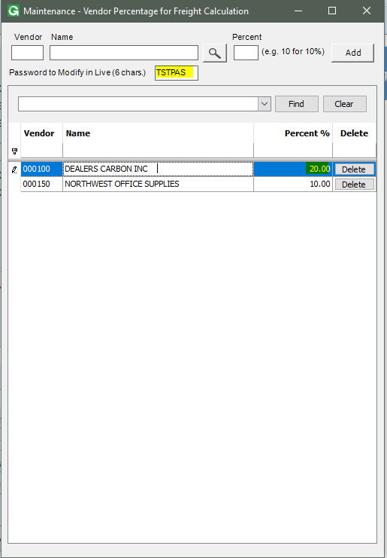

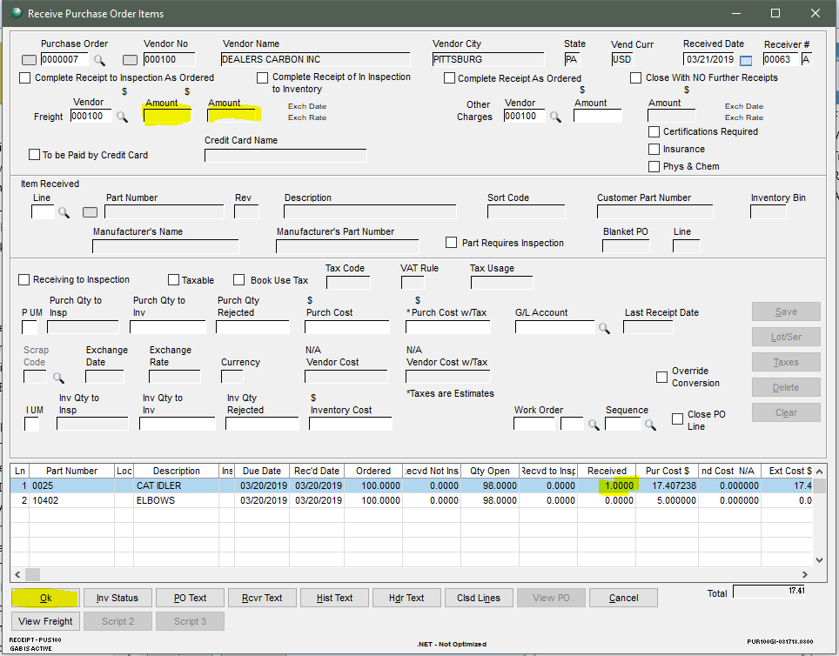

After the Ok button is clicked the freight is calculated, we can see the freight amount in the report if we close the PO Receipt screen:

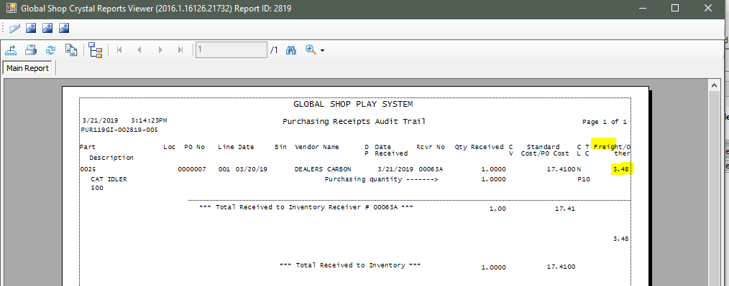

Now delete the percentage for Vendor 000100:

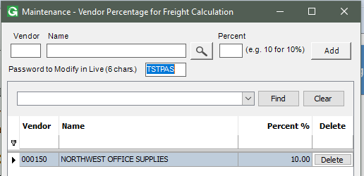

Open the PO Receipt again and receive 1 part 0025, then click OK:

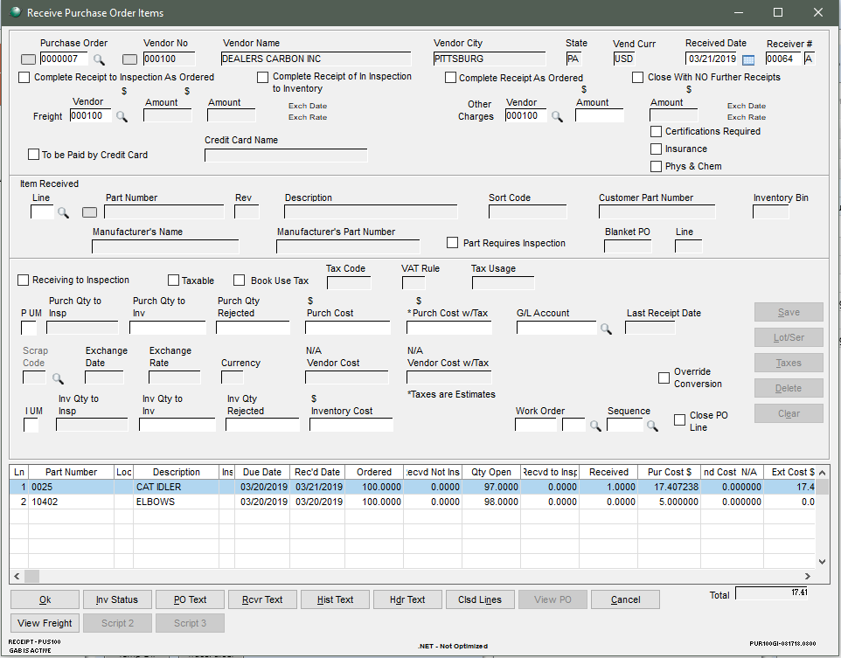

The percentage does not exist for this vendor, so a form pops up:

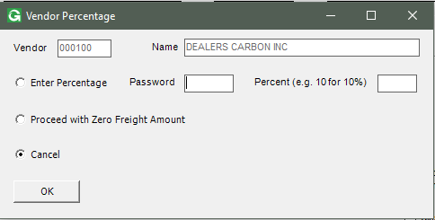

If user wants to enter percentage, he has to provide password:

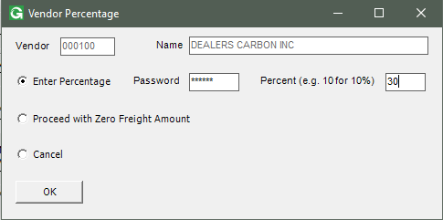

So 30% has been entered for this vendor, now the report shows the freight amount:

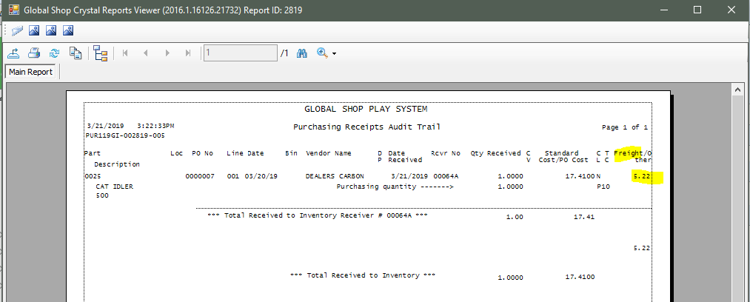

Open again the Maintenance program, we will see the percentage is added for this vendor:

