Bn, Mar 2019

Project 5484 – ACH Parser for Royal Bank of Canada RBC

Customer: Carriere Industry

**Specs: This project will create an ACH text file (currency CAD, domestic transaction in Canada, non-cross border) to upload in the web portal of RBC (type PDS)**

1. User will still use the core ACH at Accounts Payable > Transactions > ACH Export to generate the preliminary text file.

2. User will use the custom program at Accounts Payable > Transactions > ACH Parser for RBC – 5484 to parse the preliminary text file to the final version used to upload in RBC web portal.

Company setup in Company Option Standard. Make sure ACH Company ID and Immediate Origin Transit Number are the same. Others settings should be similar like following:

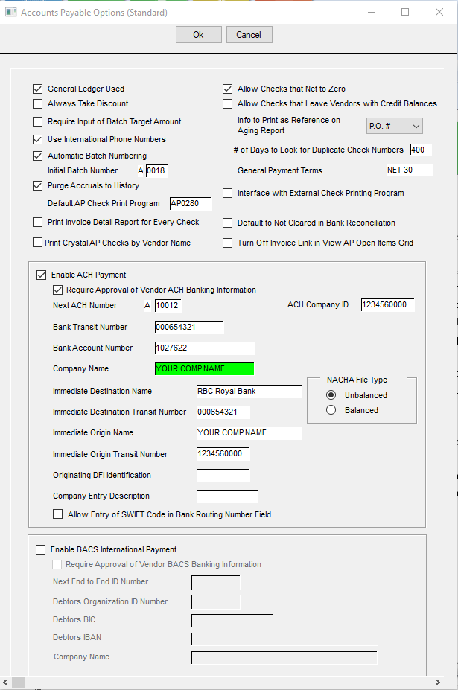

Open Accounts Payable > Transactions > ACH Export to generate the preliminary text file:

Click Filter, check the batch you want to export, check Email if you want to email vendor.

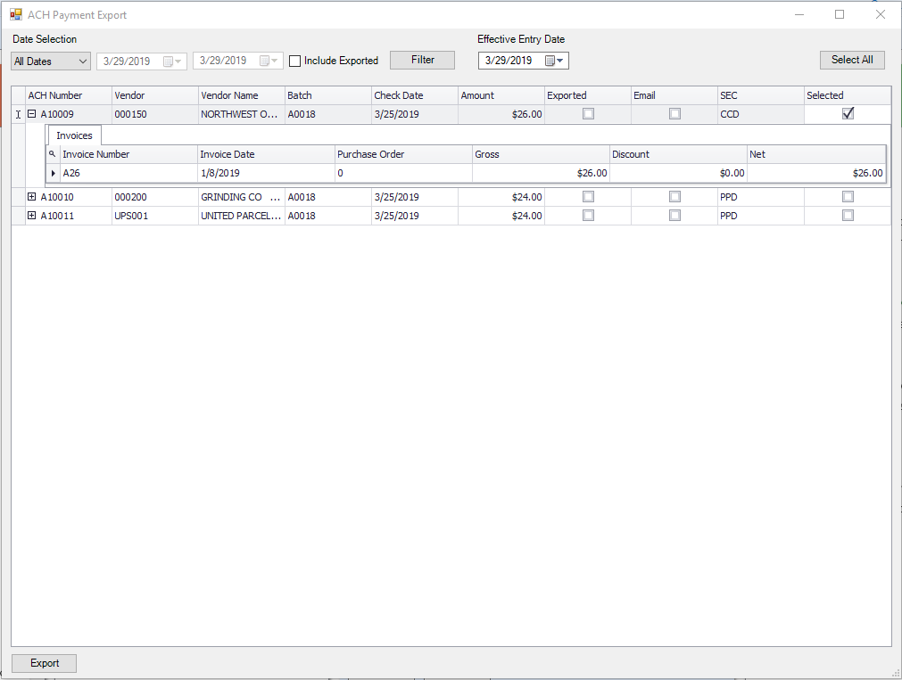

After clicking Export button, you will have to save the preliminary text file in a folder, should be in Global\Custom\5484\CompanyCode\...

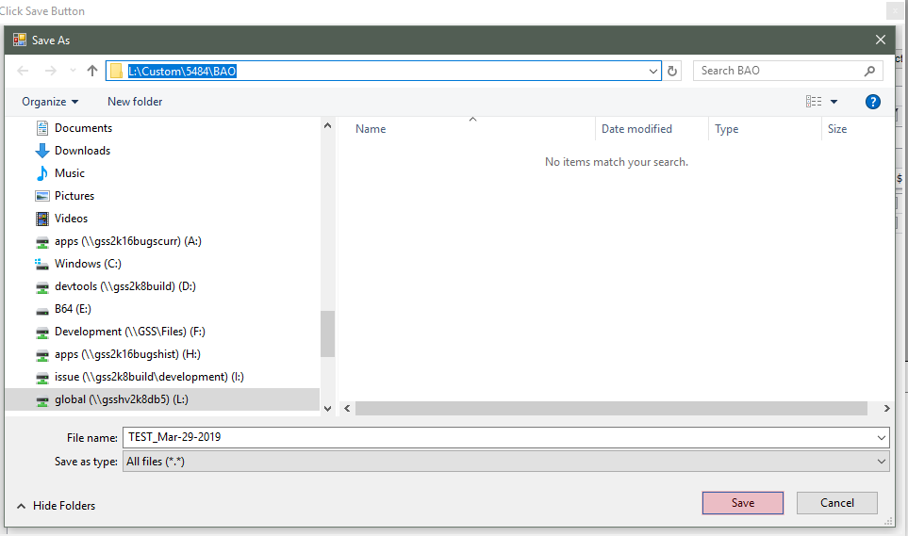

Email window will pop up if you check the email checkbox:

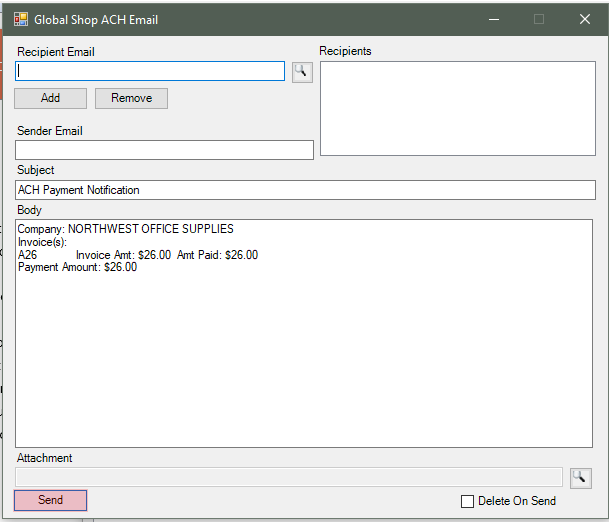

Return to the core screen, click Filter, the line is gone. It was exported to preliminary file:

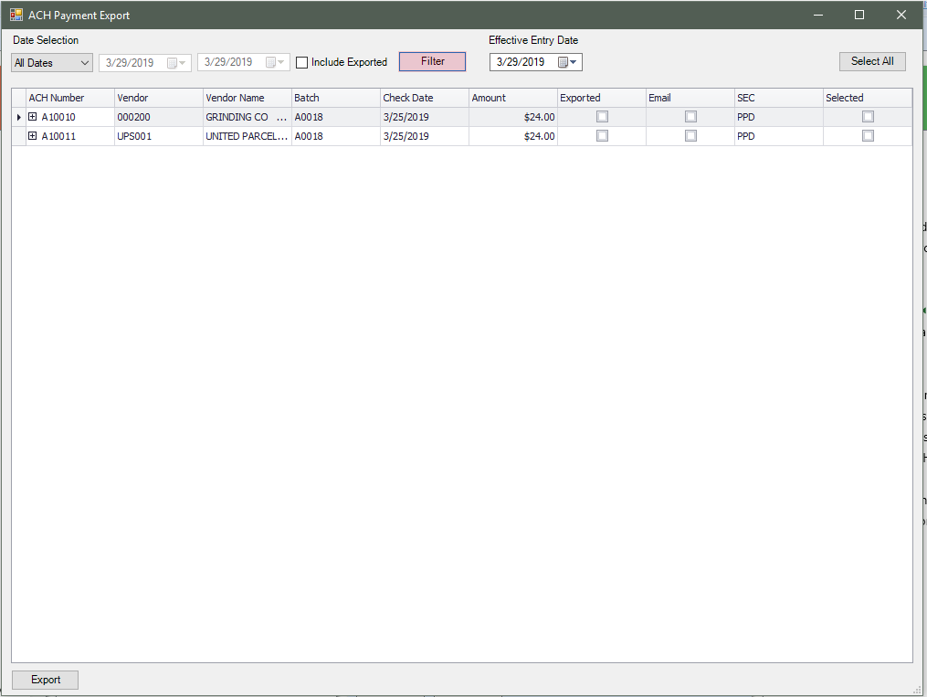

Open Accounts Payable > Transactions > ACH Parser for RBC – 5484:

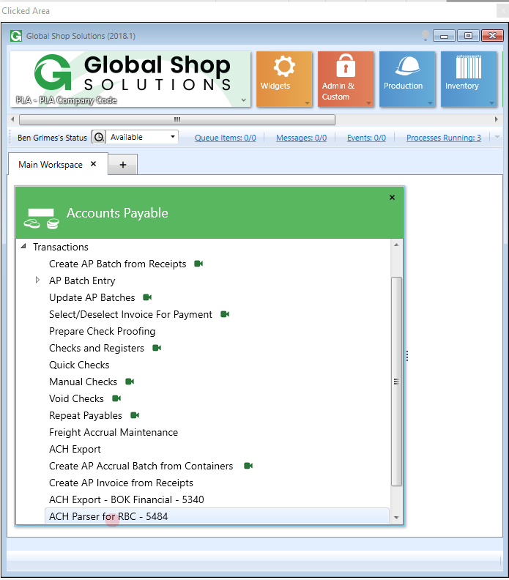

Select the preliminary file using the browser button. The default folder is Global\Custom\5484\CompanyCode:

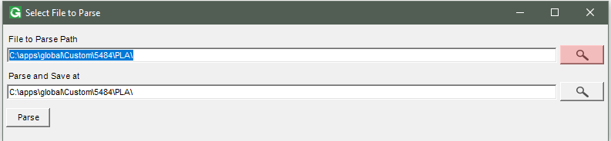

The target file name will automatically be generated with a suffix _Proc_TimeStamp. You can modify it if you want:

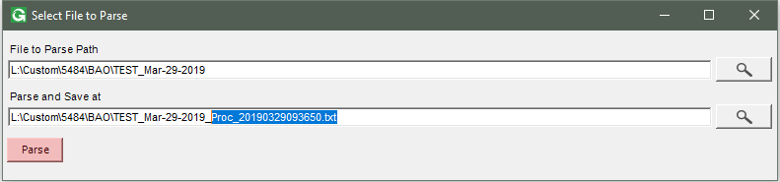

Click Parse then file file will be generated:

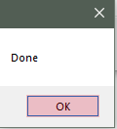

Here is the output, the preliminary file and the final file. Use the final file to upload in RBC web portal (type PDS):

