BN, May 30, 2019  
Quote: 11180  
Customer: Creed Monarch  
This project will create a dashboard that displays the next seq available and provides more fields and visibility on the floor.  
WO only pulls the L and O sequence.

**Business Case:** Production is currently struggling with production visibility in order to determine what is next to work on after they complete partial quantities on WCs Proposed.

**Solution:** Create a dashboard that is going to display the next seq available and provide more fields and visibility on the floor.

**SpecificationProject details:**

Run parameters:

Retrieve only Open Work Orders Retrieve Open Labor and Outside sequences only (exclude 99x Sequences)

New WIP Due for SS Date: Read sample in Next Pc Due Example.xlsx to understand this calculation.

**Screenshots:**

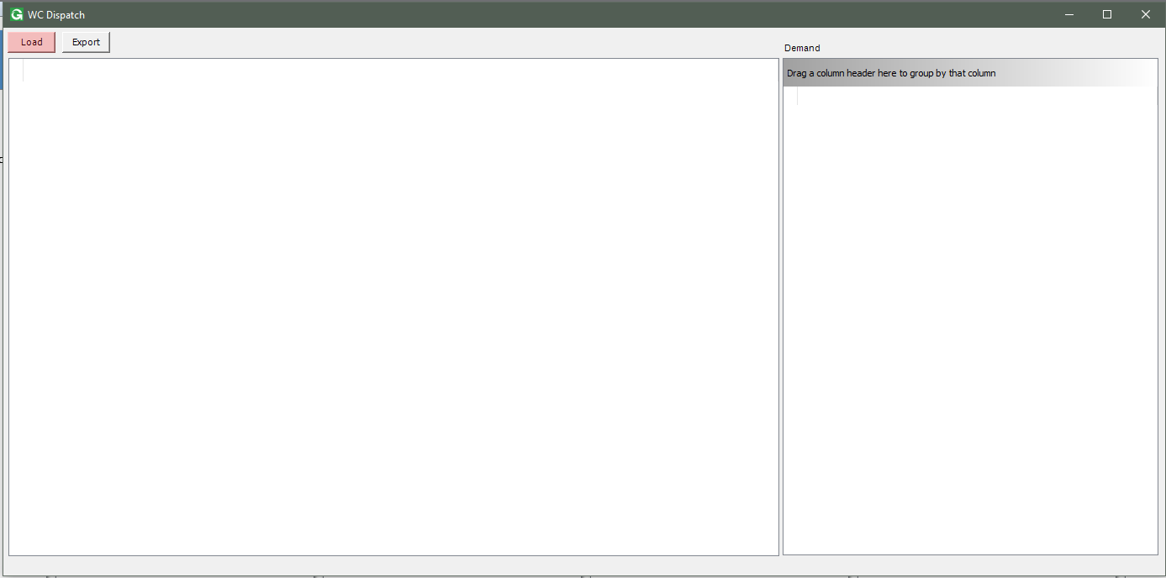

Click Load will open all open Job Sequences.

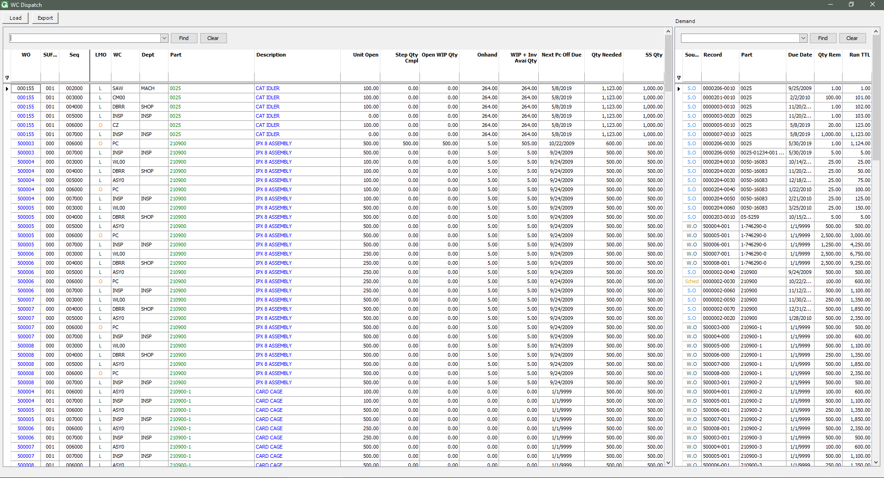

Filter 1 part. Then click on the Part number will filter the Demand for that Part.

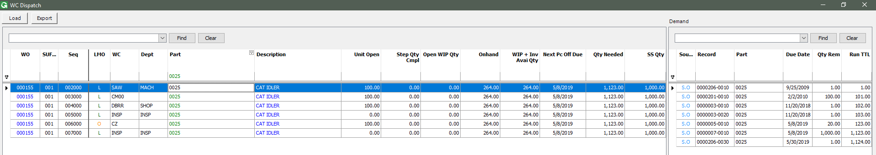

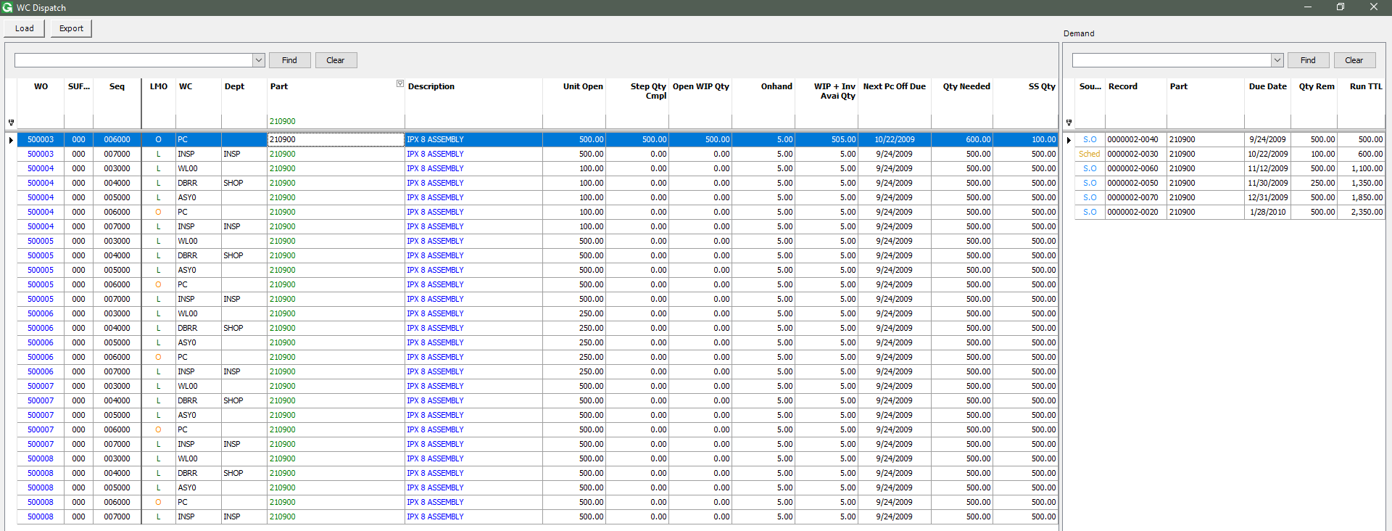

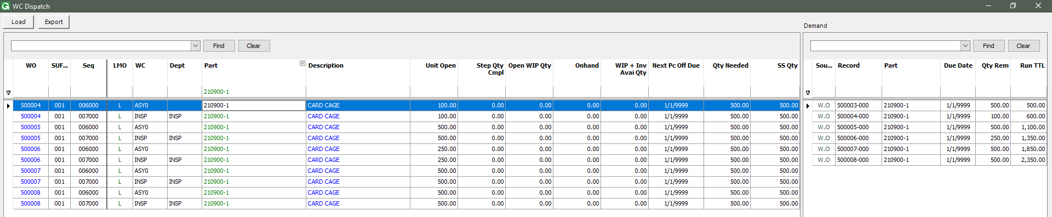

Click the Part Description will open the Supply and Demand screen with Edit.

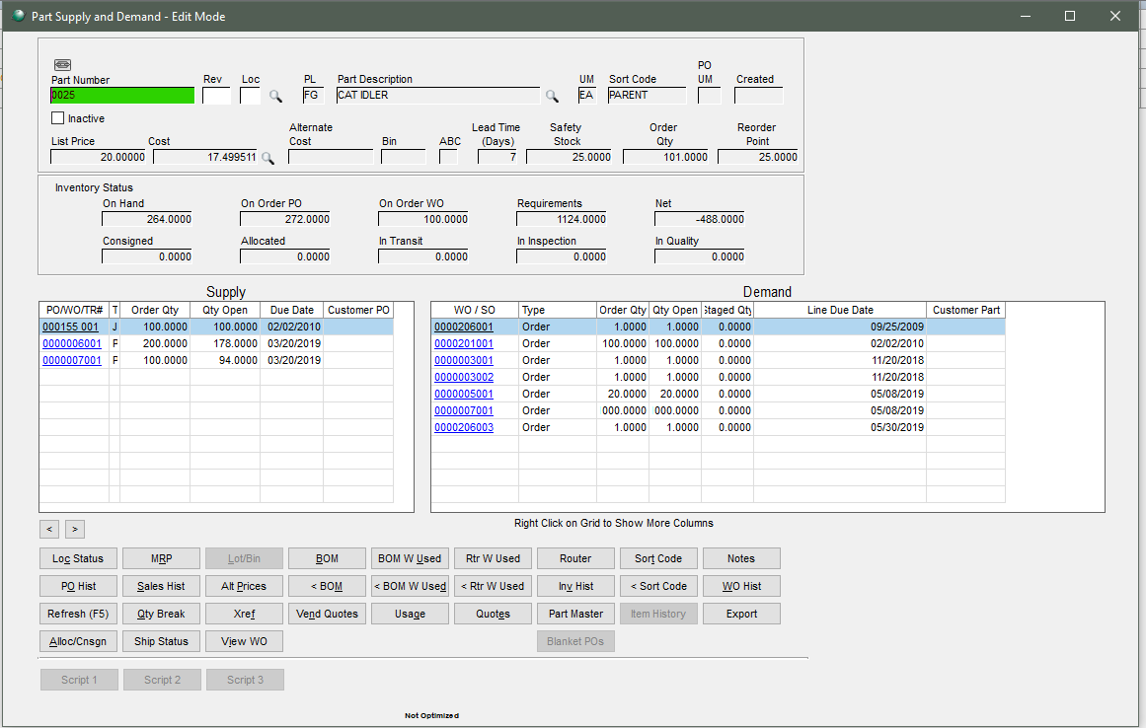

Click the WO will open the WO in view mode.

