BN, Sep 20, 2019

Project 5604 Inventory Reconcile Dashboard

**Initialize Instructions and screenshots**

**A. Initialize – The project needs to be initialized ONCE after installation from ARC:**

*1. Install 5604 Inventory Reconcile Dashboard from the ARC*

*2. Login GSS under SUPERVSR and run* ***Inventory > Administration > Inventory History Initialize******5604***

Run that menu item (it can be run only under SUPERVSR). The program will process the **Intentory_Hist** from the oldest date and refine the data. The refining process is that for a part for day, the program will get the first transaction and the last transaction of the day, as well as the next date having transaction of that part.

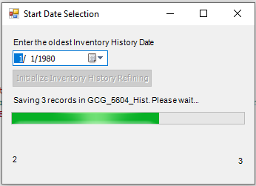

This scanning will run from 1/1/1980 thru yesterday. Based on the size of Inventory_Hist, it may take from a few minutes. Some customer has big Inventory_Hist table, for example up to 3 GB with more than 3 million records, it will take up to 8 hours. This initialize step must be run only one time after installation. The program can handle the events when user backdates the Inventory (by running the Daily Refine in the step 3), but **if user uses SQL query to MANUALLY insert/update records in the Inventory_Hist table from Pervasive Client database, not from Global Shop screens, they will have to reinitialize again.**

*3. The project once installed from ARC will create a sequence in Task Scheduler that will do the Daily Refine at 3:00 am daily:*

After refining, the project will save the last date refine into registry. If for some reason, the Daily Refine in Task Scheduler has not been running for several days, we should activate the running then the program will refine from the last date refine retrieved from registry up to yesterday.

*4. Now run the menu item Inventory > View > Inventory Reconcile Dashboard:*

Each time we click Refresh button, the program will get the last transactions of Today and merge to the custom table GCG_5604_Hist in order to do the aggregation (it deletes current today records before saving new ones) and backward update the next date of existing records in the custom table. The reason for this Today Processing is that transactions happen throughout the day, and the program needs the first and last transaction of the day in Realtime.

So, based on the number of today transactions, the loading will have a leading time of about 1 to 5 seconds for less than 500 records due to this Today Processing.

*5. GAB error and Transaction Log are saved under Global\Custom\5604\CCC where CCC is the company code:*

We can check the GAB error or transactions done in this folder. It saves the error and Daily Refine date and time.

*6. Right click the grid to Refresh/Export to Excel spreadsheet*

1. **Screenshots:**

*1. Inventory Reconcile:*

Formulas:

* 1. Inventory Transactions + AP Transactions = GL Change
  2. Cost Change – GL Change = Net Change

We can also hover the mouse over the header of the yellow column, a tool tip will display the description/formula of the column.

Net Change to be considered balanced is less than 1 cent. As you see, the Cost value from Inventory_Hist is to 6 decimals point, while the GL_AP_Detail and GL_Inventory_Dtls has only 2 decimals point. So, when we add/subtract these numbers, it’s certain that the result will have decimals up to 6 points. The Cost is displayed in 2 decimals point but in fact, it has 6 decimals point.

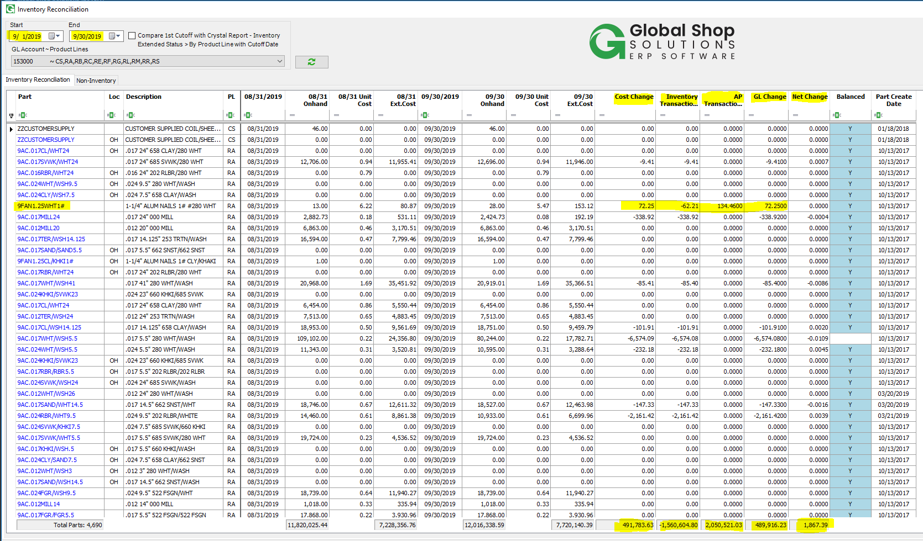

Click the Part link to drill down into Part Inventory History detail and GL Detail:

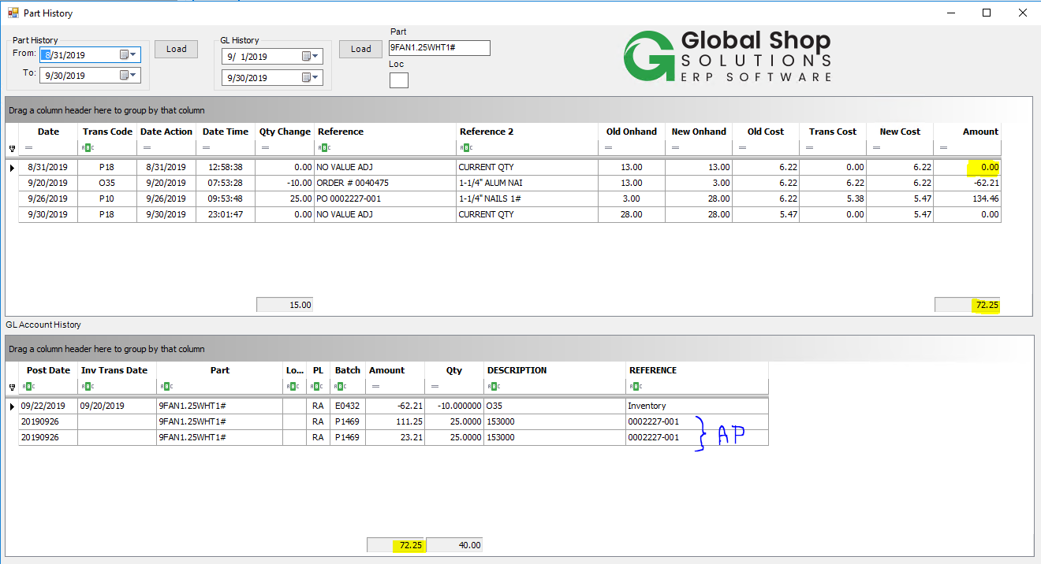

When user clicks the part number from the main window to drill down, the Part and GL History window will be open, and the Amount of the first record in the Part grid will be default to 0.00. The From and To date are default to the dates displayed from the record of the main grid. If the dates are blank, the From and To dates will default to the Start -1 and End date.

If user clicks Part History Load at the next time, the Amount will not be default to 0.00.

For a cutoff date, the dashboard will process similarly with the standard Crystal report **Inventory > Reports > Extended Status > By Product Line with Cutoff Date**. However, there are some differences between the dashboard and the report (*Please see the dashboard logic at the end of this document)*. So, there is a checkbox to compare the results of the dashboard and the Crystal report:

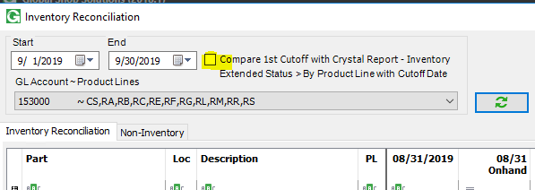

If user checks this box, a message will display:

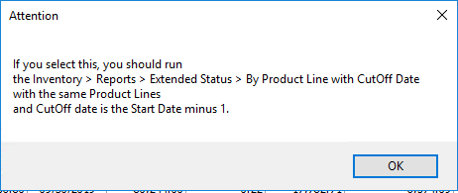

In this case, we should run the **Inventory > Reports > Extended Status > By Product Line with Cutoff Date** with the cutoff date is 08/31/2019 (09/01/2019 – 1) for all the Product Lines displayed with account 153000 before running the dashboard.

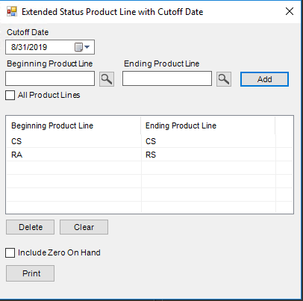

Result from the Crystal report:



After running the report, run the dashboard, we will see some more columns added to the right of the dashboard, and the dashboard will compare the first cutoff date result which is 08/31/2019 with the Crystal report result:

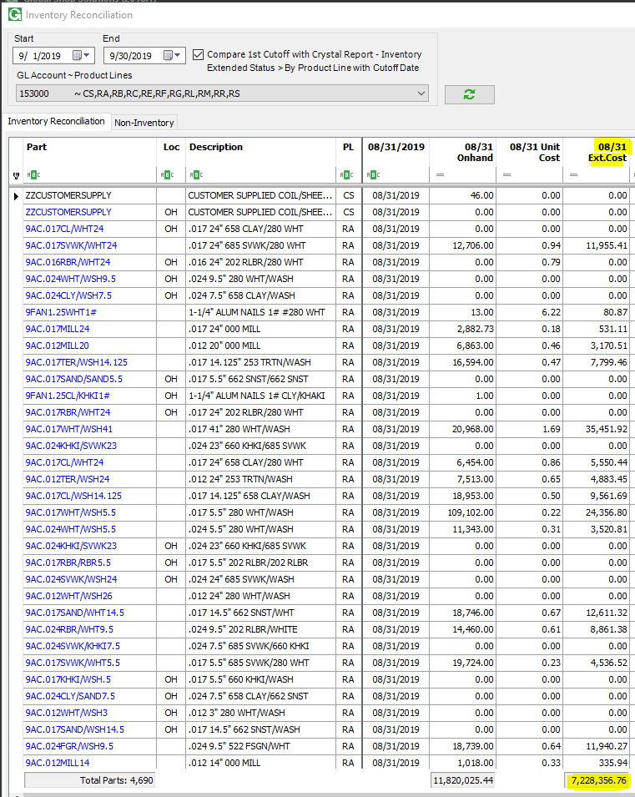 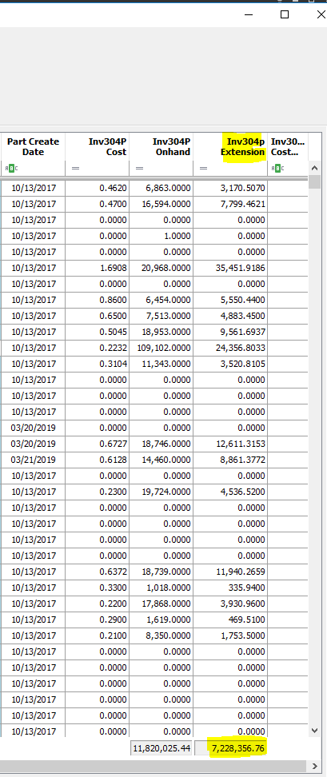

In this case we have the same results as shown above. If in some cases, there are differences between the result of the dashboard and the Crystal report, a red Y will be flagged and user can filter all Y flag to investigate (*again, please see the logic of the dashboard at the end of the document to see the differences in the way the dashboard processes compared with the Crystal report*):

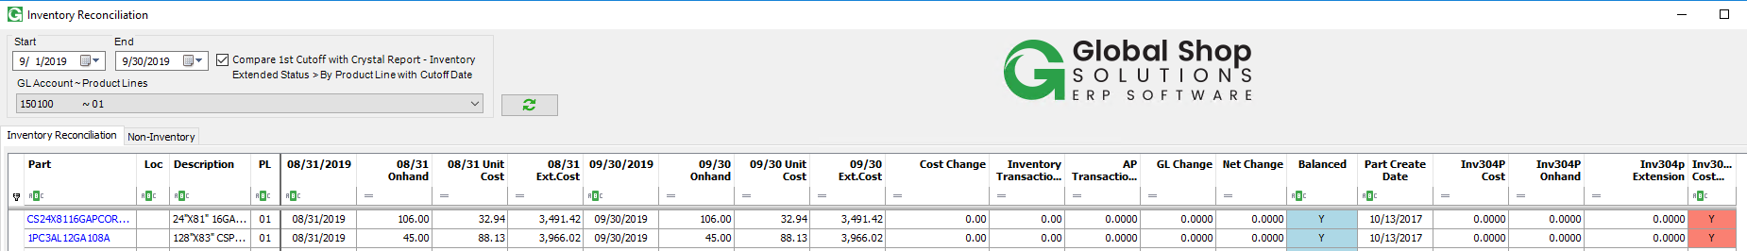

*2. Non-Inventory tab:*

As GLs from the dropdown list are for Inventory, if we select an account from the list and run the Non-Inventory tab, it is expected to have no data found. But if user wishes to get whatever GL Account there are for the non-inventory parts, it will go ahead and get all transactions then display in the grid with all GL accounts related with non-inventory parts.

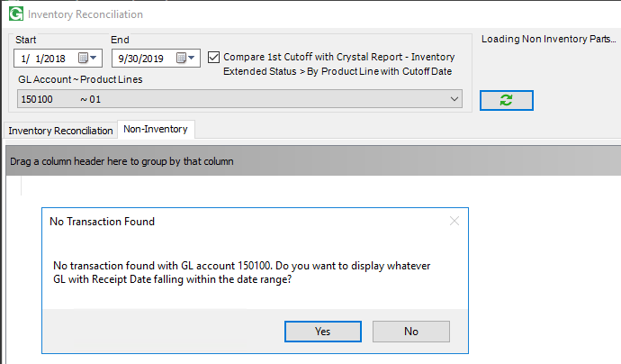

Click Yes:

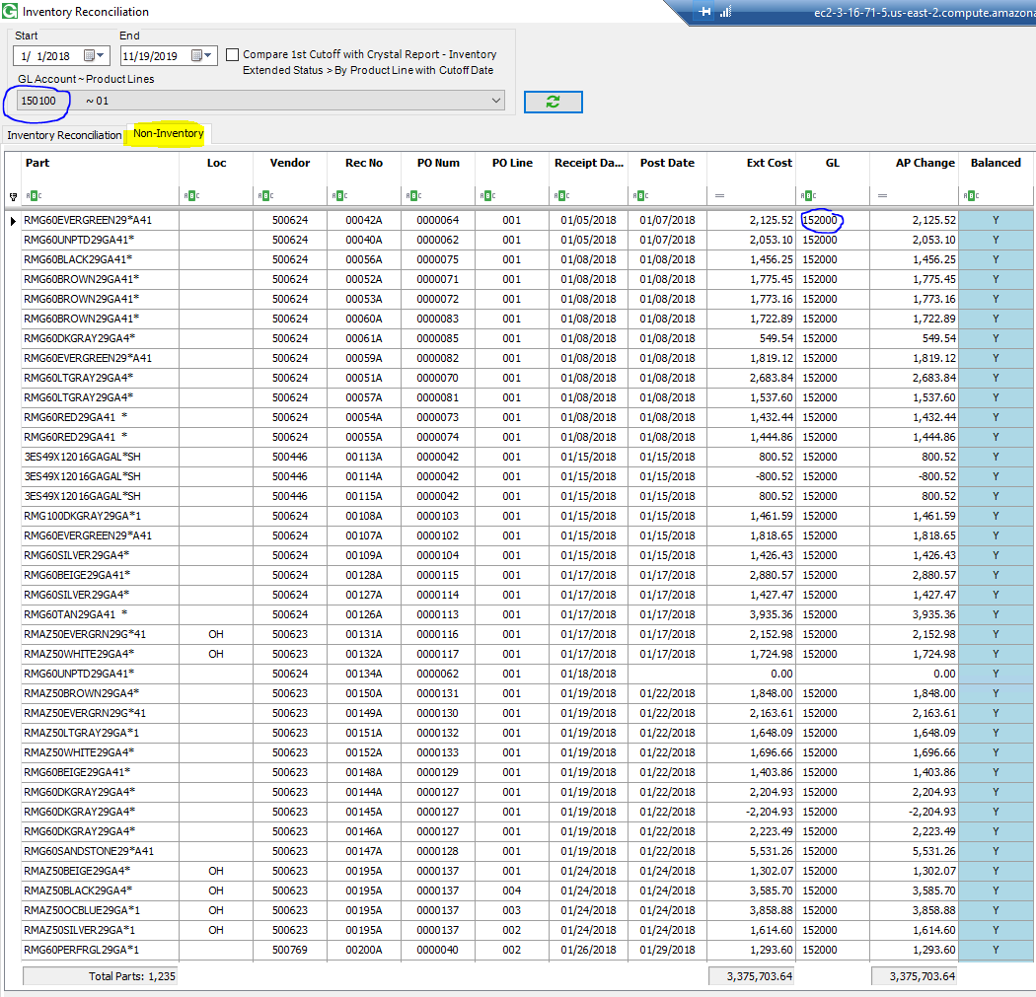

1. **Logic for Inventory Reconcile tab:**

