BN, July 24, 2019  
Customer: Clock Spring  
This project will generate a csv positive pay for Cadence Bank

Accounts Payable > Transactions > Positive Pay Cadence Bank 5620

Select a Date and click OK:

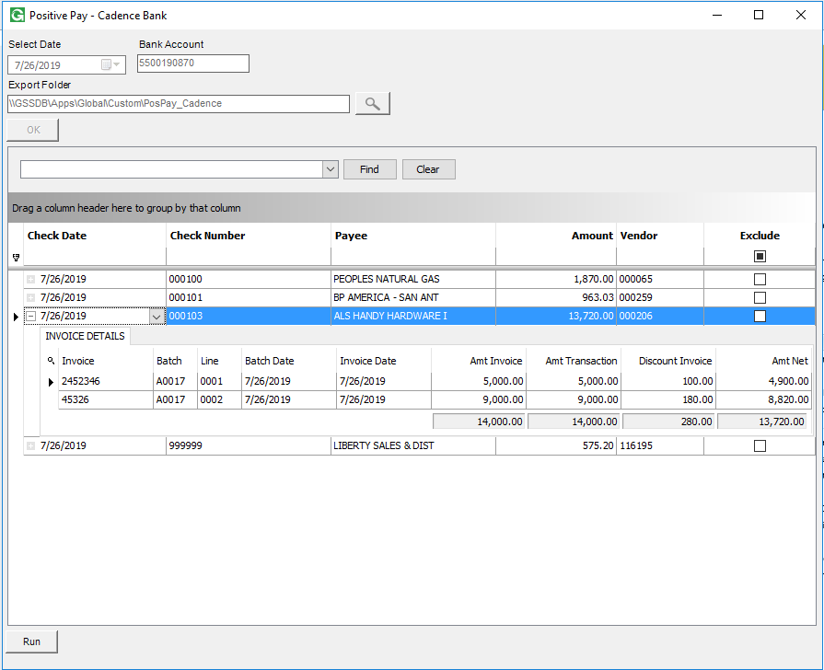

Click Run:

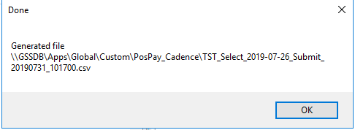

Template from Cadence Bank:

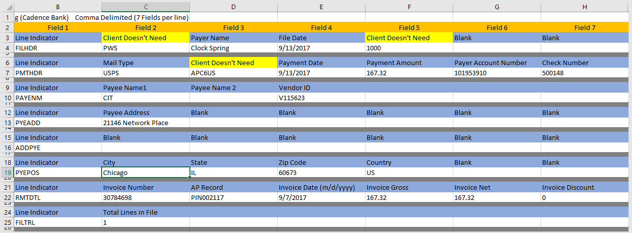

Output file:

