'BN, July 26, 2019

Customer: Clock Spring

ADP Export from Transfer Labor to Payroll.  
This program is a modification of program Payroll_ADP_Descr.g2u  
The program will remove column D,E,F  
Column C (employee number) will be modified to be Comments 1 from Emp Master  
Keep running GAB version 1  
Label Comment 1 at Employee Master is changed to "ADP File #"

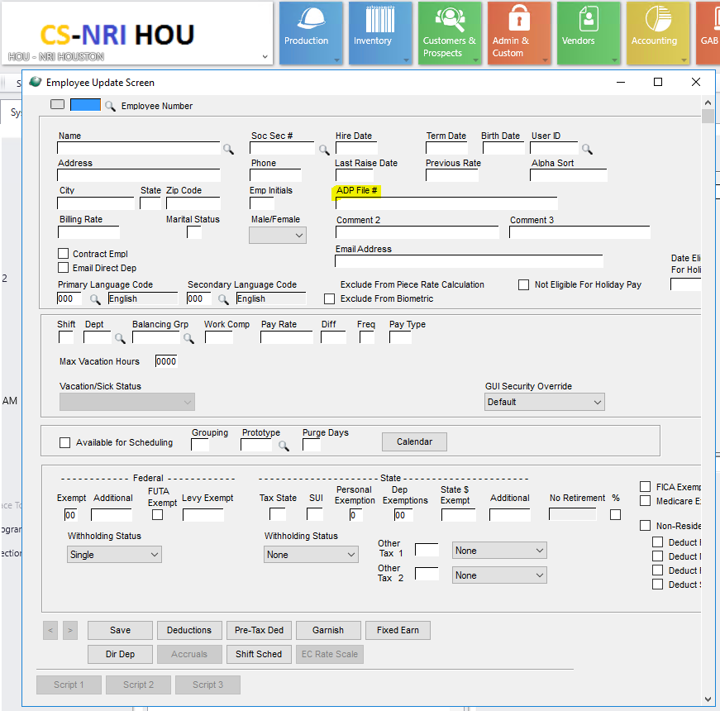

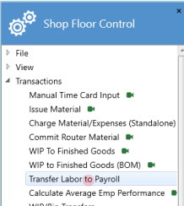 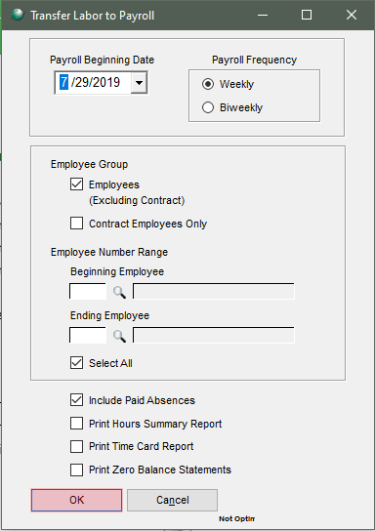

Enter ADP Company code and Batch Number

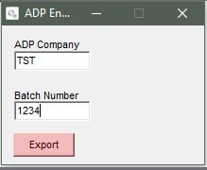

Export File in Files folder:

