BN, Aug 23, 2019  
Customer: Ohio Penal Industries  
This program will pull Aging data from multiple CCC and generate Consolidated Customer Statement

**1/Consolidating Aging Report:**

Click the button Select Customer and CCC

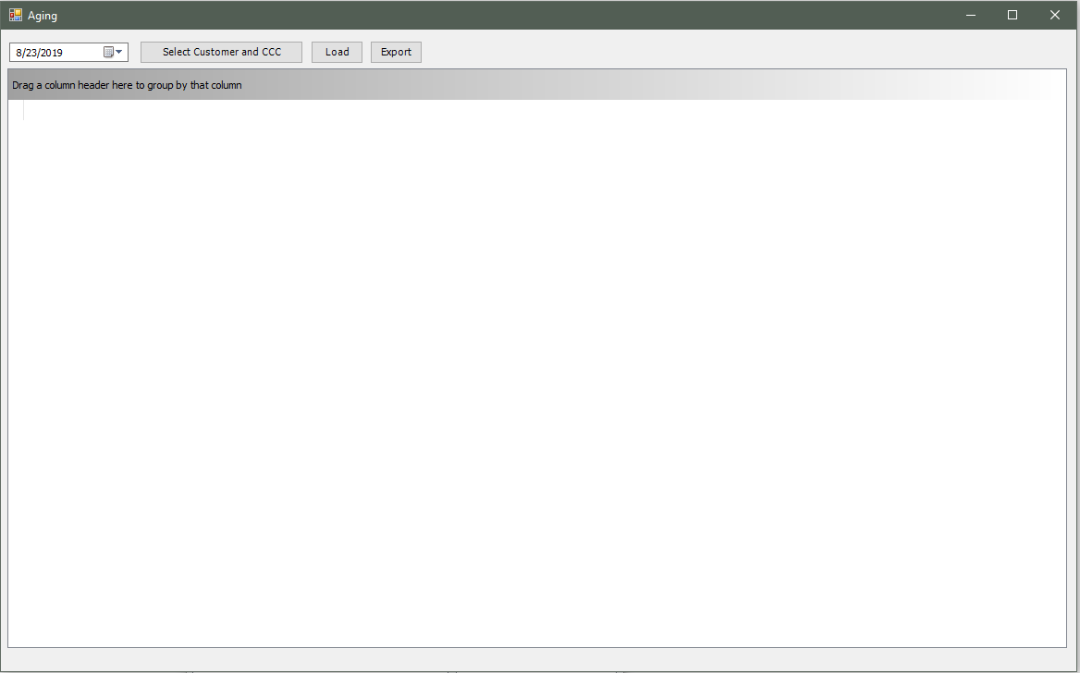

Select Customer and CCC you want to run the Aging:

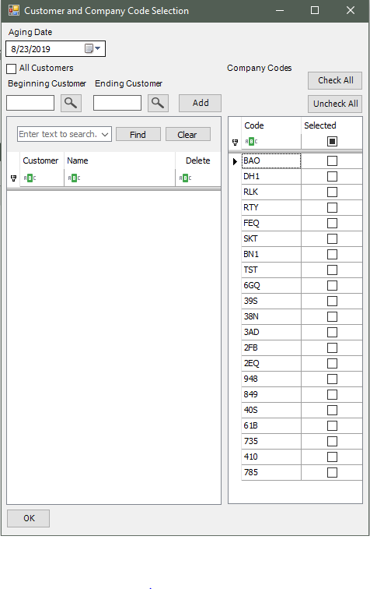

Click Load to load the data from your selection:

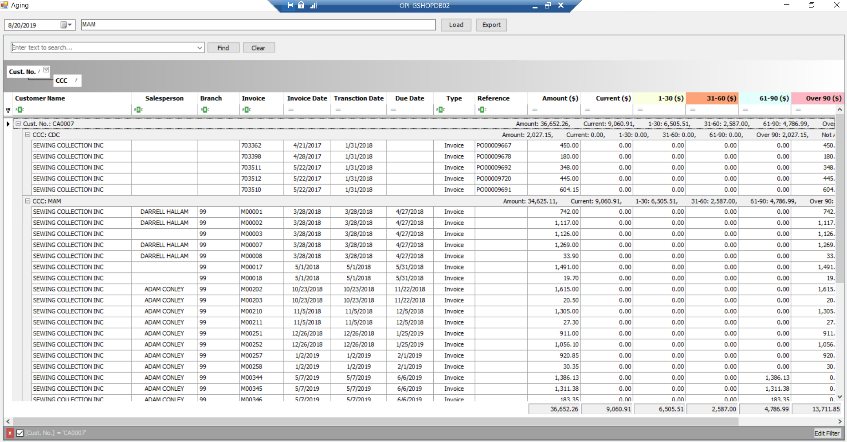

We can export the grid into Excel Spreadsheet.

**2/Consolidated Customer Statements:**

From a custom menu item Accounts Receivable > Reports > Customer Statement Consolidated 5641.

Select Customer and CCC

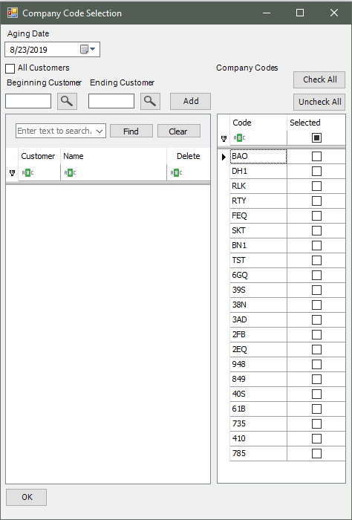

The program will generate reports for each customer in pdf format and save to Global\Custom\5641\XXX where XXX is the CCC where the program is running from.

