BN Sept 1, 2019

Project 5659

Customer: Brunswick Steel  
This program will help Create/Delete Document Control Link at Part Allocation screen when users allocate/unallocate.

**1/Current situation:**

This item with blank Serial has a Doc Link:

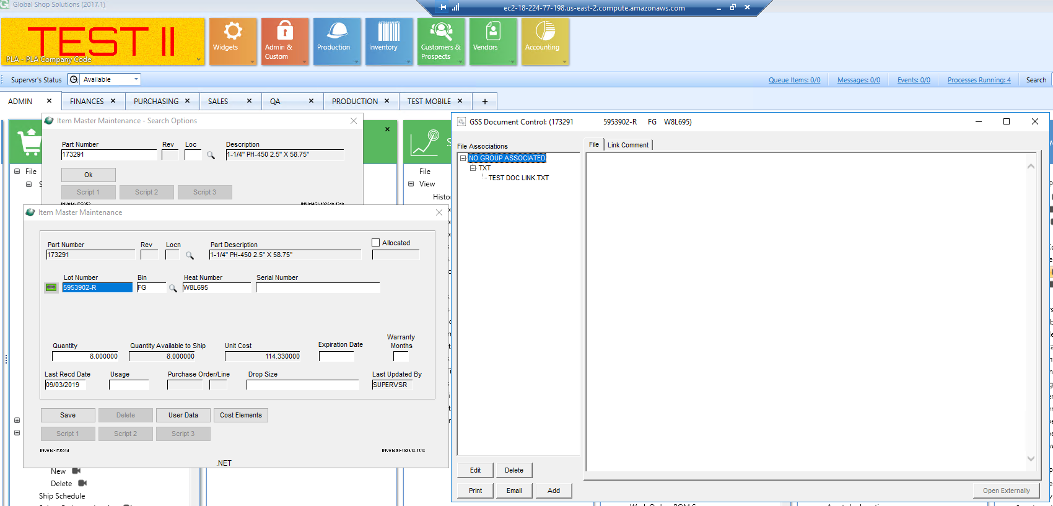

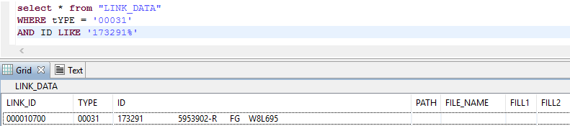

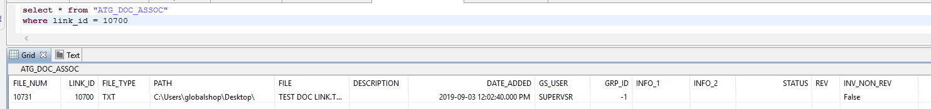

**2/Allocate to a Sales Order Line:**

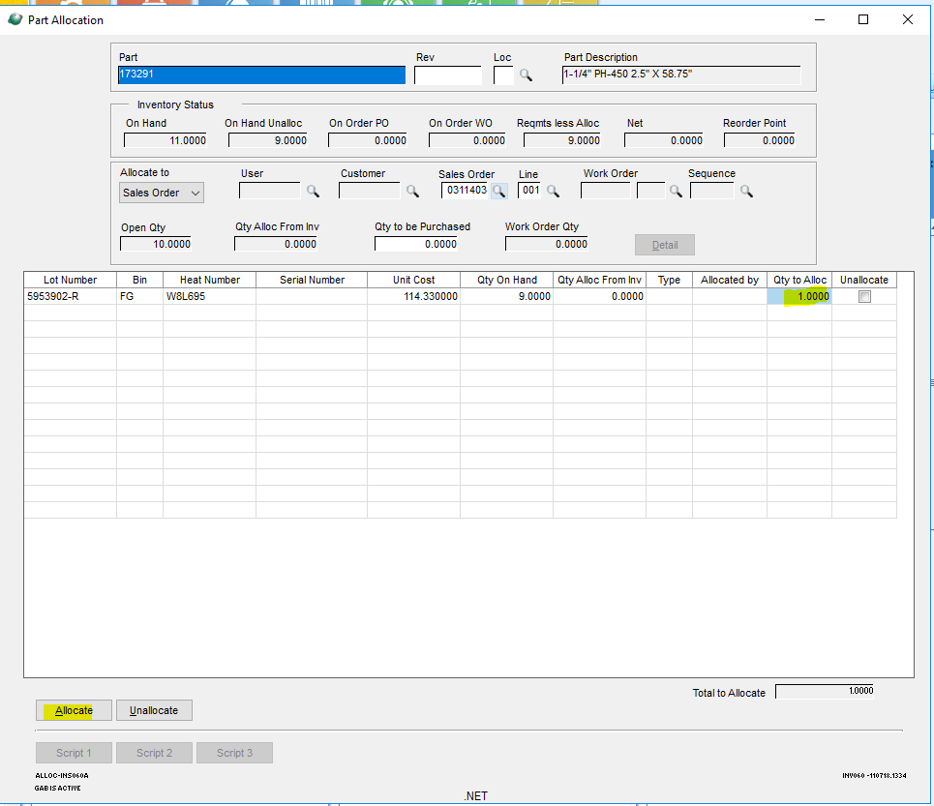

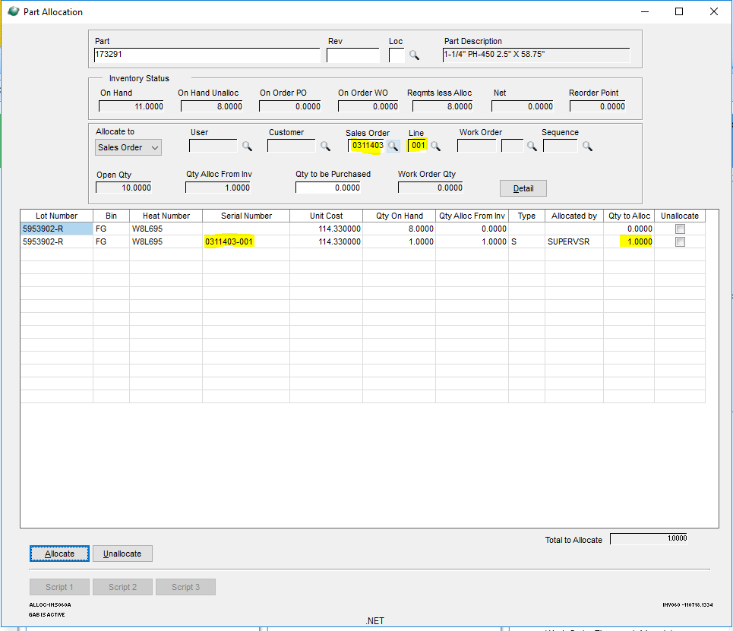

The program create a Doc Link for the new item allocated for the Sales Order Line:

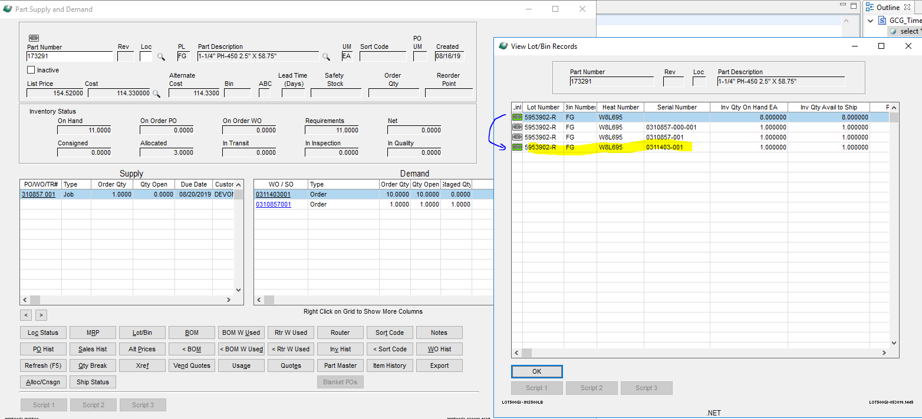

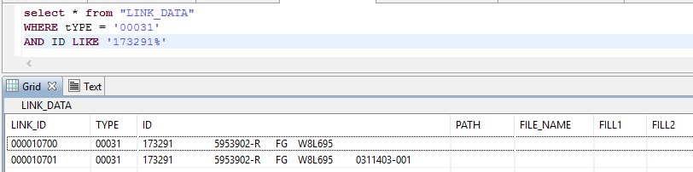

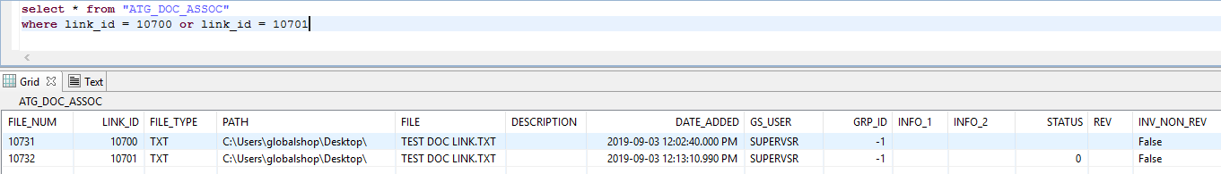

**3/Unallocate the item:**

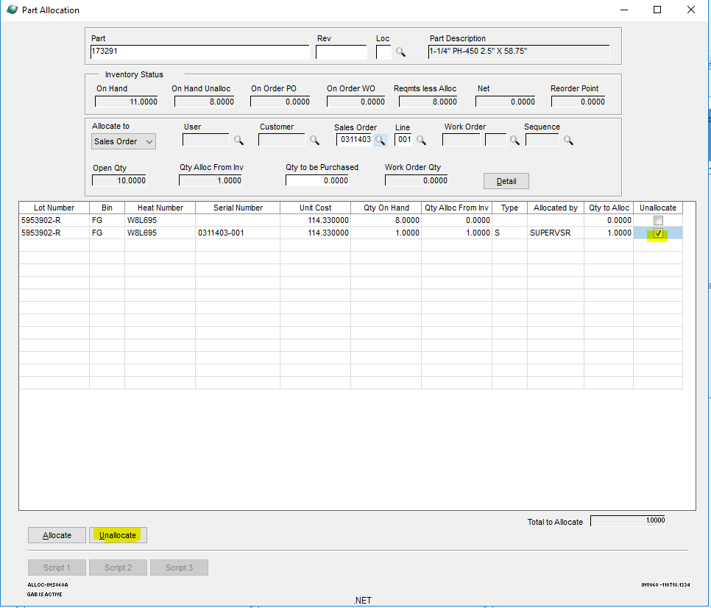

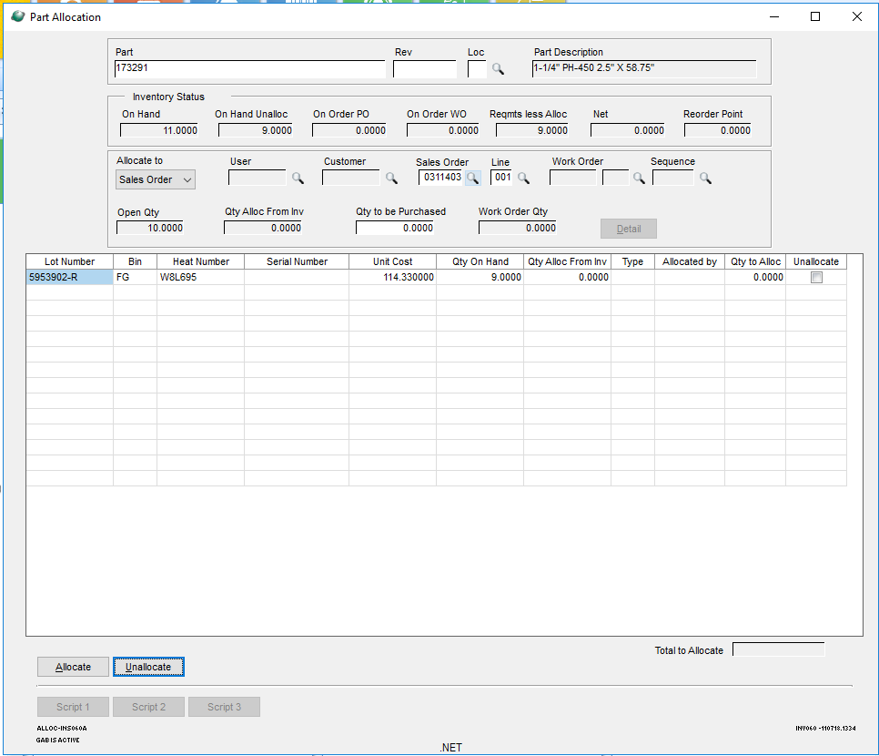

The program will delete the link of that item unallocated:

