My Approval Process can be broken down into a flow chart:

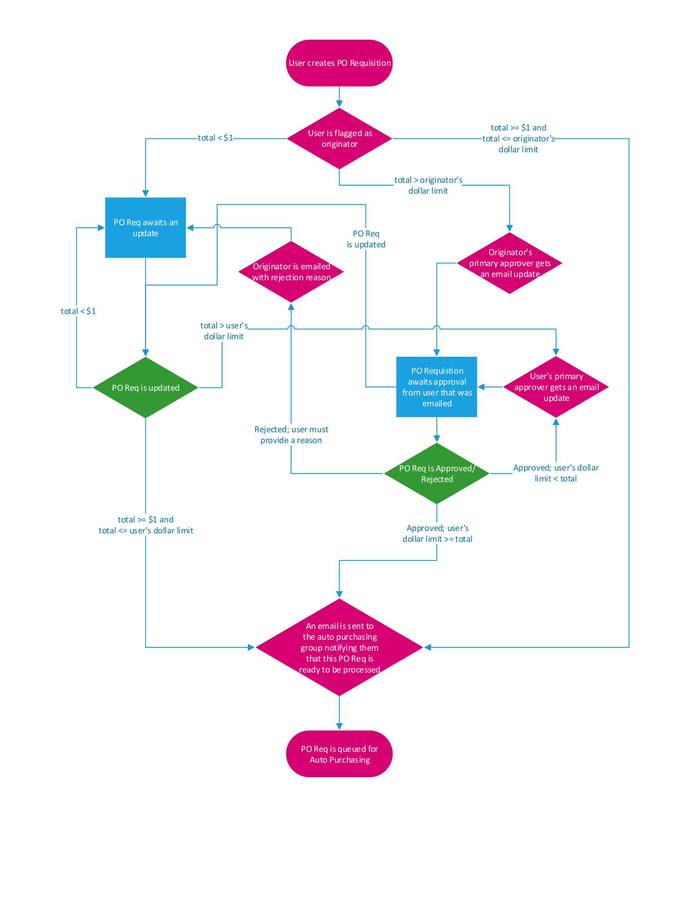

First, the users must be setup in Purchasing > Administration > Requisition Originators:

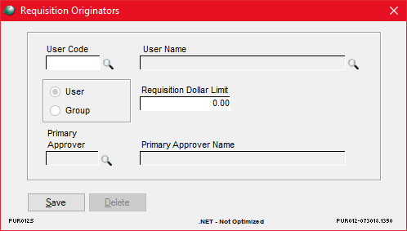

All approvers must be setup on this screen with a Primary Approver to be able to create or approve PO Reqs. Groups cannot be used for this project.

Everything starts from Purchasing > File > Purchase Requisitions > New:

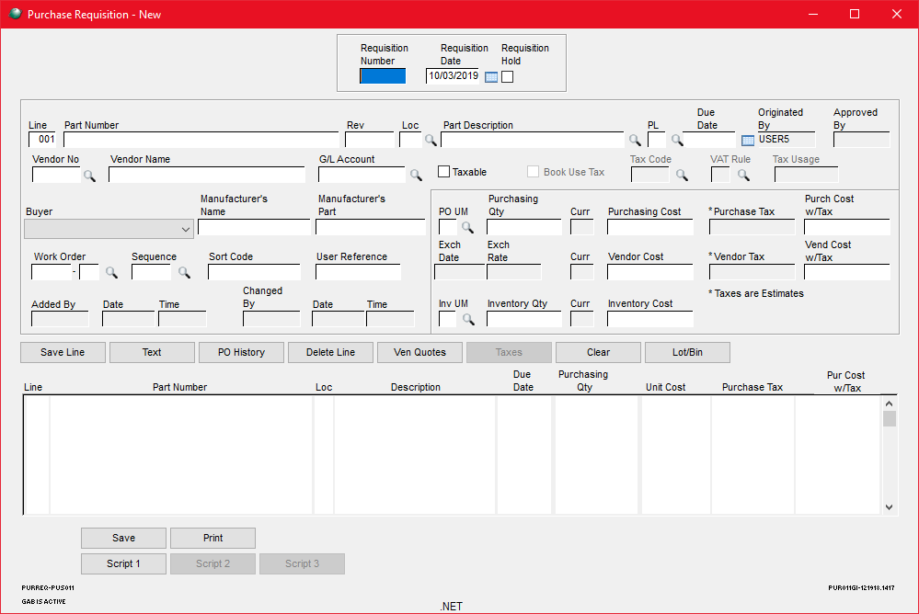

When the PO Requisition is saved, the Approval program will check to see if the total is greater than $1, if it is, it compares the user’s dollar limit to the total of the PO Req.

If the total is less than or equal to $1, the program won’t do anything and will wait for the PO Req to be updated again.

If the total is greater than the user’s dollar limit, the program will flag the PO Req approval as Pending and will email the user’s Primary Approver.

If the total is greater than $1 and less than or equal to the user’s dollar limit, the program will flag the PO Req is flagged as Approved.

Custom: Purchasing > Transactions > Requisition Approval (5688):

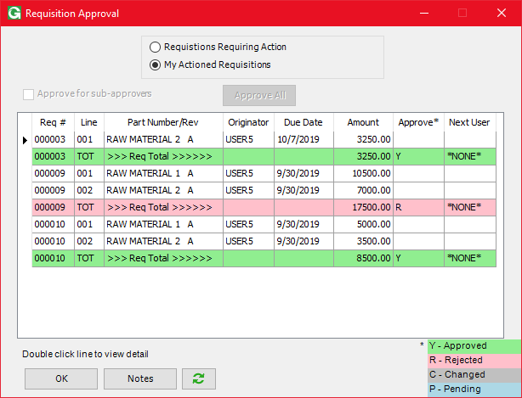

Use the radio buttons at the top to swap between ‘Requisitions that need approval’ and ‘Requisitions that have been approved/rejected’ for the current user.

By default, the screen opens to show PO Reqs that need approval.

Use the ‘Approve All’ button to flag all PO Reqs as approved.

The ‘Approve for sub-approvers’ checkbox can be used by users that are in the ‘REQAPADM’ security to refresh the screen to approve PO Reqs for users that fall below them in the PO Req approver hierarchy. Right clicking on this checkbox will allow them to see which users are below them.

On the grid, PO Reqs can be flagged as ‘Y’ for ‘Approved’ or ‘R’ for ‘Rejected’.

The Refresh button will refresh the screen.

The ‘Notes’ button will open the Notes screen for the currently focused PO Req line.

The ‘OK’ button will prompt the user for their GSS password and then process all PO Reqs flagged as ‘Y’ or ‘R’.

PO Req Approval Notes:

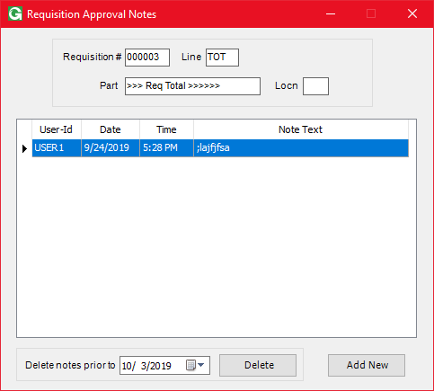

The ‘Notes’ button on the PO Req Approval Screen will open this screen to View and Edit Approval notes. Double clicking on Notes entries will allow the original creator of the note or users that are in the ‘REQAPADM’ security group to edit the notes.

Right clicking on notes will give users the option to delete specific notes entries.

The ‘Delete’ button at the bottom will delete all notes created prior to the date to its left.

The ‘Add New’ button will allow users to create note entries.

Processing PO Req Approvals:

When a PO Req is flagged as ‘Y’, the PO Req total will be compared to the user’s dollar limit. If the total is greater than the user’s dollar limit, the PO Req will be flagged as Pending and the user’s Primary Approver will be emailed notifying them that they need to act on this PO Req. If the total is less than or equal to the user’s dollar limit, the PO Req will be flagged as ‘Approved’.

When a PO Req is flagged as ‘R’, the user rejecting the PO Req will be prompted to enter a reason why they rejected it. Then, an email will be sent to the originator of the PO Req with the reject reason. The Approval process will be paused until an update is pushed to the PO Req.

If a PO Req is updated at Purchasing > File > Purchase Requisitions > Open in the middle of the Approval process: The PO Req will be flagged as ‘Changed’, the Approval process is stopped and all previous approvers of the PO Req will get an email notifying them that the PO Req has been updated.

If a PO Req is deleted at Purchasing > File > Purchase Requisitions > Delete in the middle of the Approval process: The PO Req approval steps will be deleted and all users that have approved the PO Req will get an email notifying them that the PO Req has been deleted.

When a PO Req is flagged as ‘Approved’ the program will email all users in the ‘AUTOPRCH’ security group notifying them that the PO Req can be processed at Purchasing > File > Automated Purchasing.