BN, Nov 27, 2019

Project 5782: Import Time Attendance from NOVA

Customer: Menk USA LLC

This project will import Time Attendance csv file from NOVA into GSS Time_Attendance.

User will select a date range and the file, then click OK to import. The program will delete all records in Time_Attendance in GSS. Before deleting the records will be moved to GCG_5782_Backup for backup with a time stamp at the backup time.

Format of the csv file:

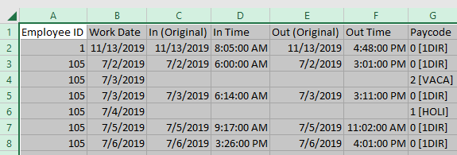

The Paycode of Nova must match the Earning Code of GSS.

Open the program from Payroll > Administration > Time Attendance Import from NOVA 5782:

Select the file and date range:

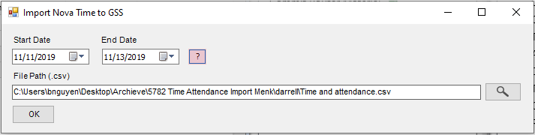.

Click the question mark button for explanation:

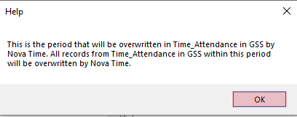

Click OK to upload:

The result file will be saved into the same folder of the import file, with a time stamp suffix:

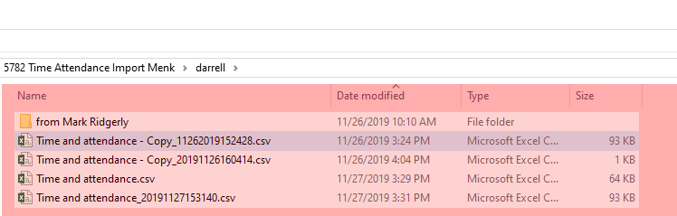

Result file:

