BN, Jan, 2019

Project 5813: SO / WO Dashboard

Customer: U.S. BOLT MANUFACTURING, INC.

This project creates a Sales Order/Work Orders Dashboard with the following columns:

**1/ Sales Order Information:**

1. SO (link to View/Edit SO)

2. SO Line

3. Customer PO

4. Customer Name

5. SO Type

6. SO Part (link to S&D)

7. PL

8. SO Line Description

9. SO Qty

10. SO BO Qty

11. SO Date

12. SO Due Date

13. Unit Price ($)

14. Extension ($)

15. Must Deliver by Date

16. Ship Sched

17. Ship to ID from SO Line

18. SO Line User Fields 1-5 (**key SO Line**)

19. Add 15 Notes fields on the Sales Order Section (**key SO Line + Job + Suffix + Seq)**

20. Add Notes button for (19):

a. Add multiple notes per (19), store date/time and user.

21. Notes Field:

a. Display last note on the screen

**2/ WO information**

22. WO information:

a. WO # (link to View/Edit)

b. Suffix (link to View/Edit)

c. WO Part

d. WO Qty

e. WO Sched Due Date (last sequence less than 990000 due date)

f. WO Due Date

g. WO Priority

h. Add a field with Open LMO Sequences, with a format similar to this: WC1 / WC2 /WC3 but only bring open sequences

i. Instead of displaying the actual WC code, we need to create a maintenance screen to show a different value, so instead of showing WC1, they can display “SAW” if no cross-reference is found, use the actual WC Code.

j. For outside or Material sequences, if a PO is found, show that in parenthesis i.e WC1/WC2/HEAT TREAT(PO:002345)/WC3

k. Add a Column with the OPCODE value per sequence, but we need to create a maintenance screen to use a different description, similar concept as item “H”

l. Add a Column with a CheckBox (when documentation is completed). **This documentation is NOT GSS Document Control**. **(Key Job + Suffix)**

m. Add a documentation notes field

n. Color coding:

i. Brown if the first opent sequence is OPCODE 1500

ii. Blue if the WO is closed

iii. Green if the WO is closed AND documentation box is checked.

23. Overall Grid functionality

a. Right click feature to (on Sales Order Line):

i. Export

ii. Refresh

iii. New SO

iv. New WO

b. View, edit, Issue, Wip to FG driven by Group Security

c. Permissions:

i. Create a maintenance screen to determine which users can edit which notes fields on the grid.

**3/Screenshots:**

Sample Data:

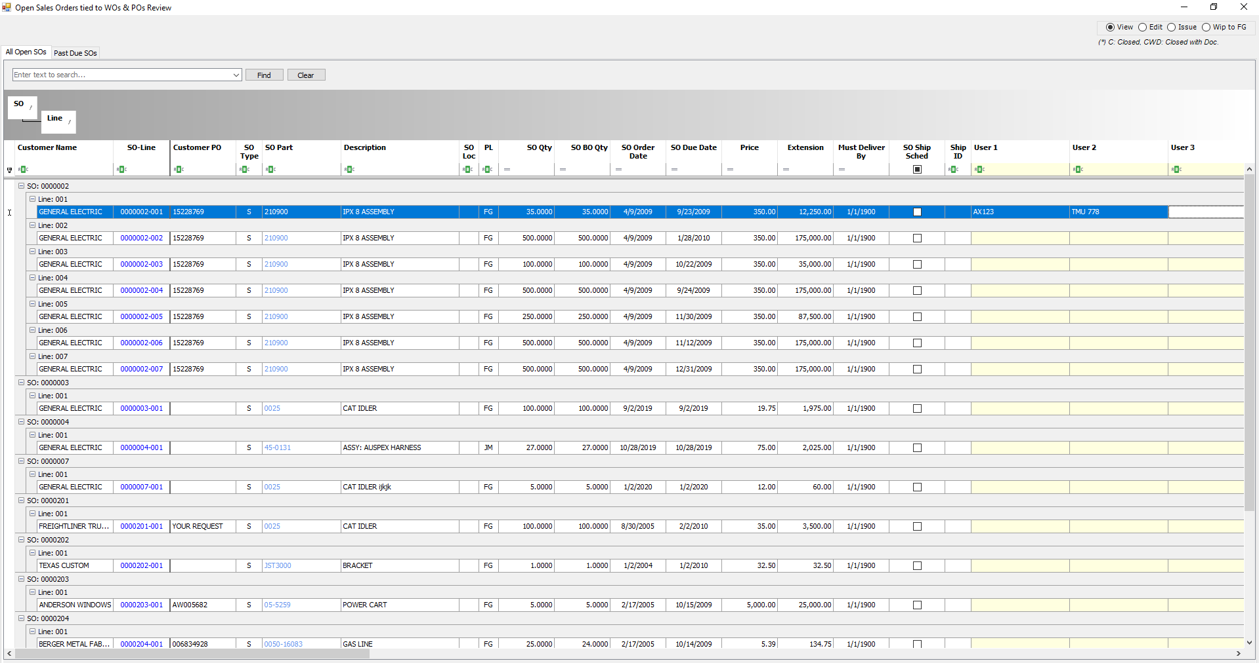

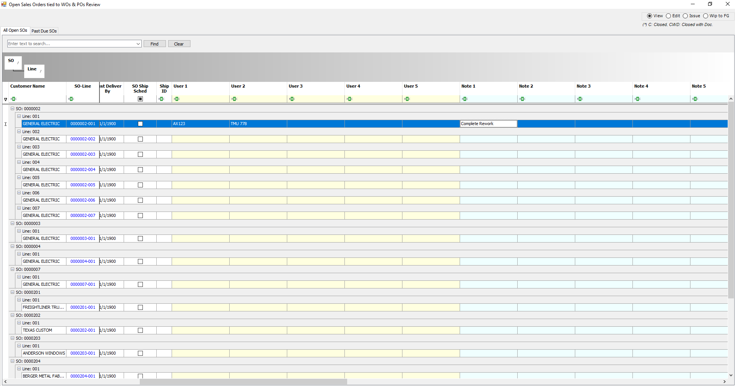

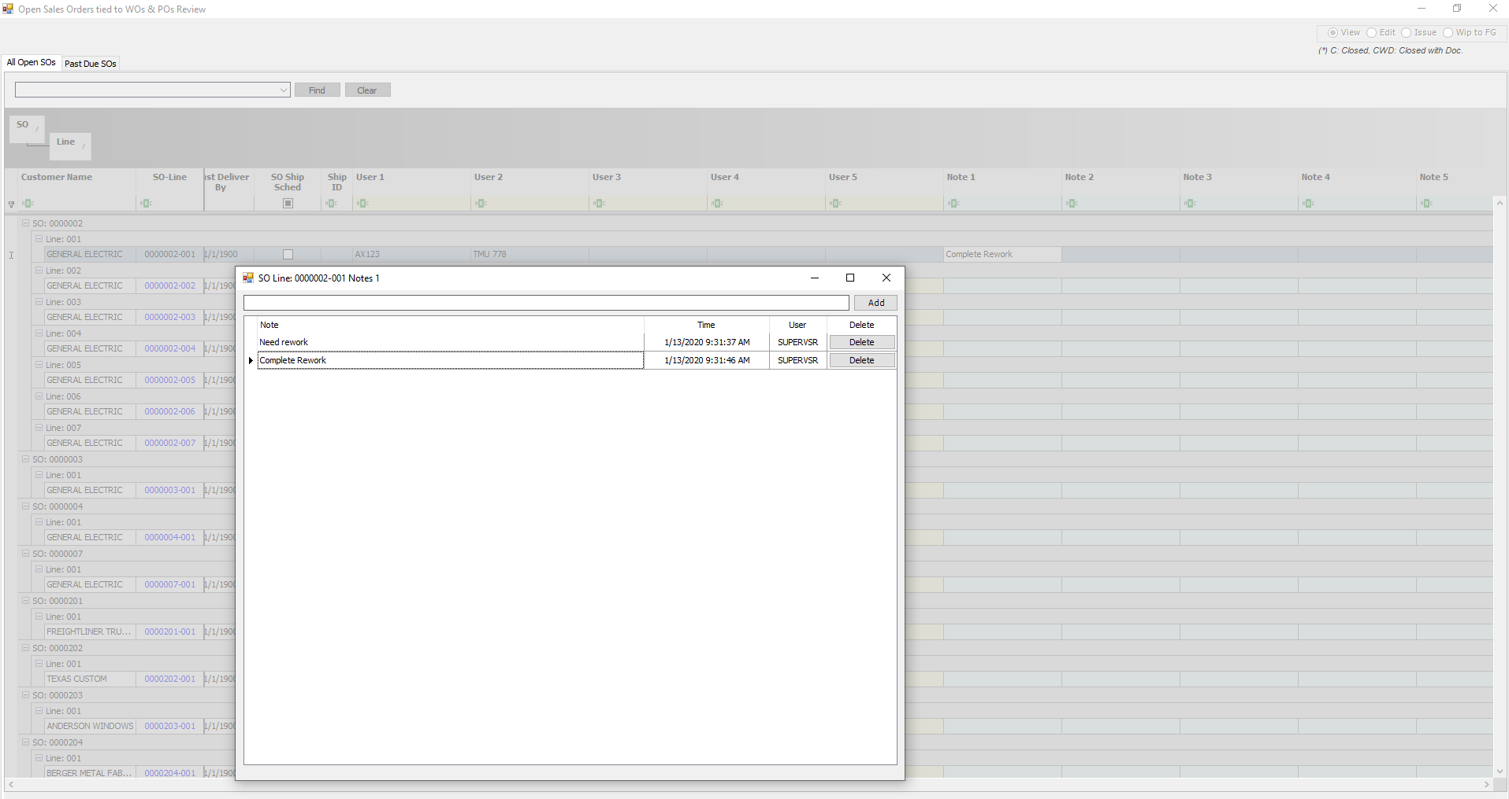

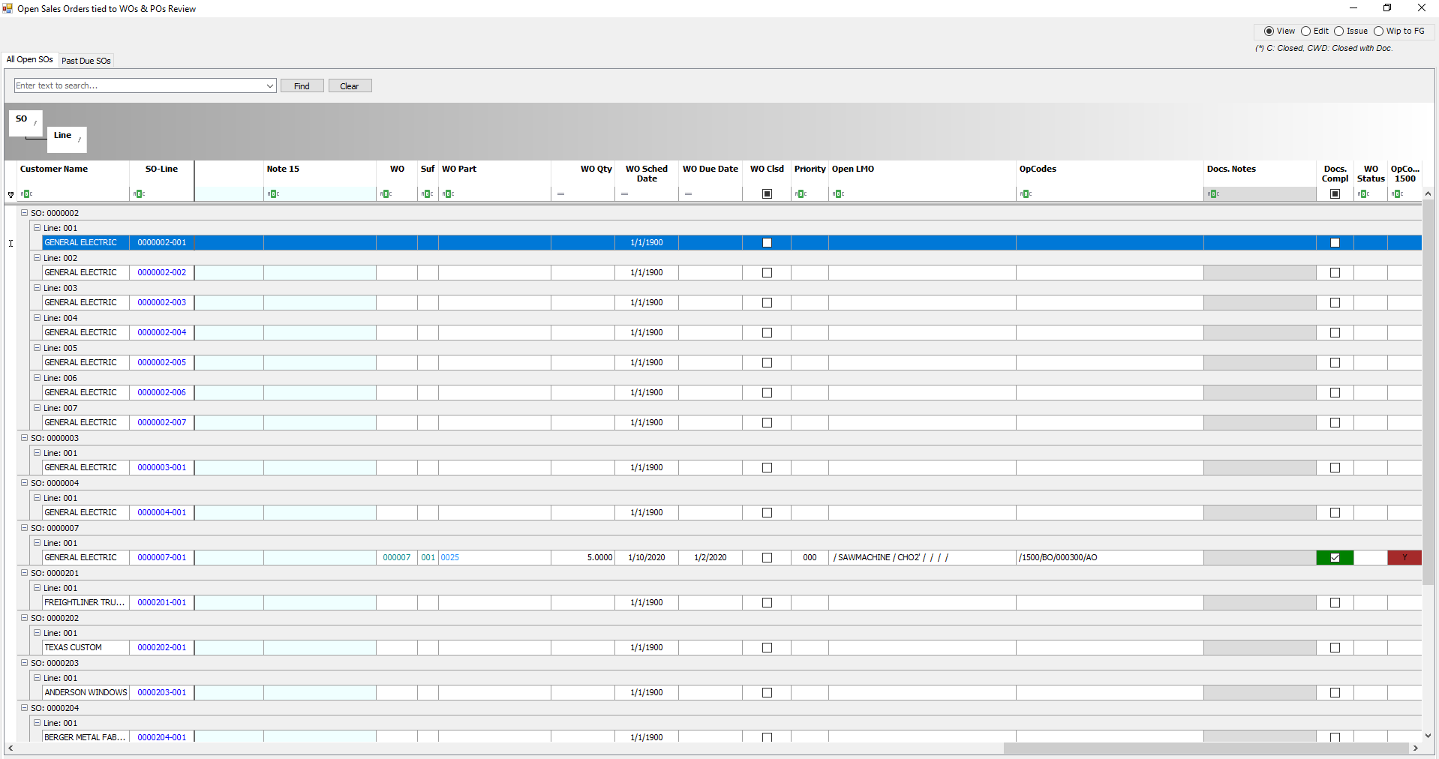

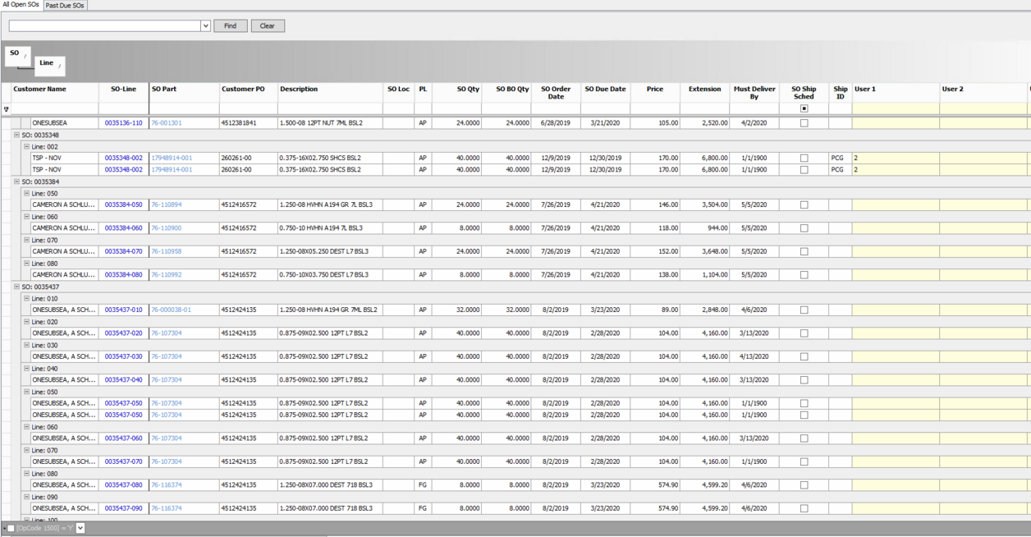

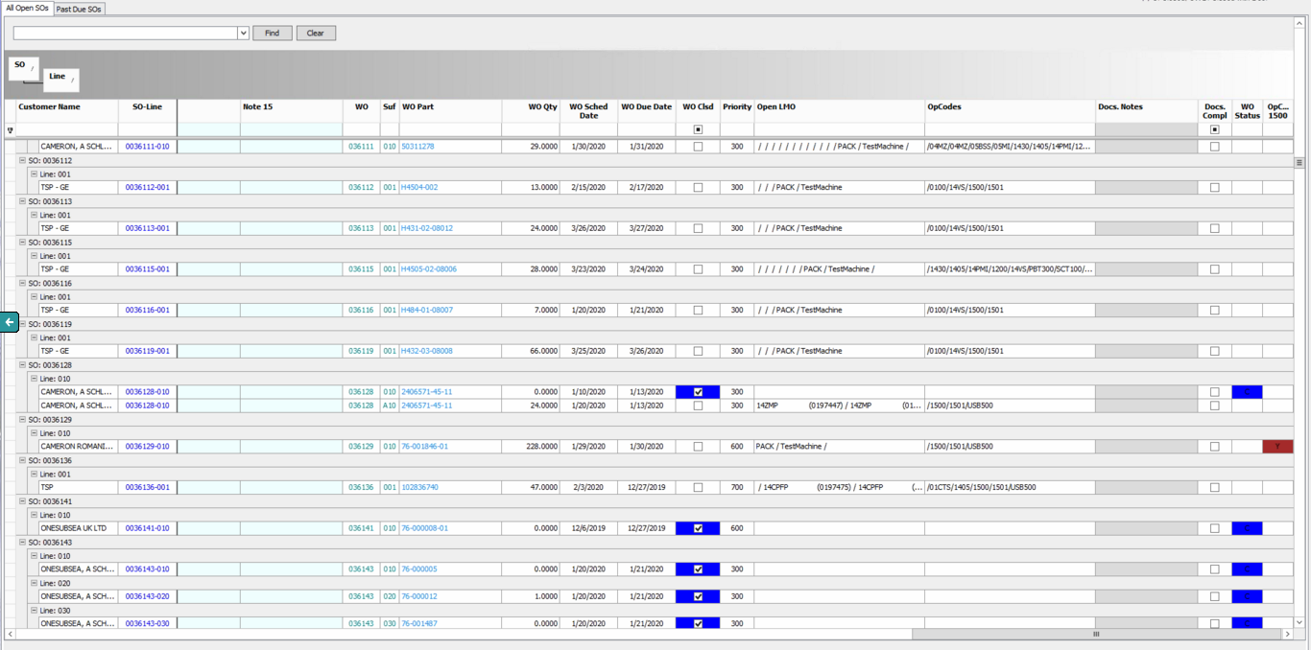

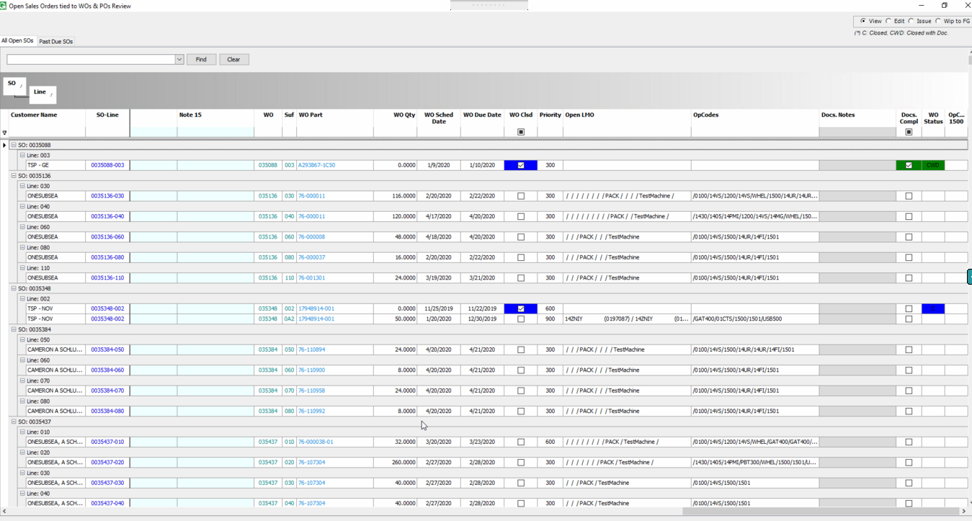

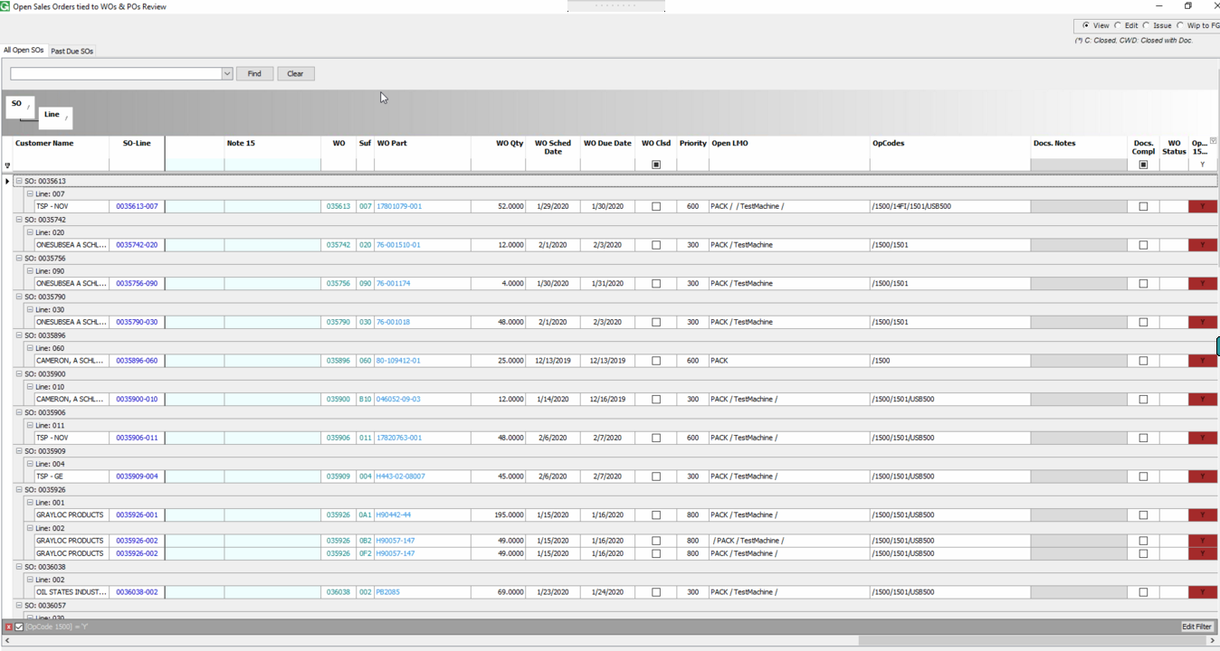

Maintenance Program: to access Maintenance screen, user must be Supervsr or in Security Group MAIN5813.

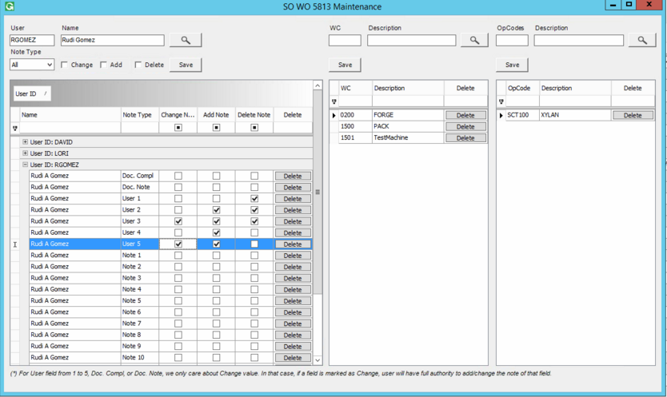

Each User has the setup at the maintenance screen to Change/Add/Delete for Notes 1-15/Documentation Notes/Documentation Checkbox/User 1-5.

Each WC/OpCode has a description setup that will be displayed in the Dashboard. Ex: 1500: PACK, in the dashboard PACK is displayed.