BN, Jan, 2019

Project: 5837 Positive Pay Export

Customer: Fortville Feeders

This project will generate a positive pay file with layout: Account#, check#, amount, Issue date, Payee

User must be in security group POSPAY to use the program. Open the program under:

*Accounts Payable > Transactions > Positive Pay 5837 (Fortville)*

Select the date range and click OK:

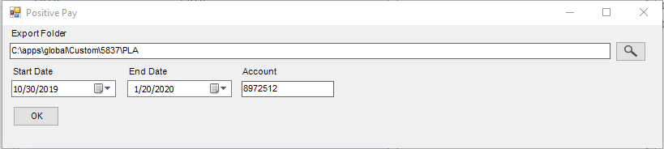

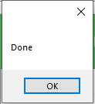

Files are exported to:

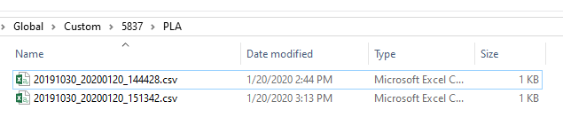

Sample file:

