BN, Feb, 2020

Project 5872: Bom Labor Explosion

Customer: Fabcon   
This project will explode a Bom, display WC data and calculate cost per Bom quantity

Run from a custom menu item: **Bill of Material > View > Bom Labor Explosion 5872**

Select a Bom and quantity. Select WC range or All WCs:

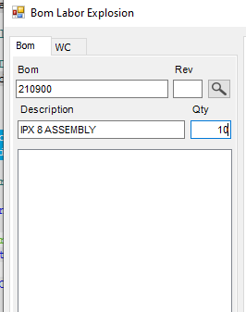 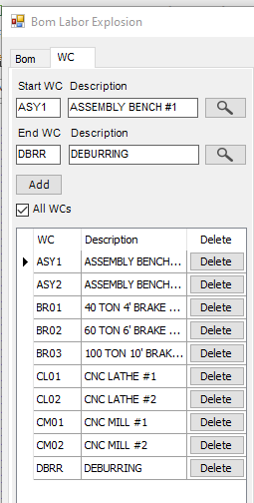

Click Load:

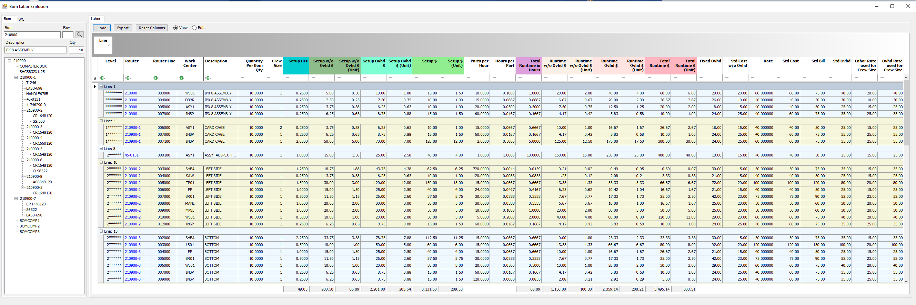

The program reads through the levels of the BOM (including Parent Level).

Calculation formulas:

**1/ Setup calculation** depends on what configured in

**System Support > Administration > Company Options (Advanced)> Estimating/Routing & Quote Management:**

If **Always Use Crew Size of 1 when Estimating Setup Cost** is checked:



* Setup w/o Ovhd Dollars = Setup Hrs * Std Cost w/o Ovhd
* Setup Ovhd Dollars = Setup Hrs * Std Ovhd

If **Always Use Crew Size of 1 when Estimating Setup Cost** is unchecked:

* Setup w/o Ovhd Dollars = Setup Hrs * Labor Rate used for Crew Size
* Setup Ovhd Dollars = Setup Hrs * Ovhd Rate used for Crew Size

In both 2 cases:

* Setup Dollars = Setup w/o Ovhd Dollars + Setup Ovhd Dollars

**2/ Runtime:**

* Total Runtime in Hours = Quantity * Hours per Part
* Runtime w/o Ovhd $ = Total Runtime in Hours * Std Cost w/o Ovhd

(If crew size <> 1, Runtime w/o Ovhd $ = Total Runtime in Hours * Labor Rate used for Crew Size)

* Runtime Ovhd $ = Total Runtime in Hours * Std Ovhd

(If crew size <> 1, Runtime Ovhd $ = Total Runtime in Hours * Ovhd Rate used for Crew Size)

* Total Runtime $ = Runtime w/o Ovhd $ + Runtime Ovhd $

**3/ Labor/Ovhd Rate used for Crew Size:**

* Labor Rate used for Crew Size = Std Cost w/o Ovhd * Crewsize
* Ovhd Rate used for Crew Size = Fixed Ovhd + [Crewsize * (Std Ovhd - Fixed Ovhd)]

*****************************************************************************

Clicking the router link will open the Router screen. Depending on View/Edit option, the screen will be View/Edit.

Clicking the router row, the bom treeview will bold the corresponding part number. Like wise, clicking a treeview node, the dashboard will highlight the corresponding router row (if there is a router for that component).

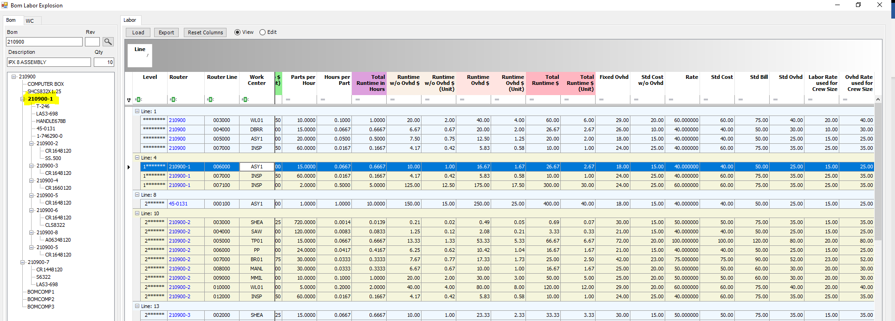

The dashboard has only 2 colors, this gives visibility to user to distinguish routers.