BN, Feb 7, 2020

Project 5882: Modification of Standard Shipping Dashboard

Customer: Werk-Brau

This project has the following features:

*1/ Add 3 columns to the Shipped Orders tab of the standard Shipping Dashboard:*

**Need Email**: displays if the customer want to receive email (customer not wanting to receive email are in the **List.txt**).

**Emailed**: displays if an email has been sent out to this customer for this sales order shipment.

**Send Email**: inline button allowing to send email manually for the specific sales order shipment.

*2/There is also the Task Scheduler that runs daily at 6:00 am and sends emails for all shipments that were shipped yesterday.*

The parameters are saved at: \Global\Custom\5882\CCC where CCC is the company code:

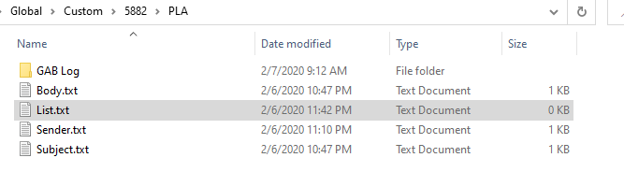

These files are generated by default when we first use the program. We can change the content of the files but need to keep the wildcards unchanged.

* Body.txt: template of the body of the email:

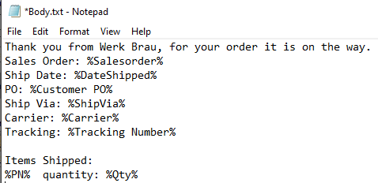

* List.txt: list of customers who do not want to receive emails, delimited by ;

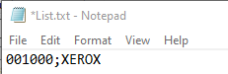

* Sender.txt: system email used to send email

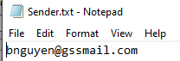

* Subject.txt:

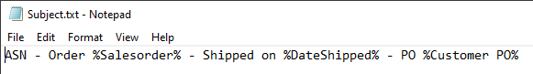

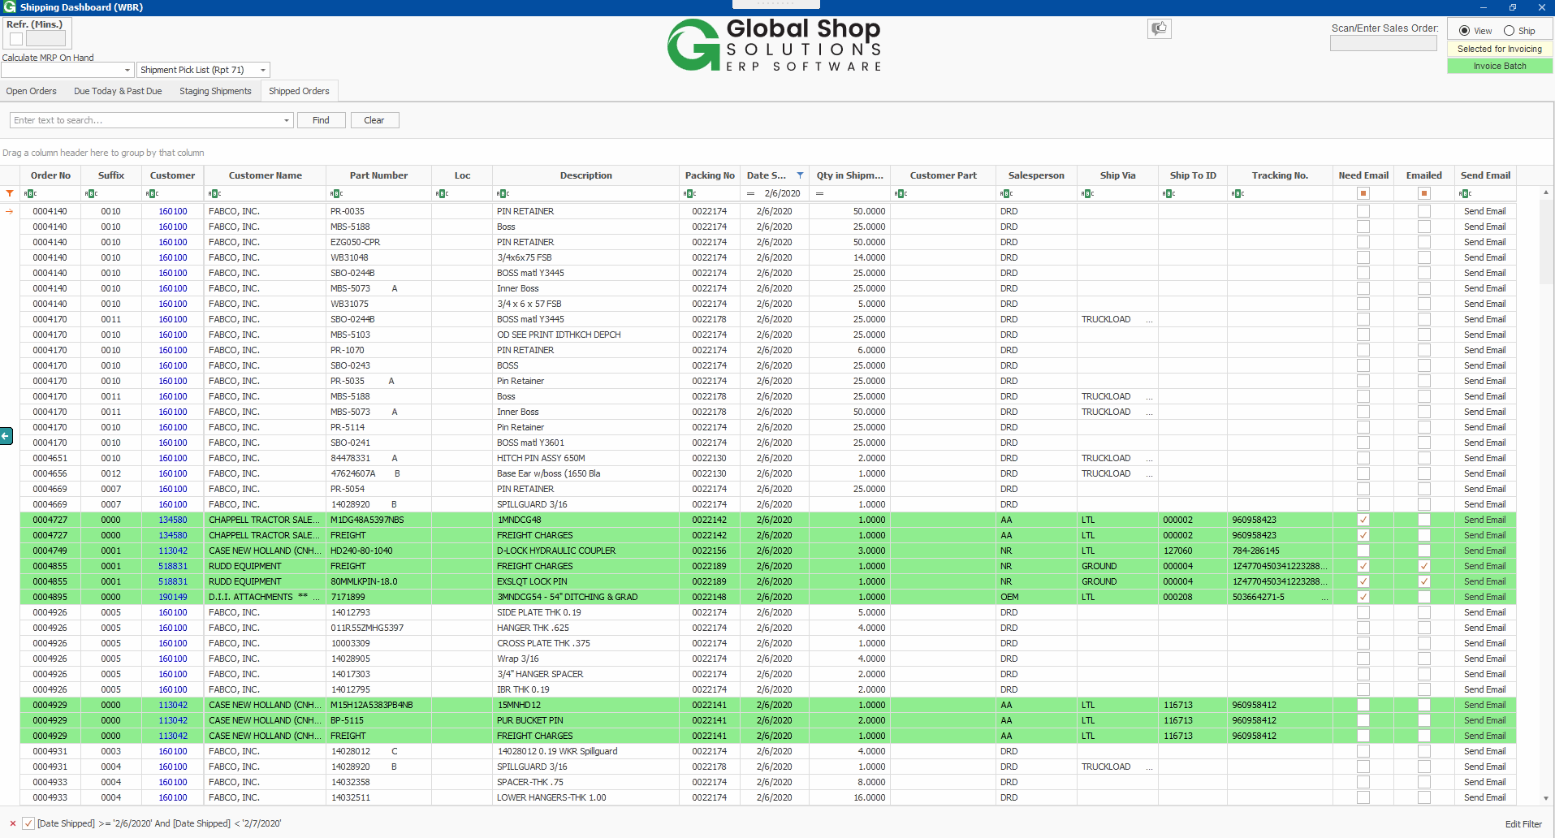

Click the Send Email button to send an email for the line. If an email was sent, a message box will ask you if you want to send again:

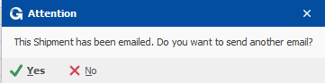

The email addresses are picked from the Sales Order header (we can use multiple emails delimited by ; ). If there is no email from the Sales Order header, emails will be pulled from Customer Master. If user puts 2 emails address in the Sales Order, make sure the 2 are valid, otherwise, no email is sent out.

This is an example of email:

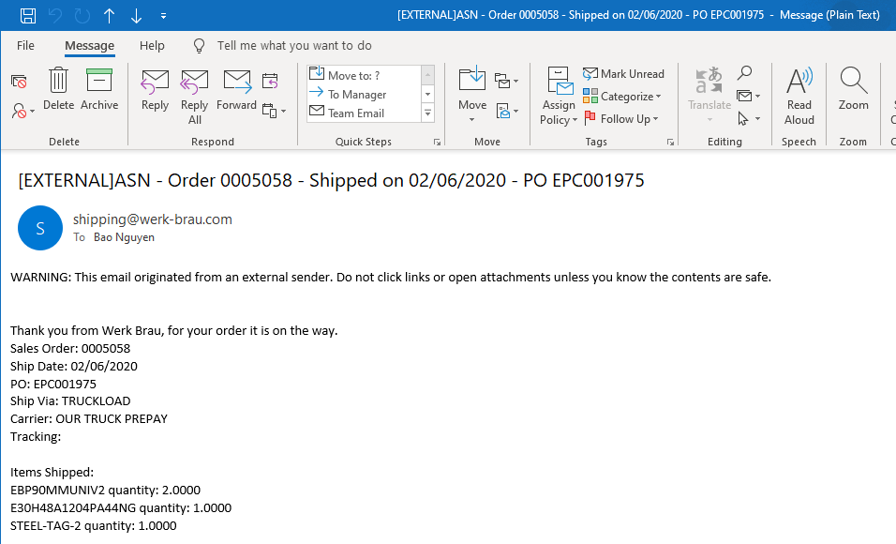

The log file in GAB Log will save the record if user clicks Send Email button, this help us to trace the transactions:

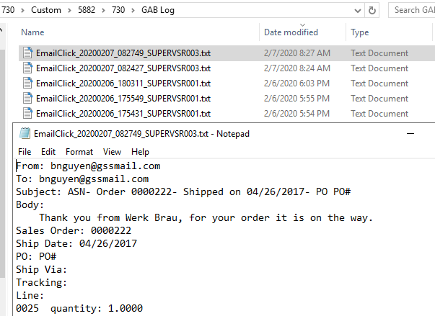

The Task Scheduler once run, will also save the transactions to a log:

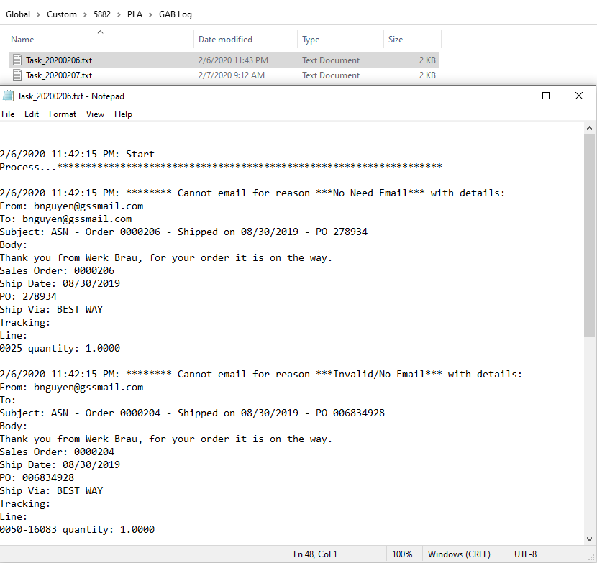

Every transactions will be saved to the custom table GCG_5882_EmailHist for auditing:

