BN, Jan 2021

Project 5884 : Quality Dashboard Modification

Customer: PRIMUS METAL, Inc.

This project is a modification to ARC 4920 Quality Dashboard.

1/The Open NCMR tab to see all RMA’s, not just open.

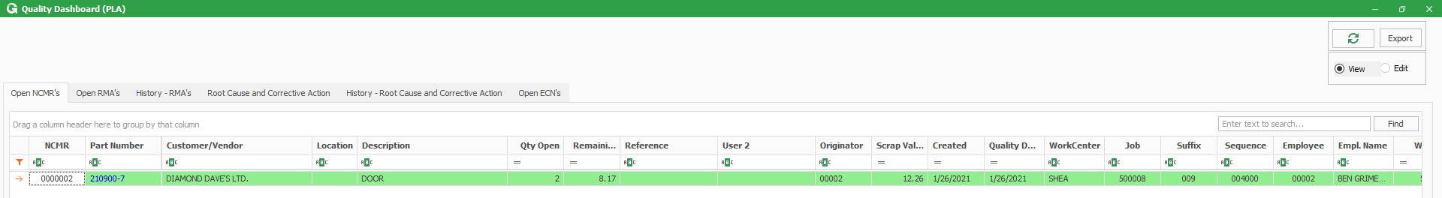

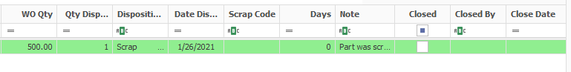

*Added columns:*

Created Date, Work Center, Job, Suffix, Sequence, Employee, Empl. Name, WO Qty, Date Disposed, Days, Scrap Dollars

2/ RMA:

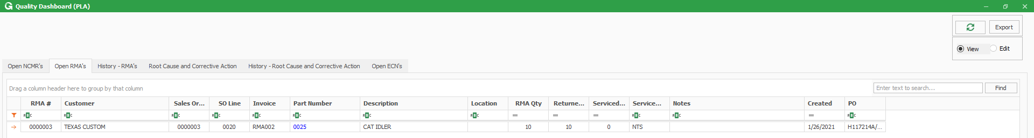

*Added tab History – RMA’s:*

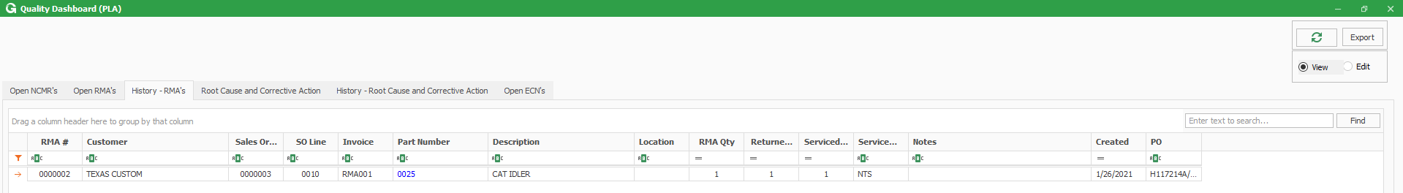

3/Root Cause & Corrective Action:

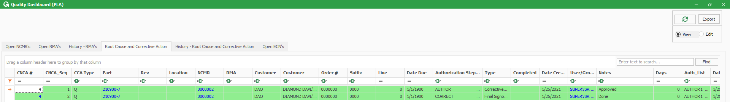

*Added:*

* Open or closed in C&CA
* Sequence completed flag so we can see which sequences are done on the C&CA.
* Date Completed

*Added History-Root Cause and Corrective Action:*

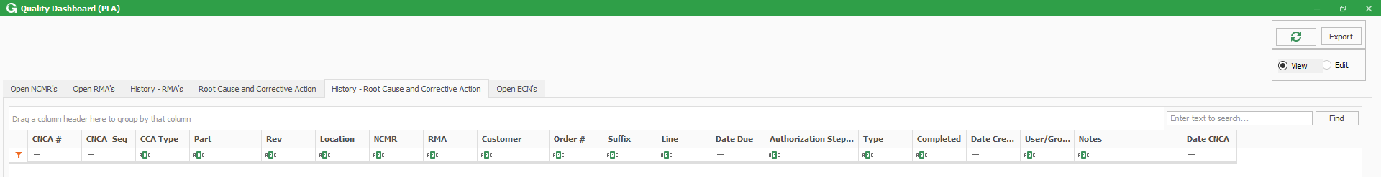

4/Security group EditQual must be created for user to select Edit radio button.

Link NCMR leads to Quality Reject/Disposition:

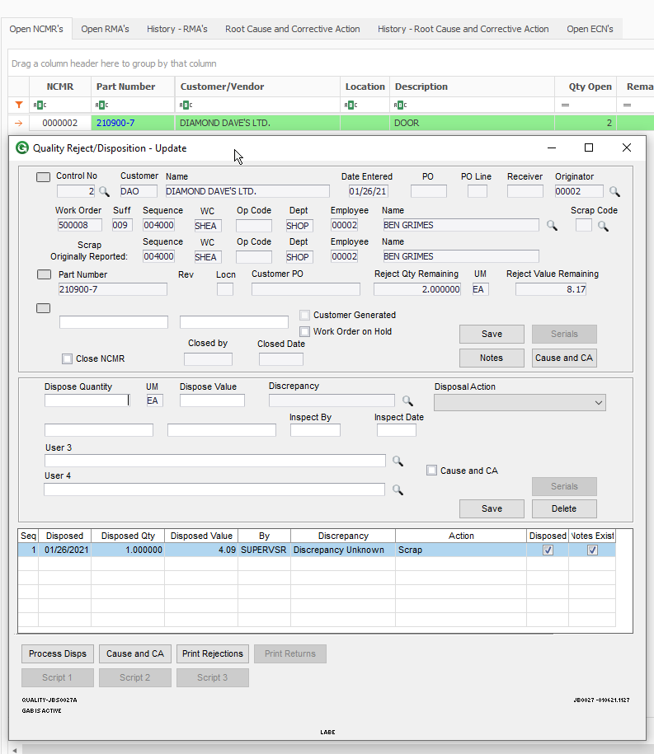

Link Part Number to Supply And Demand screen.

Link CNCA to Cause and Corrective Action screen.

