BN, Mar 2020

Project 5900 – Integration GSS with Unanet

Customer: Mentis Sciences

**Business Case:**

Mentis Science have been using Unanet to monitor project worked time, and they strictly monitor if the work order details is changed/added/deleted. Mentis also use GSS GUI station to record the time.

Now Mentis want to export the WO Details from GSS grouped by Employee, Project, Phase, Date Worked, along with the Reason Code at the details level, into Unanet.

**Solution:**

This project will export Job Details time recorded/modified/added/deleted from GSS to a csv file for importing into Unanet.

The data exported contains reason codes and time stamps, and grouped by Employee, Project, Phase, Date Worked.

The total hours worked is used in Unanet to update (**not append**).

In general, GSS records time at the GUI station, and administrator can modify/add/delete records at

*Shop Floor Control > Transactions > Edit Work* *Order Detail.*

When at the *Edit Work Order Detail*, admin is required to input the reason code from a dropdown list for every record modified.

The program is attached to the Task Scheduler running Daily, that pulls yesterday changed data. It can also be run at a menu item. If run from the menu item, user will have to specify what date changed to be exported.

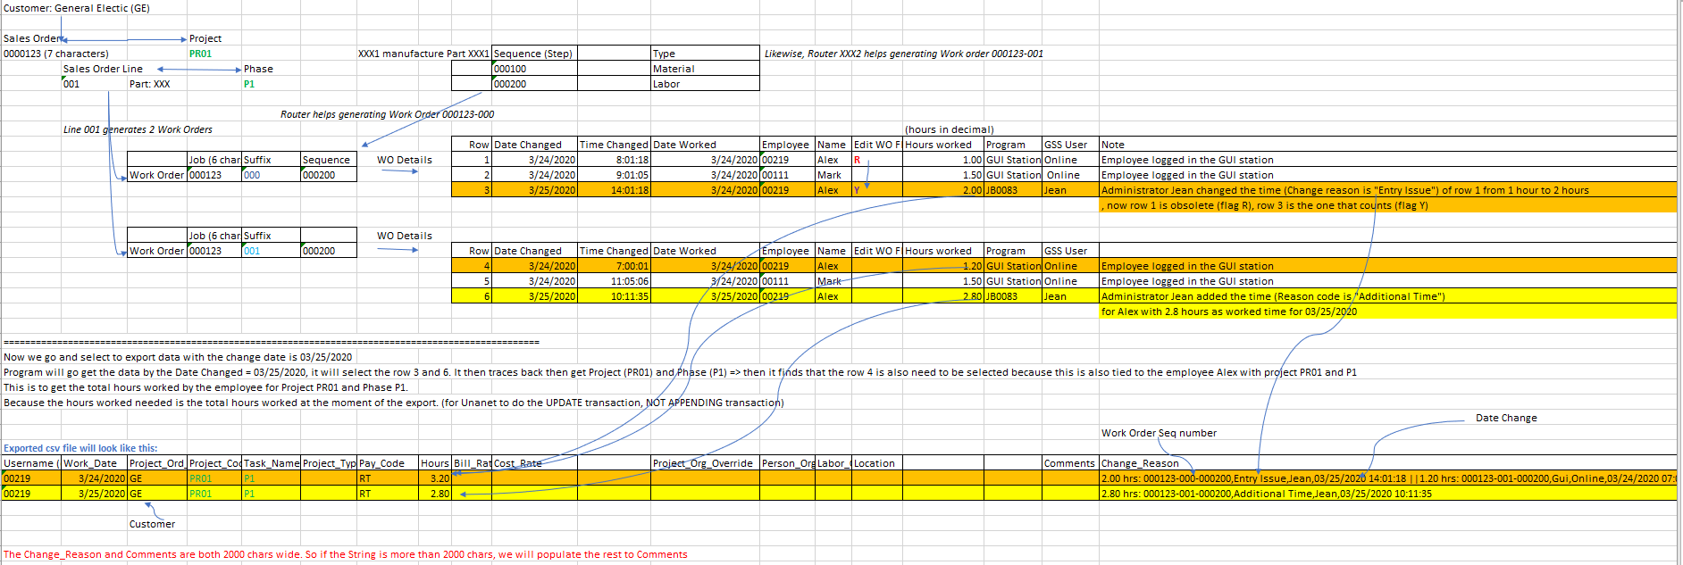

At *Shop Floor Control > Transactions > Edit Work* *Order Detail:*

* user can only modify/delete/add their own records. Only administrators in WOEDIT security group can modify/delete/add other employee records.
* After the modification, a check is made if user entered the reason code for the record. Otherwise, a message box will pop up:

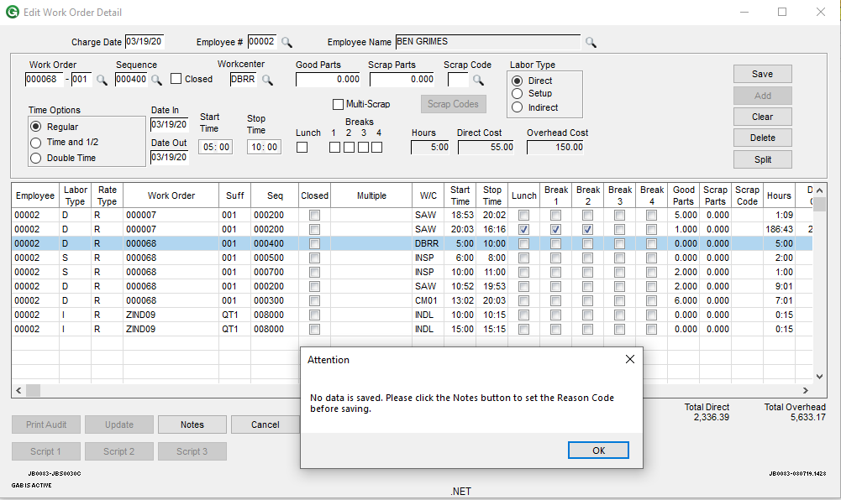

* User has to click the Notes button to enter the reason code:

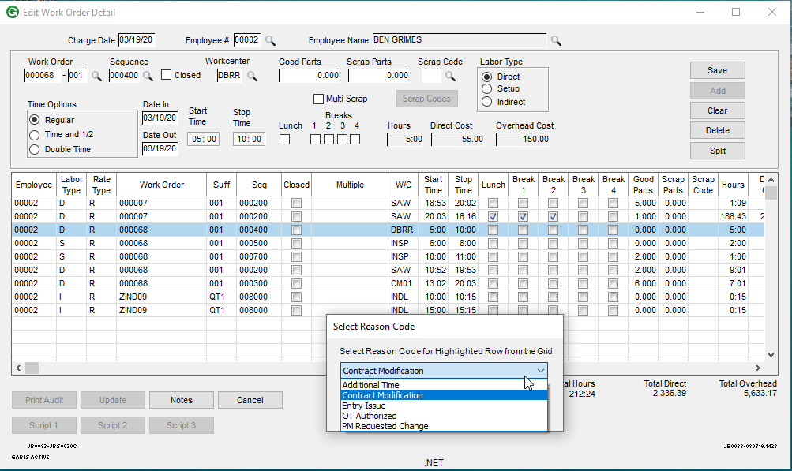 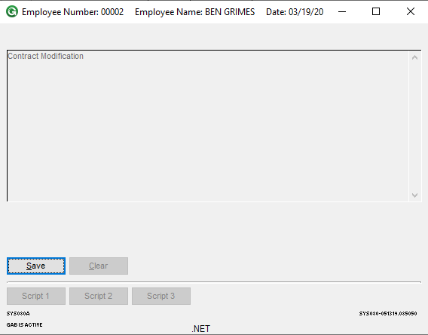

Once the Reason Code dropdown is selected, user is forced to Save the reason code as a Note attached to the record (Identified by Job-Suffix-Seq-Date_Sequence-**Sequence_Key**).

As the **Sequence_Key** is a part of the composite key that is only used by the Notes screen, we must make use of the Notes screen to tie the reason code to the WO record. So within this project, the Notes is strictly used as reason code tied to the WO Detail record.

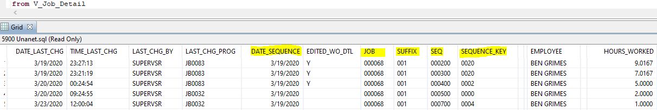

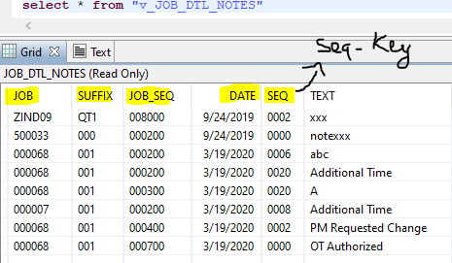

2/Generate csv file:

Exported file is saved at:



File name pattern: DateChangedSelected_DateTimeExported.csv:



