From CRM or CRM with Edit.

1. Select “Sales” on the left side of the screen.
2. Select “Contacts” under the Sales group.
3. At the top of the middle section, use the drop down to select “All Vendor Contacts”.
4. Use the column headers to sort by “Company”.
5. Select the contact you want from a specific company.
6. In the top right corner of the screen, click the button for “Contact Options”

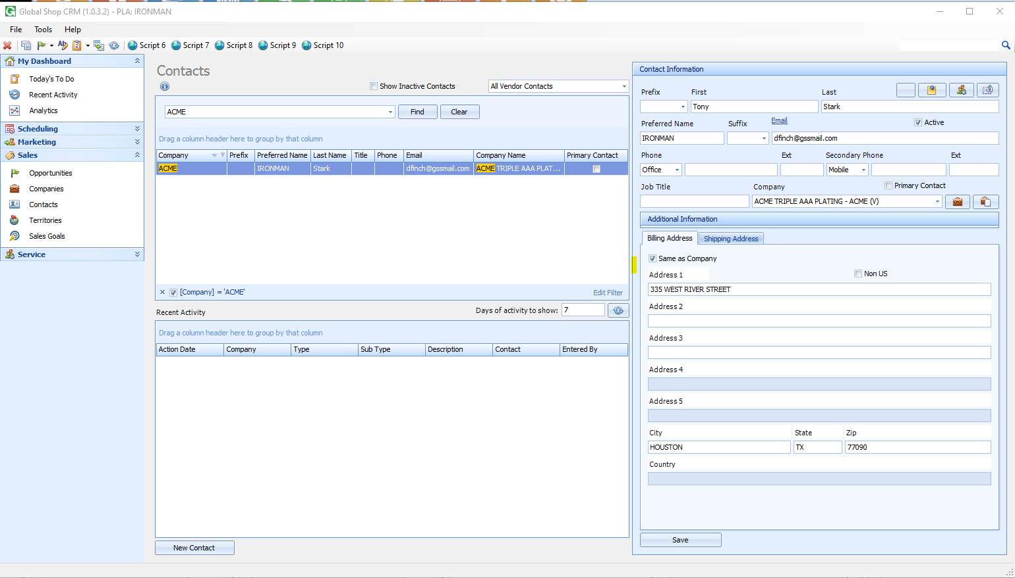

1. On the following screen, select the check for “E-Acknowledgement”

