BN, Sep 2020

Project 6034: Quality Inspection at GUI

Customer: **Primus Metal, Inc.**

This project streamlines the Quality Inspection at the GUI. User can submit requests for Quality Inspection from the GUI. The requests will be flagged as Approved/Rejected/ Need More Info by groups of Approvers. Users can check the status of the requests. Emails can be used to track the approvals.

Based on a typical router created by Primus, there are 4 categories of Labor sequences:

Cat 1. Labor sequence that is NOT subject to inspection, for example SHP for shipment. There will be a GAB maintenance program to keep track of the list of Work Center of this type of sequence.

Cat 2. Labor sequence with opcode "SETUP" is subject to inspection.

Cat 3. Labor sequence with Work Center "QUAL" is subject to inspection.

Cat 4. Other Labor sequences not in category 1,2,3 are subject to inspection.

**The processing of Goods/Scraps at the Update screen of the GUI will be validated before moving forward by applying these following rules:**

**a.** At the GUI Update Job screen, user cannot use the Process button meaning, they can click Process, but the core program will be halted if falling in the following cases:

                * If the sequence is (category 2 or 3) and there is not any approved record with quantity > 0 in the table GCG_6034_QC for that sequence.

                * If the sequence is category 4, and it exists that there is a previous category 3 or category 4  of the same Job that is not approved with quantity > 0 in the table GCG_6034_QC.

                * The program will ignore and let go if it is category 1.

**b.** User cannot start a job sequence using the Start Job button at the GUI if falling in cases like in item (a)

The program will assume that all the Primus' Routers are setup correctly with the 4 categories of labor sequences. This requires Primus to verify and fix the Routers before implementing the project.

The project once implemented will only process work orders with the WO created date or released date starting the implementation date.

1. **Instructions:**
2. **1/ Log in GSS under SUPERVSR**
3. **2/ Create a security group for Approvers. You can name the group as you’d like.**

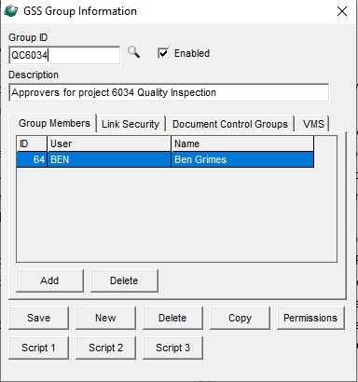

1. **3/ Install 6034 from ARC. When being prompt to assign the project, select the security group from (2). This will give access to the menu item in (4) for Approver group.**
2. **4/ After being installed successfully, still in SUPERVSR account, run *Quality System > Transactions > Quality Inspection Approval 6034***

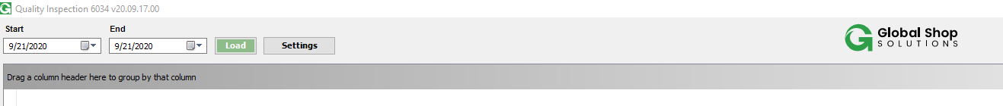

Only SUPERVSR can see the **Settings** button.

Click the **Settings** button. The following screen will open:

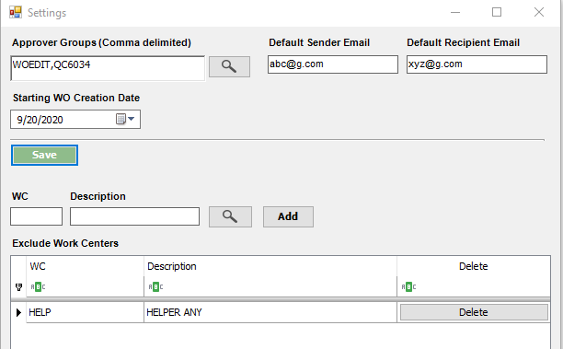

Enter again the Approver group you created in (2), Default Sender Email, Default Recipient Email and the Starting WO Creation Date (starting date for which the project 6034 applies processing Quality Inspection Process)

Click **Save**

You can add the Work Center of category 1 to the list by using the Add button.

1. **Example:**

**B.1** For the purpose of testing, we created a router name called R6034 to generate WO.

We created work order R6034-001

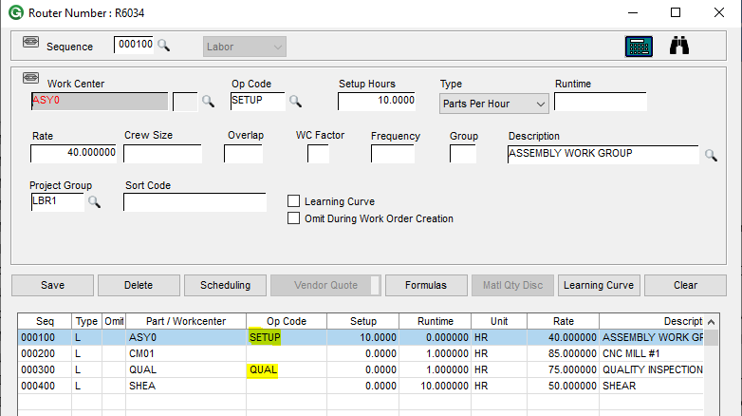

**B.2** Log in the GUI under Jim Lehman. Start a job, select sequence R6034-001-000100, Jim will get this message which does not allow to start the sequence, because the sequence is a SETUP sequence with Opcode SETUP, and there is no approval record for this sequence with qty > 0. See below picture:

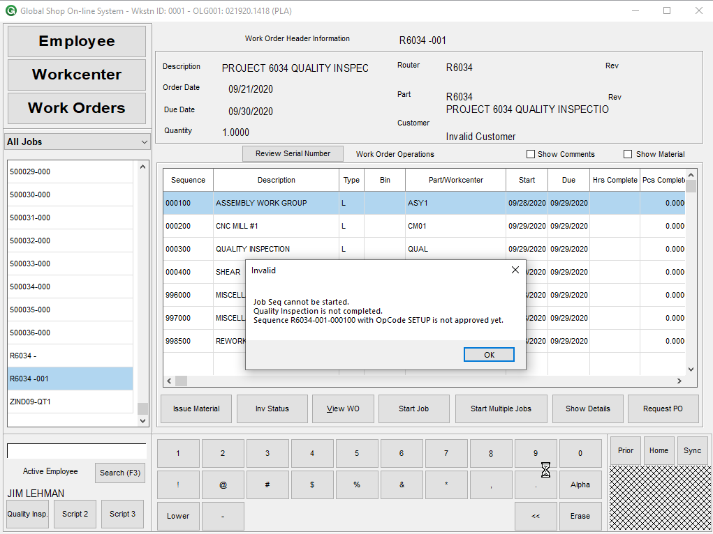

Jim cannot start sequence 000200 and 000400 because sequence 000100 and 000300 are not approved yet.

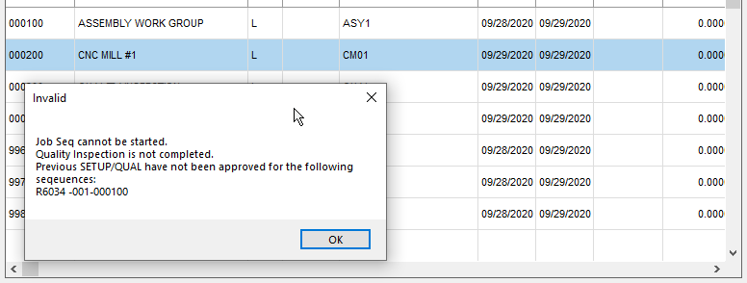

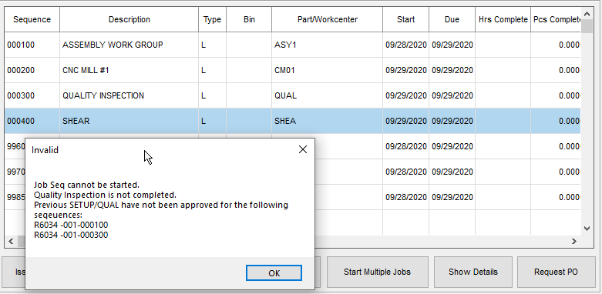

**B.3** Now Jim decides to submit a request for inspection for this sequence. Click Script 1 button as Quality Insp, the following form will open. The fields will be prefilled with information. User can scan an employee badge, and/or a work order seq.

Fill the note and click Submit:

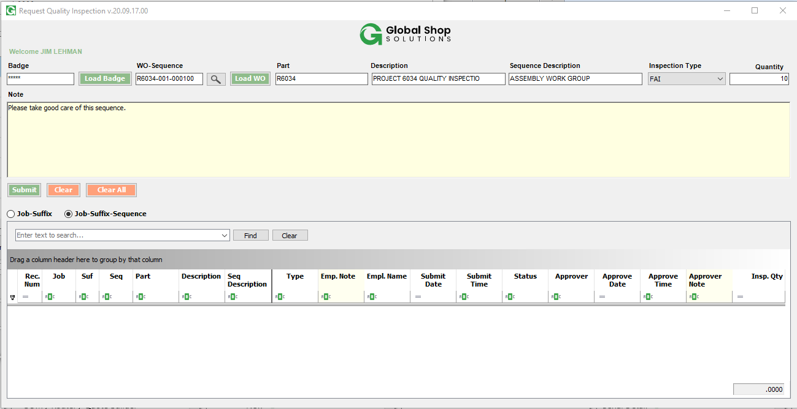

After submitting, the grid is refresh with the sequence added:

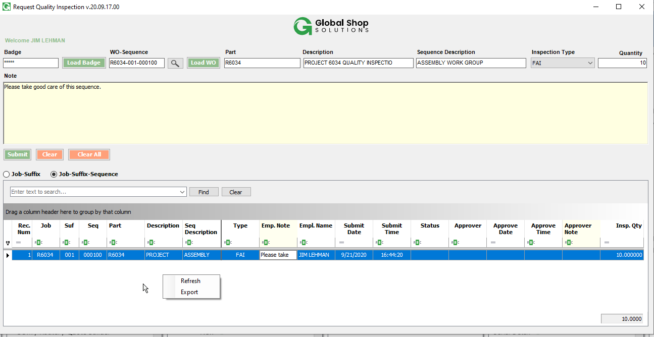

B.4 Log in GSS under Ben (Ben is in approver group). Run

Select a date range and load:

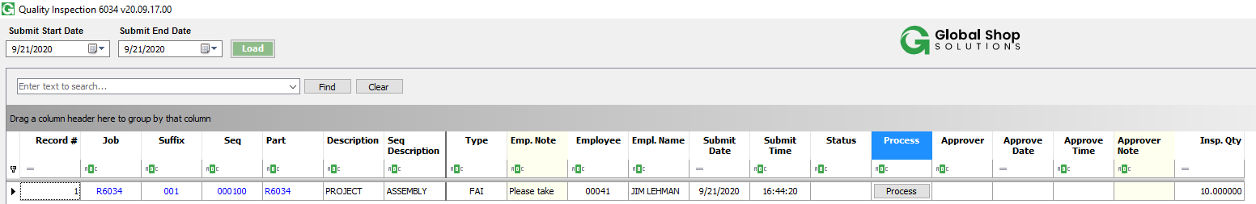

Click Process button, the following form will open:

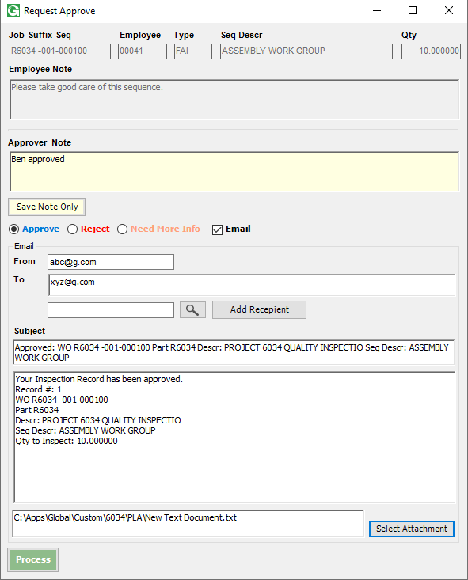

Select Approve. Ben can email and using attachment. Attachment must be in folder Global\Custom\6034.

Click Process. The record has now been approved.

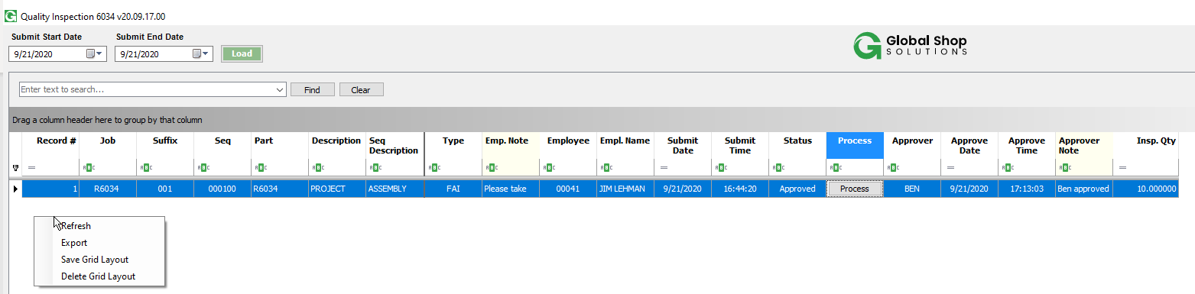

The Submit Start Date and Submit End Date selection will be saved by user and company code.

Grid layout and filter can also be saved by user. Use Save Grid Layout/Delete Grid Layout.

Go back to the GUI, Jim can log in sequence 000100 and 000200, but still cannot log in sequence 000300 as 000300 is QUAL sequence and has not been approved yet.

At the Update screen, we also have script 1 button as Quality Insp. User can check the status of the sequence by using the button Quality Insp.

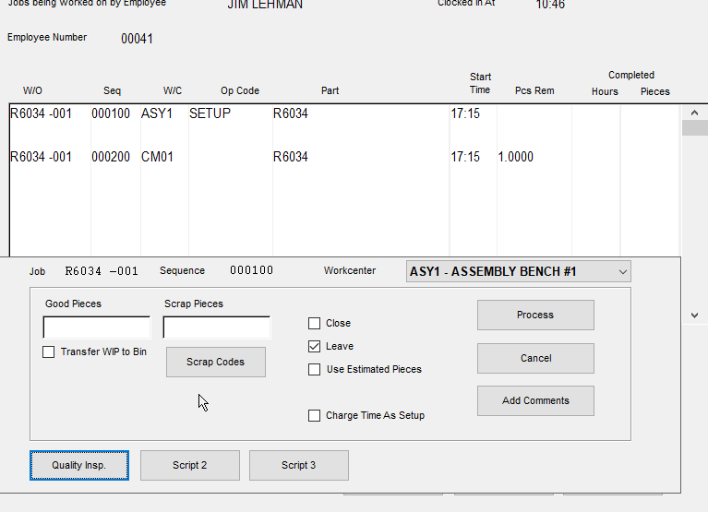

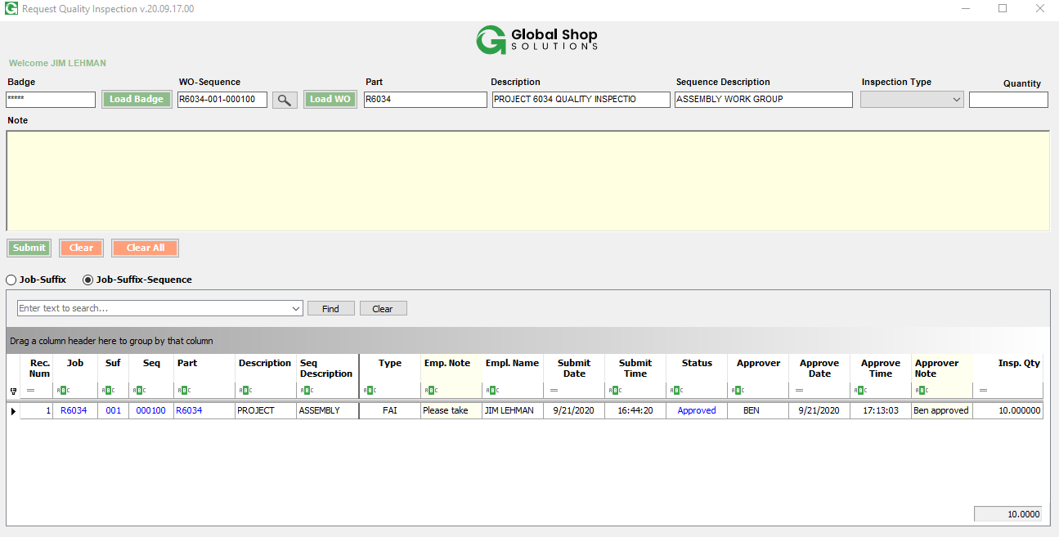

For some reason, if the inspection has been rolled back, and user are already logged in the sequences, the program will not allow user to process by using the Process button at the Update Job screen (singular or multiple toggle All). To go around it, apply 0 as Goods and check Leave, then click Process button.

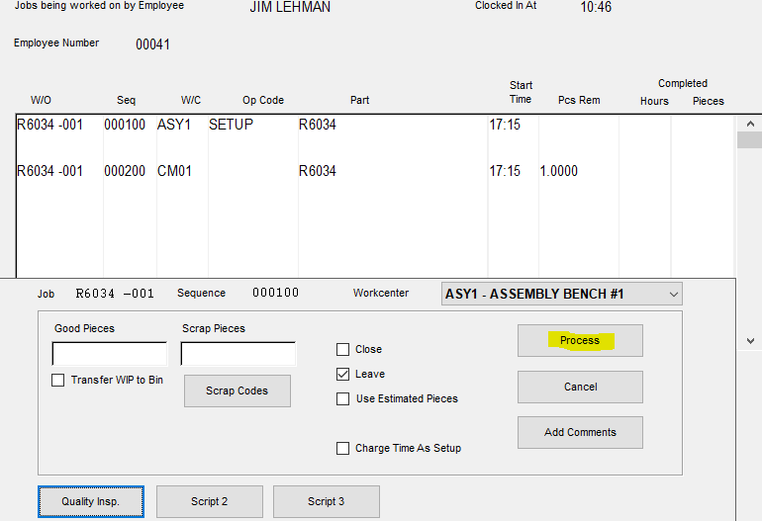

To test this, go back to Ben Approval screen and Reject the sequence 000100. Then at the GUI, click Process button, you will get this error message:

