BN, Jan 28, 2021

Project 6218: Pull/Analyze/Merge/Upload/Compare Inbound EDI vs Open Order

Customer: Triple, Inc.

Project completed with much help of Jamie Papp.

This project will:

* Pull data from 3 csv files: Commit, Forecast, Rev. These files are EDI files sent from a wholesale customer UTAS to Triple, Inc.
* Analyse the 3 files: basically the Commit and Forecast files will be used for uploading EDI orders into GSS. The Rev file will be used for matching inbound part rev with GSS part rev.
* Commit file will be scanned, restructured and uploaded on the top left grid (1)
* Forecast file will be scanned, restructured and uploaded on the top right grid (2)
* 2 files will be merged into the bottom left grid (3)
* The bottom left grid (3) will be trimmed for grouping Overdue orders and will generate the bottom right grid (4)
* The grid (4) will be used to upload EDI orders (used Rev file to lookup the Rev) and also to compare inbound EDI with orders existed in GSS

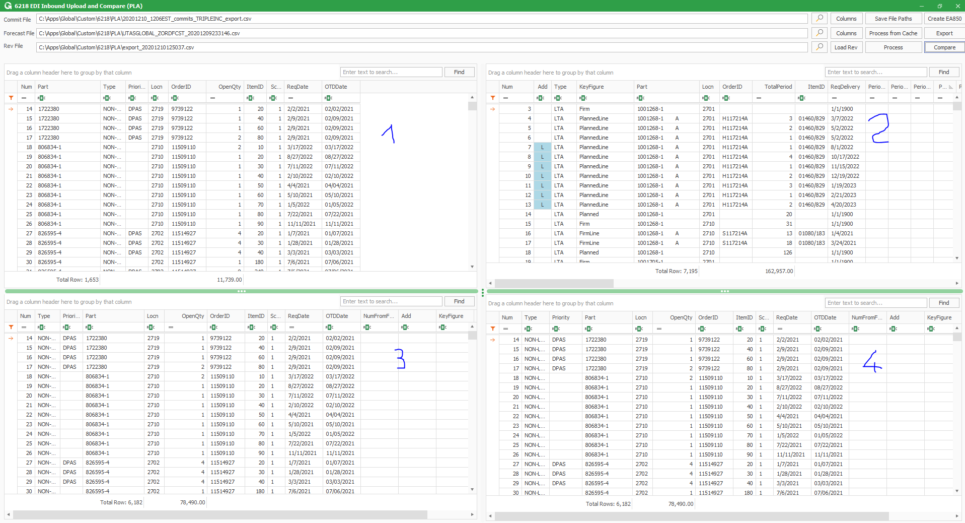

**1/Commit file:**

The Columns button at Commit file path will pop up letting us map columns from csv file. You can change the column index based on the file you have. Basically, we need these columns in the file:

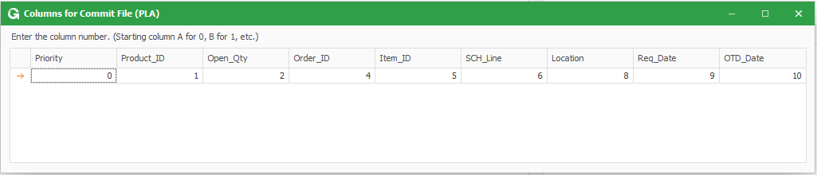

Commit csv file:

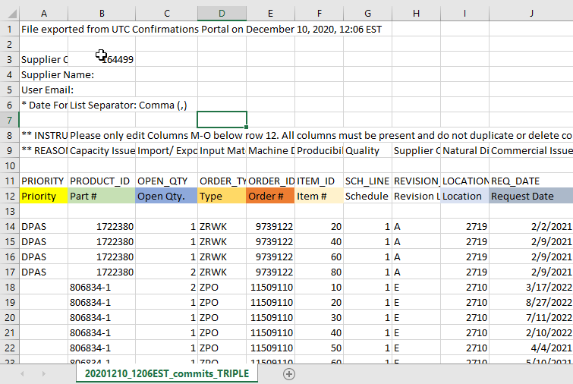

**2/ Forecast file:** like Commit file, it has the Columns mapping:

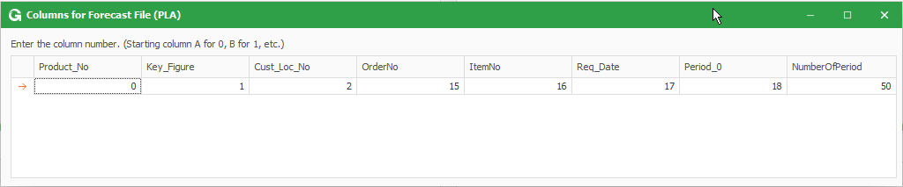

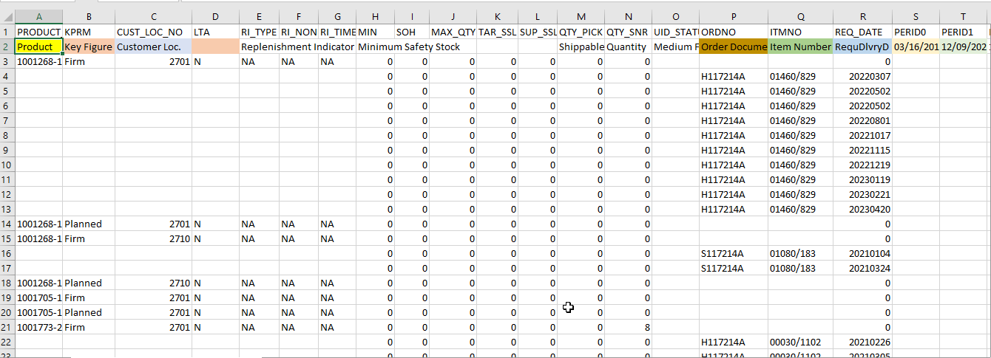

**3/ Rev file:** for now, we don’t have column mapping for Rev file, meaning, the Rev file MUST STRICTLY have column A for Order No, column B for Item No and column T for Rev containing data to process:

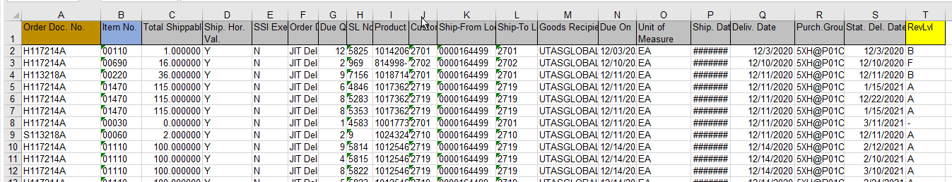

*** Click Save File Paths to save to registry so the next time open, the file paths will be auto populated

*** The 3 files will be identified by the first 8 numeric character of the Commit file as Date. This tells the program where to pick the cache.

**4/ Process data:**

If you run for the first time, click Process. It takes a few minutes to load 4 grids.

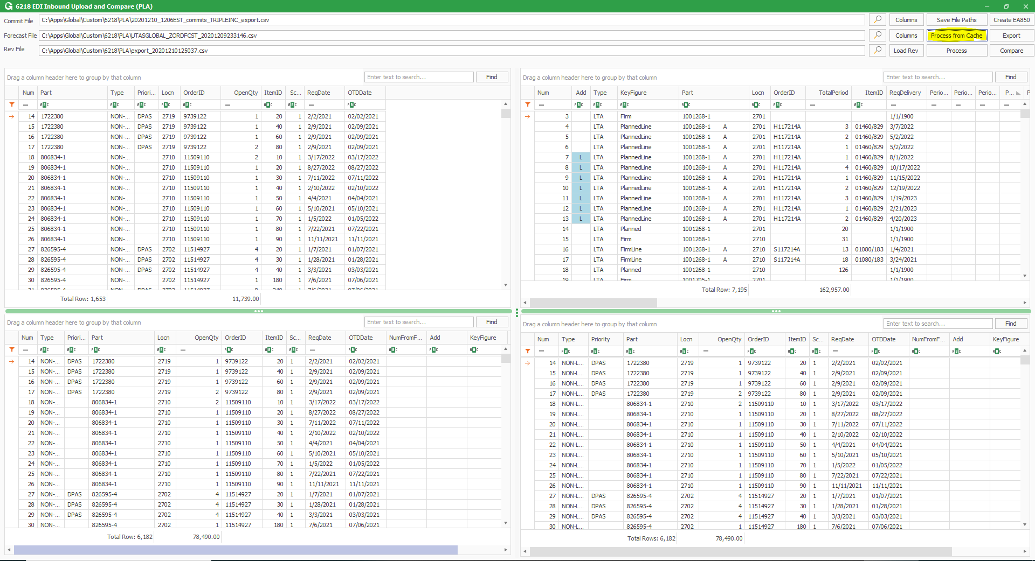

After the processing, the 4 grids are cached in Global\Custom\6218\CCC\Cached with date stamp is the first 8 numeric character of the Commit file as Date:

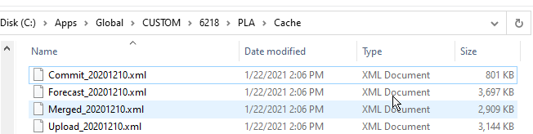

For the next time, if you want to run for the same 3 files, just click Process from Cache, the 4 grids will be loaded in just a few seconds.

**5/ Create EA850 to upload EDI:**

After processing at step 4 is done, the button Create EA850 is activated. Click this button will generate a text file based on EDI standard EA850 from the grid 4. We will use this text file to upload EDI orders to GSS.

**6/ Compare:**

After processing at step 4 is done, the button Compare is also activated. Before uploading EDI to GSS, user may want to compare the inbound files and GSS existing open orders.

*6.1 General Comparison Rules:*

Basically, we will have these categories of comparison:

* Orders existed in GSS but nothing found in the inbound files using the key: Customer_PO
* Orders existed in the inbound files but not thing found in GSS using the key: Customer_PO
* Orders in GSS and inbound files FIRST LEVEL matched using the key Customer_PO

For this matching, we have these sub-categories:

*** LTA or NON-LTA

*** Based on the criteria for matching LTA/NON-LTA:

If there is a matched, we call it Matched, a label will tell in this matched category if the qty/promised date is changed

If the lines exist in GSS but not in the Inbound files we call it Deleted

If the lines exist in the Inbound files but not in GSS, we call it Added

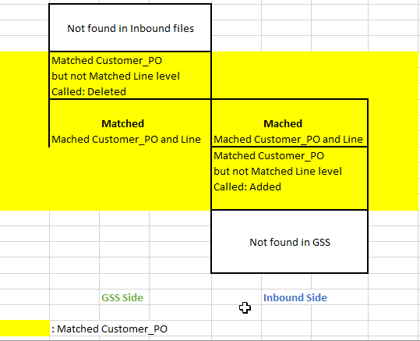

*6.2 Details of Comparison Rules:*

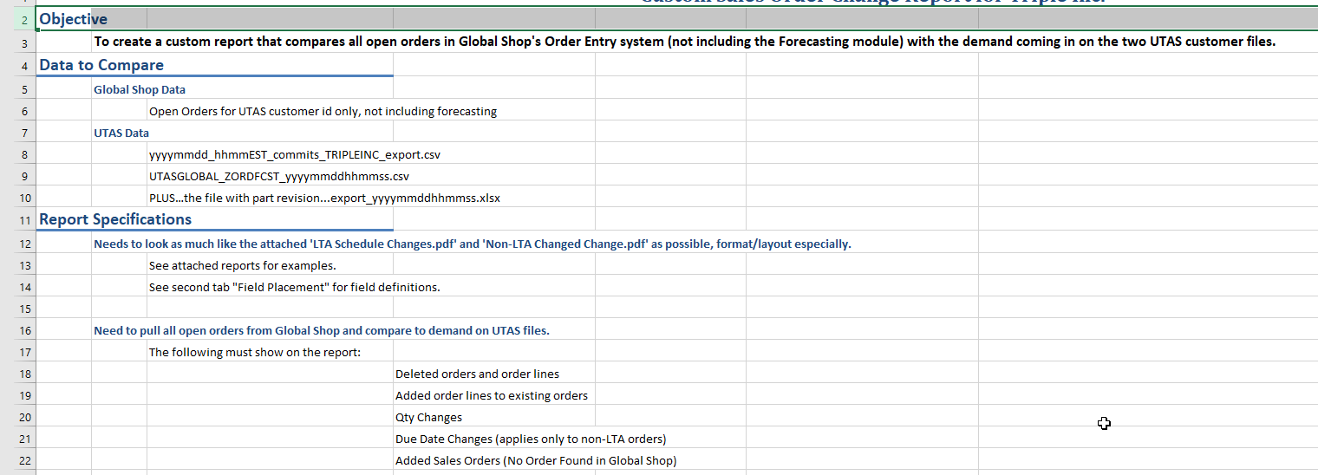

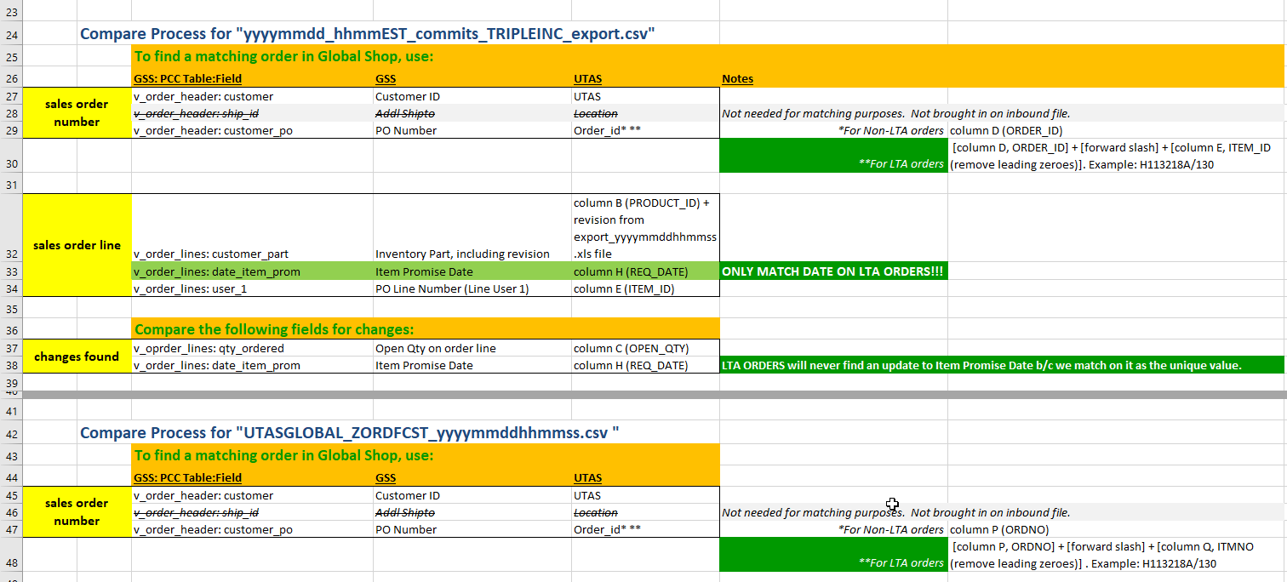

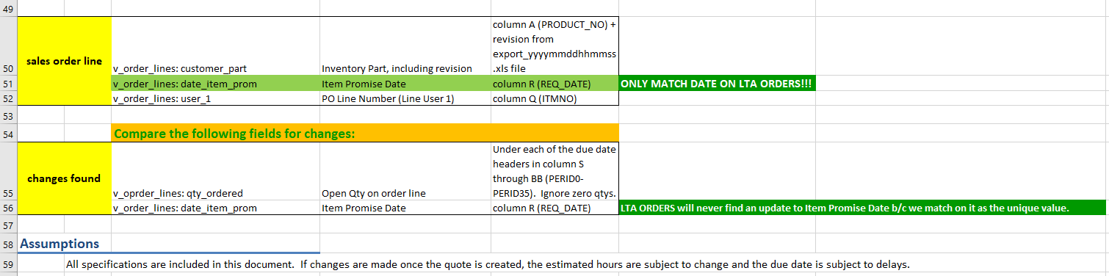

*6.3. Comparison screenshots*

Use the Customer browser to select customer in GSS for comparing. Click Add button to confirm selection. A list of customers can be entered in the Selected Customers with comma delimited.

Click Compare. The result will be displayed in 4 grids: All, LTA, NON-LTA and Part Summary.

