BN, Feb 2, 2021

Project 6262: Open Job Review Dashboard – Modification of project 4564

Customer: Washington Metalworks, LTD. – UK

Min version: 2019.1

Business Case:

Washington Metalworks currently uses ARC 4564 – Open Job Review in their production meeting.  In order to get the info they need from the dashboard they export it to excel and add items and resort, etc.  This customization would make it so that instead of exporting and creating numerous excel files each week they could simply use the live dashboard.

Solution:

Add more columns and enhance speed.

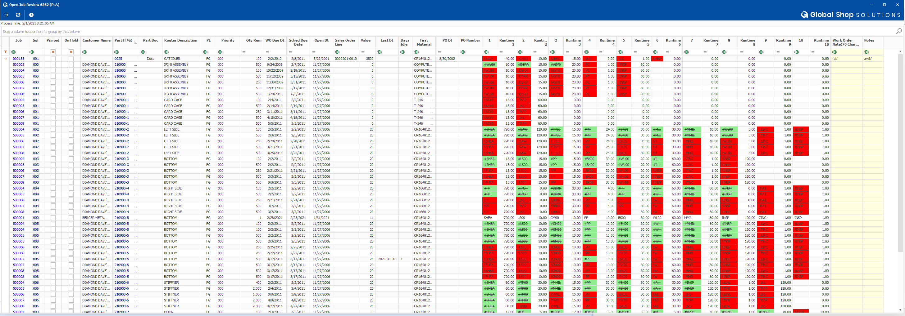

1/ Speed:

* For the customer having about 6000 records on the dashboard, we can reduce the loading time from 5 minutes to 2 seconds.
* Format color by columns, not cell by cell so speed up the processing
* Dashboard is loaded from xml file which is fetched by Online Update post process hook 38130. This hook must be attached to GCG_6262_OU.g2u Asynchronously.
* The data is updated with the time stamp as the Online Update process time. The time stamp is displayed at the top left corner.

2/ Features and Logic:

* Program processing:

1. Pull open work orders
2. Open WOs having all sequences closed will not be pulled
3. Parent WOs have suffix as 000 or blank. Children WOs have suffix as 001, 002, 003, etc.
4. Get the first Material Sequence
5. Get the first 10 Work Centers in APS and their Estimated Hours
6. If the Work Center sequence:

*** is completed => the Work Center will be prefixed with #, font strikeout and colored Green

*** is passed due => the Work Center will be prefixed with ! and colored Red

1. Columns added:
   1. Ten Runtime columns for the first 10 Work Centers
   2. Scheduled Due Date
   3. Sales Order Line value. If there is not a SO Line attached, the get the list price of parent WO part
   4. WO Date Opened
   5. Last Date touched
   6. Days Idle
   7. On hold: User must be in security group EditWO to flag WO as On Hold
   8. Part Doc**: Router Document Control** of the Part of the WO. If there is any link in Document Control, the word ‘Docs’ will be displayed in the column and we can click the cell to open Document Control
   9. Notes is from GAB_4169_WO_Notes
   10. Work Order Note (70 chars) is from WO User Field 6
2. Right click grid:

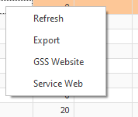

1. Left click the Job/Suffix/Part cell:

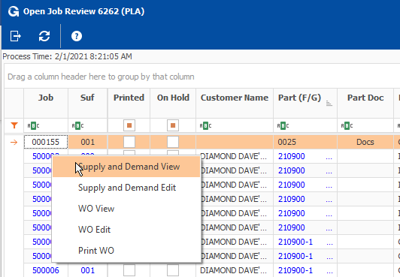

User must be assigned menu item otherwise cannot go to the links.