BN, Aug 2021 - Project 6318 - Quality Reject for Materials/Components

**BUSINESS CASE:**

MUM Industries is looking for a custom scrap/reject process that **includes custom rules for scrap**. The requirement would allow users to **scrap material/components from a work order** instead of the finished part on the work order header.

**SOLUTION:**

Current Scrap Codes are numeric. The project will map numeric Scrap Codes to alphabetical Scrap Codes.

                0 -> A, 1 -> B, 2 -> C, 3 -> D, 4 -> E, 5 -> F, 6 -> G, 7 -> H, 8 -> I, 9 -> J.

Numeric Scrap Codes are NOT auto-disposed. Alphabetical Scrap Codes are auto-disposed.

When at creating quality records (NCMR) based on custom rules that are setup, the actual Scrap Codes will be mapped to numeric or alphabetical. Emails will be sent out to group EM6318 if the actual code used is numeric.

**1/ Maintenance screen:** *Quality System > Administration > Rejected Codes Maintenance 6318*

When first loading, the maintenance grid will pull all numeric Scrap Codes, then auto-maps to alphabetical Scrap Codes. Now we can setup the custom rules for each Scrap Code.

2 Fields are used in the custom rule: **Quantity** and **Dollars Value**. For example, the first row is for Code 01 – Junk 1. We have set the *Quantity Sign:* ***<=****, Quantity Value:* ***20****, use* ***And*** *operator, Dollars Sign:* ***<=****, Dollars Value:* ***205***. This means if the condition *(Quantity <= 20 And Dollars Values <= 205)* is met, the Scrap Code will be AB, instead of 01 even though user enters 01 as the Scrap Code.

Remember to check Apply Mapping Auto Scrap column and Auto Dispose (Alpha. Code) column.

For Mum Industries, they have different rules in different company code, and there are many numeric Scrap Codes to map. To make it easy for setting the custom rules, the grid is designed for multi-selection (click a row, and to select other row, click Ctrl or click Ctrl+Shift to select a continuous section). After selecting multiple rows, right click and select **Set Bulk Value:**

A small window will pop up for selecting the column you want to set values. Select a column and hit Tab, the Value textbox/dropdown (based on column) will be displayed for you to set value.

After the custom rules are setup, click Save button  to save your settings.

**2/Create NCMR records for materials/components of a Work Order:**

*Quality System > File > Create NCMR for Components with Custom Rule 6318*

Scan the employee badge and click Load Badge. Scan WO and Click WO. Printer will be setup for Scrap Printer for the terminal using the maintenance screen from Move Ticket program.

User will input **Qty to Scrap, Numeric Code,** and **Bin** column.

At Numeric Code, there is a combo box. User can select from dropdown or type in. After the value is entered, hit Tab, the value will be set to the Numeric Code, and based on the value of **Qty to Scrap** and **Amount** (which is equal to Qty to Scrap * Cost) and the custom rule setup at the maintenance program, the **Actual Code** will be mapped. The Actual Code is the code that will be used in creating the NCMR record.

A Pre Check is run for these columns:

Reference must be non-blank.

Qty To Scrap and Amount must be positive.

Actual Code must be populated.

NCMR value must be blank. This field is populated after an NCMR is created, but if user wants to create another NCMR, it must be blank before creating new.

If the Pre Check passes, the Pre Check value will be ‘Valid’, and the row will be auto-marked as selected:

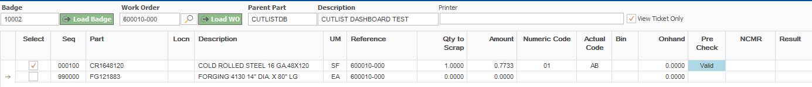

Now you will enter the Bin number. The Onhand column will show the quantity onhand of the Bin entered:

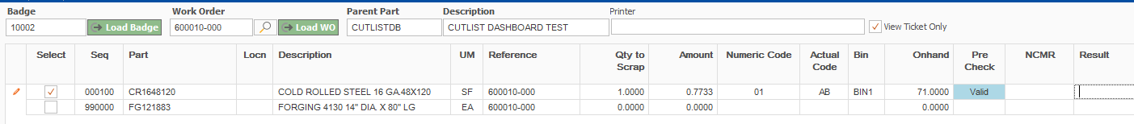

If one of the fields is not populated by user, and user clicks Save to generate an NCMR, a Post Check will show an error message at the Result cell for each row selected:



If every field entered is good, go ahead and click Save button. The program will create an NCMR record for each row (material) and populate the NCMR number back to the grid:

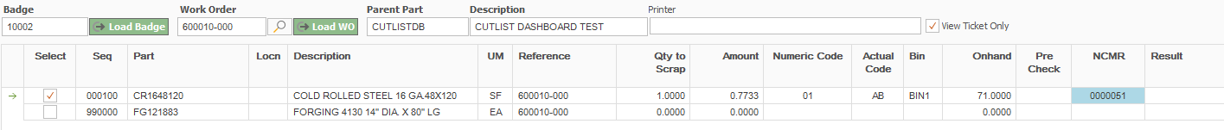

Once the NCMR is created successfully, each row selected will print a Scrap label:

If the Actual Scrap Code used for the row is alphabetical, the NCMR will be auto-disposed.

If the Actual Scrap Code used for the row is numeric, the NCMR will not be auto-disposed, and an email is sent out the group EM6318.