BN, July 2021

This project modified the AR Aging Dashboard (PPT_AR_Aging_Dash.g2u dated 06/17/2021)  
Customer: Zephyr

1/Customer has 67k records in AR_Open_Items so refreshing tab Statements takes about more than 2 hours using the standard AR Aging Dashboard. Suggestion in the quote: Add Invoice Date Start to load it faster. If we add Invoice Start date, the program will pull the wrong customer balance if that Start Date is set to a transaction seating between an invoice transaction dates.

Thus, I did approach differently: rewrite the subroutine CheckBalances. This old sub looped 67k records (Big-theta N). The new processing will not have to loop through 67k records. Instead, it uses SQL aggregation function in a smart way (Big-theta 1). The time reduces from 2 hours to 15 seconds.

2/ Use Custom Report No Zero Net: This custom report is modified from project 4141. It includes column Current, 31-60, 61-90, 91-120, and over 120 days and it will not print invoices where the invoice's balance is 0. There is a checkbox to select printing this report.

Using this report will also reduce the time to print each report from 7 seconds (old report use id 562 AR_Statements.rpt) to 5 seconds (new report GCG_4141_ARNo0_Logo.rpt).

Project is still using the GAB_4437_OVDUE_INVC for invoice notes.

All registry has been changed to 6431.

Same as standard AR Aging Dashboard:

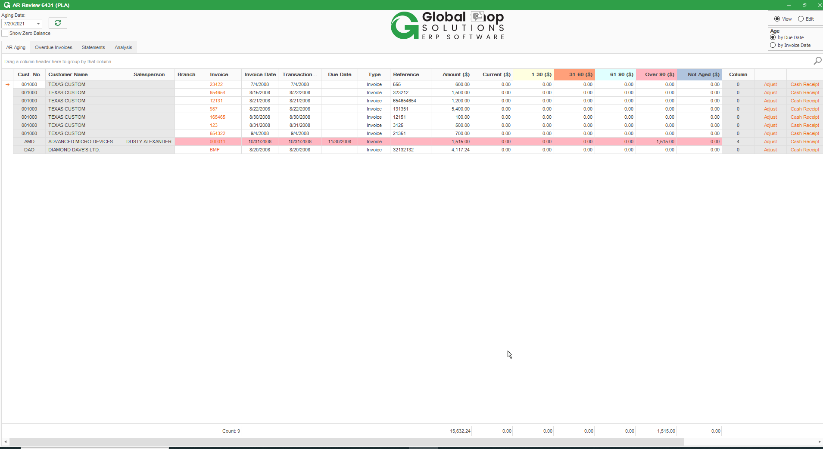

Statement tab is rewritten and added Use No Zero Rpt checkbox. Click Refresh, the output to the statements grid is the same as standard AR Aging dashboard but loads real fast for customer who has big table AR_Open_Items. 67k of lines for 15 seconds instead of 2 hours in standard AR Aging dashboard.

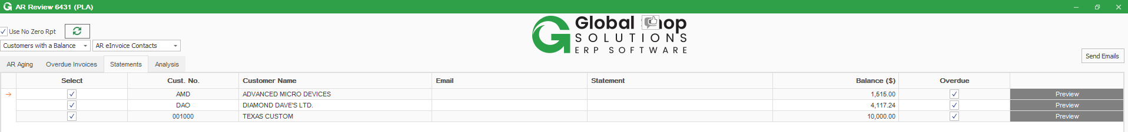

Custom report No Zero Net:

