Project 6275 –

Customer File Mapper Maintenance – Mapping incoming columns to a Custom Table and Setting Info needed for Creating an RFQ. (available file types to map. XLXS,CSV and TXT)

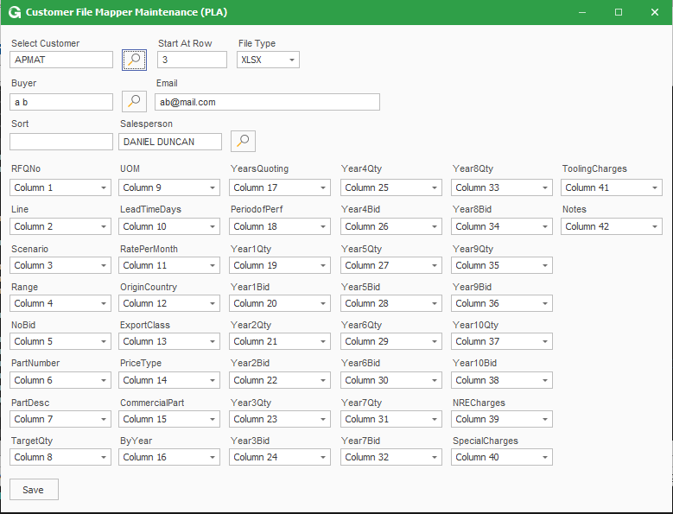

RFQ Upload.

Select Customer then browse for a file to upload RFQ.

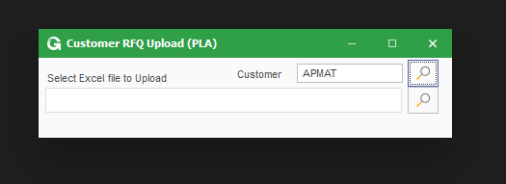

RFQ Entry: This will be used to creating RFQ’s for Customers that do not have a mapped file. (Still needing to add the ability for user to enter the additional info being saved to custom table.)

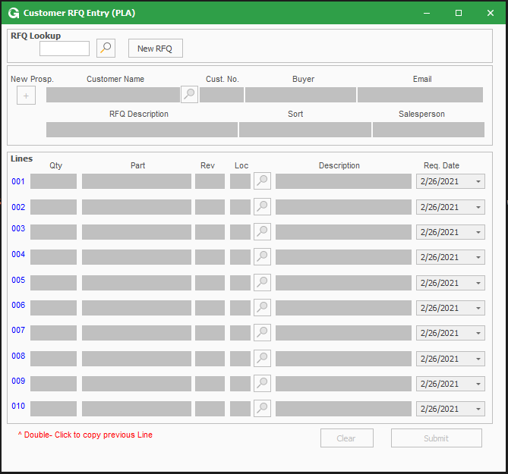

RFQ Dashboard ( From here the user can update Custom Fields – Open RFQ screen and Quote Screen when Quote is generated from the RFQ)

